
Understand and Troubleshoot Dynamic Access Control in Windows Server 2012
Microsoft Corporation
Published: September 2012
Updated: February 2013
Author: Mike Stephens
Abstract
This Understand and Troubleshoot Guide (UTG) introduces Dynamic Access Control scenarios, its dependent components and technologies, identity, claims, and authentication. Furthermore, this guide provides guidance on how-it-works architecture, message flows, and provides detail administration on the Dynamic Access Control: Using Central Access Policy scenario. Additionally, the guide contains a framework for troubleshooting Central Access Policy and its dependent technologies along with specific guidance regarding commonly encountered configuration questions.



The information contained in this document represents the current view of Microsoft Corporation on the issues discussed as of the date of publication. Because Microsoft must respond to changing market conditions, it should not be interpreted to be a commitment on the part of Microsoft, and Microsoft cannot guarantee the accuracy of any information presented after the date of publication.

This White Paper is for informational purposes only. MICROSOFT MAKES NO WARRANTIES, EXPRESS, IMPLIED OR STATUTORY, AS TO THE INFORMATION IN THIS DOCUMENT.

Complying with all applicable copyright laws is the responsibility of the user. Without limiting the rights under copyright, no part of this document may be reproduced, stored in or introduced into a retrieval system, or transmitted in any form or by any means (electronic, mechanical, photocopying, recording, or otherwise), or for any purpose, without the express written permission of Microsoft Corporation.

Microsoft may have patents, patent applications, trademarks, copyrights, or other intellectual property rights covering subject matter in this document. Except as expressly provided in any written license agreement from Microsoft, the furnishing of this document does not give you any license to these patents, trademarks, copyrights, or other intellectual property.

Unless otherwise noted, the companies, organizations, products, domain names, e-mail addresses, logos, people, places, and events depicted in examples herein are fictitious. No association with any real company, organization, product, domain name, e-mail address, logo, person, place, or event is intended or should be inferred.

©2012 Microsoft Corporation. All rights reserved.

Microsoft, Windows, Windows Server, Windows XP, Windows 7, Windows 8 are either registered trademarks or trademarks of Microsoft Corporation in the United States and/or other countries.
All other trademarks are property of their respective owners.

Contents
Understand and Troubleshoot Dynamic Access Control in Windows Server 2012 1
About Understand and Troubleshoot Guides 1
Introducing Dynamic Access Control 2
Description 2
What Is Dynamic Access Control? 2
Conditional Expressions for Permission Entries 3
File Classification Infrastructure 3
Central Access Policies 4
Purpose/Benefits 4
Technical Overview 4
Prerequisites 5
Foundation Technologies 5
Functional Description 5
Basic Deployment of most Dynamic Access Control scenarios 6
Deploy Windows Server 2012 and Windows 8 6
Domain controller 6
File Server 7
Windows 8 Member Computer (required for device claims) 7
Enable support for Dynamic Access Control 8
KDC 8
Kerberos client 8
Create claim types 8
Populate attributes used as claim sources 8
Create Resource Property objects 9
Classify files and folders 9
Secure Resources using Conditional Expressions 9
Identity 10
Identity and Claims 10
What Is Identity 10
What Is a Claim 11
Types of Claims 11
User Claim 11
Device Claim 11
Transformation Claim 12
Claim Data Types 12
Claims Support in Windows Server 2012 13
Kerberos Claim Support 13
Kerberos Security Support Provider 13
Claim Aware domains members 13
Kerberos client 13
AS Request 14
Constrained Delegation and Protocol Transition TGS Request (S4U2Proxy) 15
TGS Request 15
Service Ticket Handling 15
Key Distribution Center (KDC) 16
Claims-enabled Security Identifier 16
KDC Support for Windows authorization claims 17
KDC 17
Planning an adequate number of Windows Server 2012 Domain Controllers 18
AS-Request 20
Existing PAC Claims in a TGS Request 20
Claims Transformation 23
Claim information in the PAC 24
Kerberos Armoring (FAST) 24
How it works 25
Kerberos Armoring in a Supported Domain 26
Kerberos Armoring in a Required Domain 30
Compound Authentication 33
How It Works 33
Configuration 37
User object 37
Group-managed Service Accounts 37
Computer Accounts 38
Requirements 38
Large Service Tickets 38
Resource SID Compression 38
Interoperability 39
Default Maximum Token Size 42
KDC Maximum Token Size Warnings 43
Unsupported Scenarios 43
Windows Authorization Claims Support 44
Conditional Expressions 44
Conditional Operators 45
Operator Precedence 47
Conditional Expression Examples 47
What Conditional Expressions look like in Security Descriptor Definition Language 50
New Advanced Security Settings Editor 50
Conditional Expression Editor 51
New Effective Access User Interface 52
Active Directory Claims Support 53
Schema changes 54
Objects 54
msDS-ValueType 54
msDS-ClaimTypePropertyBase 55
msDS-ClaimType 56
msDS-ResourceProperty 57
msDS-ResourcePropertyList 57
msDS-ClaimsTransformationPolicyType 58
msAuthz-CentralAccessRule 59
msAuthz-CentralAccessPolicy 60
Attributes 60
msDS-ClaimAttributeSource 60
msDS-ClaimIsSingleValued 60
msDS-ClaimIsValueSpaceRestricted 60
msDS-ClaimPossibleValues 61
msDS-ClaimSharesPossibleValuesWith 61
msDS-ClaimSharesPossibleValuesWithBL 61
msDS-ClaimSource 62
msDS-ClaimSourceType 62
msDS-ClaimTypeAppliesToClass 62
msDS-ClaimValueType 62
msDS-AppliesToResourceTypes 63
msDS-MembersOfResourcePropertyList 63
msDS-MembersOfResourcePropertyListBL 63
msDS-ValueTypeReference 63
msDS-ValueTypeReferenceBL 63
msDS-TransformationRulesCompiled 64
msDS-TransformationRules 64
msDS-EgressClaimsTransformationPolicy 64
msDS-TDOEgressBL 64
msDS-IngressClaimTransformationPolicy 65
msDS-TDOIngressBL 65
msDS-IsUsedAsResourceSecurityAttribute 65
Containers 66
Claims Configuration (container) 66
Central Access Policies (msAuthz-CentralAccessPolicies) 66
Central Access Rules (msAuthz-CentralAccessRules) 66
Claim Types (msDS-ClaimTypes) 67
Claims Transformation Policies (msDS-ClaimsTransformationPolicies) 67
Resource Properties (msDS-ResourceProperties) 67
Resource Property Lists (container) 67
Value Types (container) 67
Named Objects 68
Global Resource Property List 68
Managing Claims and Resource Properties 69
User and Computer Claims 69
Manage Claims using Active Directory Administrative Center 69
Starting the Active Directory Administrative Center 69
Source Attribute section 70
Source Attribute 71
Display name 72
Description 72
Claims of this type are issued for User class only 73
Set ID to a semantically identical claim type in a trusted forest 73
Protect from accidental deletion 74
Suggested Values section 74
No values are suggested 74
The following values are suggested 74
Create a New Claim Type 75
Modify a Claim Type 77
Delete a Claim 77
Enabling and Disabling Claim Types 78
Windows PowerShell History 78
Manage Claim Types using PowerShell 79
Starting the Active Directory module for Windows PowerShell 79
Create a Claim Type 79
AppliesToClasses 79
Description 80
DisplayName 80
Enabled 80
ID 80
IsSingleValued 81
RestrictValues 81
ProtectedFromAccidentalDeletion 81
Server 81
SourceAttribute 82
SourceOID 82
SourceTransformPolicy 82
SuggestedValues 82
ValueType 84
Example - Creating a new claim type using Windows PowerShell (without suggested values) 84
Example - Creating a new claim type using Windows PowerShell (with suggested values) 84
Example - Create a new transform-based claim type using Windows PowerShell 84
Example - Create a new OID-based claim type using Windows PowerShell 84
Modify a Claim Type 85
AppliesToClasses 85
Description 85
DisplayName 85
Enabled 86
Identity 86
ProtectedFromAccidentalDeletion 86
Server 86
SourceAttribute 86
SourceOID 86
SourceTransformPolicy 87
SuggestedValues 87
Delete a Claim Type 88
Identity 88
Server 89
Force 89
Enabling and Disabling Claim Types 89
Managing Resource and Reference Resource Properties using Active Directory Administrative Center 90
Resource Properties 90
Resource Property object 91
Reference Resource Property object 91
Secure Resource Property objects 91
General section 92
Display name 92
Value type 92
Description 93
Set ID to a semantically identical Resource Property in a trusted forest 93
Is a secure Resource Property 94
Protect from accidental deletion 95
Suggested Values section 95
Value 95
Display name 95
Description 95
Reference section 95
Select a claim type to share its suggested values 96
Display name 96
Value type 96
Description 96
Set ID to a semantically identical Resource Property in a trusted forest 96
Is a secure Resource Property 97
Protect from accidental deletion 97
Create a New Resource or Reference Resource Property 98
Create a Resource Property 98
Create a Reference Resource Property 100
Modify a Resource or Reference Resource Property 101
Delete a Resource or Reference Resource Property 102
Enabling and Disabling Resource Property objects 102
Managing Resource and Reference Resource Properties using Windows PowerShell 103
Create a New Resource or Reference Resource Property 103
Description 104
DisplayName 104
Enabled 104
ID 104
IsSecured 105
ProtectedFromAccidentalDeletion 105
ResourcePropertyValueType 105
Server 106
SharesValuesWith 106
SuggestedValues 107
Modify a Resource or Reference Resource Property 108
Description 108
DisplayName 108
Enabled 108
Identity 109
ProtectedFromAccidentalDeletion 109
Server 109
SharesValuesWith 109
SuggestedValues 109
Delete a Resource or Reference Resource Property 110
Identity 111
Server 111
Enabling and Disabling a Resource Property 111
Resource Property Lists 112
Managing Resource Property List Membership 112
Resource Property List Management using the Active Directory Administrative Center 113
Resource Property List Management using Active Directory Windows PowerShell 114
Identity 115
Members 115
Server 115
Populating Claim Sources and Resource Properties with Information 116
Adding Claim Information to Users and Computers 116
Classify Files and Folders 118
Manual Classification 118
Continuous File Classification 121
Advanced Security Settings and Conditional Expressions 122
Advanced Security Settings 122
Name 123
Owner 123
Permissions 124
Permissions Entry List 124
Column descriptions 124
Add 127
Remove 127
Edit 127
View 128
Disable inheritance 128
Replace all child object permissions with inheritable permissions from this object 128
Permission Entry Dialog 128
Principal 129
Type 129
Permissions 130
Clear all 131
Apply these permissions to objects and/or containers within this container only 131
Auditing 131
Audit Entry List 131
Column descriptions 132
Add 134
Remove 135
Edit 135
View 135
Disable inheritance 135
Replace all child object auditing entries with inheritable auditing entries from this object 136
Audit Entry Dialog 136
Principal 136
Type 137
Permissions 137
Clear all 138
Apply these auditing settings to objects and/or containers within this container only 138
Effective Access 138
User/Group 139
Include group membership 139
Device 140
Include a user claim 140
Include a device claim 140
Update 140
Effective Access List 140
Effective access 141
Permission 141
Access limited by 141
Share 141
Evaluating Effective Permissions 142
Precedence and Canonical Ordering 143
Precedence 143
Canonical Ordering 143
Lineage 143
Access Type 144
Results of Canonical Ordering 144
Effective Permissions before Windows 8 146
Access Token 146
Applicability 146
Explicit Access 147
Implicit Access 147
Share Access Policy 147
File Access Policy 148
Effective NTFS Access Scenario 149
Effective Share Access Scenario 151
Conditional Expression Editor 154
Multiple Expressions 156
Grouping Expressions 157
Ungroup Expressions 158
Removing Expressions 159
Conditional Expressions for Access Control 159
Effective Permissions with Conditional Expressions 160
Conditional Expressions for Auditing 163
Auditing 163
Conditional Expressions 164
Managing and Deploying Central Access 165
Managing Central Access using the Active Directory Administrative Center 165
Central Access Rule 166
General 166
Name 166
Description 166
Protect from accidental deletion 167
Target Resources 167
Permissions 167
New Central Access Rule 168
Viewing or Editing a Central Access Rule 168
Create a Central Access Rule 169
Edit a Central Access Rule 170
Delete a Central Access Rule 170
Central Access Policy object 171
General 171
Name 171
Description 172
Protect from accidental deletion 172
Member 172
Name 172
Permission State 172
Create a Central Access Policy object 173
Edit a Central Access Policy object 173
Delete a Central Access Policy object 173
Managing Central Access using Windows PowerShell 174
Central Access Rule 174
Create a Central Policy Rule 174
CurrentAcl 174
Description 174
Name 175
ProposedAcl 175
ProtectedFromAccidentalDeletion 175
ResourceCondition 175
Server 176
Edit a Central Access Rule 176
CurrentAcl 176
Description 177
Identity 177
ProposedAcl 177
ProtectedFromAccidentalDeletion 177
ResourceCondition 178
Server 178
Remove a Central Access Rule 178
Identity 178
Server 179
Central Access Policy object 179
Create a Central Access Policy object 179
Description 179
Name 179
ProtectedFromAccidentalDeletion 179
Server 180
Edit a Central Access Policy object 180
Description 180
Identity 180
ProtectedFromAccidentalDeletion 180
Server 181
Remove a Central Access Policy object 181
Identity 181
Server 181
Viewing a Central Access Policy using Windows Powershell 181
Add or Remove a Central Access Rule to a Central Access Policy object 182
Identity 183
Members 183
Server 183
Deploying Central Access Policy to File Servers 183
Deploying Central Access Policy using Group Policy 183
File System Security Policy Settings 184
Add Central Access Policy objects to a Group Policy object 184
How are Central Access Polices stored in a GPO 185
Applying Central Access Policy to Folders 186
Configuring Folders to use a Central Access Policy 186
Verify Central Access Policies applied 187
Configure a folder to use Central Access Policy 187
How Windows stores Central Access Policy links 188
How File Servers receive Central Access Policies 189
Registry entries for Central Access Rules 189
Registry entries for Central Access Policies 190
Modeling Central Access using Proposed Permissions 191
Proposed Permissions 191
Central Access Policy Staging auditing 191
Configure Central Access Policy Staging auditing 192
Success and Failure Audit Events 193
Success events 193
Failure events 193
Example 194
Effective Access using Central Access Policy 195
Central Access Policy and NTFS permissions 195
Share permissions, Central Access Policy, and NTFS permissions 195
Managing and Deploying Claims-based Global Object Access Auditing 200
Managing Global Object Access Auditing 200
Configuring Global Object Access Auditing 201
Domain-based Policy 202
Configure Global Object Access Policy 203
Deploying Global Object Access Auditing 204
Applying Global Access Auditing to a File Server 204
Policy behaviors 204
Confirming Policy applied to the file server 204
Combining File system and Global Object Access Auditing 204
Windows 7 and Windows Server 2008 R2 205
Windows 8 and Windows Server 2012 205
Claim Transformations and Policies 206
Scenarios 206
Value-based filtering 206
Claim type-based filtering 206
Claim type-based transformation 207
Claim Transformation and Filtering 207
Transform Engine 207
Parsing and Compiling Rules 208
Claim Filtering and Transformation 209
Managing and Deploying Claims Transformation Policies 214
Claim Transformation Policy 214
Transformation Rules 217
Transformation Rule Language 217
Claim object 218
Condition Statement 219
Issue Statement 220
Forward Rule Example 221
Transformation Rule Example 222
Empty Condition Forward Rule 223
Multiple Condition Rule 223
Multiple Rules 224
Filter Rules 225
Managing Claims Transformation Policies 226
Create a Claim Transformation Policy 227
Description 227
Name 227
ProtectedFromAccidentalDeletion 227
Server 227
AllowAll 227
AllowAllExcept 228
DenyAll 228
DenyAllExcept 228
Rule 228
Modify a Claim Transformation Policy 229
Description 229
Identity 229
ProtectedFromAccidentalDeletion 229
Server 229
AllowAll 229
AllowAllExcept 230
DenyAll 230
DenyAllExcept 230
Rule 230
Remove a Claim Transformation Policy 231
Identity 231
Server 231
Display a Claim Transformation Policy 231
Identity 231
Server 231
Deploying Claims Transformation Policies 232
Linking Transformation Policy object to Forests 232
Managing Claim Transformation Links 233
Linking a Claim Transformation Policy 233
Removing a Claim Transformation Policy 234
Confirm a Claim Transformation Policy Link 235
Troubleshooting Dynamic Access Control 237
General Troubleshooting Methodology 237
Infrastructure 238
Domain controller 239
Windows 8 and Windows Server 2012 member computers 239
Windows Server 2012 Domain Controller 239
More than one Windows Server 2012 Domain Controller 239
Configure Domain Controllers to Support Dynamic Access Control 240
Active Directory 240
Create Claim Types in Active Directory 240
File Server 241
Apply Permissions and Auditing to the File Server 241
Authentication 241
User Claims 242
Claim Information is Dynamic 242
Claims Types are Specific 242
Confirm User Claims using Event Logs 242
Show User claims on the Client 245
Show User claims on the File Server 246
Confirm Claims Processing 248
User Claims traversing a Forest Trust 249
Claims Transformation Policy linked to the Trusted Domain 250
No Claims Transformation Policy linked to the Trusting Domain 250
Claims Transformation Policies linked to the Trusting Domain 250
Semantically Different Claim IDs 251
Claims Transformation Problems 251
Summary 252
Access Problem 252
Effective Access 252
Manual Evaluation 254
Allow and Deny Type Permission Entries 254
Explicit Permissions vs. Inherited Permissions 254
Conditional Permission Entries 255
Effective Permissions without Central Access Policy 255
Effective Permissions with Central Access Policy 255
Summary 256
Common Misconfigurations 256
Central Access Policy and Rules 256
Behaviors 257
Users cannot see files after a Central Access Policy is applied to a shared folder 257
Central Access Policy disallows access when it was not expected 258
Central Access Policy allows access when it was not expected 259
Configuration Problems 262
Central Access Policy not visible in the GP Management 262
Central Access Policy staging events are not written in the Security event log 264
Resource Properties 265
Classification tab does not appear in Windows Explorer 265
Classification Tab Installation 265
Classification Tab does not show newly configured Resource Property 266
Refresh the Local Cache 266
Users cannot view or assign a Resource Property to a file or folder 268
Global Object Access Auditing 268
Audit events do not appear in the System event log 268
Enable Auditing 269
Configure Resources for Auditing using Global Object Access Auditing 269
Conditional Expressions 269
Group Policy 270
Event Logs 270
Advanced Security Settings Editor 270
The Central Policy Tab is not visible or the Central Policy Tab does not show a specific Central Access Policy 271
Central Policy Tab 271
Event Logs 271
Active Directory 272
Active Directory and Sysvol Replication 272
Registry Settings 273
The Conditional Expression editor does not show a specific claim type 273
Domain Connectivity 273
Claim Types 274
Resource Property 274
Global Resource Property List 275
Active Directory Replication 275
Portions of the Advanced Security Settings editor are unavailable and I cannot change settings 275
Domain Connectivity 275
Edit Mode 276
Complex or Invalid Conditional Expression 276
Active Directory Replication 279
Help Desk or equivalent personnel cannot use the Effective Access tab 279
The effective access rights shown are based on group membership on this computer. For more accurate results, calculate effective access rights on the target server. 279
The RPC server is unavailable. Please enable the Netlogon Service Authz (RPC) firewall rule on the target server and try again. 280
You do not have permission to evaluate effective access rights for the remote resource. Contact the administrator of the target server. 280
Help Desk or equivalent personnel cannot see information in the Share tab in the Advanced Security Settings Editor 280
The requested security information is either unavailable or can’t be displayed 281
Troubleshooting Summary 282
Infrastructure 283
Authentication 283
General Access Problems 283

Understand and Troubleshoot Dynamic Access Control in Windows Server 2012
This module explains the concepts of claims and Windows Server 2012 uses claims as identity. Windows Server 2012 can evaluate and use claims as a form of identity when it checks for access and auditing access control lists. It is important to understand claims to understand how Windows' security model builds and uses them to express user and resource identity.

About Understand and Troubleshoot Guides
Understand and Troubleshoot guides enable customers to learn about technical concepts, functionality, and general troubleshooting methods for new Windows features and enhancements. The Understanding and Troubleshooting Guide helps the user in developing an understanding of key technical concepts, architecture, functionality, and troubleshooting tools and techniques. This understanding enables more successful testing and early adoption experiences during the evaluation phase, and supports early ramp-up of help desk and technical support roles.

Introducing Dynamic Access Control

Description
Dynamic Access Control represents several feature enhancements introduced with Windows Server 2012 Server that work together to improve authorization management for Windows Server 2012 file servers.
- Kerberos support for user claims and device authorization information
- Support for conditional expressions in permission and audit entries
- File classification, and central access policies provide an end-to-end authorization management solution.
- Include conditional expression support in Global Object Access Auditing.
- Automatic Rights Management Services (RMS) encryption for sensitive Office documents (not included in this document).
- Access denied assistance to ease the burden of troubleshooting share access problems (not included in this document).

What Is Dynamic Access Control?
In Windows Server 2012, you will be able to apply data governance across your file servers to control who can access information and to audit who has accessed information. Dynamic Access Control provides:
- Identify data – Automatic and manual classification of files can be applied to tag data in file servers across the organization
- Control access to files - Central access policies enable organizations to apply safety net policies. For example, you could define who can access health information within the organization.
- Audit access to files - Central audit policies for compliance reporting and forensic analysis. For example, you could identify who accessed highly sensitive information.
- Apply RMS protection - Automatic Rights Management Services (RMS) encryption for sensitive Office documents. For example, you could configure RMS to encrypt all documents containing HIPAA information.
This feature set is based on infrastructure investments that can be further leveraged by partners and line-of-business applications and provide great value for organizations that use Active Directory. This infrastructure includes:
- A new Windows authorization and audit engine that can process conditional expressions and central policies.
- Kerberos authentication support for user claims and device claims.
- Improvements to the File Classification Infrastructure.
- RMS extensibility support so that partners can provide solutions that encrypt non-Office files.

Conditional Expressions for Permission Entries
Windows Server 2008 R2 and Windows 7 enhanced Windows security descriptors by introducing a conditional access permission entry. Windows Server 2012 takes advantage of conditional access permission entries by inserting user claims, device claims, and resource properties, into conditional expressions. Windows Server 2012 security evaluates these expressions and allows or denies access based on results of the evaluation. Securing access to resources through claims is known as claims-based access control. Claims-based access control works with traditional access control to provide an additional layer of authorization that is flexible to the varying needs of the enterprise environment.

File Classification Infrastructure
Windows Server 2008 R2 introduced File Classification Infrastructure (FCI). FCI provides:
- The ability to define classification properties
- Automatically classify files based on location and content
- Apply file management tasks such as file expiration and custom commands based on classification
- Produce reports that show the distribution of a classification property on the file server.
With Windows Server 2012, the File Classification Infrastructure is claims aware. This enhancement allows FCI to present resource properties as classification properties. Administrators can choose classifications manually using Windows Explorer. Alternatively, they can use the File Server Resource Manager (FSRM) to perform continuous classification. Resource properties allow claims-based access control to evaluate how claims about the user relate to claims about the resource. Windows accomplishes this evaluation through conditional access control entries, which is an additional layer to traditional authorization. FCI in Windows Server 2012 also supports:
- Security properties so that they can be used for authorization decisions in the new authorization expressions
- Continuous classification which will classify files a few seconds after they are created or modified on the server
- Manual classification to allow information owners and users to classify files using explorer
- Folder based inherited classification that allows information owners to tag a folder and all the files that are in that folder as well as newly created files in that folder

Central Access Policies
Central Access policy is a new feature of Windows Server 2012. Central Access Policies allow administrators to create access policies that apply to Windows Server 2012 file servers using Group Policy. Each Central Access Policy object can contain one or more Central Access rules. Administrators can configure applicability, and permissions within each Central Access policy rule. Windows stores Central Access policies and rules centrally in Windows Server Active Directory. This provides a centralized approach to manage authorization on Windows Server 2012 file servers.

Purpose/Benefits
Dynamic Access Control focuses on four main end-to-end scenarios:
- Central access policy for access to files – enable organizations to set safety net policies that reflect the business and regulatory compliance.
- Auditing for compliance and analysis – Enable targeted auditing across file servers for compliance reporting and forensic analysis
- Protecting sensitive information – Identifying and protecting sensitive information both in a Windows Server 2012 environment and when it leaves the Windows Server 2012 environment
- Access denied assistance– Improve access denied experience to reduce the helpdesk load and incident time for troubleshooting access denied

Technical Overview
Dynamic Access Control is not a single feature, but rather a file server solution built using a Windows Server 2012 infrastructure to provide a versatile and flexible end-to-end authorization scenario. Windows Server 2012 enhancements that make up Dynamic Access Control include
- Direct claims support in Kerberos
- Support in Active Directory to store user and device claims and resource properties
- Support in Active Directory for storing Central Access Policy objects
- Support for deploying Central Access Policy objects using Group Policy
- Support for claims-based file authorization and auditing for file system using Group Policy and Global Object Access Auditing.
- New Advanced Security Settings user interface that includes a conditional expression editor and improved Effective Access functionality that is used for modeling and troubleshooting access control
- Claim Transformation Policy objects to transform claims traversing Active Directory forest trusts

Prerequisites
Claims-based authorization and auditing requires:
• Windows Server 2012
• At least one Windows Server 2012 domain controller accessible by the Windows client in the user's domain
• At least one Windows Server 2012 domain controller in each domain when using claims across a forest trust
- Windows 8 client (required when using device claims)

Foundation Technologies
Dynamic Access Control relies on many technologies. Dynamic Access Control combines many different Windows Server 2012 technologies to provide a robust, flexible, and granular authorization and auditing experience. Some of the fundamental technologies used by Dynamic Access Control include:
- Network protocols (includes TCP/IP, RPC, SMB, LDAP)
- Name resolution (DNS)
- Active Directory and its dependent technologies
- Microsoft's Kerberos v5 implementation including Kerberos armoring (FAST) and Compound authentication
- Windows Security (LSA, Netlogon)

Functional Description
Dynamic Access Control provides a flexible way to apply and manage access and auditing to domain-based file servers. Dynamic Access Control accomplishes flexibility by leveraging claims in the authentication token, resource properties on the resource, and conditional expressions within permission and auditing entries. With this combination of features, you can now grant access to file and folders based on Active Directory attributes. For example, the user Alice is granted access to the file server share because the department attribute on her user object in Active Directory contains the value Accounting.
Ease of management is accomplished by creating Central Access Policy objects. Each Central Access Policy object includes one or more linked Central Access Rule objects. Each Central Access Rule object contains one or more permission entries. Central Access Policy objects allow you to define access for files and folder one time, and then deploy that access to multiple shares on multiple file servers through Group Policy.

Basic Deployment of most Dynamic Access Control scenarios
One feature of Dynamic Access Control is to use claims-based access control for authorization and auditing. You use a pragmatic approach when deploying claims-based access control to file servers. The following overview provides the order in which you deploy claim-based authorization and auditing, but also serves as the order in which you troubleshoot claims-base access control.
- Deploy Windows Server 2012 and optionally Windows 8 clients if you need to use device claims.
- Enable Windows 8 Kerberos clients to support claims and Windows Server 2012 domain controllers to support claims.
- Create and enable user and device claim types, use existing security groups, or use a combination of both.
- Provide data on user and computer attributes used to source claim types. Provide the object identifier (OID) for the issuance policy used to source the certificate-based claim type.
- Create and enable Resource Property objects.
- Classify file and folders.
- Create conditional expressions directly on the resource or deploy using Central Access policy using Group Policy, or Global Object Access Auditing.

Deploy Windows Server 2012 and Windows 8
Claims-based authorization and auditing requires
- A Windows Server 2012 domain controller
- A domain-joined Windows Server 2012 file server
- A domain-joined Windows 8 computer (only needed when using device claims)
Claims-based authorization and auditing requires Windows Server 2012 and Windows 8 for a few reasons.

Domain controller
The first requirement is a Windows Server 2012 domain controller. This new authorization and auditing mechanism requires extensions to Active Directory. These new extensions build Windows claim types, which is where Windows stores claims for an Active Directory forest.
Another dependency upon which claims authorization relies in the Kerberos Key Distribution Center (KDC). The Windows Server 2012 KDC contains Kerberos enhancements required to transport claims within a Kerberos ticket and compound authentication. Windows Server 2012 KDC also includes an enhancement to support Kerberos armoring.
 Note: | Your environment only requires a Windows Server 2012 KDC when you base authorization decisions on claims that are sourced from Active Directory attributes or certificates. Authorization decisions based on group memberships, including conditional expressions that use the memberOf operator do not require a Windows Server 2012 KDC.

Lastly, the Security Accounts Manager (SAM) portion of the Windows Server 2012 domain controller understands claim types, where they are stored, and claims transformation. The KDC relies on the SAM to retrieve claim information that it uses in Kerberos tickets.
Claim-based authorization and auditing does not have a forest functional or domain functional requirement. You can implement and configure claims with a mixture of Windows Server 2008 and 2008 R2 domain controllers provided the domain has an adequate number Windows Server 2012 domain controllers to support authentication requests that include claim information.

File Server
The next requirement for claim-based authorization and auditing is a Windows Server 2012 file server. When a user connects to a file share, the file server performs an access check to the share using the credentials of the incoming connection. This means the file server determines access to share. This also means that various components on the file server must be claims aware, such as the Local Security Authority and the Kerberos application server. The file server hosting the share must be a Windows Server 2012 file server to read claims and device authorization data from a Kerberos ticket, translate those security identifiers (SIDs) and claims from the ticket into an authentication token, and compare the authorization data in the token against conditional expressions included in the security descriptor.

Windows 8 Member Computer (required for device claims)
Windows 8 member computers are required for claim-based authorization and auditing when using device claims. A Windows Server 2012 domain controller issues claims in Kerberos tickets when the Kerberos client requests claims in its request. Domain joined Windows 8 computers request claim information when they make Kerberos requests and, these computers understand how to locate a claims-aware domain controller. Also, Kerberos client requests from Windows Server 2012 member computers include the device’s (computer) ticket-granting ticket (TGT) when the domain controller supports Dynamic Access Control.
You can use claim-based authorization with member computers running previous versions of Windows provided the file server hosting the files is running Windows Server 2012, you configured the Microsoft network server: Attempt S4U2Self to obtain claim information local security policy setting to default or enabled, and the file server can successfully communicate with a Windows Server 2012 domain controller. Windows Server 2012 file servers automatically enable S4U2Self when you deploy one or more Central Access policies to the file server.

Enable support for Dynamic Access Control
You must enable Windows 8 computers and Windows Server 2012 file servers to support claims and compound authentication.

KDC
You enable claim support by creating a Group Policy object that includes the Group Policy setting KDC support for claims, compound authentication and Kerberos armoring. You apply this Group Policy object to the Domain Controllers organization unit (OU) to apply this setting to all domain controllers in the OU. Windows Server 2012 domain controllers read this configuration while other domain controllers ignore this setting.

Kerberos client
You enable claim support in the Windows 8 and Windows Server 2012 Kerberos client by creating a Group Policy object that includes the Group Policy setting Kerberos client support for claims, compound authentication and Kerberos armoring. The Windows 8 and Windows Server 2012 Kerberos clients do not request claims, armor Kerberos requests, or perform compound authentication by default-- you must enable it.
After you enable claim support on the KDC and the Kerberos client, reboot domain-joined Windows Server 2012 member servers and Windows 8 computers to ensure these computers use Kerberos armoring and request claims. You should not need to reboot the domain controllers.

Create claim types
The domain controllers can now issue claims; however, you need to configure claim types before the domain controller can issue claims. Using the Active Directory Administrative Center, you create attribute-based claim types that source their information from user and computer attributes. You can create certificate-based claim types using the Active Directory module for Windows PowerShell. Also, you can create transformation-based claim types, which are used exclusively for the purpose of transforming claims across forest trusts.
Windows stores the claim types you create in the configuration partition of Active Directory. All domains within that forest share the claim types and domain controllers from those respective domain issue claim information during user and computer authentication.
 Important: | It is important that information contained in Active Directory attributes used to source claim types contain accurate information, or remain blank. Incorrect attribute information can lead to unexpected access to information using claims-based authorization. As a best practice, validate the accuracy of attribute information or clear the values of attributes that you intend to use a source attributes for claim types.

Populate attributes used as claim sources
The Active Directory forest partition stores claim types that domain controllers can issue. You source these claims types based on Active Directory attributes such as department or country. You need to configure your computer and user accounts in Active Directory with the information that is correct for the respective user or computer. Windows Server 2012 domain controllers do not issue a claim for an attribute-based claim type when the attribute for the authenticating principal is empty. Therefore, ensure you configure attributes that source claim types with correct information.
Important: | Dynamic Access Control enables you to use user and computer attribute data for authorization information. Therefore, you need to secure these attributes as appropriate for your environment.

Create Resource Property objects
The Windows access check needs information included on files and folders to validate claims. The way to configure this information on these resources is to create Resource Property objects. Resource property objects define the additional properties that appear on file and folders. Windows uses these properties for compliancy and reporting as well as authorization and auditing. Use the Active Directory Administrative Center to create and manage global resource properties and the Resource Property lists to which they belong.

Classify files and folders
Creating Resource Property objects provides you the ability to select properties to include on the files and folders. Now, you must configure the resource properties you want to apply to those files and folders and the values for those properties. Windows uses the values in these properties with the values from user and device claims when evaluating file authorization and auditing.

Secure Resources using Conditional Expressions
With user and device claims, and resource properties configured, you then need to protect the file and folders using conditional expressions that evaluate user and device claims against values within resource properties, or constant values. You do this one of two ways. You can create conditional expressions directly in the security descriptor using the advanced security settings editor. Alternatively, you can create Central Access rules and link those rules to Central Access Policy objects. Then, you can deploy Central Access policy objects to file servers using Group Policy and configure the share to use the Central Access Policy object. Central Access Policies is the most efficient preferred method of securing files and folders.
You can add conditional expression directly in the security descriptor for auditing purposes. Or, you can use Windows Security policy and deploy claim-based auditing to files and folders using Global Object Access Auditing.

Identity
This lesson briefly introduces the concept of identity. It is important to understand identity and its relationship to the Windows operating system. Subsequent lessons build on this knowledge to explain how claims serve as another form of identity.

Identity and Claims
Identity in Windows is not a new concept. Windows Server operating system introduced identity with the release of Windows NT and subsequent releases based on Windows NT. Windows Server 2012 enhances the concept of identity through claims. The concept of identity must be understood before covering identity enhancements.

What Is Identity
Identity is simple in design and concept. Consider the non-computer related example of Alice preparing for business trip to Germany.
Alice lives in the United States. When Alice arrives at the airport, she will check in at the airline ticket counter. The attendant at the ticket counter asks Alice for her passport. Her passport contains information about her such as her name, address, date of birth, and photograph. Each country ensures the information published in a passport is accurate for that person. This makes the source of the information authoritative. Each country trusts other countries to follow the same procedure.
The passport is Alice's identity. Her identity is represented by personal information published in her passport. Each item of personal information is a "claim" made about Alice by the country issuing the passport. The airline trusts that the issuing country's claims about Alice are true. Therefore, they use the passport to validate Alice's identity.
The Windows operating system provides a similar concept of identity. An administrator creates a user account named Alice in Active Directory. The domain controller publishes information about Alice such as security identifier, and group membership in attributes of Alice's user account. Windows creates an authorization token when Alice accesses a resource.
To connect the analogy-- Alice is the user. The authorization token is the passport. Each unique piece of information in the authorization token is a "claim" made about Alice's user account. Domain controllers issue these claims. Domain-joined computer and domain users trust domain controllers to provide authoritative information.
Both of these examples illustrate the concept of identity. Identity, with respect to authentication and authorization, is simply information published about an entity from a trusted source. The information is considered authoritative because the source is trusted.
Earlier versions of Windows Server used the security identifier (SID) as the primary information to represent identity of a user or computer. Users authenticate to the domain with a specific user name and password. The unique logon name translates into a security identifier. The domain controller validates the password and publishes the SID of the security principal and the SIDs of all the groups of which the principal is a member. The domain controller "claims" the user's SID is valid and should be used as the identity of the user. All domain members trust the domain controller; therefore, the response is treated as authoritative.
Identity is not limited to the user's SID. Applications can use any information about the user as a form of identity-- provided the application trusts the source of the information to be authoritative. For example, many applications implement role-based access control. Role-based access control limits access to resources based on if the user is a member of a specific role. SharePoint Server is good example of software that implements role-based security.

What Is a Claim
A claim is information a trusted source makes about an entity. The SID of a user or computer; the department classification of a file; and the health state of a computer are all valid examples of a claim. An entity can contain more than one claim, and any combination of those claims can be used to authorize access to resources.
Windows Server 2012 extends authorization to files and folders by using claims. Traditionally, Windows servers based authorization on the SID of the user or the SID of the group to which a user belonged. Windows Server 2012 extends authorization identity beyond using the SID for identity and allows administrators to configure authorization based on claims issued in Active Directory. With Windows Server 2012, administrators can protect files and folders based a user's department, cost center, or country.

Types of Claims
Windows Server 2012 introduces three new types of claims: user, device, and transformation claim types. Windows Server 2012 continues to allow you to use group membership for authorization decisions.

User Claim
A user claim is information provided by a Windows Server 2012 domain controller about a user. Windows Server 2012 domain controllers can use most Active Directory user attributes as claim information.

Device Claim
A device claim is information provided by a Windows Server 2012 domain controller about a device represented by a computer account in Active Directory. A device claim type can use most Active Directory attributes that are applicable to computer objects.

Transformation Claim
A transformation claim is a claim issued by a domain controller through a claim transformation policy. Windows Server 2012 domain controllers can transform claims exiting a trusted forest or entering a trusting forest. Transformation claims are not based on an Active Directory attribute as the source of the claim; but rather, the source typically is created from the rules within the transformation policy.

Claim Data Types
Claims, like Active Directory attributes, are strongly typed to hold specific information. This is important because Windows evaluates claims through one or more Boolean expressions. Boolean expressions are expressions that have a left value, an operator (an equal sign or greater than sign), and a right value. For Windows to correctly evaluate the expression, values on either side of the operand must be of the same or compatible data type.
Windows Server 2012 includes the following claim data types
Table 1 Default claim data types in Windows Server 2012
Claim data type | Usage description
Boolean | An integer-based claim that represents true and false values
Multi-valued String | A claim that contains one or more string values
Multi-valued Unsigned Integer | A claim that contains one or more positive integer values
Security Identifier | A claim that contains one or more security identifiers
String | A claim that contains literal alpha-numeric characters
Unsigned Integer | A claim that contains a positive numerical value

Claims Support in Windows Server 2012
Microsoft includes many changes to allow Windows Server 2012 to support claims-based authorization and auditing. Claims-based authorization and auditing require several enhancements to dependent components to allow this protection on files and folders. These improvements include Kerberos enhancements, changes and enhancements to LSASS and other security components, and enhancements in Active Directory to support claim types.

Kerberos Claim Support
Kerberos authentication remains the preferred authentication method in Windows Server 2012. The enhancements to Kerberos authentication includes:
- Kerberos Security Support Provider (SSP)
- Key Distribution Center (KDC)
- Claim information within the privilege attribute certificate (PAC)
- Kerberos armoring (FAST)
- Compound authentication
- Tokens size reduction

Kerberos Security Support Provider
The Kerberos security support provider is the heart of Kerberos client activity. Windows Server 2012 and Windows 8 include changes to Kerberos.dll to include user claims and device authorization data within the Kerberos Privilege Account Certificate (PAC).

Claim Aware domains members
By default, Windows Server 2012 and Windows 8 authentication works the same as Windows Server 2008 R2 and Windows 7. Windows does not automatically enable claim support -- it requires administrative configuration.
You can easily configure claim support for a domain using Group Policy. The policy setting for the Kerberos client is located under
Policies\Computer Configuration\Administrative Templates\System\Kerberos

Kerberos client
The policy setting to enable claims and Kerberos armoring for Windows 8 and Windows Server 2012 Kerberos clients is Kerberos client support for claims, compound authentication and Kerberos armoring.
Apply this policy setting to computers running Windows 8 and Windows Server 2012 that you want to request claims, use Kerberos armoring, and computers that need to support compound authentication. The Windows 8 and Windows Server 2012 Kerberos client does not request claims, Kerberos armoring, or perform compound authentication by default. You must enable the client to support these features.
The registry configuration location for this policy setting is located at HKLM\Software\Microsoft\Windows\CurrentVersion\Policies\Kerberos\Parameters
The registry value name is EnabledCbacAndArmor, which use the registry data type REG_DWORD. The EnabledCbacAndArmor can contain a value of one (1), which enables claim support and Kerberos armoring. Or, it can contain a value of zero (0), which disables claim support and Kerberos armoring.
Important: | Computers running Windows 8 and Windows Server 2012 with claim support enabled always use a Windows Server 2012 domain controller for authentication. Windows Server 2012 domain controllers are the only domain controllers that can issue claims. Carefully consider this configuration for branch locations that do not have a local Windows Server 2012 domain controller.

AS Request
The Kerberos SSP changes how it requests an authentication service request. When generating the AS-Request, the Kerberos client checks the account domain’s Kerberos capabilities. AS-Request behavior for non-claim domains remains the same as in previous version of Windows.
For domains and Kerberos clients supporting claims, the Kerberos SSP relies on the KDC configuration. You can only configure KDCs running in domains with a domain functional level earlier than Windows Server 2012 to support claims if requested by the Kerberos client. You can configure KDCs running in a domain with a domain functional level of Windows Server 2012 to support claims if requested by the Kerberos client and always provide claims, which provides claims regardless of the Kerberos client configuration.
Kerberos AS Request behavior depends on the KDC configuration. A domain configured to support claims and cannot locate a Windows Server 2012 KDC will simply use the TGT issued by the domain controller running an earlier version of Windows Server, which does not include claim authorization data. A domain configured to always provide claims requires a domain functional level of Windows Server 2012. Therefore, a domain controller running an earlier version of Windows Server cannot exist in the domain.
Once the Kerberos client locates a Windows Server 2012 KDC, it generates an AS-Request. While generating the request, the client enables the claim bit in the PA-PAC-OPTIONS. This indicates the Kerberos client is requesting claim data in the return TGT.

Constrained Delegation and Protocol Transition TGS Request (S4U2Proxy)
The constrained delegation TGS request generation behaves similarly to AS-Request generation for domains and Kerberos clients supporting claims. During the request generation, the Kerberos SSP looks for a claim enabled KDC in the account domain. Again, the outcome of this action depends on the domain claim configuration. Otherwise, the Kerberos SSP enables the claim bit in the PA-PAC-OPTIONS of the TGS request and sends the request to the discovered KDC.
TGS requests performed through protocol transition do not provide the ability to request claims. The Kerberos client must deliver a service ticket for the principal containing claims to the middle tier-- the middle tier does not attempt to extract claims about the principal.

TGS Request
The Windows 8 Kerberos SSP implements new functionality when generating a TGS-Request. The new functionality allows claims and read-only domain controllers (RODC) to work together.
The Kerberos SSP changes how it requests a ticket-granting-ticket service request. During referrals, the Kerberos client checks if the domain supports dynamic access control and if it does then generates an armored TGS request [see Kerberos Armoring (FAST)]. For the service ticket, the Kerberos client checks if the domain supports claims and if it does then it generates a TGS request and optionally can request a compound authenticated ticket (see Compound Authentication). The TGS request behavior for domains that do not support claims remains the same as in previous version of Windows.
Additionally, new functionality allows Kerberos clients and read-only domain controllers (RODC) to work together to ensure that contextual authorization data is not lost when accessing resources outside the branch office. In Windows 7, when a Kerberos client has authorization data that includes contextual SIDs for authentication assurance mechanisms accesses a resource outside the branch, the client loses the SID mapping to the smart card’s certificate OID and the hub domain controllers do not trust the data provided by the RODC. In a branch office with a Windows 8 RODC, the Windows 8 device will initiate an AS exchange with the hub domain controller whenever the service ticket required needs to be obtained outside the branch office.

Service Ticket Handling
The Kerberos SSP includes server side changes that affect how the security provider processes incoming service tickets requests. Computers running Windows Server 2012 and Windows 8 look in the PAC for authorization information. Ultimately, Windows uses information from the PAC to create an authentication token on the computer hosting the resource. Information within the PAC includes
- Security identifiers (SIDs) for the user and the SIDs of any groups in which the user is a member
- User claims
- SIDs for the device and the SIDs of any groups of which the device is a member (if compound authentication is configured on the Windows Server 2012 domain controller and the requesting computer is running Windows 8 or a member server running Windows Server 2012)
- Device claims (if compound authentication is configured on the Windows Server 2012 domain controller and the requesting computer is running Windows 8 or a member server running Windows Server 2012)
The computer running Windows Server 2012 or Windows 8 receives an AP-Request. Normal validation of the AP-Request occurs to ensure the service ticket is presented to the correct computer. After validation, the security provider discards claims data if the claims valid SID is missing and discards device data if the compounded authentication SID is missing. The Local Security Authority (LSA) creates an access token using the resulting SIDs and claims. This ensures that authentication that crosses a forest boundary to a down-level domain controller creates an access token that only contains authorization data that is properly SID filtered and claims transformed.

Key Distribution Center (KDC)
All Windows Server 2012 domain controllers run the Key Distribution Center (KDC) service, which provides domain authentication to domain users and computers. The KDC in Windows Server 2012 changed to accommodate support for claims.

Claims-enabled Security Identifier
Kerberos support for Dynamic Access Control provides a mechanism to include user claim and device authorization information in a Windows authentication token. Access checks on resources, like files a folders, use the included authorization information as a means of identity. Identity is a factor used in determining access to the resource. Incorrect or malicious claim information could provide a user access to information they otherwise were not allowed.
Windows Server 2012 KDCs help mitigate from untrustworthy claim information by including a Claims-valid, security identifier in the PAC. Domain controllers running earlier versions of Windows remove the Claims-valid SID from the PAC. The Claims-valid SID is a well-known security identifier with a SID string value of S-1-5-21-0-0-0-497.
The Claims-valid SID indicates that claims are present in the PAC and/or the claims were successfully transformed, if needed.

KDC Support for Windows authorization claims
Windows Server 2012 is the only KDC that supports claim issuance. A domain controller that supports claim issuance reads claim types published in Active Directory, performs compound authentication, and provides device authorization when requested. The claim types define the attribute or certificate source on which Windows authorization claims are based. The domain controller reads source attribute (or object identifier for certificate-based claim types) from the claim type and retrieves the attribute data for the authenticating principal. Then, the KDC inserts the retrieved attribute data into the PAC and the PAC is included in the TGT and returned to the requestor.
The Windows Server 2012 KDC (Kdcsvc.dll) is claim aware. All Windows Server 2012 KDCs understand claims and compound authentication. Earlier versions of Windows Server KDCs do not understand Windows authorization claims, but preserve authorization data. This is why SIDs are added to the PAC when using claims-- to ensures that domain controllers from previous version of Windows filter out the SIDs. Windows Server 2012 domain controllers transform claims that cross forest trusts and ensure the Claims-valid SID remains. Windows Server 2012 KDCs are the only KDCs aware of the Claims-valid SID. KDCs from previous versions of Windows filter this SID when crossing forest boundaries because the relative identifier (RID) portion of the security identifier is considered forest specific. Also, the domain portion of the security identifier is 0-0-0, which does not match any domain in the forest. Windows Server 2012 KDCs preserve the Claims-valid SID within the forest and across forest boundaries when all KDCs on both sides of the forest trust are Windows Server 2012 KDCs.

KDC
The policy setting to enable claims and Kerberos armoring for a Windows Server 2012 KDC is Policies\Computer Configuration\Administrative Templates\System\KDC\KDC support for claims, compound authentication and Kerberos armoring. You configure this policy setting by choosing one of the four listed options:
- Not Supported
- Supported
- Always provide claims
- Fail unarmored authentication requests
Apply this policy setting to Windows Server 2012 domain controllers to enable the domain to support claims and device authorization data and Kerberos armoring. Claims and Kerberos armoring support are disabled by default, which is the same as if this policy setting is not configured or configured to Not Supported. The policy setting value Supported configures Dynamic Access Control and Kerberos armoring in a mix-mode environment, when there is a mixture of Windows Server 2012 domain controllers and domain controllers running earlier versions of Windows Server.
The remaining policy settings are used when all the domain controllers are Windows Server 2012 domain controllers and the domain functional level is configured to Windows Server 2012. The Always provide claims policy setting and the Fail unarmored authentication requests policy setting enable Dynamic Access Control and Kerberos armoring for the domain; however, both settings require a Windows Server 2012 domain functional level,
The registry configuration location for this policy settings are located at HKLM\Software\Microsoft\Windows\CurrentVersion\Policies\KDC
The registry value names are EnabledCbacAndArmor and CbacAndArmorLevel. Both values use the registry data type REG_DWORD. The EnabledCbacAndArmor can contain a value of one (1), which enables claims and Kerberos armoring. Or, it can contain a value of zero (0), which disables claims and Kerberos armoring.
The CbacAndArmorLevel can contain a value between zero through four (0-3), inclusive. A value of zero (0) disables support for claims and Kerberos armoring. A value of one (1), enables mix-mode support for claims and Kerberos armoring, which is used when the domain is not Windows Server 2012 domain functional level. The values two (2) and three (3) provide support for claims and Kerberos armoring and require the domain functional level to be Windows Server 2012 domain. The difference between values two (2) and three (3) is that value three (3) requires all Kerberos authentication to use Kerberos armoring.

Planning an adequate number of Windows Server 2012 Domain Controllers
How can you find out how many domain controllers are needed? Prior to deploying Windows Server 2012, the KDC AS Requests and KDC TGS Requests performance counters can be used to determine how much of a domain controller’s load is due to Kerberos traffic. After deploying Windows 8 and Windows Server 2012 and enabling claim support for the Kerberos clients, use the new KDC AS Request with claims for domain controllers, KDC AS Requests with FAST for domain controllers, and KDC TGS Requests with FAST for domain controllers performance counters to determine how much load clients generate by requesting claims before you configure claims. Windows Server 2012 domain controllers do not issue claims unless the domain supports the request. To estimate an adequate number of domain controllers, assume all domain controllers have the same amount of Windows 8 and Windows Server 2012 client load for AS Requests. Once you configure the new Kerberos features in Windows 8 and Windows Server 2012, then Windows Server 2012 domain controllers handle all the load of AS Requests that include claims and a proportionate amount down-level AS Requests load.
So for example, you have 10 domain controllers in a domain and your existing performance data shows equal distribution of KDC AS-REQs and KDC TGS-REQs across all domain controllers. After upgrading one domain controller to Windows Server 2012, you use the KDC AS Request with claims performance counter to determine the number of KDC AS-REQs that includes claims is 10 percent of the total KDC AS-REQs ($KDC AS REQs with claims+KDC AS REQs without claims=total AS REQs$).

Figure 1 Graphical depiction of total authentication requests

You upgrade another domain controller to Windows Server 2012 and claim support enable for the domain. Ten percent of the total KDC AS-REQs is distributed between two Windows Server 2012 domain controllers. Ninety percent of the total KDC AS-REQs is distributed across 10 domain controllers. Therefore, the distribution of total KDC AS-REQs handled by Windows Server 2012 domain controllers is higher than that of non-Windows Server 2012 domain controllers because the Windows Server 2012 domain controllers can respond to KDC AS-REQs with or without claims whereas non-Windows Server 2012 domain controllers only respond to KDC AS-REQs without claims. Windows Server 2012 domain controllers receive 14 percent of the total KDC AS REQs while non- Windows Server 2012 domain controllers receive 9 percent of the total KDC AS REQs.

Figure 2 Graph of normally distributed authentication load among mixed domain controllers

In this example, KDC AS-REQs are distributed. Production environments contain additional decision variables such as authentication traffic patterns, sites, hardware variation, and network latency. Therefore, performance data among domain controllers can significantly vary. One upgraded domain controller may not be representative of all domain controllers. In addition, this example does not consider TGS referral and TGS request traffic.

AS-Request
KDCs supporting claims check incoming AS-Requests to see if the pending response should include claim information in the PAC. The KDC checks if the claims bit in the PA-PAC-OPTION flags is set to true. If the claim bit is true, then the claim enabled domain controller retrieves the claim information from Active Directory, maps the claim type source to the security principal, and includes the claim information, as well as the Claims-valid SID into the PAC.

Existing PAC Claims in a TGS Request
There are multiple scenarios a claims-aware KDCs must consider when it processes an incoming TGS request that contains claims in the PAC.

Incoming Request that Crosses a Forest Trust
The incoming TGS request contains claim information in the PAC or the claim bit in the PA-PAC-OPTION flags is set to true. The Windows Server 2012 KDC receiving the TGS-Request checks for the presence of claims in the PAC. If claims in the PAC or the claim bit in the PA-PAC-OPTION flag is true, the claims provided in the PAC are transformed and resultant set of claims are included in the new PAC.

Incoming Request from an External Forest
External trusts do not support TGS requests containing claim information. When a Windows Server 2012 KDC receives a TGS request with claim information and the request crosses an external trust, then the KDC removes all claim information from the PAC.

Incoming Request from a Different Domain within the Forest
Windows Server 2012 KDCs do not change their behavior when they receive an incoming TGS from different domain within the same forest. The KDC copies claim information into the PAC.

Read-only Domain Controller (RODC)
Claims-aware KDCs running on read-only domain controllers must contact a claims-aware KDC running on a writable domain controller to process the TGS request when authentication is beyond the branch. Upon receiving the TGS request, the KDC on the read-only domain controller locates a Windows Server 2012 writable domain controller and forwards the TGS request to the discovered claims-aware KDC in the hub site. The Windows Server 2012 KDC process the TGS request and sends the TGS reply to the Windows Server 2012 read-only domain controller. The KDC on the read-only domain controller returns the TGS reply to the requesting client.
Windows performs this process to ensure contextual authentication information remains present in the authorization token for the hub resources. Context authentication information is authorization information relevant to the current context of the authentication-- information from one authentication can be different from another authentication, such as Authentication Mechanism Assurance. Forwarding the TGS-REQ for to the hub domain controller ensures the authentication information is accurate for context of the resource (which resides in the hub site; not the branch). Read-only domain controllers perform the same behavior as in earlier version of Windows Server with regard to TGS-REQs for branch resources.
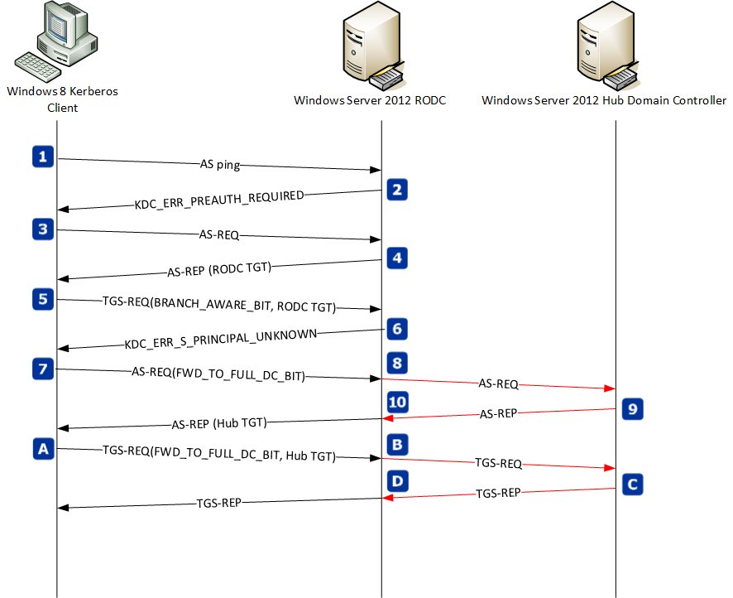
Figure 3 Kerberos message flow between a Windows Server 2012 RODC and a Windows Server 2012 hub domain controller

Table 2 Detailed message descriptions of Kerberos traffic between Windows Server 2012 RODC and a Windows Server 2012 domain controller
The Windows 8 Kerberos client discovers the Windows Server 2012 RODC and sends an AS-Ping.
Branch Windows Server 2012 RODC retuns KDC_ERR_PREAUTH_REQUIRED.
The Windows 8 Kerberos client sends AS-REQ to the branch RODC
The branch RODC returns an AS-REP containing TGT sources from the branch RODC. The Windows 8 Kerberos client caches the TGT.
The Windows 8 Kerberos client sends a TGS-REQ for a resource located in the hub site that includes the new BRANCH_AWARE_BIT in the PA-PAC_OPTIONS.
The branch RODC determines the service principal name in the TGS-REQ is not cached on the RODC. The RODC checks the TGS_REQ for the enabled BRANCH_AWARE_BIT. An enabled BRANCH_AWARE_BIT causes the RODC to return KDC_ERR_S_PRINCIPAL_UNKNOWN to the Kerberos client
The Kerberos client receives the KDC error. The client then sends a AS-REQ to the branch RODC that includes the new FORWARD_TO_FULL_DC bit enabled.
The branch RODC receives the AS-REQ, detects the FORWARD_TOFULL_DC bit is enabled, and forward the AS-REQ to a writable domain controller in the hub location.
The hub location domain controller returns a TGT in an AS-REP to the branch RODC
The branch RODC forwards the AS-REP received from the hub domain controller to the Kerberos client. The Windows 8 Kerberos client caches the new hub TGT.
The Kerberos client sends a TGS-REQ, which includes the hub TGT with the FORWARD_TO_FULL_DC bit enabled, to the branch RODC.
The branch RODC receives the TGS-REQ, detects the FORWARD_TO_FULL_DC bit is enabled, and forward the TGS-REQ to a writable domain controller in the hub location
The writable, hub domain controller returns the service tick for the service principal in a TGS-REP to the branch RODC
The branch RODC forward the TGS-REP to the Windows 8 Kerberos client, which then presents the service ticket to the resource through an AP-REQ and AP-REP message exchange.

Claims Transformation
Windows Server 2012 domain controllers can transform claim information only when the TGT crosses a forest trust. Transformations only occur across forest trust because each forest has its own collection of claim types. Claim transformation is performed by domain controllers on each side of the forest trust. Therefore, all the domain controllers in each forest root domains must run Windows Server 2012 to ensure claims traverse the trust. The forest root KDCs can transform incoming and outgoing Kerberos claims.
 More Information: | For more information about this topic, see:  Claim Transformations and Policies

Claim information in the PAC
The Privilege Attribute Certificate (PAC) in a Kerberos TGT contains identity information for a security principal and optionally the device. The PAC from previous versions of Windows included the user's security identifier and the security identifiers for each group of which the user is a member.
Windows Server 2012 KDCs now include the user's claims, security identifier, and the security identifiers of all the groups of which the user is a member in the PAC. Optionally, the PAC may also contain the device's claims, security identifier, and the security identifiers of all the groups of which the device is a member. During TGT creation, the domain controller retrieves the claim type information from Active Directory, maps the claim type's source value to a claim for the security principal, and includes the claim information in the PAC. The KDC also includes the Claims Valid security identifier in the PAC to indicate the claims included in the PAC.

Kerberos Armoring (FAST)
The Key Distribution Center (KDC) requires the user to identify who they are, in a secure manner, before it issues a ticket. During a password-based initial authentication, the Kerberos client provides an encrypted timestamp using a key derived from the password of the principal. The KDC looks up principal by the name provided in the AS-Request and used the corresponding key to verify the principal’s identity. When the key is generated from a user’s password, an attacker can use an offline dictionary attack on captured AS-Request messages to determine the key and then logon as the user. Additionally, Kerberos errors from the KDC can be spoofed which allows cryptographic downgrades and when SPNego is used to downgrade to the weaker NTLM protocol.
Windows Server 2012 implements Kerberos armoring, or Flexible Authentication Secure Tunneling (FAST) as defined in RFC 6113. FAST uses the computer's TGT to armor the user's AS messages exchanged between domain-joined Windows Server 2012 and Windows 8 Kerberos client and a Windows Server 2012 KDC. This protected channel increases security against network monitoring and KDC Kerberos error spoofing.

How it works
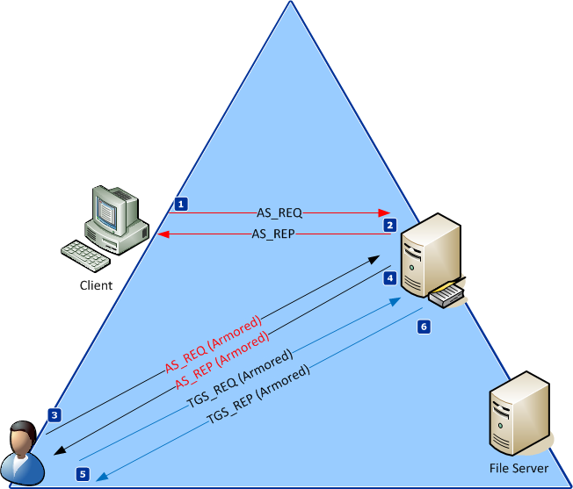
Figure 4 Conceptual representation of Kerberos Armoring
Kerberos armoring is designed to protect the user pre-authenticated data sent during the user's AS-REQ for the domain. The user's AS-REQ, when using a key generated from a user's password, is the most vulnerable portion of the Kerberos Exchange to offline-dictionary attacks.
Table 3 Detailed message flow of Kerberos armoring.
A computer or device running a Kerberos armoring enabled Kerberos client sends an send an AS-REQ to a Windows Server 2012 KDC.
The Windows Server 2012 KDC sends, either in a AS-REP pre-authentication exchange (AS-Ping) or in the AS-REP containing the computer's TGT information that informs the computer the domain supports Kerberos armoring.
Regardless of discovery method, the computer receives a TGT for the domain and caches the domain's capabilities, such as Kerberos armoring and claims.
The user authenticates the domain by sending a AS-REQ to the Windows Server 2012 KDC. The Kerberos client has a domain capabilities cache that stores each domains capabilities as it discovers them. The computer AS exchange discovered the domain capabilities, which is how the user AS exchange knows it must armor.

The user authenticator portion of the request is armored using the computers TGT request; thereby protecting the authenticator dictionary attacks.

If the user and computer are from different domains, then the computer uses Kerberos referrals to receive an inter-realm TGT from the user's domain. The user's AS-REQ is then armored using the inter-realm TGT shared between the two domains.
As usual, the KDC validates the user authenticator presented in the AS-REQ. Once the authenticator is validated, the KDC builds an AS-REP, armors the AS-REP with using a new key based on the computer's or inter-realm TGT's, and sends the AS-REP to the user.
The user receives it's TGT for the domain from the armored AS-REP. The user must authenticate to each resources it uses. To do so, the user sends a TGS-REQ to the KDC and armors this request using a key based on the user's TGT.
The KDC receives the armored TGT for the user's request to authenticate for the targeted service principal name. The KDC validates the user's incoming TGT, and the service principal name. It creates a service ticket, a service session key in an TGS-REP. The TGS-REP is armored using a new key derived from the user's TGT, and sent to the user.

Kerberos Armoring in a Supported Domain
You configure a domain for Kerberos armoring using the KDC Group Policy setting KDC support for claims, compound authentication and Kerberos armoring. The policy setting has four sub settings:
Table 4 Supported KDC configurations for claims, compound authentication, and armoring
Configuration | Results | Windows Server 2012 DC behavior
Not supported (default) | No minimum requirement of Windows Server 2012 domain controllers | Claims not provided  Compound authentication not supported  Kerberos armoring not supported
Supported | All domain controllers will advertise support for claims and compound authentication for Dynamic Access Control and Kerberos armoring  Requires sufficient Windows Server 2012 domain controllers to handle all the Windows 8 Release Preview device authentication requests for the domain | Claims provided on request  Compound authentication provided on request when resource supports  Kerberos armoring supported
Always provide claims | All domain controllers will advertise support for claims and compound authentication for Dynamic Access Control and Kerberos armoring  Requires Windows Server 2012 domain functional level | Claims always provided  Compound authentication provided on request when resource supports  Kerberos armoring supported and RFC FAST behavior
Fail unarmored authentication requests | All domain controllers will advertise support for claims and compound authentication for Dynamic Access Control and Kerberos armoring  Requires Windows Server 2012 domain functional level  Requires all FAST aware devices requesting authentication | Claims always provided  Compound authentication provided on request when resource supports  Rejects unarmored Kerberos messages

The Supported Group Policy setting enables Kerberos armoring in a hybrid domain ( a domain that may have a mixture of Windows Server 2012 KDCs and KDCs running an earlier version of Windows Server 2008 or Windows Server 2008 R2).
The Kerberos client, when the domain is in supported mode, must learn about the domain's capabilities differently than the discovery process documented in RFC 6113. This additional discovery mechanism is required because of how a domain advertises it is capable of supporting Kerberos armoring.
Enabling the Supported Group Policy setting writes a policy registry key that triggers the Netlogon service to write the FAST supported bit (0x00010000) of the msDS-SupportedEncryptionTypes attribute on the domain's krbtgt account. Once enabled, Windows Server 2012, Windows Server 2008 R2, and Windows Server 2008 KDCs advertise the domain is capable of supporting Kerberos armoring. However, not all domain controllers in the domain can support Kerberos armoring. The Kerberos client must be aware of when to locate and use a Windows Server 2012 KDC, which is the only KDC that supports Kerberos armoring.
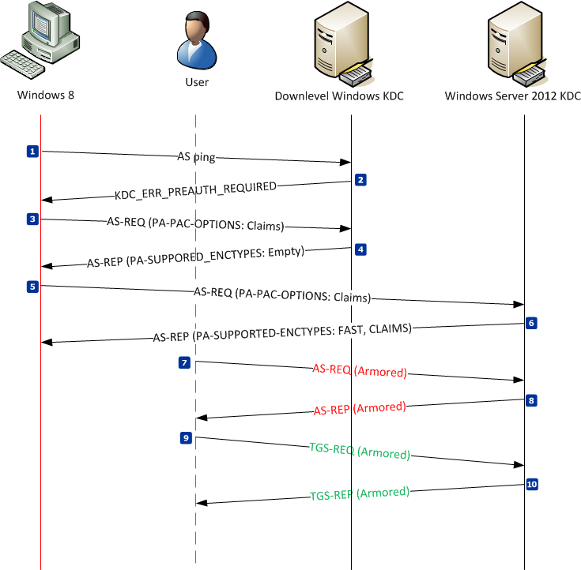
Figure 5 Kerberos message flow when the domain supports Kerberos armoring.

The Windows 8 Kerberos client is Kerberos armored and claim enabled. This configuration means the client is capable of performing Kerberos armoring and always requests claims. Its entirely up to the contacting KDC to determine if claims and armoring are honored in the request
Table 5 Detail message flow of Kerberos armoring in a supported domain
The Windows 8 Kerberos client performs a normal AS-REQ for pre-authentication, also known as the AS-PING
The down-level KDC returns the normal KDC_ERR-PREAUTH-REQUIRED in an AS-REP
The Windows 8 Kerberos client performs another AS-REQ, but enables the request for claims bit in the PA-PAC-OPTIONS (along with the authenticator).
The down-level KDC validates the computer's authenticator and creates a session key and TGT for the AS-REQ. The KDC sends the session key and TGT to the client computer in an AS-REP with the PA-SUPPORTED-ENCTYPES encrypted field empty.
The Windows 8 Kerberos client receives the AS-REP and extracts the TGT from the request. The PA-SUPPORTED-ENCTYPES is evaluated to determine if issuing KDC supports Kerberos armoring and claims.
The down-level KDC does not support either because the PA-SUPPORTED-ENCTYPES is empty. Therefore, the Windows 8 Kerberos client attempts to locates a Windows Server 2012 domain controller for the domain using the DsGetDcName API and a Windows Server 2012 KDC is located
The Kerberos client discards the TGT received from the down-level KDC and sends a new AS-REQ to the Windows Server 2012 KDC with the PA-PAC-OPTIONS: Claim bit enabled.
The Windows Server 2012 KDC validates the authenticator from the incoming AS-REQ, builds a session key, and a TGT. The KDC sends the session key and the TGT to the Kerberos client in an AS-REP that includes the Kerberos Armoring, and Claims bit enabled on in the encrypted portion of the PA-SUPPORTED_ENCTYPES field.
The Windows 8 Kerberos client receives the AS-REP and extract the TGT from the request. The PA-SUPPORTED-ENCTYPES is evaluated to determine if the issuing KDC supports Kerberos armoring and claims.
The Kerberos armoring and claims bits were enabled in the AS-REP. Therefore, the Kerberos clients updates its realm capabilities cache to indicate the domain supports Kerberos armoring and claims. Additionally, the Kerberos binding is updated to point to the Windows Server 2012 KDC.

All future User AS exchanges are armored using a key derived from the computer's TGT. All future User TGS exchanges are armored using a key derived from the user's TGT.
The user authenticates to the domain by sending an AS-REQ armored with a key derived from the computer's TGT. This armoring protects the user's authenticator from the possibility of a dictionary attack.
(AS-Ping and possible referral chasing performed by the computer are not shown).
The Windows Server KDC validates the user's authenticator, creates a session key and a TGT. The KDC sends the session key and TGT to the Kerberos client in an AS-REP that is armored with a new key derived from the computer's TGT.
The user has a TGT and requests authentication for a service. The Kerberos client sends a TGS-REQ to the KDC that includes the user's TGT and the targeted service principal name to which the user wants to authenticate. The TGS-REQ is armored with a key derived from the user's TGT.
The KDC locates the service principal name, creates a session key, and a service ticket. The KDC returns the session key and the service ticket to the Kerberos client in a TGS-REP. The TGS-REP is armored with a new key derived from the user's TGT.

Kerberos Armoring in a Required Domain
A domain configured to require Kerberos armoring takes a dependency on the domain's functional level. A domain requiring Kerberos armoring must have a domain functional level of Windows Server 2012, which means the domain no longer contains any domain controllers running versions of Windows Server other than Windows Server 2012. A domain requiring Kerberos armoring has fewer message exchanges than a domain that supports Kerberos armoring, which is the behavior documented in RFC 6113.

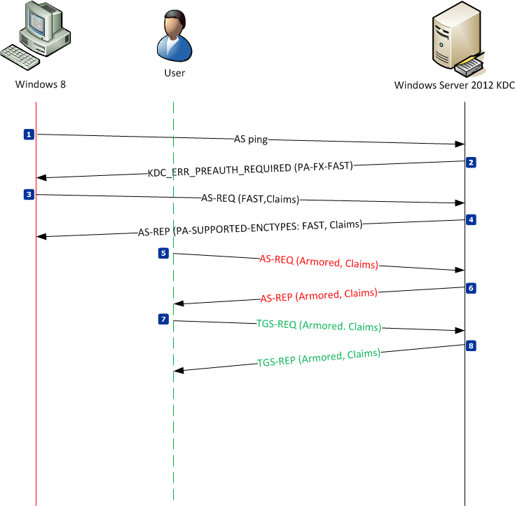
Figure 6 Kerberos message flow in a domain requiring Kerberos armoring.

Table 6 Detailed message flow in a domain requiring Kerberos armoring
The Windows 8 Kerberos client performs a normal AS-REQ for pre-authentication, also known as the AS-PING
The down-level KDC returns the normal KDC_ERR-PREAUTH-REQUIRED in an AS-REP. The AS-REP includes the PA-FX-FAST option.

Kerberos armoring is enabled in the AS-REP. Therefore, the Kerberos clients updates its realm capabilities cache to indicate the domain supports Kerberos armoring. Additionally, the Kerberos binding is updated to point to the Windows Server 2012 KDC.

All future User AS exchanges are armored using a key derived from the computer's TGT. All future User TGS exchanges are armored using a key derived from the user's TGT.
The Kerberos client sends an AS-REQ to the Windows Server 2012 KDC with the PA-PAC-OPTIONS: Kerberos armoring and Claims bits enabled
The Windows Server 2012 KDC validates the authenticator from the incoming AS-REQ, builds a session key, and a TGT. The KDC sends the session key and the TGT to the Kerberos client in an AS-REP that includes the Kerberos Armoring, and Claims bit enabled on in the encrypted portion of the PA-SUPPORTED_ENCTYPES field.
The Windows 8 Kerberos client receives the AS-REP and extract the TGT from the request. The PA-SUPPORTED-ENCTYPES is evaluated to determine if the issuing KDC supports Kerberos armoring and claims.
The Kerberos armoring and claims bits were enabled in the AS-REP. Therefore, the Kerberos clients updates its realm capabilities cache to indicate the domain supports Kerberos armoring and claims. Additionally, the Kerberos binding is updated to point to the Windows Server 2012 KDC.

All future User AS exchanges are armored using a key derived from the computer's TGT. All future User TGS exchanges are armored using a key derived from the user's TGT.
The user authenticates to the domain by sending an AS-REQ armored with a key derived from the computer's TGT. This armoring protects the user's authenticator from the possibility of a dictionary attack.
(AS-Ping and possible referral chasing performed by the computer are not shown).
The Windows Server KDC validates the user's authenticator, creates a session key and a TGT. The KDC sends the session key and TGT to the Kerberos client in an AS-REP that is armored with a new key derived from the computer's TGT.
The user has a TGT and requests authentication for a service. The Kerberos client sends a TGS-REQ to the KDC that includes the user's TGT and the targeted service principal name to which the user wants to authenticate. The TGS-REQ is armored with a key derived from the user's TGT.
The KDC locates the service principal name, creates a session key, and a service ticket. The KDC returns the session key and the service ticket to the Kerberos client in a TGS-REP. The TGS-REP is armored with a new key derived from the user's TGT.

Compound Authentication
Windows Server 2012 enhances Kerberos authentication by introducing compound authentication. Compound authentication allows a Kerberos TGS request to include two identities: the identity of the user and the identity of the user’s device. Windows accomplishes compound authentication by extending Kerberos Flexible Authentication Secure Tunneling (FAST). The protected tunnel used by the Kerberos client and the KDC is secured using the computer's TGT to armor the TGS request. The KDC verifies the target service is compound authentication capable, and includes the authorization data from the primary TGT (user account) and the armoring TGT (computer account) in the PAC of the service ticket.

How It Works

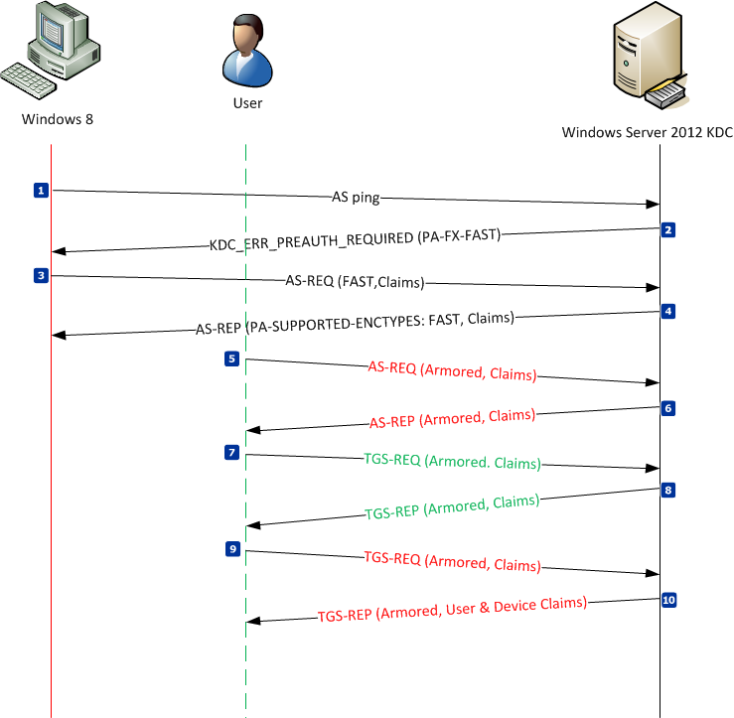
Figure 7 Kerberos message flow for compound authentication.

Table 7 Detailed message exchange for Kerberos compound authentication
The Windows 8 Kerberos client performs a normal AS-REQ for pre-authentication, also known as the AS-PING
The down-level KDC returns the normal KDC_ERR-PREAUTH-REQUIRED in an AS-REP. The AS-REP includes the PA-FX-FAST option.

Kerberos armoring is enabled in the AS-REP. Therefore, the Kerberos clients updates its realm capabilities cache to indicate the domain supports Kerberos armoring. Additionally, the Kerberos binding is updated to point to the Windows Server 2012 KDC.

All future User AS exchanges are armored using a key derived from the computer's TGT. All future User TGS exchanges are armored using a key derived from the user's TGT.
The Kerberos client sends an AS-REQ to the Windows Server 2012 KDC with the PA-PAC-OPTIONS: Kerberos armoring and Claims bits enabled
The Windows Server 2012 KDC validates the authenticator from the incoming AS-REQ, builds a session key, and a TGT. The KDC sends the session key and the TGT to the Kerberos client in an AS-REP that includes the Kerberos Armoring, and Claims bit enabled on in the encrypted portion of the PA-SUPPORTED_ENCTYPES field.
The Windows 8 Kerberos client receives the AS-REP and extract the TGT from the request. The PA-SUPPORTED-ENCTYPES is evaluated to determine if the issuing KDC supports Kerberos armoring and claims.
The Kerberos armoring and claims bits were enabled in the AS-REP. Therefore, the Kerberos clients updates its realm capabilities cache to indicate the domain supports Kerberos armoring and claims. Additionally, the Kerberos binding is updated to point to the Windows Server 2012 KDC.

All future User AS exchanges are armored using a key derived from the computer's TGT. All future User TGS exchanges are armored using a key derived from the user's TGT.
The user authenticates to the domain by sending an AS-REQ armored with a key derived from the computer's TGT. This armoring protects the user's authenticator from the possibility of a dictionary attack.
(AS-Ping and possible referral chasing performed by the computer are not shown).
The Windows Server KDC validates the user's authenticator, creates a session key and a TGT. The KDC sends the session key and TGT to the Kerberos client in an AS-REP that is armored with a new key derived from the computer's TGT.
The user has a TGT and requests authentication for a service. The Kerberos client sends a TGS-REQ to the KDC that includes the user's TGT and the targeted service principal name to which the user wants to authenticate. The TGS-REQ is armored with a key derived from the user's TGT.
The KDC locates the service principal name and reads the msDS-SupportedEncryptionTypes attribute to determine resource supports compound authentication (bit 0x20000 enabled). The resource supports compound authentication. The KDC creates a session key, and a service ticket. The KDC returns the session key and service ticket to the Kerberos client in a TGS-REP. The TGS-REP includes the compound authentication flag and is armored with a new key derived from the user's TGT.
The Kerberos client receives the TGS-REQ and determines the resource for which it just received a service tickets supports compound authentication. The Kerberos client then determines if it is capable of requesting compound authentication, which Windows 8 is capable.
The Kerberos client discards the recently acquired service ticket and requests a new compound authentication service ticket.
The Kerberos client sends a TGS-REQ to the KDC that includes the user's TGT, the targeted service principal name to which the user wants to authenticate, and the compound authentication flag. The TGS-REQ is armored with a key derived from the computer's TGT rather than the user's TGT.
(Computers will authenticate the resource domain if they do not possesses a TGT for the domain, including Kerberos referral chasing. Those requests are armored using the inter-realm TGT of the trust).
The KDC locates the service principal name, validates the compound authentication request armored with keys by the computer and the user, creates a session key, and a service ticket that includes authentication data for the user and the computer. The KDC returns the session key and the service ticket to the Kerberos client in a TGS-REP. The TGS-REP is armored with a new key derived from the computer's or inter-realm trust's TGT.

Configuration
You enable compound authentication using Group Policy. The scope of the Group Policy setting should apply to file servers hosting the resource that uses compound authentication. The Group Policy setting Support compound authentication has three options
- Never: KDC will not provide compound authentication.
- Automatic: Once a Dynamic Access Control aware application is installed, the KDC will always provide compound authentication and after the last Dynamic Access Control aware application is removed the KDC will not provide compound authentication.
Automatic applications support for compound authentication requires the application to register itself under the HKEY_LOCAL_MACHINE\SYSTEM\CurrentControlSet\Services\Netlogon\Paramaters\CompoundIdentity registry key.
- Always: KDC will always provide compound authentication.
Prior to sending the TGS-Reply to the client, the KDC checks the Compound identity supported (0x00020000) bit in the value of the msDS-SupportedEncryptionTypes attribute of the security principal's object that runs the service. An enabled bit means the service can accept compound authentication. This policy setting, when configured to Always, enables the bit on the computer to ensure when the KDC checks the attribute that compound authentication is reported enabled in the TGS-Reply
By setting the compound identity supported (0x00020000) bit in the value of the msDS-SupportedEncryptionTypes attribute of the krbtgt, clients will always request compounded authentication. Otherwise, you can set this bit on individual principals and the Kerberos client discovers they support compound authentication
You can also enable a principal to support compound authentication using the Active Directory module for Windows PowerShell. Windows Server 2012 principals that support compound authentication include user, group-managed service accounts, and computer accounts.

User object
Use the Set-ADUser cmdlet with the -CompoundIdentitySupported:$true argument to enable compound authentication on the user account and -CompoundIdentitySupported:$false to disable compound authentication on the user account.

Group-managed Service Accounts
Use the Set-ADServiceAccount cmdlet with the -CompoundIdentitySupported:$true argument to enabled compound authentication on the service account and -CompoundIdentitySupported:$false to disabled compound authentication on the service account.

Computer Accounts
Use the Set-ADComputer cmdlet with the -CompoundIdentitySupported:$true argument to enabled compound authentication on the computer account and -CompoundIdentitySupported:$false to disable compound authentication on the computer account.

Requirements
Compound authentication requires:
- Windows Server 2012domain controllers
- All DCs configured for KDC support for claims, compound authentication and Kerberos armoring enabled
- The client device must support compound authentication (Windows 8)
- Clients configured for Kerberos client support for claims, compound authentication and Kerberos armoring enabled
- The resource device must support compound authentication (Windows 8 or Windows Server 2012)
- Applications must support device-based access control

Large Service Tickets
Windows Server 2012 introduces enhancements with regard to controlling the size of the Privilege Account Certificate (PAC). These enhancements include:
- Compressing Resource SIDs in service ticket PACs (supported on Windows XP, Windows Server 2003 or later)
- Increasing the default maximum token size and managing the setting through Group Policy
- Configurable setting through Group Policy to have the KDC issue warning events when it issues a PAC that is close to or exceeding the defined maximum token size

Resource SID Compression
Kerberos authentication includes inserting the security identifiers (SIDs) of the security principal, SID history, all the groups to which it is a member including universal groups and groups from the resource domain. Security principals with too many group memberships greatly affect the size of the authentication data. Sometimes the authentication data is larger than the allocated size reported by Kerberos to applications. This can causes authentication failure in some applications.
Windows Server 2012 KDCs help reduce the size of the PAC by taking advantage of resource SID compression. The KDC accomplishes resource SID compression by first determining if the target resource has disabled SID compression. The KDC checks the principal's account in Active Directory-- specifically if the disable resource SID compression bit is set on the msDS-SupportedEncryptionTypes attribute.
The msDS-SupportedEncryptionTypes attribute is a 32-bit number where bit 0x00080000 dictates the disabled status of SID compression for the target. The KDC reads this bit to determine if it should not use SID compression when creating authentication information for this principal during service ticket creation.
Without resource SID Compression, the KDC inserts all the SIDs added by the resource domain in the Extra-SID portion of the PAC structure, which is a list of SIDs. SIDs from the resource domain share the same domain portion of the SID, these SIDs can be compressed by only providing the resource domain SID once for all SIDs in the resource domain.
By default, a Windows Server 2012 KDC will always compress SIDs. To compress resource SIDs, the KDC sets the ResourceGroupID bit in the UserFlags structure to true. Then, the KDC writes the ResourceGroupDomainSID with the SID of the resource domain to which the target resource is a member. Finally, the KDC inserts only the RID portion of each resource SID into the ResourceGroupIds portion of the authentication data. This reduces the size of each stored instance of a resource SID because the domain SID is stored once rather than with each instance

Interoperability
Other Kerberos implementations may not understand resource group compression and therefore are not compatible. In these scenarios, you may need to disable resource group compression to allow the Windows Server 2012 KDC to interoperate with the third-party Kerberos implementation.
Resource group compression is on by default; however, you can disable it. There are two ways to disable resource group compression: for the KDC or on a per-principal basis. As previously documented, Windows stores the configuration for resource group compression as a bit value (0x00080000) in the msDS-SupportedEncryptionTypes attribute on the security principal object responsible for running the service.

Per-principal
The preferred practice of disabling resource group compression is on a per-principal basis. Most environment have only a few operating systems or devices the support Kerberos that do not support resource group compression. These devices can coexist in a Windows Server 2012 enterprise environment by simply configuring the security principal object responsible for running the service( the object where the service principal name is registered), such as a user account used by NAS devices. You can use the following Windows PowerShell scripts to disable and enable resource group compression to ease the configuration and to avoid misconfiguring other bit values in the msDS-SupportedEncryptionTypes attribute that can cause authentication to fail for devices using these accounts.
Once the account is configured to disable resource group compression, the KDC translates that configuration when building a service ticket for that resource. When building the ticket, it ensures the resource groups are not compressed for the targeted service principal name.

#
# Script to Disable Kerberos Group SID Compression
#

param( $principalName)

$newValue = 0

# Get the AD principal and value
$obj = get-adobject -Filter {(cn -like $principalName)} -Properties *
if($obj -eq $null) # Check
{
Write-Host "Cannot find $principalName in the directory"
break
}

$newValue = $value = $obj."msDS-SupportedEncryptionTypes"
$msgBefore =$msgAfter = "Resource group compression status on principal {0}: " -f $principalName

if( ($value -band 0x0080000) -eq 0)
{$msgBefore += "Enabled"}
else
{$msgBefore += "Disabled"}

Write-Host $msgBefore

if( ($value -band 0x00080000) -eq 0) #enable the disable bit
{$newValue = $value -bor 0x00080000}

if($newValue -ne $value) #update if values are different
{
Set-ADObject $obj -Replace @{"msDS-SupportedEncryptionTypes"=$newValue}

if( ($newvalue -band 0x0080000) -eq 0)
{$msgAfter += "Enabled"}
else
{$msgAfter += "Disabled"}

Write-Host $msgAfter
}
else
{ Write-Host "Resource group compression did not change."}

#
# Script to Enable Kerberos Group SID Compression
#

param( $principalName)

# vars
$newValue = 0

# Get the AD principal and value
$obj = get-adobject -Filter {(cn -like $principalName)} -Properties *
if($obj -eq $null)
{
Write-Host "Cannot find $principalName in the directory"
break
}

$newValue = $value = $obj."msDS-SupportedEncryptionTypes"

$msgBefore =$msgAfter = "Resource group compression status on principal {0}: " -f $principalName

if( ($value -band 0x0080000) -eq 0)
{$msgBefore += "Enabled"}
else
{$msgBefore += "Disabled"}

Write-Host $msgBefore

if( ($value -band 0x00080000) -eq 0x00080000) #remove the disable bit
{$newValue = $value -bxor 0x00080000}

if($newValue -ne $value) #update if values are different
{
Set-ADObject $obj -Replace @{"msDS-SupportedEncryptionTypes"=$newValue}

if( ($newvalue -band 0x0080000) -eq 0)
{$msgAfter += "Enabled"}
else
{$msgAfter += "Disabled"}

Write-Host $msgAfter
}
else
{ Write-Host "Resource group compression did not change."}

Per KDC
When most of the devices in your domain do not support resource group compression, then the other alternative to disabling resource group compression is to disable the Windows Server 2012 KDC from compressing resource groups. You disable the KDC from issues compressed tickets using the DisableResourceGroupsFields registry value under the HKLM\Software\Microsoft\Windows\CurrentVersion\Policies\System\Kdc\Parameters registry key. This registry value has a DWORD registry value type. You completely disable resource SID compression when you set the registry value to 1.
The KDC reads this configuration when building a service ticket. With the bit enabled, the KDC does not use resource group compression when building the service ticket.
When disabling resource group compression on a per-KDC basis, you must provide the registry setting to all Windows Server 2012 KDCs to ensure none of the KDCs issues a compressed ticket to a device that does not support resource group compression. Neglecting this configuration could result in intermittent authentication failures for the device when it receives a ticket from a specific KDC, which is significantly more challenging to diagnose.

Default Maximum Token Size
Windows Server 2012 and Windows 8 introduce a new default maximum size of the authentication token. Authentication and authorization errors occurred in scenarios where users where members of numerous groups. The over-abundance of group memberships information cause the authentication token to increase beyond the size allocated by Windows.
Previous versions of Windows had a default maximize token size of 12k. However, this value remained too low for many environments and required reconfiguring each computer in the enterprise. Windows Server 2012 and Windows 8 increase the default maximum token size to 48k. This new value is the maximum viable size for SSPI tokens in Windows and may require additional settings changes for applications to support. For example, HTTP settings are required for SSPI tokens over 12K.
Windows Server 2012 helps manage existing environments that need to increase the maximum token size by creating a Group Policy setting. Administrators can easily configure the maximum token size for Windows Kerberos clients by enable the Set maximum Kerberos SSPI context token buffer size policy setting. This policy setting is located at Computer Configuration\Policies\Administrative Templates\System\Kerberos. The registry location affected by this policy setting is HKLM\System\CurrentControlSet\Control\LSA\Kerberos\Parameters. The names of the values modified by the policy setting are EnableMaxTokenSize and MaxTokenSize. Both values are DWORD registry data types. The EnabledMaxTokenSize can contain a value of zero (0) or one (1). A value of zero indicates the policy setting is disabled. A value of one indicates the policy setting is enabled. The MaxTokenSize contains a value that represents the maximum size of a Kerberos authentication token.
Important: | The following Group Policy setting does not write to a well-known policy key. Therefore, this setting behaves more of a preference and not like a policy setting. Unlike most policy settings, this setting persists if the GPO containing the policy is removed.

KDC Maximum Token Size Warnings
New with Windows Server 2012 KDCs is an optional warning event that is enabled through Group Policy. This Group Policy setting is located at Computer Configuration\Policies\Administrative Templates\Systems\KDC. The policy setting name is Warning events for large Kerberos tickets. This Group Policy setting, when enabled, establishes a threshold at which the KDC issues a warning if a ticket it issues is more than the threshold value. You can monitor for these warning events to determine if you need to change the maximum token size for your environment.
The registry located affected by this policy setting is HKLM\Software\Microsoft\Windows\CurrentVersion\Policies\System\KDC\Parameters. The names of values modified by the policy setting are EnableTicketSizeThreshold and TicketSizeThreshold. Both values are DWORD registry data types. The EnableTicketSizeThreshold can contain a value of zero (0) or one (1). A value of zero indicates the policy setting is disabled. A value of one indicates the policy setting is enabled. The TicketSizeThreshold contains a value that represents the threshold value used by the KDC when determining if it should issue a warning event.

Unsupported Scenarios
There are known scenarios in which claims are not supported. These scenarios include:
- NTLM downgrade scenarios - Windows Server 2012 does not provide claims support authentication scenarios using NTLM
- External Trusts - Claims are discarded when authentication traverses an external trust.
- Down-level Domain Controllers across Forest Boundaries - Domain controllers on the outbound trust side across a forest do not support claims unless they are Windows Server 2012 domain controllers. Additionally, Windows 8 clients cannot use claims if their authentication referral path includes a domain controller running an version of Windows earlier than Windows Server 2012
- Protocol Transition - Middle tier authentication does not procure claims about the user unless the client delivers a service ticket that contains claims to the middle tier
- Unmanaged clients - Claim support is not tested or supported with non-domain joined computers.

Windows Authorization Claims Support
Windows Server 2012 security subsystem introduced many changes to support claims-based authorization and auditing. Fundamental changes were made to accommodate storing claim information in authorization token used by the Local Security Authority. Other enhancements include:
- Conditional Expressions
- New Advanced Security Editor
- New Effective Permission Viewer

Conditional Expressions
Windows 7 introduced the underlying framework that allows permission entries to contain conditional expressions, also known as a conditional permission entries.
Conditional Expressions are also known as Boolean expressions or logical expressions. These expressions consider of a left-hand-side (LHS) operand and a right-hand-side (RHS) operand separated by an operator. All conditional expressions provide a true or false result. Software can use these Boolean results to increase its decision-making capabilities.
The Local Security Authority reads this information from the Kerberos PAC to create security tokens. When users access resources, the Local Security Authority performs an access check. This access check compares the permissions assigned to users and groups on the resource with the group membership information in the security token. This is how Windows determines if it should allow or deny access to the resource.
Windows Server 2012 KDCs introduce claims into Kerberos authentication information. A claim is information a trusted source makes about an entity. A KDC can now include additional information (or claims) about a security principal other than its security identifier (SID). You can use conditional permission entries to protect file system resources based on the user's department attribute, their cost center, or their country.
Windows Server 2012 can evaluate conditional access control entries for the purposes of auditing as well as authorization. You can use the same conditions for authorization as for auditing. With conditional permission entries, you can audit a file's use by any user whose department attribute equals marketing. Or, any file system resource that is considered high business impact, intellectual property, or top secret.
Window represents claims in two parts: a claim type and a claim name. The two entities are separated by a single period. Windows uses the claim type portion of the claim to identify the type of claim. There are two types of claim types: user and device.
A claim type is represented by the at-sign (@) followed by the word user, resource, or device. This identifies the type of claim used in the conditional expression. The claim name is simply the name of the claim provided at the time of its creation. Therefore, an example of claim for a user's department would look like @user.department
Table 3 shows examples of common conditional expressions. A claim
Table 5 Valid Conditional Expressions
Expression Element | Description
ClaimType.ClaimName | Test whether the specified claim has a non-zero value
Exists ClaimType.ClaimName | Test whether the specified claim exists for the security principal
Not_Exists ClaimType.ClaimName | Test whether the specified claim does not exist for the security principal
ClaimType.ClaimName Operator Value  or  ClaimType.ClaimName Operator ClaimType.ClaimName | Returns the result of the specific operation
Conditional Expression || Conditional Expression | Test whether either of the specified conditional expressions is true
Conditional Expression && Conditional Expression | Test whether both of the specified conditional expressions are true
!(Conditional Expression) | Inverses the result of a conditional expression
Memberof SID String or SDDL SID Alias, … | Tests whether the security principal's SID matches all SIDs present in the comma-separated list
DeviceMember_of SID String or SDDL SID Alias, … | Tests whether device's SID matches all the SIDs present in the comma-separated list
MemberOf_Any SID String or SDDL SID Alias, … | Tests whether the security principal's SID matches any SIDs present in the comma-separated list
DeviceMemberOf_Any SID String or SDDL SID Alias, … | Tests whether device's SID matches any the SIDs present in the comma-separated list

Conditional Operators
The following operators compare any left-hand-side (LHS) and right-hand-side (RHS) combination of claim variables. Additionally the RHS operands may contain literals representing claim values of the same value type as the claim variable represented by the LHS operand.
All operators where the LHS operand or the RHS operand contain multi-valued claims fail and produce an unknown value except when using the Contains and Any_of operators.
Table 6 Valid Conditional Expression Operators
Operator | Evaluation Description
Equals (==) | Evaluates to TRUE if the right-hand side operand evaluates to the exact value of the left-hand side operand; otherwise, it evaluates to FALSE
Not Equals (!=) | Evaluates to FALSE if the right-hand side operand evaluates to the exact value of the left-hand side operand; otherwise, it evaluates to TRUE
Greater than (>) | Evaluates to TRUE if the left-hand side operand is greater than the right-hand side operand; otherwise, it evaluates to FALSE
Greater than or equal to  (>=) | Evaluates to TRUE if the left-hand side operand is greater than or equal to the right-hand side operand; otherwise, it evaluates to FALSE
Less than (<) | Evaluates to TRUE if the left-hand side operand is less than the right-hand side operand; otherwise, it evaluates to FALSE
Less than or equal to  (<=) | Evaluate to TRUE if the left-hand side operand is less than or equal to the right-hand side operand; otherwise, it evaluates to FALSE
Contains | Evaluates to TRUE if the left-hand side operand contains the right-hand side operand; otherwise, it evaluates to FALSE  Note: The right-hand side operand can be a single valued, multi-valued, or a constant
Any_Of | Evaluates to TRUE if the left-hand side operand is contained in the union of the right-hand side operand; otherwise, it evaluates to FALSE  Note: The left-hand side operand can be a single valued, multi-valued, or a constant
MemberOf | Evaluates the same as Contains operator; however, both operands must represent a security identifier (SID)
MemberOf_Any | Evaluates the same as Of_Any operator; however, both operands must represent a security identifier (SID)
Not (!) | Evaluates to TRUE if the conditional expression that follows the operator evaluates to FALSE  Evaluates to FALSE if the conditional expression that follows the operator evaluates to TRUE
And (&&) | Evaluates to TRUE if both the left-hand side and right-hand side expressions evaluate to TRUE; otherwise, it evaluates to FALSE
Or (||) | Evaluate to TRUE if either the left-hand side or right-hand side expressions evaluate to TRUE; otherwise, it evaluates to FALSE

Operator Precedence
Windows Server 2012 evaluates conditional in the following order of precedence. Operators with equal precedence are evaluated from left to right.
Table 7 Operator Precedence
Exists, MemberOf, MemberOf_Any, DeviceMemberOf, DeviceMemberOf_Any
Contains, Any_Of
==, !=, >, >=, <, <=
!
&&
||

Additionally, any portion of a conditional expression can be enclosed in parenthesis. Windows Server 2012 evaluates expressions within parentheses first.

Conditional Expression Examples
Desired Result
Apply access to the designated trustee if the user's title is PM and the User's division is either Finance or Sales.
Conditional Expression
@User.Title=="PM" && (@User.Division=="Finance" || @User.Division =="Sales")
Correlation
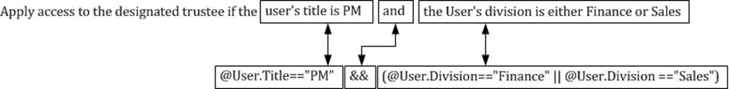
Evaluation
User: Wendy
Permission: Allow
Title: PM
Division: Sales
@User.Title=="PM" && (@User.Division=="Finance" || @User.Division =="Sales")
1 2 3
The preceding expression contains three conditional expressions using claims. Based on operator precedence, all claims in parenthesis are evaluated first.
@User.Title=="PM" && (@User.Division=="Finance" || @User.Division =="Sales")
The operators == and || appear in the conditional expressions within the parenthesis. Based on operator precedence, the == operator is evaluated before the || operator. Also, there are two == operators. Both of these operators have equal precedence order; therefore, the conditional expressions are evaluated from left to right. The first conditional expression is
@User.Title=="PM" && (@User.Division=="Finance" || @User.Division =="Sales")
@User.Division is a user claim type. The claim name is "division". The operator in the expression is ==, which represents "equal to". The value that follows the operator (==) is the value to which the claim is compared. The value in this expression is "Finance". This expression evaluates to FALSE because the user's division does not equal "Finance"
@User.Title=="PM" && (FALSE || @User.Division =="Sales")
@User.Division is a user claim type. The claim name is "division". The operator in the expression is the "equal to" operator. The value following the operator is the value to which the claim is compared. The value in this expression is "Sales"). This expression evaluates to TRUE because the user's division equals "Sales".
@User.Title=="PM" && (FALSE || TRUE)
The parenthesis still exists, as well as the || operator, which represents a logical "OR". Logical OR expressions evaluate to TRUE when at least one of the operands is TRUE. The result of the OR operation is TRUE and the expression is simplified.
@User.Title=="PM" && TRUE
Based on operator precedence, the "==" operators must be evaluated before the "&&" operator. @User.Title is a user claim type. The claim name is "Title". The value in this expression is "PM". This expression evaluates to TRUE because the user's tile equals "PM".
TRUE && TRUE
The simplified conditional expression leaves one remaining operator, the logical AND operator (&&). A logical AND is evaluated to TRUE when both operands are true; all other permutations evaluate to FALSE. The simplified conditional expression evaluates to TRUE; therefore, the user Wendy is allowed access to the resource protected by this conditional expression.

Desired Result
Apply access to the designated trustee if the user's project value matches any of the resource's project values
Conditional Expression
@User.Project Any_of @Resource.Project
Correlation
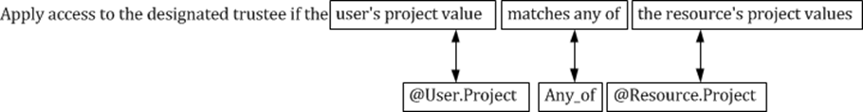
Evaluation
User: Wendy
Permission: Allow
Project: Windows

@User.Project Any_of @Resource.Project
The preceding expression is a single conditional expression. @User.Project is a user claim type. The claim name is "Project". The expression does not contain a literal value, but rather the expression is the value, which can be single or multi-valued.
The right-side value @Resource.Project is resource claim. The claim name is also "Project". This value may also be either single or muiti-valued. This is understood by the use of the Any_of operator.
Results from the Any_of operator return true if the any of the left-side values are present in any of the values held by the right-side value. The Any_of operator is different from the Contains operator in that only one left-side value must be present in the right-side value to evaluate to true. The Contains operator requires that all left-side values present in the right-side value.

Desired Result
Apply access to the designated trustee if a user department claim exists.
Conditional Expression
Exists(@User.Department)
Correlation
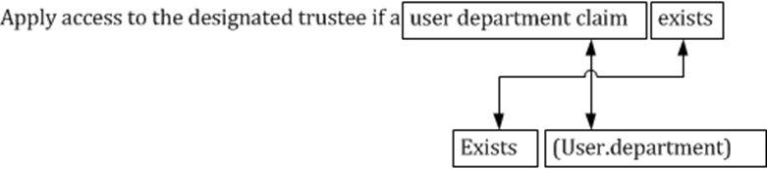
Evaluation
User: Wendy
Permission: Allow
Department: <Empty>
Exists(@User.Department)
The preceding expression is a single conditional expression. The expression only contains a right-side value, @User.Deptarment. The operator Exists determines if any value is present in the specified right-side value.
This conditional expressions determines if the user has a claim value for Department. Windows does not build claims for property without values. Therefore , this expression evaluates to false for the user Wendy because the department property for Wendy is blank; therefore, Wendy's authentication token does not include a Department claim.

What Conditional Expressions look like in Security Descriptor Definition Language
Windows Server 2012 introduces changes in the Security Descriptor Definition Language (SDDL) to identify conditional expressions associated for a permission entry, also known as an access control entry (ACE). SDDL is a text-based shorthand used to describe security descriptors. The minor change to SDDL in Windows Server 2012 includes adding the conditional expression to the access control entry (ACE) string format.
AceType;AceFlags;Rights;ObjectGuid;InheritObjectGuid;AccountSid;(ConditionalExpression)
The ACE string format is a semi-colon delimited string where each token within the string representing an aspect of an access control entry. SDDL represents the conditional expression of the ACE by appending the current ACE string with the conditional expression surrounded by parenthesis.

New Advanced Security Settings Editor
Windows Server 2012 and Windows 8 introduce a new advanced security settings editor. Windows uses these lists of permission and audit entries to apply authorization and auditing behaviors to users and computers accessing resources. The new advanced security settings editor is accessed through the Advanced button on the basic security settings editor.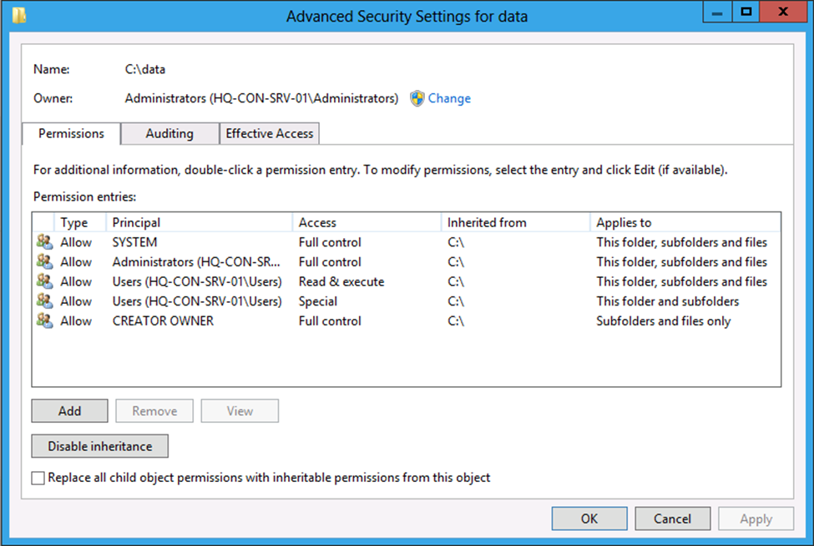
Figure 8 Advanced security settings editor

Conditional Expression Editor
Conditional Expression is a new access control entry exposed in Windows Server 2012. Conditional Expressions are managed through the Advanced Security Settings editor when editing permissions for a local or remote file.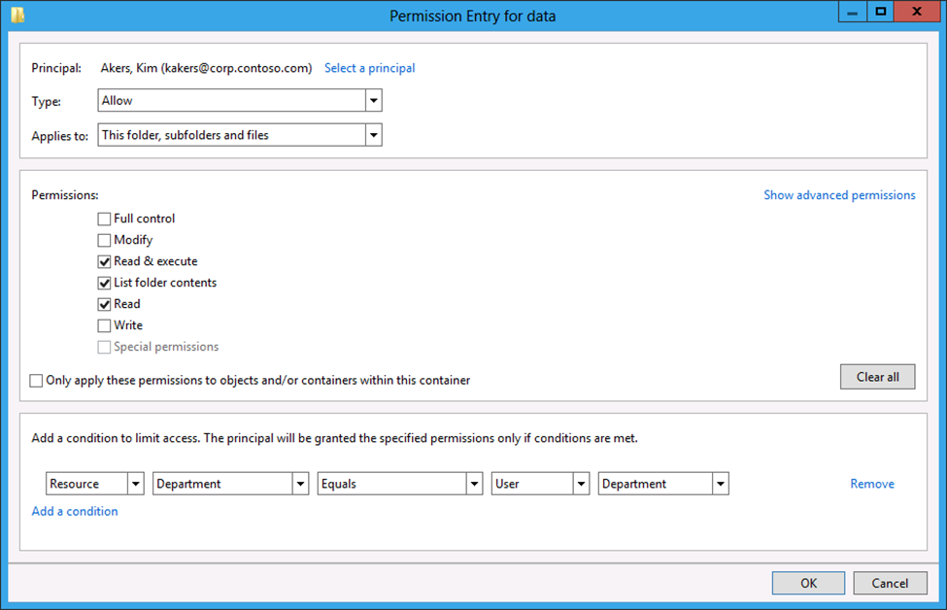
Figure 9 Conditional expression editor in the Advanced Security Settings editor

New Effective Access User Interface
The significant security improvements in Windows Server 2012 require improving how the operating system represents effective access. These improvements begin with a new user interface to display effective access. The Effective Access tab shows the simulated effective access of a security principal, which includes claim and conditional permission entry support and improved algorithms for determining the effective permissions locally and remotely.
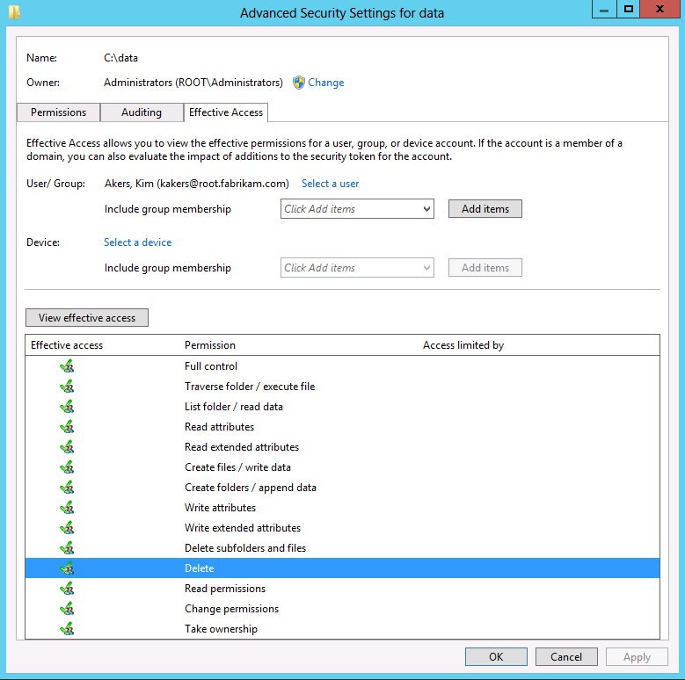
Figure 10 Effective Access show in the Advanced Security Settings editor

Active Directory Claims Support
Claims-based access in Windows Server 2012 depends on Active Directory. Active Directory is the backing store for claim types. To support claims, Active Directory introduced several changes to the schema as well as new objects and containers.
Important: | Windows Server 2012's claims-based access control only protects files and folders.

Schema changes

Objects
The following is a list of new Active Directory objects used by claims-based access control.
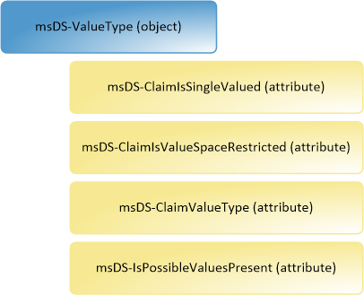
Figure 11 Conceptual representation of an msDS-ValueType object.

msDS-ValueType
The msDS-ValueType Active Directory class is a structural class object that represents the value type of a Resource Property. Value types define the type of data a Resource Property can store. The default value type objects include:
- MS-DS-DateTime
- MS-DS-MultivaluedChoice
- MS-DS-MultiValuedText
- MS-DS-Number
- MS-DS-OrderedList
- MS-DS-SinglevaluedChoice
- MS-DS-Text
- MS-DS-YesNo.
New attributes used by msDS-ValueType include:
- msDS-ClaimIsSingleValued
- msDS-ClaimIsValueSpaceRestricted
- msDS-ClaimValueType
- msDS-IsPossibleValuesPresent
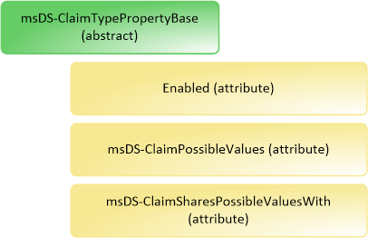
Figure 12 Conceptual representation of an msDS-ClaimTypePropertyBase abstract object

msDS-ClaimTypePropertyBase
The msDS-ClaimTypePropertyBase Active Directory class is an abstract class object used to provided common attributes for msDS-ClaimType and msDS-ResourceProperty class objects.
New attributes used by msDS-CLaimTypePropertBase include:
- Enabled
- msDS-ClaimPossibleValues
- msDS-ClaimsSharesPossibleValuesWith
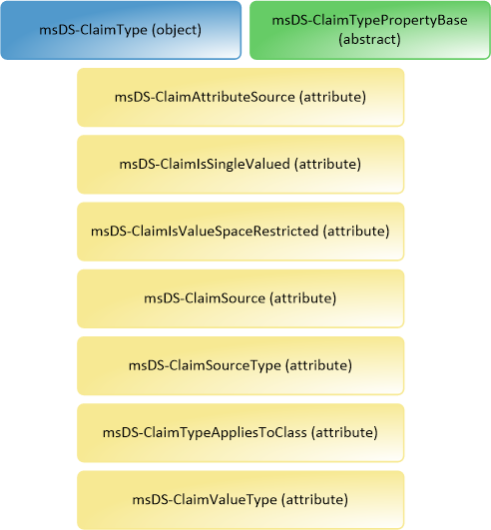
Figure 13 Conceptual representation of an msDS-ClaimType object.

msDS-ClaimType
The msDS-ClaimType Active Directory class is a structural class object used to represent claims that are applicable to security principals such as computers and users. This class object inherits properties from is parent object msDS-ClaimTypePropertyBase.
New attributes used by msDS-ClaimType include:
- msDS-ClaimAttributeSource
- msDS-ClaimIsSingleValued
- msDS-ClaimIsValueSpaceRestricted
- msDS-ClaimSource
- msDS-ClaimSourceType
- msDS-ClaimTypeAppliesToClass
- msDS-ClaimValueType
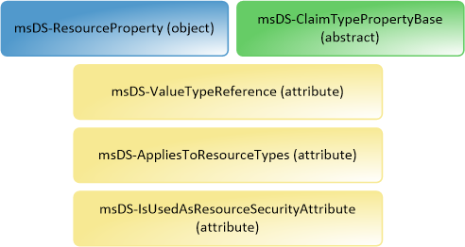
Figure 14 Conceptual representation of an msDS-ResourceProperty object.

msDS-ResourceProperty
The msDS-ResourceProperty Active Directory class is a structural class object use to represent a property of a resource. Resource properties provide additional metadata about resources that can be used for authorization and classification. This class object inherits properties from is parent object msDS-ClaimTypePropertyBase.
New attributes used by msDS-ResourceProperty incude:
- msDS-ValueTypeReference
- msDS-AppliesToResourceTypes
- msDS-IsUsedAsResourceSecurityAttribute
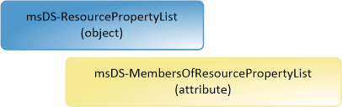
Figure 15 Conceptual representation of an msDS-ResourcePropertyList object.

msDS-ResourcePropertyList
The msDS-ResourcePropertyList Active Directory class is a structural class object used to store a list of msDS-ResourceProperties. The new Advanced Security Settings editor and conditional expression editor use an msDS-ResourcePropertyList to populate the list of resource properties that can be used for authorization decisions.
The msDS-ResourcePropertyList uses the new attribute msDS-MembersOfResourcePropertyList to store the list of resource properties.
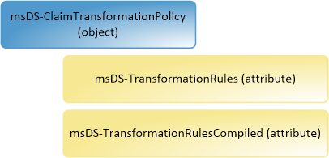
Figure 16 Conceptual representation of msDS-ClaimTransformationPolicyType object.

msDS-ClaimsTransformationPolicyType
The msDS-ClaimsTranformationPolicyType Active Directory class is a structural class object used to store claim transformation rules. Claim transformation rules are used to describe how claims should traverse across Kerberos-based forest trusts.
New attributes used by msDS-ClaimsTransformationPolicyType include:
- msDS-TransformationRules
- msDS-TransformationRulesCompiled
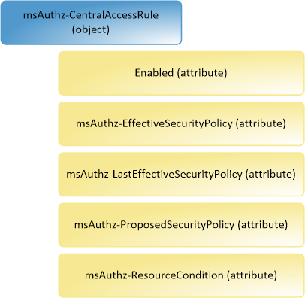
Figure 17 Conceptual representation of an msAuthz-CentralAccessRule object.

msAuthz-CentralAccessRule
The msAuthz-CentralAccessRule Active Directory class is a structural class object that stores a single central access rule. Central access rules are linked to central access policies and describe targeting and conditional authorization rules that are applied to Windows Server 2012 file servers.
New attributes used by msAuthz-CentralAccessRule include:
- Enabled
- msAuthz-EffecitiveSecurityPolicy
- msAuthz-LastEffectiveSecurityPolicy
- msAuthz-ProposedSecurityPolicy
- msAuthz-ResourceCondition
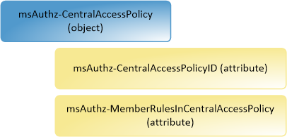
Figure 18 Conceptual representation of an msAuthz-CentralAccessPolicy object.

msAuthz-CentralAccessPolicy
The msAuthz-CentralAccessPolicy Active Directory class is a structural class object that store collection of link msAuthz-CentralAccessRules. The msAuthz-CentralAccessPolicy objects distributed through Group Policy and apply linked msAuthz-CentralAccessRule objects to targeted file servers.
New attributes used by msAuthz-CentralAccessPolicy include:
- msAuthz-CentralAccessPolicyID
- msAuthz-MemberRulesInCentralAccessPolicy

Attributes

msDS-ClaimAttributeSource
The msDS-ClaimAttributeSource attribute is available on msDS-ClaimType objects. This attribute accepts the distinguished name of the schema definition of the attribute used as the source of the claim.

msDS-ClaimIsSingleValued
The msDS-ClaimIsSingleValue attribute is available on msDS-ValueType and msDS-ClaimType objects. This attribute accepts a Boolean value that determines if the claim or value type can only contain a single value.

msDS-ClaimIsValueSpaceRestricted
The msDS-ClaimIsValueSpaceRestricted attribute is available on msDS-ValueType and msDS-ClaimType objects. This attribute accepts a Boolean value that determines if it is acceptable for the class object to accept values other than the values defined in the msDS-ClaimPossibleValues attribute.

msDS-ClaimPossibleValues
The msDS-ClaimPossibleValues attribute is implemented on the msDS-ClaimTypePropertyBase abstract class object and inherited on msDS-ClaimType and msDS-ResourceProperty objects. This attribute accepts a Unicode string value that defines the suggested values presented in the user interface. The Unicode string represents the entire contents of a properly formatted XML file.
Example XML file:
<?xml version="1.0" encoding="utf-16"?>
<PossibleClaimValues xmlns:xsd="http://www.w3.org/2001/XMLSchema" xmlns:xsi="http://www.w3.org/2001/XMLSchema-instance" xmlns="http://schemas.microsoft.com/2010/08/ActiveDirectory/PossibleValues">
<StringList>
<Item>
<ValueGUID>fae3491d-5402-4bcf-9ace-4224fcec3762</ValueGUID>
<ValueDisplayName>Sales</ValueDisplayName>
<ValueDescription>The Sales department value</ValueDescription>
<Value>Sales</Value>
</Item>
</StringList>
</PossibleClaimValues>

msDS-ClaimSharesPossibleValuesWith
The msDS-ClaimSharesPossibleValuesWith attribute is implemented on the msDS-ClaimTypePropertyBase abstract class and inherited on msDS-ClaimType and msDS-ResourceProperty objects. This attribute accepts a distinguished name of an msDS-ClaimType object. An msDS-ResourceProperty object uses this attribute as the source for suggested values rather than the values present in its own msDS-ClaimPossibleValues attribute.
The msDS-ClaimSharesPossibleValuesWith attribute is linked to the msDS-ClaimSharesPossibleValuesWithBL on an msDS-ClaimType object. The msDS-ClaimSharesPossibleValuesWith attribute stores the actual value (forward link) while the msDS-ClaimSharesPosssibleValuesWithBL contains a calculated value from its linked attribute (back link).

msDS-ClaimSharesPossibleValuesWithBL
The msDS-ClaimSharesPossibleValuesWithBL attribute is implemented on the msDS-ClaimTypePropertyBase abstract class and inherited on msDS-ClaimType and msDS-ResourceProperty objects. An msDS-ClaimType object uses this attribute and its value is the distinguished name of the msDS-ResourceProperty object
The msDS-ClaimSharesPossibleValuesWithBL attribute is linked to the msDS-ClaimSharesPossibleValuesWith attribute found on an msDS-ResourceProperty object. The msDS-ClaimSharesPossibleValuesWithBL contains a calculated value (back link) derived from its linked attribute msDS-ClaimSharesPossbileValuesWith, which stores the actual value (forward link).

msDS-ClaimSource
The msDS-ClaimSource attribute is available on msDS-ClaimType objects. This attribute indicates a non-attribute source of an msDS-ClaimType object, such as a certificate.

msDS-ClaimSourceType
The msDS-ClaimSourceType attribute is available on msDS-ClaimType objects. This attribute indicates the claim type’s source. Claims types sourced from an Active Directory attribute are indicated by the value "AD”. Claim types sourced from a certificate’s issuance policy object identifier are indicated by a value of “certificate”.

msDS-ClaimTypeAppliesToClass
The msDS-ClaimTypeAppliesToClass attribute is available on msDS-ClaimType objects. This attribute indicates the security principal schema class object to which the claim is issued. Windows Server 2012 issues claims to users and computers.

msDS-ClaimValueType
The msDS-ClaimValueType attribute is available on msDS-ValueType and msDS-ClaimType objects. This attribute associates a unique value in the form of a large integer when defined on an msDS-ValueType object. The msDS-ClaimType object uses this attribute to determine the value type of the claim. When the value in the msDS-ClaimValueType attribute on an msDS-ClaimType object shares the same value on the msDS-ClaimValueType attribute on an msDS-ValueType object, then the msDS-ClaimType object's value type is the value type of the corresponding msDS-ValueType.
Table 11 Claim types and their values
msDS-ValueType | msDs-ClaimValueType
msDS-DateTime | 1
msDS-Number | 1
msDS-OrderedList | 1
msDS-MultivaluedChoice | 3
msDS-SinglevaluedChoice | 3
msDS-MultivaluedText | 3
msDS-Text | 3
msDS-YesNo | 6

For example, an msDS-ClaimType object is created. The msDS-ValueType attribute has a value of three (3). An msDS-ValueType object exist with an msDS-ValueType attribute value of three (3). Therefore, the value type of the msDS-ClaimType object is the corresponding msDS-ValueType object because the two objects are logically linked by sharing the same value.

msDS-AppliesToResourceTypes
The msDS-AppliesToResourceTypes attribute is available on msDS-ResourceProperty objects

msDS-MembersOfResourcePropertyList
The msDS-MembersOfResourcePropertyList attribute is available on msDS-ResourcePropertyList objects. This linked, multi-valued attribute contains one or more distinguished names of msDS-ResourceProperty objects. This attribute identifies the list of msDS-ResourceProperty objects that are associated with a given msDS-ResourcePropertyList.
The msDS-MembersOfResourcePropertyList attribute is linked to the msDS-MembersOfResourcePropertyListBL attribute on msDS-ResourceProperty objects. This attribute stores the actual value (forward link) while the msDS-MembersOfResourcePropertyListBL contains a calculated value from its linked attribute (back link).

msDS-MembersOfResourcePropertyListBL
The msDS-MembersOfResourcePropertyListBL attribute is available on msDS-ResourceProperty objects. The msDS-ResourceProperty object uses this attribute to identify the msDS-ResourcePropertyLists to which the msDS-ResourceProperty object belongs.
The msDS-MembersOfReosourcePropertyListBL attribute is linked to the msDS-MembersOfResourcePropertyList attribute on an msDS-ResourcePropertyList object. The attribute contains a calculated value (back link) derived from its linked attribute msDS-MembersOfResourcePropertyList, which stores the value (forward link).

msDS-ValueTypeReference
The msDS-ValueTypeReference attribute is available on msDS-ResourceProperty objects. This attribute is a linked, single-valued attribute that contains the distinguished name of an msDS-ValueType object. The msDS-ResourceProperty object uses this attribute to identify it’s the value type associated with the msDS-ResourceProperty.
The msDS-ValueTypeReference attribute is linked to the msDS-ValueTypeReferenceBL attribute on an msDS-ValueType object. This attribute stores the actual value (forward link) while the msDS-ValueTypeReferenceBL contains calculated values from its linked attribute (back link).

msDS-ValueTypeReferenceBL
The msDS-ValueTypeReferenceBL attribute is available on msDS-ValueType objects. This attribute is a linked, multi-valued attribute that contains one or more distinguished names of msDS-ResourceProperty object. The msDS-ValueType object uses this attribute to indicate all the msDS-ResourceProperty objects that use the associated msDS-ValueType object as their value type.
The msDS-ValueTypeReferenceBL attribute is linked to the msDS-ValueTypeReference attribute on msDS-ResourceProperty object. The attribute contains calculated values (back link) derived from its linked attribute msDS-ValueTypeReference, which stores the actual value (forward link).

msDS-TransformationRulesCompiled
The msDS-TransformationRulesCompiled attribute is available on msDS-ClaimsTransformationPolicyType objects. This single-valued, calculated attribute contains a binary representation of the claims transformation rules found in the msDS-TransformationRules attribute of the msDSClaimsTransformationPolicyType object.

msDS-TransformationRules
The msDS-TransformationRules attribute is available on msDS-ClaimsTransformationPolicyType objects. This is a single valued attribute accepts a Unicode string value the defines the claim transformation rules. The Unicode string represents the partial contents of an XML file.
<ClaimsTransformationPolicy>
<Rules version="1.0">
<![CDATA[C1:[Type!="Company"]=>Issue(claim=C1);]]>
</Rules>
</ClaimsTransformationPolicy>

msDS-EgressClaimsTransformationPolicy
The msDS-EgressClaimsTransformationPolicy attribute is available on trustedDomain objects. This attribute is a linked, single-valued attribute that contains a distinguished name of an msDS-ClaimsTransformationPolicyType object. The trustedDomain object uses this attribute to indicate the msDS-ClaimsTranformationPolicyType object linked to the trustedDomain object when the trustedDomain object represents the trusting domain in the context of the trust relationship.
The msDS-EgressClaimsTransformationPolicy attribute is linked to the msDS-TDOEgressBL attribute on msDS-ClaimsTransformationPolicyType objects. The msDS-EgressClaimsTransformation attribute stores the actual value (forward link) while the msDS-TDOEgressBL attribute contains calculated values derived from its linked attribute (back link).

msDS-TDOEgressBL
The msDS-TDOEgressBL attribute is available on msDS-ClaimTransformationPolicyType objects. This attribute is a linked, multi-valued attribute that contains one or more distinguished names of trustedDomain objects. The msDS-ClaimTransformationPolicyType object uses this attribute to indicate all the trustedDomain objects to which the msDS-ClaimTransformationPolicyType object is linked as an egress transformation policy.
The msDS-TDOEgressBL attribute is linked to the msDS-EgressClaimsTransformationPolicy attribute on trustedDomain objects. This attribute contains calculated values (back link) derived from its linked attribute msDS-EgressClaimsTransformationPolicy, which stores the actual value (forward link).

msDS-IngressClaimTransformationPolicy
The msDS-IngressClaimsTransformationPolicy attribute is available on trustedDomain objects. This attribute is a linked, single-valued attribute that contains a distinguished name of an msDS-ClaimsTransformationPolicyType object. The trustedDomain object uses this attribute to indicate the msDS-ClaimsTransformationPolicyType object linked to the trustedDomain object when the trustedDomain object represents the trusted domain in the context of the trust relationship.
The msDS-IngressClaimsTransformationPolicy attribute is linked to the msDS-TDOIngressBL attribute on msDS-ClaimsTransformationPolicyType objects. The msDS-IngressClaimsTransformation attribute stores the actual value (forward link) while the msDS-TDOINgressBL attribute contains calculated values (back link) derived from its linked attribute.

msDS-TDOIngressBL
The msDS-TDOIngressBL attribute is available on msDS-ClaimTransformationPolicyType objects. This attribute is a linked, multi-valued attribute that contains one or more distinguished nams of trustedDomain objects. The msDS-ClaimTransformationPolicyType object uses this attribute to indicate all the trustedDomain objects to which the msDS-ClaimTransformationPolicyType object is linked as an ingress transformation policy.
The msDS-TDOIngressBL attribute is linked to the msDS-IngressClaimsTransformationPolicy attribute on trustedDomain objects. This attribute contains calculated values (back link) derived from its linked attribute msDS-IngressClaimsTransformationPolicy, which stores the actual value (forward link).

msDS-IsUsedAsResourceSecurityAttribute
The msDS-IsUsedAsResourceSecurityAttribute is available on msDS-ResourceProperty objects. This attribute is a single-valued Boolean attribute that contains either a true or a false value. The msDS-ResourceProperty object uses this attribute to indicate if the msDS-ResourceProperty object is available for authorization purposes. The advanced security settings editor does not show an msDS-ResourceProperty object that has an msDS-IsUsedAsResourceSecurityAttribute with a value of false. The advanced security settings editor shows msDS-ResourceProperty objects that have an msDS-IsUsedAsResourceSecurity Attribute with a value of true.

Containers
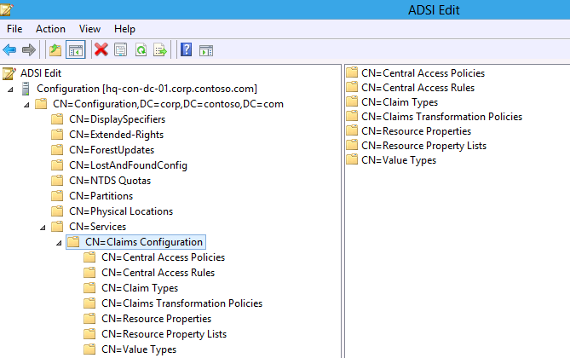
Figure 19 Dynamic Access Control containers in ADSI Edit.

Claims Configuration (container)
The Claims Configuration object is a container object. This container is under the Services container stored in the Configuration partition of an Active Directory forest and is the central storage location for claim configuration metadata.

Central Access Policies (msAuthz-CentralAccessPolicies)
The Central Access Policies container is an msAuthz-CentralAccessPolicies object located under the Claims Configuration container and serves as a specialized Active Directory container object. This container exclusively holds msAuthz-CenralAccessPolicy objects. These objects represent central access policy objects that are distributed to file servers using Group Policy.

Central Access Rules (msAuthz-CentralAccessRules)
The Central Access Rules container is an msAuthz-CentralAccessRules object located under the Claims Configuration container and serves as a specialized Active Directory container object. This container exclusively holds msAuthz-CentralAccessRule objects. These objects represent central access rules that are linked to one or more Central Access Policy objects.

Claim Types (msDS-ClaimTypes)
The Claim Type container is an msDS-ClaimTypes object located under the Claims Configuration container and serves as specialized Active Directory container object. This container exclusively holds msDS-ClaimType objects. These objects represent user and computer claims. This container serves as the claim data dictionary for the forest. Windows Server 2012 domain controllers use the claim data dictionary to determine claims included in tokens for users and computers.

Claims Transformation Policies (msDS-ClaimsTransformationPolicies)
The Central Transformation Policies container is an msDS-ClaimsTransformationPolicies object located under the Claims Configuration container and serves as a specialized Active Directory container object. This container exclusively holds msDS-ClaimsTransformationPolicyType objects. These objects represent claim transformation policy objects used to filter and transform claims across forest trusts.

Resource Properties (msDS-ResourceProperties)
The Resource Properties container is an msDS-ResourceProperties object located under the Claims Configuration container and serves as a specialized Active Directory container object. This container exclusively holds msDS-Resource Property objects. These objects represent secure and non-secure resource properties used by the File Server role, the Access Control Editor, and the Central Policy Rules Editor.

Resource Property Lists (container)
The Resource Property List object is a container object located under the Claims Configuration container and serves as a container for msDS-ResourcePropertyList objects. Objects within this container represent a logical grouping of linked Resource Property objects.

Value Types (container)
The Value Types object is a container object located under the Claims Configuration container and serves as a container for msDS-ValueType objects. Objects within this container represent various value types that can be used among user and computer claims and resource properties.
Important: | Windows Server 2012 does not support the use of user created msDS-ValueType objects. You can create these objects; however, they may not appear and work in all user interfaces.

Named Objects

Global Resource Property List
The Global Resource Property List is an msDS-ResourcePropertyList object created with the first Windows Server 2012 domain controller in the forest. This object serves as the default object used by the file server to determine the list of available Resource Property objects. Resource properties linked to this Resource Property list appear in the Advanced Security Settings editor.

Managing Claims and Resource Properties
Claims are statements issued from a trusted source. You define claims in a claims data dictionary. The claim type metadata is stored in the configuration partition for the Active Directory forest. Resource properties are stored in the configuration partition of an Active Directory forest; however, their storage is separate from user and computer claims.
This lesson introduces the fundamental concepts associated with managing user and computer claims, and with managing resource properties.

User and Computer Claims
Windows Server 2012 domain controllers can issue statements that can be used to authorize a user or computer to a file system resource. These statements are known as claims. Claims issued from a Windows Server 2012 domain controller are trusted; therefore, Windows can use these claims for authorization decisions.
A Windows Server 2012 domain controller must be configured to issue claims for a user or computer, or both. You configure claims using the Active Directory Administrative Center or Windows PowerShell.

Manage Claims using Active Directory Administrative Center
You use the Active Directory Administrative Center to manage user and computer claim types. Using Active Directory Administrative Center, you can create, modify, and delete user and computer claim types.

Starting the Active Directory Administrative Center
The Active Directory Administrative Center is available from the Start Page after the Active Directory Domain Services role is installed on the computer. Alternatively, you can start Active Directory Administrative Center from the Search or Run menu by typing DSAC.EXE and pressing Enter.
Creating and modifying claim types share the following user interface options.
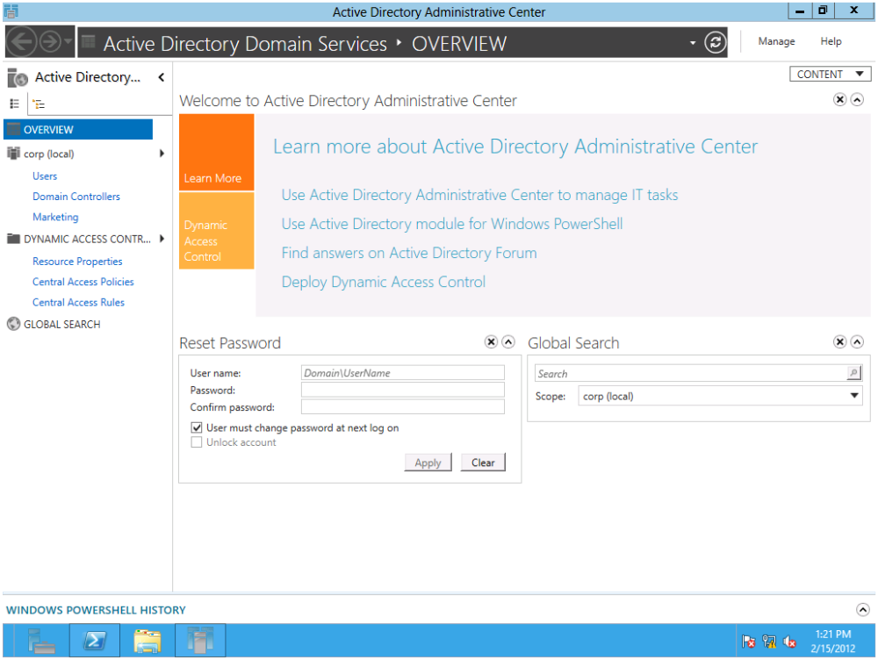
Figure 20 Active Directory Administrative Center start page.

Source Attribute section
Use the Source Attribute section to select the source attribute upon which the claim type is based and additional configuration items represented in the newly created claim type.
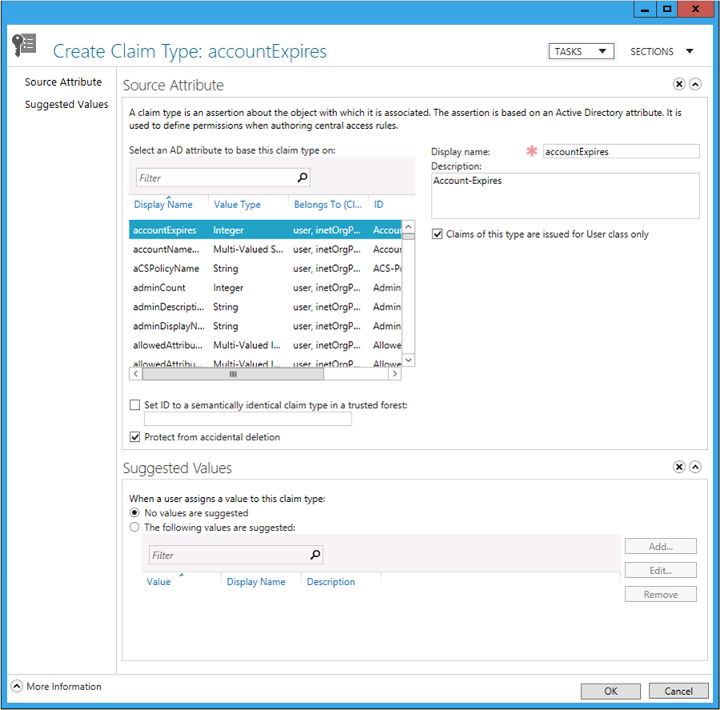
Figure 21 Create Claim Type dialog from Active Directory Administrative Center

Source Attribute
The Source Attribute list provides a list attributes from which you can select as the attribute source for the claim type. Windows creates the list of attributes from the following schema class objects
- User
- InetOrgPerson
- Computer
- ManagedServiceAccount
- GroupManagedServiceAccount
- Auxiliary class objects
Additionally, the Active Directory Administrative Center excludes attributes based on the following criteria
- Attributes marked as defunct in the schema
- Blocked attributes such as dBCSPwd, lmPwdHistory, and unicodePwd
- Attributes that are not replicated
- Attributes that are not available on read-only domain controllers
- Attributes with syntaxes not based on the following
  - String Object (DS-DN)
  - String (Unicode)
  - Boolean
  - Integer
  - Large Integer
  - String (OID)
  - String (SD)
The selected source attribute is the attribute associated with the newly created claim type. Windows inserts the unique identifier of the claim type and the value on which the claim is based in the Kerberos service ticket.

Display name
The Display name box holds the unique display name given to the claim type. Windows uses a claim type display name when presenting it as a choice throughout the user interface. The Display name accepts alphanumeric characters as valid data.
Important: | The Windows authorization claims contain the unique identifier, or name in the actual service ticket. The display name is not present in the service ticket

Description
The Description box holds a short description about the claim type. Comments can contain alphanumeric characters. Its content typically includes purpose, department usage, or business justification.

Claims of this type are issued for User class only
The Claims of this type are issued for User class only check box designates a claim type exclusively issued to user security principals. Selecting this check box ensures the newly created claim type is only issued to user security principals. Clearing this check box allows a Windows Server 2012 domain controller to issue the claim of this claim type to user and computer security principals.

Set ID to a semantically identical claim type in a trusted forest
The Set ID to a semantically identical claim type in a trusted forest check box controls how the Active Directory Administrative Center creates the claim identifier. The Active Directory Administrative Center automatically generates a claim identifier when creating a new claim type. The automatically generated claim identifier begins with the lowercase letters ad followed by a single colon (:), two forward slashes (//), the letters ext, and a single forward slash (/). The Active Directory Administrative Center then concatenates the attribute name followed by a colon (:) and randomly generated value represented in hexadecimal notation to the moniker style prefix (looks similar to a global unique identifier- GUID).
ad://ext/attributeName:uniqueHexidecimalNumber
ad://ext/carLicense:88ce92d4b3d1f468
You use claims across a forest trust provided there are an adequate number of Windows Server 2012 domain controllers in both domains. However, the claim type metadata is unique to each forest. Therefore, domain controllers in a trusting forest receiving claims from a trusted forest will not understand these claims unless:
- You define the claim identifier in both forests
- The claim identifier is semantically identical between the trusted and trusting forest
- You link a Claims Transformation Policy object in the trusting forest to allow incoming claims across the forest trust.
When this check box is cleared, Active Directory Administrative Center automatically generated the claim type identifier. When this check box is selected, Active Directory Administrative Center allows you to enter a custom claim type identifier.
Active Directory claim type identifiers conform to a strict naming context. Understand the following constraints when creating a unique claim identifier.
New claim identifiers must:
- The claim identifier must start with ad://ext/
- Up to 32 characters may follow
- The 32 characters may not contain spaces, \, *, ?, ", <, >, and |
- Cannot end with a forward slash (/)
- The claim identifier must be unique
You should use automatically generated claim type identifiers unless a business need justifies otherwise, such as the use of claim transformation policies or using Windows authorization claims with Active Directory Federation Services (AD FS). This ensures that all newly created claim types are created with unique claim type identifiers.

Protect from accidental deletion
The Protect from accidental deletion check box protects the newly created claim type from accidental deletion by users. By default, only members of Domain and Enterprise Admins groups have the permission to create, modify, and delete claim types. However, it is a good best practice to safeguard these objects from accidental deletion.
Selecting the Protect from accidental deletion check box prohibits all users, including Domain and Enterprise administrators from deleting the object. Active Directory Administrative Center applies this protection through permissions. When this box is selected, Active Directory Administrative Center adds an explicit permission entry to the newly created claim type that denies the built in security principal Everyone the ability to delete the object.
Accidental deletion protection is removed when this check box is cleared by removing the explicit permission entry to deny the delete access.

Suggested Values section
The Suggested Values section allows you to configure predetermined selectable values from which you can choose when using the claim type in a conditional expression.
Important: | It is important to remember when changing or removing suggested values to also update conditional expressions using the suggested values.

No values are suggested
The No values are suggested option is the default option when creating a new claim type. This option prevents you from creating suggested values. Claim types created without suggested values require you to type their values when using them in conditional expressions.

The following values are suggested
Using the The following values are suggested options enables you to create one or more suggested value associated with this claim type. These values appear in a list when creating conditional expressions. Use the Add, Edit, and Remove buttons to modify a claim type's suggested values.

Value
Type the value of the suggested value item in the Value box. This required information represents the value associated with the Display name and is the value used when evaluating conditional expressions.

Display name
Type the display name of the suggested value item in the Display name box. This required information is the name that appears in lists when creating and modifying conditional expressions.

Description
Type an optional description of the suggested value item in the Description box.

Create a New Claim Type
You must create claim types in Active Directory before a Windows Server 2012 domain controller issues claims to users or computers. Windows Server 2012 domain controllers only issue claims from accounts stored in Active Directory. Claims issued by the domain controller are sourced from attributes of user or computer objects, or the object identifier of a certificate's issuance policy.
Important: | Claims issued by Windows Server 2012 domain controllers are Windows authorization claims and should not be confused with claims issued by a federation server such as Active Directory Federated Services (AD FS).

Figure 22 Create Claim Type dialog.
New claim types are created in the Claim Types container under the Dynamic Access Control container found in the navigation pane of the Active Directory Administrative Center. You can create new claim type objects through the task pane. Or, you can create a new claim type by clicking the Claim Types node in the navigation pane and then right-clicking the white space of the management list and then clicking New and then clicking Claim Type.
Create a new claim type using Active Directory Administrative Center
- Start the Active Directory Administrative Center.
- Click Claim Types in the navigation pane under the Dynamic Access Control folder.
- From the tasks pane, click New and then click Claim Type.
- On the Create Claim Type dialog in the Source Attribute section, click the Active Directory attribute on which you want to base your claim.
- Type the Display name and Description.
- Select the Claims of this type are issued for User class only check box to limit the issuance of this claim type only to user. Clear this check box to allow this claim to be issued to both user and computers.
- Select the Set ID to a semantically identical claim type in a trusted forest if the claim type must match an existing claim type across a forest. Type the claim identifier. Clear this check box to generate the claim identifier automatically.
- Select the Protect from accidental deletion check box to ensure an administrator cannot accidentally delete the claim type. Clear the check box to remove accidental deletion protection.
- In the Suggested Values section, click the option you want for suggested values. Create suggested value items as needed.
- Click OK.

Modify a Claim Type
Modify a claim type using Active Directory Administrative Center
- Start the Active Directory Administrative Center.
- Click Claim Types in the navigation pane under the Dynamic Access Control folder.
- Right-click the claim type you want to modify and then click Properties.
- Modify the Display name, Description, Claims of this type are issued for User class only, or Protect from accidental deletion.
- Use the Add button to create a new suggested value item. Use the Edit button to remove a suggested value item. Use the Remove button to delete a suggested value item from the claim type.
- Click OK to save the modified claim type.

Delete a Claim
Delete a claim using Active Directory Administrative Center
- Start the Active Directory Administrative Center.
- Click Claim Types in the navigation pane under the Dynamic Access Control folder.
- Right-click the claim type you want to delete and then click Delete.
- Click Yes to confirm the claim type deletion.
 Tip: | Windows may prompt you with a dialog stating you do not have sufficient permission to delete the claim type. If you encounter this dialog, then modify the claim type and clear the Protect from accidental deletion check box. If this check box is cleared, then examine the object's security and ensure you have permission to delete the claim type.

Important: | You cannot delete claim type objects that share their suggested values with reference Resource Property objects. You can view all the reference Resource Property objects linked to a claim type object by displaying all the values from the msDS-ClaimSharesPossibleValuesWithBL attribute on the claim type object.

Enabling and Disabling Claim Types
Windows claim types have two states: disabled and enabled. Disabled claim types are valid claim types configured in the claim metadata, but are unavailable for use in production. A claim type becomes available for production use once you enable it. Until it is enabled, a disabled claim type is not issued to user or computer by the Windows Server 2012 domain controller, and is filtered from view in the access control editor and the expression editor. The Active Directory Administrative Center automatically enables newly created claim types. You need to manually enable all claim types created using Windows PowerShell.
To Enable or disable a claim using Active Directory Administrative Center
- Start the Active Directory Administrative Center.
- Click Claim Types in the navigation pane under the Dynamic Access Control folder.
- To enable a claim, right-click the disabled claim type you want to enable and then click Enable. To disable a claim type, right-click the enabled claim type you want to disable and then click Disable.

Windows PowerShell History
The Active Directory Administrative Center relies on Active Directory Web Services and Active Directory PowerShell to read and write to Active Directory. The Active Directory Administrative Center uses equivalent Active Directory PowerShell cmdlets to accomplish most administrative tasks performed in the user interface.
The Active Directory Administrative Center in Windows Server 2012 introduces the Windows PowerShell History. This portion of the user interface allows you to view the accumulative history of Active Directory PowerShell cmdlets used by the Active Directory Administrative Center.
You can use the Windows PowerShell History to associate common administrative tasks performed in the user interface with PowerShell cmdlets that perform equivalent functions. The Windows PowerShell History provides copy and paste functionality to help administrators new to PowerShell to learn and create custom cmdlets to perform automated administrative tasks.

Manage Claim Types using PowerShell
You can also manage claim types using Active Directory PowerShell cmdlets. These cmdlets provide claim type management functionality equivalent to functionality found in the Active Directory Administrative Center.

Starting the Active Directory module for Windows PowerShell
You can start Windows PowerShell to load the Active Directory module for Windows PowerShell automatically by clicking Active Directory Module for Windows PowerShell from Start Page after the Active Directory Domain Services role is installed on the computer. Alternatively, you can start Windows PowerShell.
Starting the Active Directory Module for Windows PowerShell
- Click the Start button.
- Right-click Active Directory Module for Windows PowerShell from the Start page and then click Run as Administrator.
Tip: | If you are familiar with earlier versions of Windows PowerShell, then you are accustom to importing the module that host the cmdlets you want to run. Windows PowerShell in Windows Server 2012 and Windows 8 no longer requires you to import the module.

Create a Claim Type
Windows authorization claim types are created using the New-ADClaimType Active Directory cmdlet. This cmdlet behaves in a manner similar to a command line application, so you can treat and think of cmdlet as a command line application. You identify configuration options by passing arguments to the cmdlet.
Create a New Claim type using Windows PowerShell
New-ADClaimType
-AppliesToClasses:@('user')
-Description:"User department attribute claim"
-DisplayName:"Department"
-IsSingleValued:$true
-PassThru:$null
-RestrictValues:$false
-Server:"hq-con-dc-01.corp.contoso.com"
-SourceAttribute:"CN=Department,CN=Schema,CN=Configuration,DC=contoso,DC=com"

AppliesToClasses
Use the AppliesToClasses argument to specify the classes to which the new claim type applies. Claim types can be applied to user, computer, inetOrgPerson, msDS-ManagedServiceAccount, and msDS-GroupManagedServiceAccount objects. You represent a list in Windows PowerShell by preceding the arguments value with an at-sign (@). Immediately following the at-sign is a beginning and ending parentheses. These parentheses represent all the items included in the list that are passed as a single argument.

Example
-AppliesToClasses:@('user')
-AppliesToClasses:@('computer', 'msDS-ManagedServiceAccount')

Description
Use the Description argument to provide a short description that clarifies the purpose or existence of the claim type.

Example
-Description:"This is a claim type description."

DisplayName
Use the DisplayName argument to configure the new claim type with a name that is used for display purposes.

Example
-DisplayName:"Department"

Enabled
Use the Enabled argument to enable or disable a claim type.

Example
-Enabled:$true
-Enabled:$false

ID
Use the ID argument only when you need to set an ID to a semantically identical claim type in a trusted forest.
Active Directory claim type identifiers conform to a strict naming context. Understand the following constraints when creating a unique claim identifier.
New claim identifiers must:
- The claim identifier must start with ad://ext/
- Up to 32 characters may follow
- The 32 characters may not contain spaces, \, *, ?, ", <, >, and |
- Cannot end with a forward slash (/)
- The claim identifier must be unique

Example
-id:ad://ext/attributeName:uniqueHexidecimalNumber
-id:ad://ext/carLicense:88ce92d4b3d1f468
-id:ad://ext/carLicense/1

IsSingleValued
Use the IsSingleValued argument to configure the new claim type as a single or multi-valued claim type. Suffix the argument with $true to configure the new claim type as a single-valued. Suffix the argument with $false to configure the new claim type as a multi-valued claim type.
Important: | A claim type is based on an Active Directory attribute. Therefore, the value type of a claim must match the value type of the Active Directory attribute on which it is based. Single-valued attributes require single-valued claim types. Multi-valued attributes require multi-valued claim types.

Example
-IsSingleValued:$true
-IsSingleValued:$false

RestrictValues
Use the RestrictValues argument to restrict the new claim type to only use its configured suggested values. Suffix the argument with $true to restrict the new claim type to only use its suggested values. Suffix the argument with $false to allow the new claim type to accept any compatible value.

Example
-RestrictedValues:$true
-RestrictedValues:$false

ProtectedFromAccidentalDeletion
Use the ProtectedFromAccidentalDeletion argument to enable or disable protection against deletion when an administrator tries to delete the claim type.

Example
-ProtectFromAccidentalDeletion:$true
-ProtectFromAccidentalDeletion:$false

Server
Use the optional Server argument to force the responsibility of creating the new claim type to a specific server. Suffix the argument with the fully qualified domain name of the computer you want to create the new claim type.

Example
-Server:"hq-con-dc-01.corp.contoso.com"

SourceAttribute
Use the SourceAttribute argument to configure the Active Directory attribute from which the claim type is based, and from which the claim value is obtained. Suffix the attribute with the distinguished name of the attribute class object from the Active Directory Schema.

Example
-SourceAttribute:"CN=Department,CN=Schema,CN=Configuration,DC=contoso,DC=com"

SourceOID
Use the SourceOID argument to configure a certificate-based claim type source. For example, create certificate-based claim types when you want to use smartcard logon claims for authorization decisions. The sourceOID argument uses the string representation of an object identifier (OID) from the issuance policy found in the certificate and on the certificate template when using Active Directory Certificate Services.

Example
-SourceOID:"1.3.6.1.4.1.311.47.2.5"

SourceTransformPolicy
Use the SourceTransformPolicy argument to configure a claim type that is sourced by an incoming or outgoing claim transformation policy rather than an attribute in Active Directory. For example, create a transformed-based claim type role so you can use a claim transformation policy to issue a role claim when Active Directory does not provide a role attribute.

Example
-SourceTransformPolicy

SuggestedValues
Use the SuggestedValues argument to configure the newly created claim type with one or more suggested values. You use the SuggestedValues argument only when the RestrictedValues argument is present and suffixed with $true.
Tip: | Understanding how to create a claim type object with suggested values using Active Directory PowerShell may require knowledge of Windows PowerShell outside the scope of this document. If you are new to Windows PowerShell, then consider creating claim type objects using Active Directory Administrative Center, or consult Microsoft TechNet for more information on Windows PowerShell.

New-ADClaimType
-AppliesToClasses:@('user')
-Description:"User department attribute claim"
-DisplayName:"Department"
-IsSingleValued:$true
-PassThru:$null
-RestrictValues:$true
-Server:"hq-con-dc-01.corp.contoso.com"
-SourceAttribute:"CN=Department,CN=Schema,CN=Configuration,DC=contoso,DC=com"
-SuggestedValues:@((New-Object Microsoft.ActiveDirectory.Management.ADSuggestedValueEntry("hr", "Human Resource", "Human Resources suggested value")), (New-Object Microsoft.ActiveDirectory.Management.ADSuggestedValueEntry("sales", "Sales", "Sales department suggested value")), (New-Object Microsoft.ActiveDirectory.Management.ADSuggestedValueEntry("marketing", "Marketing", "Marketing suggested value")))
The SuggestedValues argument receives a list of SuggestedValueEntry objects. You represent a list in Windows PowerShell by preceding the arguments value with an at-sign (@). Immediately following the at-sign is a beginning and ending parentheses. These parentheses represent all the items included in the list that is passed as a single argument.
As previously mentioned, each item in the list is a SuggestedValueEntry object. You create a single instance of this object using the New-Object Windows PowerShell cmdlet. The syntax for this cmdlet is
New-Object object-type(object-type-argument-1, object-type-argument-2, …)
The object type for a suggested value item reads as Microsoft.ActiveDirectory.Management.ADSuggestedValueEntry. A valid suggested value item contains three parts: a value, a name, and a description. These parts are represented as three object-type arguments that follow the object type name; separated by a comma, and enclosed within parentheses.
(New-Object Microsoft.ActiveDirectoryManagement.ADSuggestedValueEntry("hrDepartmentValue", "Human Resources", "Human Resources Department Description))
Ensure you include each New-Object cmdlet resides within an opening and closing parenthesis and that each pair of parentheses including a New-Object cmdlet is separated from the next using a comma. The correct syntax creates a new suggested value item and assigns that item as distinct item in the list of suggested values.
-SuggestedValues:@((New-Object Microsoft.ActiveDirectory.Management.ADSuggestedValueEntry("hrDepartementValue", "Human Resources ", "Human Resource Description")), (New-Object Microsoft.ActiveDirectory.Management.ADSuggestedValueEntry("SalesDepartmentValue", "Sales Department", "Sales Department Description")))

ValueType
Use the ValueType argument to configure the value type of a transformed-based claim type. Attribute-based claim types have their values determined by the attribute used to source the claim type. Certificate-based claim types automatically use the OID value type.

Example
-ValueType:string

Example - Creating a new claim type using Windows PowerShell (without suggested values)
New-ADClaimType
-AppliesToClasses:@('user')
-Description:"User department attribute claim"
-DisplayName:"Department"
-IsSingleValued:$true
-RestrictValues:$false
-SourceAttribute:"CN=Department,CN=Schema,CN=Configuration,DC=contoso,DC=com"

Example - Creating a new claim type using Windows PowerShell (with suggested values)
New-ADClaimType
-AppliesToClasses:@('user')
-Description:"User department attribute claim"
-DisplayName:"Department"
-IsSingleValued:$true
-RestrictValues:$true
-SourceAttribute:"CN=Department,CN=Schema,CN=Configuration,DC=contoso,DC=com"
-SuggestedValues:@((New-Object Microsoft.ActiveDirectory.Management.ADSuggestedValueEntry("hrDepartmentValue", "Human Resources ", "Human Resource Description")), (New-Object Microsoft.ActiveDirectory.Management.ADSuggestedValueEntry("SalesDepartmentValue", "Sales Department", "Sales Department Description")))

Example - Create a new transform-based claim type using Windows PowerShell
New-ADClaimType
-SourceTransformPolicy
-DisplayName:role
-ID:"ad://ext/role/1"
-ValueType:string

Example - Create a new OID-based claim type using Windows PowerShell
New-ADClaimType
-AppliesToClasses:@('user')
-Description:"SmartCard Logon Claim Type"
-DisplayName:"SmartCard Logon"
-ID:"ad://ext/sclogon/1"
-Enabled:$true
-SourceOID:"1.3.6.1.4.1.311.47.2.5"

Modify a Claim Type
You can modify claim types using the Set-ADClaimType Active Directory cmdlet. This cmdlet behaves in a manner similar to a command line application, so you can think of cmdlets as a command line application. You identify configuration options by passing arguments to the cmdlet.
Modifying a claim type using Windows PowerShell
Set-ADClaimType
-Identity:"CN=ad://ext/Department/1,CN=Claim Types,CN=Claims Configuration,CN=Services,CN=Configuration,DC=contoso,DC=com"
-SuggestedValues:@((New-Object Microsoft.ActiveDirectory.Management.ADSuggestedValueEntry("hrDepartementValue", "Human Resources ", "Human Resource Description"))

AppliesToClasses
Use the AppliesToClasses argument to specify the classes to which the claim type applies. Claim types can be applied to user, computer, inetOrgPerson, msDS-ManagedServiceAccount, and msDS-GroupManagedServiceAccount objects. You represent a list in Windows PowerShell by preceding the arguments value with an at-sign (@). Immediately following the at-sign is a beginning and ending parentheses. These parentheses represent all the items included in the list that is passed as a single argument.

Example
-AppliesToClasses:@('user')
-AppliesToClasses:@('computer', 'msDS-ManagedServiceAccount')

Description
Use the Description argument to provide a short description that clarifies the purpose or existence of the claim type.

Example
-Description:"This is a claim type description."

DisplayName
Use the DisplayName argument to configure the claim type with a name that is used for display purposes.

Example
-DisplayName:"Department"

Enabled
Use the Enabled argument to enable or disable a claim type.

Example
-Enabled:$true
-Enabled:$false

Identity
Use the Identity argument to specific the claim type object on which the Set-ADClaimType cmdlet performs the action. A valid identity argument includes the object's display name, name, distinguished name, or globally unique identifier (GUID).

Example
-Identity:"CN=ad://ext/Department/1,CN=Claim Types,CN=Claims Configuration,CN=Services,CN=Configuration,DC=contoso,DC=com"

ProtectedFromAccidentalDeletion
Use the ProtectedFromAccidentalDeletion argument to enable or disable protection against deletion when an administrator tries to delete the claim type.

Example
-ProtectFromAccidentalDeletion:$true
-ProtectFromAccidentalDeletion:$false

Server
Use the optional Server argument to force the responsibility of modifying the claim type to a specific server. Suffix the argument with the fully qualified domain name of the computer you want to create the new claim type.

Example
-Server:"hq-con-dc-01.corp.contoso.com"

SourceAttribute
Use the SourceAttribute argument to configure the Active Directory attribute from which the claim type is based, and from which the claim value is obtained. Suffix the attribute with the distinguished name of the attribute class object from the Active Directory Schema.

Example
-SourceAttribute:"CN=Department,CN=Schema,CN=Configuration,DC=contoso,DC=com"

SourceOID
Use the SourceOID argument to configure a certificate-based claim type source. For example, create certificate-based claim types when you want to use smartcard logon claims for authorization decisions. The sourceOID argument uses the string representation of an object identifier (OID) from the issuance policy found in the certificate and on the certificate template when using Active Directory Certificate Services.

Example
-SourceOID:"1.3.6.1.4.1.311.47.2.5"

SourceTransformPolicy
Use the SourceTransformPolicy argument to configure a claim type that is sourced by an incoming or outgoing claim transformation policy rather than an attribute in Active Directory. For example, create a transformed-based claim type role so you can use a claim transformation policy to issue a role claim when Active Directory does not provide a role attribute.

Example
-SourceTransformPolicy

SuggestedValues
Use the SuggestedValues argument to configure attribute-based claim types with one or more suggested values. You use the SuggestedValues argument only when the RestrictedValues argument is present and suffixed with $true.
Tip: | Understanding how to create a claim type object with suggested values using Active Directory PowerShell may require knowledge of Windows PowerShell outside the scope of this document. If you are new to Windows PowerShell, the consider creating claim type objects using Active Directory Administrative Center, or consult Microsoft TechNet for more information on Windows PowerShell.

Set-ADClaimType
-AppliesToClasses:@('user')
-Description:"User department attribute claim"
-DisplayName:"Department"
-IsSingleValued:$true
-PassThru:$null
-RestrictValues:$true
-Server:"hq-con-dc-01.corp.contoso.com"
-SourceAttribute:"CN=Department,CN=Schema,CN=Configuration,DC=contoso,DC=com"
-SuggestedValues:@((New-Object Microsoft.ActiveDirectory.Management.ADSuggestedValueEntry("hr", "Human Resource", "Human Resources suggested value")), (New-Object Microsoft.ActiveDirectory.Management.ADSuggestedValueEntry("sales", "Sales", "Sales department suggested value")), (New-Object Microsoft.ActiveDirectory.Management.ADSuggestedValueEntry("marketing", "Marketing", "Marketing suggested value")))
The SuggestedValues argument receives a list of SuggestedValueEntry objects. You represent a list in Windows PowerShell by preceding the arguments value with an at-sign (@). Immediately following the at-sign is a beginning and ending parentheses. These parentheses represent all the items included in the list that is passed as a single argument.
As previously mentioned, each item in the list is a SuggestedValueEntry object. You create a single instance of this object using the New-Object Windows PowerShell cmdlet. The syntax for this cmdlet is
New-Object object-type(object-type-argument-1, object-type-argument-2, …)
The object type for a suggested value item reads as Microsoft.ActiveDirectory.Management.ADSuggestedValueEntry. A valid suggested value item contains three parts: a value, a name, and a description. These parts are represented as three object-type arguments that follow the object type name; separated by a comma, and enclosed within parentheses.
(New-Object Microsoft.ActiveDirectoryManagement.ADSuggestedValueEntry("hrDepartmentValue", "Human Resources", "Human Resources Department Description))
Ensure you include each New-Object cmdlet resides within an opening and closing parenthesis and that each pair of parentheses including a New-Object cmdlet is separated from the next using a comma. The correct syntax creates a new suggested value item and assigns that item as distinct item in the list of suggested values.

Example
-SuggestedValues:@((New-Object Microsoft.ActiveDirectory.Management.ADSuggestedValueEntry("hrDepartementValue", "Human Resources ", "Human Resource Description")), (New-Object Microsoft.ActiveDirectory.Management.ADSuggestedValueEntry("SalesDepartmentValue", "Sales Department", "Sales Department Description")))

Delete a Claim Type
You can delete claim types using the Remove-ADClaimType Active Directory cmdlet. This cmdlet behaves in a manner similar to a command line application, so you can think of cmdlets as a command line application. You identify configuration options by passing arguments to the cmdlet.
Delete a claim type using Windows PowerShell
Remove-ADClaimType
-Identity:"CN=ad://ext/Department/1,CN=Claim Types,CN=Claims Configuration,CN=Services,CN=Configuration,DC=contoso,DC=com"

Identity
Use the Identity argument to specific the claim type object on which the Remove-ADClaimType cmdlet performs the action. A valid identity argument includes the object's display name, name, distinguished name, or globally unique identifier (GUID).

Example
-Identity:"CN=ad://ext/Department/1,CN=Claim Types,CN=Claims Configuration,CN=Services,CN=Configuration,DC=contoso,DC=com"

Server
Use the optional Server argument to force the responsibility of deleting the new claim type to a specific server. Suffix the argument with the fully qualified domain name of the computer you want to create the new claim type.

Example
-Server:"hq-con-dc-01.corp.contoso.com"

Force
Use the optional force argument to remove objects that cannot otherwise be changed due to attribute validation failures. Windows replicates claim type information using Active Directory replication. Replication failures and excessively slow replication convergence can leave claim type objects in an inconsistent state. This state can cause validation errors when attempting to modify or delete claim type objects. Use the force argument only when normal deletions through the user interface or through Windows PowerShell are unsuccessful.

Example
-force
Tip: | Windows may prompt you with a dialog stating you do not have sufficient permission to delete the claim type. If you encounter this dialog, then modify the claim type and clear the Protect from accidental deletion check box. If this check box is cleared, then examine the object's security and ensure you have permission to delete the claim type.

Important: | You cannot delete claim type objects that share their suggested values with reference Resource Property objects. You can view all the reference Resource Property objects linked to a claim type object by displaying all the values from the msDS-ClaimSharesPossibleValuesWithBL attribute on the claim type object. The force argument allows the cmdlet to remove objects that cannot otherwise be removed due to some attribute validation failures. Using this argument can negatively affect all reference Resource Property objects that use the claim type as a source for their suggested values.

Enabling and Disabling Claim Types
An alternative to deleting claims is disabling them. Windows claim types have two states: disabled and enabled. Disabled claims are valid claims configured in Active Directory, but are unavailable for use in production. A claim type becomes available for production use once you enable it. Until it is enabled, a disabled claim type is not issued to user or computer by the Windows Server 2012 domain controller, and is filtered from view in the Advanced Security Settings editor and the expression editor. By default, Active Directory Administrative Center enables all newly created claim types.
You can enable and disable claim types using the Set-ADClaimType Active Directory cmdlet.

Example: Disabling a claim type
Set-ADClaimType
-Identity:"CN=ad://ext/Department/1,CN=Claim Types,CN=Claims Configuration,CN=Services,CN=Configuration,DC=contoso,DC=com"
-enabled:$false

Example: Enabling a claim type
Set-ADClaimType
-Identity:"CN=ad://ext/Department/1,CN=Claim Types,CN=Claims Configuration,CN=Services,CN=Configuration,DC=contoso,DC=com"
-enabled:true$

Managing Resource and Reference Resource Properties using Active Directory Administrative Center
Windows Server 2012 expands the role of resource properties to become an intricate component in Dynamic Access Control. Windows Server 2008 R2 introduces resource properties as part of the File Classification Infrastructure (FCI). This infrastructure, managed through the File Server Resource Manager (FSRM) provided file server administrators with a way to automatically assign classification information to files on Windows file servers. Resource properties and FCI helped reduce overall cost of ownership and enabled compliance scenarios.

Resource Properties
Windows Server 2012 increases the value of FCI by using resource properties for authorization decisions. Administrators can now configure authorization access based on one or more Resource Property values by using conditional expressions. Multiple expressions provides administrators the flexibility to use Dynamic Access Control to solve even the most complex authorization scenarios.
Resource properties use alternate data streams within each file metadata about that file. Information within the alternate data stream stays with each file as it moves to various NTFS volumes. Windows uses this metadata for activities such as compliance and authorization decisions.
For example, files with personal information can be classified as Personal Identification Information (PII). Windows Server 2012 can determine access based on if the user is allowed access to files that include personal information based on the metadata, or Resource Property of the file. If the file is classified to contain PII and the user is not entitled to view PII data, then that user is denied access to that file. There are two Resource Property types: a Resource Property and a reference Resource Property.

Resource Property object
A Resource Property is a complete instance of a Resource Property in which any suggested values defined for the object are stored in the msDS-ClaimPossibleValues attribute of that object.

Reference Resource Property object
Reference Resource Property objects differ from Resource Property objects in that they do not store their own suggested values. Reference resource properties use the suggested values of a claim type object referenced by a distinguished name stored in the msDS-ClaimSharesPossibleValuesWith attribute of reference Resource Property object. The benefit of using referenced Resource Property objects over Resource Property objects is to guarantee that an expression similar to user.PII == resource.PII is comparable, which reduces the manual maintenance of data consistency.

Secure Resource Property objects
Windows primarily uses resource properties for file classification and authorization. A Resource Property must be configured for use in authorization decisions. Newly created Resource Property objects are configured for use in authorization decisions. This configuration object is represented by a true or false value stored in the msDS-IsUsedAsResourceSecurityAttribute of the Resource Property object. These Resource Property objects are known as secure Resource Property objects because they can be used for authorization decisions.
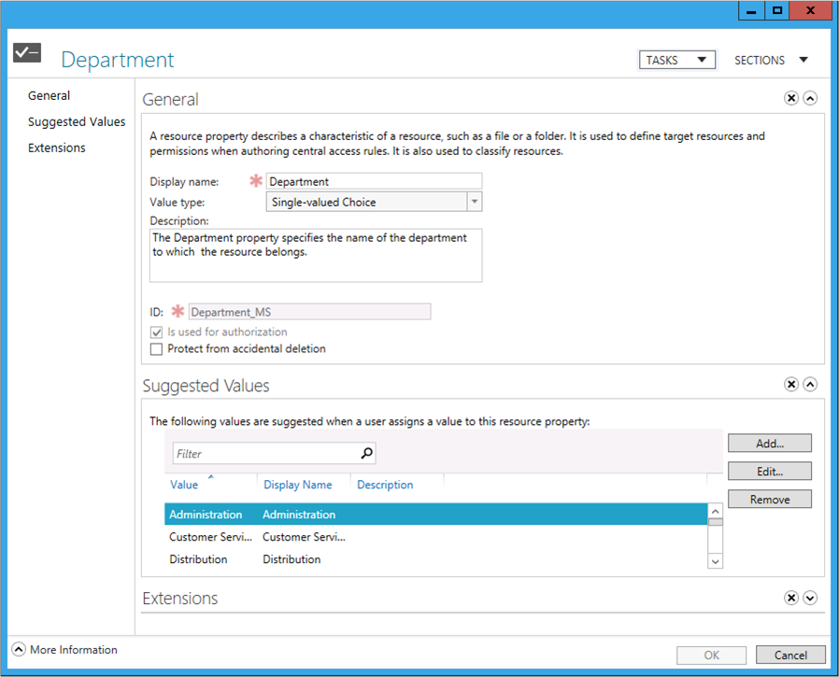
Figure 23 Resource Property dialog from the Active Directory Administrative Center.

General section

Display name
The Display name box holds the unique display name given to the Resource Property. Windows displays the Resource Property display name throughout the user interface. The display name accepts alphanumeric characters as valid data.

Value type
The Value type list provides a list of logical data types Windows uses to characterize the data stored in the Resource Property. The possible logical data types include:

Date Time
Resource property objects based on this logical value type based on date and time. You cannot base a secure resource object on the Date Time logical value type.

Multi-valued Choice
Resource property objects based on this logical value type contain multiple suggested values where you can select one or more suggested values to create a list of multiple valid choices. It is important to know that multi-valued choices cannot be compared.
Note: | The conditional expression editor in the Advanced Security Settings editor prevents you from using the equal operator when the value type of either value in the condition is multi-valued. If you need to use the equal operator in a conditional expression to compare a single item from a list of values, use the single-valued choice value type.

Single-valued Choice
Resource property objects based on this logical value type contain multiple suggested values where you can only select one suggested value from the list to create a single choice. Unlike multi-valued choices, single-valued choices can be compared.

Multi-valued Text
Resource property objects based on this logical value type can contain multiple text entries.

Number
Resource property objects based on this logical value type can contain a single number.

Ordered List
Resource property objects based on this logical value type can contain a single choice entry from the list of suggested values that can be compared to other Resource Property objects of the same type.

Text
Resource property objects based on this logical value type contain a single text entry.

Yes/No
Resource property objects based on this logical value type contain Boolean values represented as true or false.

Description
The Description box holds a short description about the Resource Property. Comments can contain alphanumeric characters. Its content typically includes purpose, department usage, or business justification.

Set ID to a semantically identical Resource Property in a trusted forest
The Set ID to a semantically identical Resource Property in a trusted forest check box controls how Active Directory Administrative Center creates the Resource Property identifier. The Active Directory Administrative Center automatically generates a Resource Property identifier when creating a new Resource Property. The automatically generated Resource Property identifier is based on the Resource Property's display name, followed by an underscore (_) and suffixed with uniquely generated number represented in hexadecimal notation (looks similar to a global unique identifier- GUID).
Semantically identical Resource Property identifiers are important when copying and accessing files across Active Directory forest trusts. You use resource properties to create metadata about a file. Windows writes this metadata into an alternate data stream of a file and stays with the file as it is copied and moved from one NTFS volume to the next, or from one Windows file server to the next. Conditional expressions are used to evaluate user claims and resource properties. The conditional expression editor retrieves claim and Resource Property information from the computer's forest. Resource property information inserted into files from forest A must contain the same Resource property identifier in forest B for the conditional expressions to evaluate correctly. Otherwise, files with Resource Property identifiers that differ from the Resource Property identifier found in the conditional expression will evaluate false and most likely prevent access to file resources.
When this check box is cleared, the Active Directory Administrative Center automatically generates a Resource Property identifier. When this check box is selected, Active Directory Administrative Center allows you to enter a custom Resource Property identifier.
An Active Directory Resource Property identifier must conform to a strict naming context. Understand the following constraints when creating a custom Resource Property identifier.
New Resource Property identifiers must:
- Begin with 1 to 15 characters
- Followed by an underscore
- Suffixed with 1 to 15 characters
- May only contain characters that are valid in filenames
You should use automatically generated resource property identifiers unless a business need justifies otherwise, such as data that is known to move between forests. Automatically generated resource property identifiers ensure that all newly created Resource Property objects are created with unique identifiers.

Is a secure Resource Property
The Is a secure Resource Property check box configures the Resource Property for use in authorization decisions. Select this check box to make the Resource Property object a secure Resource Property object, which can be used in conditional expressions to determine the type of access allowed to files and folders. Clear this check box to ensure the Resource Property cannot be used in conditional expressions that determine access to files and folders. This check box is selected by default for all new Resource Property that do not have the Date Time logical value type as the selected value type.

Protect from accidental deletion
The Protect from accidental deletion check box protects the newly created Resource Property objects from accidental deletion by users. By default, only Domain and Enterprise administrators have the permission to create, modify, and delete Resource Property objects. However, it is a best practice to safeguard these objects from accidental deletion.
Selecting the Protect from accidental deletion check box prohibits all users, including Domain and Enterprise administrators from deleting the object. The Active Directory Administrative Center applies this protection through permission entries. When this check box is selected, the Active Directory Administrative Center adds an explicit permission entry to the newly created Resource Property object that disallows the built in security principal Everyone delete access.
Accidental deletion protection is removed when this check box is cleared and the explicit permission entry to deny delete access for Everyone is removed.

Suggested Values section
The Suggested Values section allows you to configure predetermined selectable values from which you can choose when using the Resource Property.
Important: | The option to create suggested values is only available for Resource Property objects where the value type is configured to Single-valued Choice, Multi-valued Choice or Ordered List.

Use the Add, Edit, and Remove buttons to manage a Resource Property’s suggested values.

Value
Type the value of the suggested value item in the Value box. This required information represents the value associated with the Display name and is used throughout the user interface.

Display name
Type the display name of the suggested value item in the Display name box. This required information is the name that appears in lists when using the Resource Property.

Description
Type an optional description of the suggested value item in the Description box.

Reference section
The Reference section appears when you create a new reference Resource Property using the Active Directory Administrative Center.

Select a claim type to share its suggested values
The Select a claim type to share its suggested values list provides a list of claim types that are configured with suggested values.
Choose from the list the claim types that contain the suggested values you want your referenced resource object to use. This selection writes the claim type's distinguished name in the msDS-ClaimSharePossibleValuesWith attribute of the reference resource property object. This attribute is a linked attribute; therefore, it updates is back linked attribute, msDS-ClaimSharePossibleValuesWithBL, on the claim type object with the distinguished name of the reference resource object that holds the forward link.

Display name
The Display name box holds the unique display name given to the Resource Property. Windows displays the Resource Property display name throughout the user interface. The display name accepts alphanumeric characters as valid data.

Value type
The Active Directory Administrative Center automatically selects the reference Resource Property's value type based on the claim type selected in the Select a claim type to share its suggested values. However, if the selected claim type's value type is a string (and obviously contains suggested values), then you can choose Single-valued Choice, which is the default choice, or Multi-valued Choice as the referenced resource objects Value Type.

Description
The Description box holds a short description about the reference Resource Property. Comments can contain alphanumeric characters. Its content typically includes purpose, department usage, or business justification.

Set ID to a semantically identical Resource Property in a trusted forest
The Set ID to a semantically identical Resource Property in a trusted forest check box controls how the Active Directory Administrative Center creates the reference Resource Property identifier. The Active Directory Administrative Center automatically generates a reference Resource Property identifier when creating a new reference Resource Property. The automatically generated identifier is based on the reference Resource Property's display name, followed by an underscore (_) and suffixed with uniquely generated number represented in hexadecimal notation (looks similar to a global unique identifier- GUID).
Semantically identical Resource Property identifiers are important when copying and accessing files across Active Directory forest trusts. You use resource properties to create metadata about a file. Windows writes this metadata into an alternate data stream on the file and stays with the file as it is copied and moved from one NTFS volume to the next, or from one Windows file server to the next. You use conditionally expressions to evaluate user claims and resource properties. The conditional expression editor retrieves claim and Resource Property information from the computer's forest. Resource property information inserted into files from forest A must contain the same Resource property identifier in forest B for the conditional expressions to evaluate correctly. Otherwise, files with Resource Property identifiers that differ from the Resource Property identifier found in the conditional expression will evaluate false and most likely prevent access to file resources.
When you clear this check box, the Active Directory Administrative Center automatically generates a Resource Property identifier. When this check box is selected, the Active Directory Administrative Center allows you to enter a custom Resource Property identifier.
An Active Directory reference Resource Property identifier must conform to a strict naming context. Understand the following constraints when creating a custom Resource Property identifier.
New reference Resource Property identifiers must:
- Begin with 1 to 15 characters
- Followed by an underscore
- Suffixed with 1 to 15 characters
- May only contain characters that are valid in filenames
You should use automatically generated Resource Property identifiers unless a business need justifies otherwise, such as data that is known to be or moved between forests. This ensures that all newly created Resource Property objects are created with unique identifiers.

Is a secure Resource Property
The Is a secure Resource Property check box configures the reference Resource Property for use in authorization decisions. Select this check box to make the reference Resource Property object a secure reference Resource Property object, which can be used in conditional expressions to determine access allowed to files and folders. Clear this check box to ensure the reference Resource Property cannot be used in conditional expressions that determine access to files and folders. The Active Directory Administrative Center selects this check box by default for all new reference Resource Property objects.

Protect from accidental deletion
The Protect from accidental deletion check box protects the newly created Resource Property objects from accidental deletion by users. By default, only Domain and Enterprise administrators have the permission to create, modify, and delete Resource Property objects. However, it is a good best practice to safeguard these objects from accidental deletion.
Selecting the Protect from accidental deletion check box prohibits all users, including Domain and Enterprise administrators from deleting the object. Active Directory Administrative Center applies this protection through permissions. When this check box is selected, Active Directory Administrative Center adds an explicit permission entry to the newly created Resource Property object that disallows the built in security principal Everyone delete access.
Accidental deletion protection is removed when this check box is cleared and the explicit permission entry to disallow delete access for Everyone is removed.

Create a New Resource or Reference Resource Property
You must configure an Active Directory forest with resource properties before you can classify files. Administrators configure resource and secure Resource Property objects using the Active Directory Administrative Center or Windows PowerShell.
Creating and modifying Resource Property and secure Resource Property objects share the following user interface options.
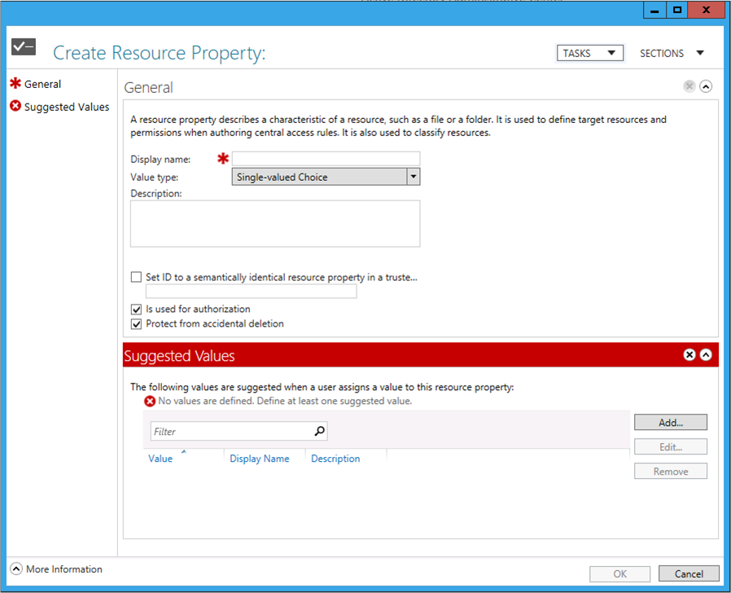
Figure 24 Create New Resource Property dialog from the Active Directory Administrative Center.

Create a Resource Property
Create a new Resource Property using Active Directory Administrative Center
- Start the Active Directory Administrative Center.
- Click Dynamic Access Control in the navigation pane.
- Double-click Resource Properties in the management list.
- From the tasks pane, click New and then click Resource Property.
- Type the name of the Resource Property in the Display name box in the General section of the Create Resource Property dialog.
- Select a logical value type from the Value type list.
- Type a description for the Resource Property in the Description box.
- Select the Set ID to a semantically identical Resource Property in a trusted forest if the Resource Property identifier must match an existing Resource Property identifier from another forest. Type the Resource Property identifier. Clear this check box to generate the identifier automatically.
- Select the Protect from accidental deletion check box to ensure an administrator cannot accidentally delete the Resource Property. Clear the check box to remove accidental deletion protection.
- In the Suggested Values section, click the option you want for suggested values. Create suggested value items as needed.
- Click OK.

Create a Reference Resource Property
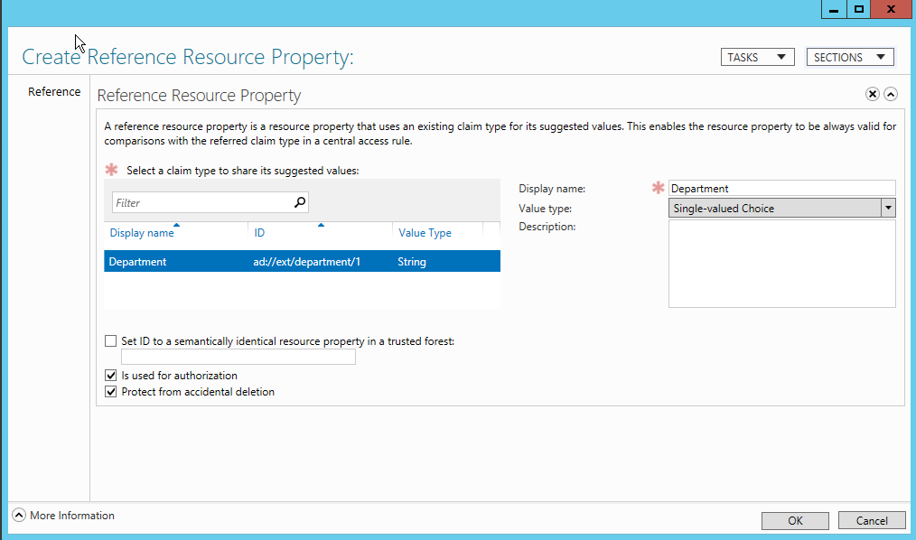
Figure 25 Reference resource property user interface in the Active Directory Administrative Center
Create a new Reference Resource Property using the Active Directory Administrative Center
- Start the Active Directory Administrative Center.
- Click Dynamic Access Control in the navigation pane.
- Double-click Resource Properties in the management list.
- From the tasks pane, click New and then click Resource Property.
- Select the claim type the reference Resource Property will use for its suggested values from the Select a claim type to share its suggested values list.
- Type the name of the reference Resource Property in the Display name box in the General section of the Create Reference Resource Property dialog.
- Type a description for the reference Resource Property in the Description box.
- Select the Set ID to a semantically identical Resource Property in a trusted forest if the reference Resource Property identifier must match a reference Resource Property identifier from another forest. Type the reference Resource Property identifier. Clear this check box to generate the identifier automatically.
- Select the Protect from accidental deletion check box to ensure an administrator cannot accidentally delete the Resource Property. Clear the check box to remove accidental deletion protection.
- Click OK.

Modify a Resource or Reference Resource Property
Modifying attributes on resource and reference Resource Property objects can have some inadvertent ramifications, especially if the Resource Property is a secure Resource Property. In this scenario, a user may be allowed to access a file when they should not. For reasons like this, Windows Server 2012 incorporates some constraints when modifying attributes on Resource Property objects. These constraints limit what you can edit using the Active Directory Administrative Center and Windows PowerShell. However, these limitations ensure that critical portions of the Resource Property remain unaltered, which ensures the Resource Property remains valid for its intended purpose.
You can modify the Display name, Description, and Protect from accidental deletion configuration on resource and reference Resource Property objects. You can also change the enabled and disabled state on both Resource Property types. You can add, edit, and remove suggested values on secure and non-secure Resource Property objects; however, you cannot remove the last suggested value from the list of suggested values. Resource property objects configured to use suggested values must contain at least one suggested value.
Important: | Resource property displays names must be unique. You cannot modify a Resource Property's display name to a display name that already exists.

You cannot modify the Value type, ID, and Is a secure Resource Property attributes of secure or non-secure resource and reference Resource Property objects. Also, you cannot modify suggested values for secure and non-secure reference Resource Property objects because these objects source the suggested values from a claim type object.
Modify a Resource Property using Active Directory Administrative Center
- Start the Active Directory Administrative Center.
- Click Dynamic Access Control in the navigation pane.
- Double-click Resource Properties in the management list.
- Right-click the Resource Property you want to modify and then click Properties.
- Modify the Display name, Description, or Protect from accidental deletion.
- You can modify a Resource Property's suggested values only if the Resource Property is not a reference Resource Property and the Resource Property object's value type supports suggested values. Use the Add button to create a new suggested value item. Use the Edit button to remove a suggested value item. Use the Remove button to delete a suggested value item from the Resource Property.
Important: | A Resource Property object configured with suggested values must contain a minimum of one suggested value items. Therefore, you cannot remove the last suggested value item from a Resource Property configured with suggested values.  To remove all suggested items, you must delete the Resource Property and then create a new Resource Property using a value type that does not require suggested values.

- Click OK to save the modified Resource Property.

Delete a Resource or Reference Resource Property
Delete a Resource Property using Active Directory Administrative Center
- Start the Active Directory Administrative Center.
- Click Dynamic Access Control in the navigation pane.
- Double-click Resource Properties in the management list.
- Right-click the Resource Property you want to delete and then click Delete.
- Click Yes to confirm the claim type deletion.
Tip: | Windows may prompt you with a dialog stating you do not have sufficient permission to delete the Resource Property. If you encounter this dialog, then modify the Resource Property and clear the Protect from accidental deletion check box. If this check box is cleared, then examine the object's security and ensure you have permission to delete the Resource Property.

Enabling and Disabling Resource Property objects
Resource Property objects have two states: disabled and enabled. Disabled resource properties are unavailable for use in production. A Resource Property becomes available for production use once you enable it. The Resource Property is unavailable until you enable it. Windows Server 2012 filters disabled secure Resource Property objects from view in the Advanced Security Settings editor and the conditional expression editor.
To Enable or disable a Resource Property using Active Directory Administrative Center
- Start the Active Directory Administrative Center.
- Click Dynamic Access Control in the navigation pane.
- Double-click Resource Properties in the management list.
- To enable a Resource Property, right-click the disabled Resource Property object you want to enable and then click Enable. To disable a Resource Property, right-click the enabled Resource Property object you want to disable and then click Disable.

Managing Resource and Reference Resource Properties using Windows PowerShell
Many features in Windows Server 2012 provide an alternative way to accomplish a task using Windows PowerShell. You can manage resource and reference Resource Property objects using the New-ADResourceProperty, Set-ADResourceProperty, and Remove-ADResourceProperty Active Directory cmdlets.
Important: | The Advanced Security Settings Editor only displays secure Resource Property objects that are members of the Global Resource Property List (see the Resource Property Lists section). The Active Directory Administrative Center automatically adds newly created Resource Property objects to the Global Resource Property List. If you create Resource Property objects using Active Directory cmdlets, then remember to add the Resource Property to the Global Resource Property List using the Add-ADResourcePropertyListMember cmdlet.

Create a New Resource or Reference Resource Property
Create a Secure Resource Property object using Windows PowerShell
New-ADResourceProperty
-Description:"Identifies the business impact of the resource"
-DisplayName:"Business Impact"
-IsSecured:$true
-ID:"businessImpact_12345678"
-ResourcePropertyValueType:"CN=MS-DS-OrderedList,CN=Value Types,CN=Claims Configuration,CN=Services,CN=Configuration,DC=contoso,DC=com"
-SuggestedValues:@((New-Object Microsoft.ActiveDirectory.Management.ADSuggestedValueEntry(1000, "Low", "Low business impact")), (New-Object Microsoft.ActiveDirectory.Management.ADSuggestedValueEntry(2000, "Medium", "Medium business impact")), (New-Object Microsoft.ActiveDirectory.Management.ADSuggestedValueEntry(3000, "High", "High business impact")))
Note: | The command is displayed on multiple lines for readability. Ensure you type all arguments on a single line when using this command.

Create a Secure Reference Resource Property object using Windows PowerShell
New-ADResourceProperty
-Description:"Identifies the department to which the resource belongs"
-DisplayName:"Department"
-IsSecured:$true
-ResourcePropertyValueType:"CN=MS-DS-MultivaluedChoice,CN=Value Types,CN=Claims Configuration,CN=Services,CN=Configuration,DC=contoso,DC=com"
-ID:"department_12345678"
-SharesValuesWith:"CN=department,CN=Claim Types,CN=Claims Configuration,CN=Services,CN=Configuration,DC=contoso,DC=com"
Note: | The command is displayed on multiple lines for readability. Ensure you type all arguments on a single line when using this command.

Description
Use the Description argument to provide a short description that clarifies the purpose or existence of the Resource Property.

Example
-Description:"This is a Resource Property description."

DisplayName
Use the DisplayName argument to configure the new Resource Property object with a unique name that is used for display purposes.

Example
-DisplayName:"Department"

Enabled
Use the Enabled argument to enable or disable a Resource Property.

Example
-Enabled:$true
-Enabled:$false

ID
Use the optional ID argument to configure the identifier with a semantically identical or custom identifier. Omitting this argument forces Windows PowerShell to generate a unique identifier. An Active Directory Resource Property identifier must conform to a strict naming context. Understand the following constraints when creating a semantically identical or custom Resource Property identifier.
New Resource Property identifiers must:
• Begin with 1 to 15 characters
• Followed by an underscore
• Suffixed with 1 to 15 characters
• May only contain characters that are valid in filenames
You should use automatically generated Resource Property identifiers unless a business need justifies otherwise. This ensures that all newly created Resource Property objects are created with unique identifiers.

Example
-ID:"department_12345678"

IsSecured
Use the IsSecured argument to configure the Resource Property as a secure or non-secure Resource Property. You can use secure Resource Property objects for authorization decisions. You cannot use non-secure Resource Property objects for authorization.

Example
-IsSecured:$true
-IsSecured:$false

ProtectedFromAccidentalDeletion
Use the ProtectedFromAccidentalDeletion argument to enable or disable protection against deletion when an administrator tries to delete the claim type.

Example
-ProtectFromAccidentalDeletion:$true
-ProtectFromAccidentalDeletion:$false

ResourcePropertyValueType
Use the ResourcePropertyValueType argument to configure the Resource Property object's value type. This argument accepts the distinguished name of an msDS-ValueType object.
Value types are logical data types Windows uses to characterize the data stored in the Resource Property. Value types for the forest are stored in the Active Directory configuration partition under CN=Value Types,CN=Claims Configuration,CN=Services. Windows Server 2012 provides the following default logical data types:

Date Time
Resource property objects based on this logical value type based on date and time. You cannot base a secure resource object on the Date Time logical value type. The Active Directory object name for this value type is MS-DS-DateTime.

Multi-valued Choice
Resource property objects based on this logical value type contain multiple suggested values where you can select one or more suggested values to create a list of multiple valid choices. It is important to know that multi-valued choices cannot be compared. The Active Directory object name for this value type is MS-DS-MultivaluedChoice.

Single-valued Choice
Resource property objects based on this logical value type contain multiple suggested values where you can only select one suggested value from the list to create a single choice. Unlike multi-valued choices, single-valued choices can be compared.

Multi-valued Text
Resource property objects based on this logical value type can contain multiple text entries. The Active Directory object name for this value type is MS-DS-MultivaluedText.

Number
Resource property objects based on this logical value type can contain a single number. The Active Directory object name for this value type is MS-DS-Number.

Ordered List
Resource property objects based on this logical value type contain a single choice entry from the list of suggested values that can be compared to other Resource Property objects of the same type. The Active Directory object name for this value type is MS-DS-OrderedList.

Text
Resource property objects based on this logical value type contain a single text entry. The Active Directory object name for this value type is MS-DS-Text.

Yes/No
Resource property objects based on this logical value type contain Boolean values represented as true or false. The Active Directory object name for this value type is MS-DS-YesNo

Example
-ResourcePropertyValueType:"CN=MS-DS-MultivaluedChoice,CN=Value Types,CN=Claims Configuration,CN=Services,CN=Configuration,DC=contoso,DC=com"

Server
Use the optional Server argument to force the responsibility of creating the new claim type to a specific server. Suffix the argument with the fully qualified domain name of the computer you want to create the new claim type.

Example
-Server:"hq-con-dc-01.corp.contoso.com"

SharesValuesWith
Use the SharesValuesWith argument when creating a reference Resource Property. Reference Resource Property objects do not provide their own suggested values, but rather use the suggested values from the claim type object specified in this argument. This argument accepts the distinguished name of a claim type object and becomes the source for suggested values presented for this Resource Property.

Example
-SharesValuesWith:"CN=ad://ext/department/1,CN=Claim Types,CN=Claims Configuration,CN=Services,CN=Configuration,DC=contoso,DC=com"

SuggestedValues
Use the SuggestedValues argument to configure a Resource Property with one or more suggested values. You cannot use the SuggestedValues argument with the SharesValuesWith argument.
Tip: | Understanding how to create a Resource Property object with suggested values using the Active Directory module for Windows PowerShell may require knowledge of Windows PowerShell outside the scope of this document. If you are new to Windows PowerShell, the consider creating Resource Property objects using Active Directory Administrative Center, or consult Microsoft TechNet for more information on Windows PowerShell.

-SuggestedValues:@((New-Object Microsoft.ActiveDirectory.Management.ADSuggestedValueEntry(1000, "Low", "Low business impact")), (New-Object Microsoft.ActiveDirectory.Management.ADSuggestedValueEntry(2000, "Medium", "Medium business impact")), (New-Object Microsoft.ActiveDirectory.Management.ADSuggestedValueEntry(3000, "High", "High business impact")))
The SuggestedValues argument receives a list of SuggestedValueEntry objects. You represent a list in Windows PowerShell by preceding the arguments value with an at-sign (@). Immediately following the at-sign is a beginning and ending parentheses. These parentheses represent all the items included in the list that is passed as a single argument.
As previously mentioned, each item in the list is a SuggestedValueEntry object. You create a single instance of this object using the New-Object Windows PowerShell cmdlet. The syntax for this cmdlet is
New-Object object-type(object-type-argument-1, object-type-argument-2, …)
The object type for a suggested value item reads as Microsoft.ActiveDirectory.Management.ADSuggestedValueEntry. A valid suggested value item contains three parts: a value, a name, and a description. These parts are represented as three object-type arguments that follow the object type name; separated by a comma, and enclosed within parentheses.
(New-Object Microsoft.ActiveDirectory.Management.ADSuggestedValueEntry(1000, "Low", "Low business impact"))
Ensure each New-Object cmdlet resides within an opening and closing parenthesis and that each pair of parentheses including a New-Object cmdlet is separated from the next using a comma. The correct syntax creates a new suggested value item and assigns that item as distinct item in the list of suggested values.

Example
-SuggestedValues:@((New-Object Microsoft.ActiveDirectory.Management.ADSuggestedValueEntry(1000, "Low", "Low business impact")), (New-Object Microsoft.ActiveDirectory.Management.ADSuggestedValueEntry(2000, "Medium", "Medium business impact")))

Modify a Resource or Reference Resource Property
To modify a Resource Property object using Windows PowerShell
Set-ADResourceProperty
-Description:"Identifies the business impact of the resource"
-DisplayName:"Business Impact"
-IsSecured:$true
-ID:"businessImpact_12345678"
-ResourcePropertyValueType:"CN=MS-DS-OrderedList,CN=Value Types,CN=Claims Configuration,CN=Services,CN=Configuration,DC=contoso,DC=com"
-SuggestedValues:@((New-Object Microsoft.ActiveDirectory.Management.ADSuggestedValueEntry(1000, "Low", "Low business impact")), (New-Object Microsoft.ActiveDirectory.Management.ADSuggestedValueEntry(2000, "Medium", "Medium business impact")), (New-Object Microsoft.ActiveDirectory.Management.ADSuggestedValueEntry(3000, "High", "High business impact")))

Description
Use the Description argument to provide a short description that clarifies the purpose or existence of the Resource Property.

Example
-Description:"This is a Resource Property description."

DisplayName
Use the DisplayName argument to configure the Resource Property object with a new unique name that is used for display purposes.

Example
-DisplayName:"Department"

Enabled
Use the Enabled argument to enable or disable a Resource Property.

Example
-Enabled:$true
-Enabled:$false

Identity
Use the Identity argument to specify the Resource Property object on which the Set-ADResourceProperty cmdlet performs the action. A valid identity argument includes the object's display name, name, distinguished name, or globally unique identifier (GUID).

Example
-Identity:"CN=Department_88ce349c3363759e,CN=Resource Properties,CN=Claims Configuration,CN=Services,CN=Configuration,DC=contoso,DC=com"

ProtectedFromAccidentalDeletion
Use the ProtectedFromAccidentalDeletion argument to enable or disable protection against deletion when an administrator tries to delete the Resource Property object.

Example
-ProtectFromAccidentalDeletion:$true
-ProtectFromAccidentalDeletion:$false

Server
Use the optional Server argument to force the responsibility of modifying the Resource Property object to a specific server. Suffix the argument with the fully qualified domain name of the computer you want to perform the action.

Example
-Server:"hq-con-dc-01.corp.contoso.com"

SharesValuesWith
Use the SharesValuesWith argument to configure the reference Resource Property to reference a claim type object from which the reference Resource Property receives its suggested values. The argument accepts the distinguished name of the claim type object that is configured with suggested values. You can use the SharesValuesWith argument provided you are not using the SuggestedValues argument. Reference Resource Property objects are not configured with their own suggested values.

Example
-SharesValuesWith:"CN=ad://ext/department/1,CN=Claim Types,CN=Claims Configuration,CN=Services,CN=Configuration,DC=contoso,DC=com"

SuggestedValues
Use the SuggestedValues argument to configure a Resource Property with one or more suggested values. You cannot use the SuggestedValues argument with the SharesValuesWith argument.
Tip: | Understanding how to create a Resource Property object with suggested values using the Active Directory module for Windows PowerShell may require knowledge of Windows PowerShell outside the scope of this document. If you are new to Windows PowerShell, then consider creating Resource Property objects using Active Directory Administrative Center, or consult Microsoft TechNet for more information on Windows PowerShell.

-SuggestedValues:@((New-Object Microsoft.ActiveDirectory.Management.ADSuggestedValueEntry(1000, "Low", "Low business impact")), (New-Object Microsoft.ActiveDirectory.Management.ADSuggestedValueEntry(2000, "Medium", "Medium business impact")), (New-Object Microsoft.ActiveDirectory.Management.ADSuggestedValueEntry(3000, "High", "High business impact")))
The SuggestedValues argument receives a list of SuggestedValueEntry objects. You represent a list in PowerShell by preceding the arguments value with an at-sign (@). Immediately following the at-sign is a beginning and ending parentheses. These parentheses represent all the items included in the list that is passed as a single argument.
As previously mentioned, each item in the list is a SuggestedValueEntry object. You create a single instance of this object using the New-Object Windows PowerShell cmdlet. The syntax for this cmdlet is
New-Object object-type(object-type-argument-1, object-type-argument-2, …)
The object type for a suggested value item reads as Microsoft.ActiveDirectory.Management.ADSuggestedValueEntry. A valid suggested value item contains three parts: a value, a name, and a description. These parts are represented as three object-type arguments that follow the object type name; separated by a comma, and enclosed within parentheses.
(New-Object Microsoft.ActiveDirectory.Management.ADSuggestedValueEntry(1000, "Low", "Low business impact"))
Ensure each New-Object cmdlet resides within an opening and closing parenthesis and that each pair of parentheses including a New-Object cmdlet is separated from the next using a comma. The correct syntax creates a new suggested value item and assigns that item as distinct item in the list of suggested values.

Example
-SuggestedValues:@((New-Object Microsoft.ActiveDirectory.Management.ADSuggestedValueEntry(1000, "Low", "Low business impact")), (New-Object Microsoft.ActiveDirectory.Management.ADSuggestedValueEntry(2000, "Medium", "Medium business impact")))

Delete a Resource or Reference Resource Property
You can delete Resource Property objects using the Remove-ADResourceProperty Active Directory cmdlet. You identify configuration options by passing arguments to the cmdlet.
Delete a claim type using Windows PowerShell
Remove-ADResourceProperty
-Identity:"Department_88ce349c3363759e,CN=Resource Properties,CN=Claims onfiguration,CN=Services,CN=Configuration,DC=contoso,DC=com"

Identity
Use the Identity argument to specific the Resource Property object on which the Remove-ADResourceProperty cmdlet performs the action. A valid identity argument includes the object's display name, name, distinguished name, or globally unique identifier (GUID).

Example
-Identity:"CN=Department_88ce349c3363759e,CN=Resource Properties,CN=Claims onfiguration,CN=Services,CN=Configuration,DC=contoso,DC=com"

Server
Use the optional Server argument to force the responsibility of removing the Resource Property object to a specific server. Suffix the argument with the fully qualified domain name of the computer you want to create the new claim type.

Example
-Server:"hq-con-dc-01.corp.contoso.com"

Enabling and Disabling a Resource Property
An alternative to deleting Resource Property objects is disabling them. Resource property objects have two states: disabled and enabled. Disabled Resource Property objects are unavailable for use in production. A Resource Property object becomes available for production use once you enable it. Until it is enabled, a disabled Resource Property is filtered from view in the Advanced Security Settings editor, conditional expression editor, and Explorer Classification tab. By default, the Active Directory Administrative Center enables all newly created Resource Property objects.
You can enable and disable Resource Property objects using the Set-ADResourceProperty Active Directory cmdlet.
To disable a Resource Property using Windows PowerShell
Set-ADResourceProperty
-Identity:"CN=Department_88ce349c3363759e,CN=Resource Properties,CN=Claims Configuration,CN=Services,CN=Configuration,DC=contoso,DC=com"
-enabled:$false
To enable a Resource Property using Windows PowerShell
Set-ADClaimType
-Identity:"CN=Department_88ce349c3363759e,CN=Resource Properties,CN=Claims onfiguration,CN=Services,CN=Configuration,DC=contoso,DC=com"
-enabled:$true

Resource Property Lists
Resource property lists provide a way to logically group Resource Property objects. Logically grouping Resource Property objects through Resource Property lists provides an easy and efficient way to assign a selective set of Resource Property objects for use with a specific file server. By default, Windows Server 2012 creates one default Resource Property object named the Global Resource Property List. You can create multiple Resource Property list objects, and you can assign a Resource Property object to one or more lists. Then, using Group Policy, you can configure Windows Server 2012 file servers to use a specific Resource Property list.
The Global Resource Property List is the default Resource Property list used for an Active Directory forest. A Windows Server 2012 file servers can use multiple Resource Property lists. However, the new Advanced Security Settings and conditional expression editors only display secure Resource Property objects that are members of the Global Resource Property List object. Non-secure Resource Property objects are not displayed in these editors. Therefore, if you want to use a Resource Property object for authorization decisions, then you must ensure you add that Resource Property object to the Global Resource Property List.

Managing Resource Property List Membership
You manage Resource Property object membership using the Active Directory Administrative Center or by using the Active Directory module for Windows PowerShell.
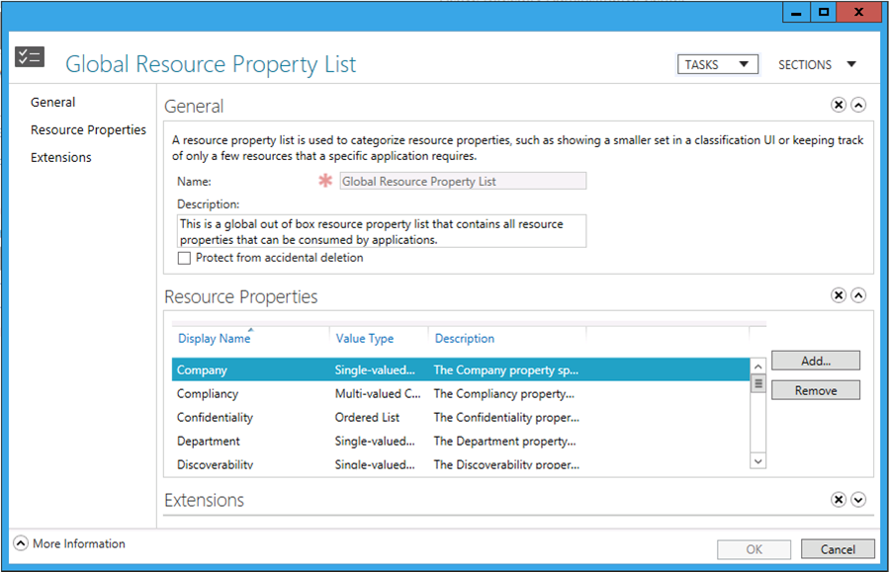
Figure 26 Resource Property List dialog from the Active Directory Administrative Center.

Resource Property List Management using the Active Directory Administrative Center
To add Resource Property to the Global Resource Property List object using Active Directory Administrative Center
- Start the Active Directory Administrative Center.
- Click Dynamic Access Control in the navigation pane.
- Double-click Global Resource Properties List in the management list.
- Right-click the Resource Property you want to modify and then click Properties.
- From the Global Resource Property List dialog, click Add from the Resource Properties section.
- From the Select Resource Properties dialog, click the Resource Property object you want to add to the list. You can hold down the CTRL key and click to choose more than one Resource Property object. Click the right facing double arrow button to add the selected Resource Property objects to the Add the following resource properties list.
- Click OK. Click OK again to return the list of Resource Property list objects.

To remove a Resource Property from the Global Resource Property List object using Active Directory Administrative Center
- Start the Active Directory Administrative Center.
- Click Dynamic Access Control in the navigation pane.
- Double-click Global Resource Properties List in the management list.
- Right-click the Resource Property you want to modify and then click Properties.
- From the Global Resource Property List dialog, click Resource Property object you want to remove from the list. You can hold down the CTRL key and click to choose more than one Resource Property object.
- Click Remove.
- Click OK. Click OK again to return the list of Resource Property list objects.

Resource Property List Management using Active Directory Windows PowerShell
Alternatively, you can use the Active Directory module for Windows PowerShell to manage Resource Property Lists. You use Add-ADResourcePropertyListMember to add a Resource Property object to a Resource Property list. You use Remove-ADResourcePropertyListMember to remove a Resource Property object from a Resource Property list.
To add a Resource Property to the Global Resource Property List using Windows PowerShell
Add-ADResourcePropertyListMember
-Identity:"CN=Global Resource Property List,CN=Resource Property Lists,CN=Claims Configuration,CN=Services,CN=Configuration,DC=contoso,DC=com"
-Members:"CN=Department_88ce349c3363759e,CN=Resource Properties,CN=Claims Configuration,CN=Services,CN=Configuration,DC=contoso,DC=com"
To remove a Resource Property from the Global Resource Property List using Windows PowerShell
Remove-ADResourcePropertyListMember
-Identity:"CN=Global Resource Property List,CN=Resource Property Lists,CN=Claims Configuration,CN=Services,CN=Configuration,DC=contoso,DC=com"
-Members:"CN=Department_88ce349c3363759e,CN=Resource Properties,CN=Claims Configuration,CN=Services,CN=Configuration,DC=contoso,DC=com"
The following arguments are common between the Add-ADResourcePropertyListMember and Remove-ADResourcePropertyListMember cmdlets.

Identity
Use the Identity argument to specific the Resource Property list object that is the target of the add or remove operation. A valid identity argument includes the object's display name, name, distinguished name, or globally unique identifier (GUID).

Example
-Identity:"CN=Global Resource Property List,CN=Resource Property Lists,CN=Claims Configuration,CN=Services,CN=Configuration,DC=contoso,DC=com"

Members
Use the Members argument to identify one or more Resource Property objects that the cmdlet adds or removes from the Resource Property list object specified with the Identity argument. A valid members argument includes the object's display name, name, distinguished name, or globally unique identifier (GUID).
-Members:"CN=Department_88ce349c3363759e,CN=Resource Properties,CN=Claims Configuration,CN=Services,CN=Configuration,DC=contoso,DC=com"

Server
Use the optional Server argument to force the responsibility of removing the Resource Property object to a specific server. Suffix the argument with the fully qualified domain name of the computer you want to create the new claim type.

Example
-Server:"hq-con-dc-01.corp.contoso.com"
To add multiple Resource Property objects to the Global Resource Property List using Windows PowerShell
Add-ADResourcePropertyListMember
-Identity:"CN=Global Resource Property List,CN=Resource Property Lists,CN=Claims Configuration,CN=Services,CN=Configuration,DC=contoso,DC=com"
-Members:"CN=Company_MS,CN=Resource Properties,CN=Claims Configuration,CN=Services,CN=Configuration,DC=contoso,DC=com", "CN=Compliancy_MS,CN=Resource Properties,CN=Claims Configuration,CN=Services,CN=Configuration,DC=contoso,DC=com"

Populating Claim Sources and Resource Properties with Information
It is important to understand how to configure claim information on user and computer objects. Equally important is how to manually classify files and folders using resource properties. Understanding the concepts related to automatically classify files and folders using near real-time file classification using Windows Server 2012 File Server Resource Manager (FSRM) can help with deciding the best file classification strategy.

Adding Claim Information to Users and Computers
User and computer objects must contain information for a Windows Server 2012 domain controller to issue a claim. Creating an attribute or certificate-based claim type in Active Directory simply make the forest aware of the claim type; however, it does not provide the all the information that is contained in the actual claim.
Attribute-based claim-type objects are based on attributes defined in the Active Directory Schema. These attributes are common among many objects-- most importantly user and computer objects. The claim type object is the configuration used to define what attributes the domain controller uses when creating claims for users and computers.
In simple terms, a user or computer authenticates to a domain controller. The domain controller needs to build the security principal's TGT once the user or computer authenticates successfully. The domain controller determines if the authentication request can support claims. Upon successfully determining claims support, the domain controller then reads the authenticating principal's Active Directory forest for all enabled claim types, and maps those claim types to the attributes on the authenticating user or computer. The domain controller then retrieves this information from the mapped attributes, creates claims based on those attributes, and inserts those claims into the authenticating principal's TGT.
Certificate-based claims work in a similar manner. For example, a user authenticates with a smartcard using a certificate. The certificate used for authentication contains an issuance policy, which contains an object identifier (OID) that uniquely identifies the issuance policy. The domain controller extracts this OID from the authentication certificate and then reads the user's Active Directory forest for a certificate-based claim type that uses this OID as the claim's source. If present, then the domain controller issues the claim for the authenticating user.
A Windows Server 2012 domain controller does not issue blank claims. This means that it is possible for you to configure and enabled claim in Active Directory and the domain controller not issue the claim during authentication. Remember, a claim type object only maps claim information to a source object or certificate. The information present in the attribute for the user or computer is the actual contents, or value, of the issued claim. The claim identifier and name are defined in the claim type object. Therefore, a Windows Server 2012 domain controller does not issue a claim for a claim type object sourced from the Active Directory attribute when the attribute for the authenticating user or computer does not contain information.
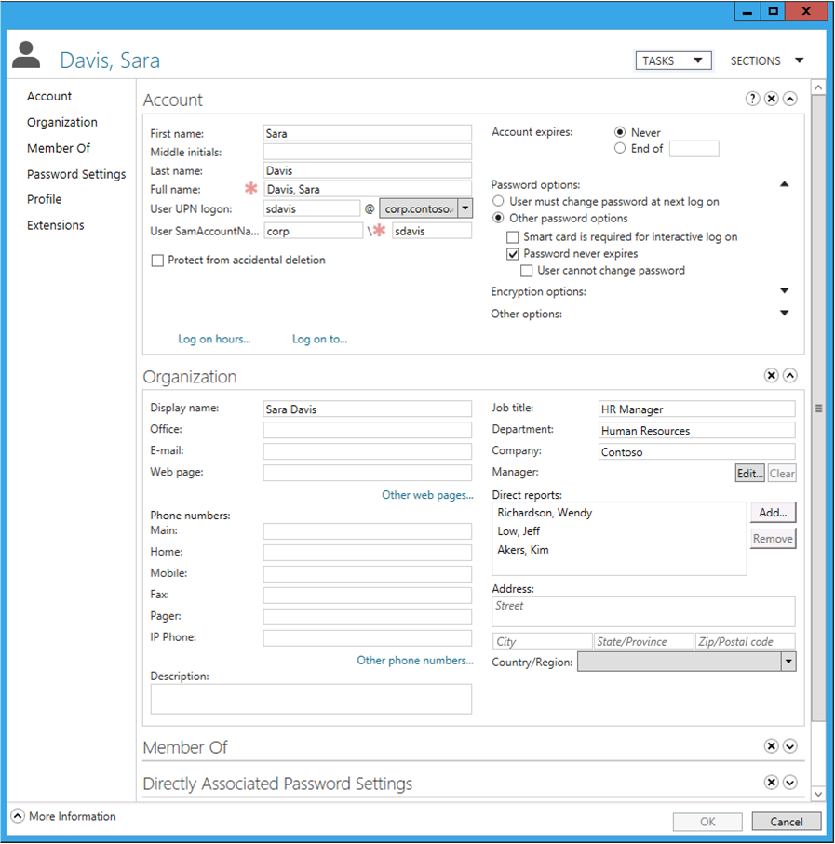
Figure 27 User properties for Sara Davis in the Active Directory Administrative Center.
Figure 19 shows the properties for the user Sara Davis. Sara's user object has many attributes that contain information. The organization section for the user account displays values for the Display Name, Job Title, Department, and Company Active Directory attributes. An attribute-based claim type object sourced from any of these attributes produces a claim for Sara Davis when she authenticates from a Windows 8 computer to a domain running a Windows Server 2012 domain controller that is claim enabled. However, an attribute-based claim type object sourced from the email address attribute would not produce a claim for Sara Davis because the email attribute for her user object does not contain any information.
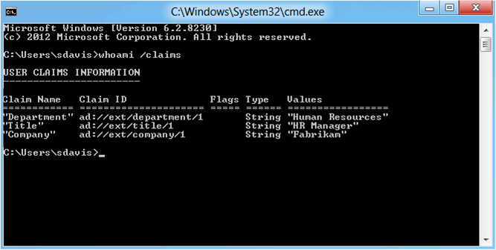
Figure 28 WHOAMI /CLAIMS output for the user Sara Davis.

Classify Files and Folders
Resource properties allow you to configure assertions about files or folders. These assertions are represented as the values stored within a Resource Property. Windows stores resource properties and their values in an alternate data stream on the file and folder. This ensures the assertions configured on a specific file or folder remains on the file as it is copied or moved from one NTFS file system to another.
Resource properties use the file classification infrastructure to allow you to configure files with metadata describing the file or how it may be used. You can use this metadata for compliance reporting, disk quotas, or authorization decisions.
Adding values to resource properties on a file or folder is known as classification. You can classify files and folders two ways using Windows Server 2012. The first way to classify files and folders is by using the Classification tab found on the properties of a file or folder when using Windows Explorer. The second way is continuous classification, which you configure through classification rules using the File System Resource Manager.

Manual Classification
You configure manual classification using Windows Explorer. You located the classification tab by viewing the properties of a file and folder.
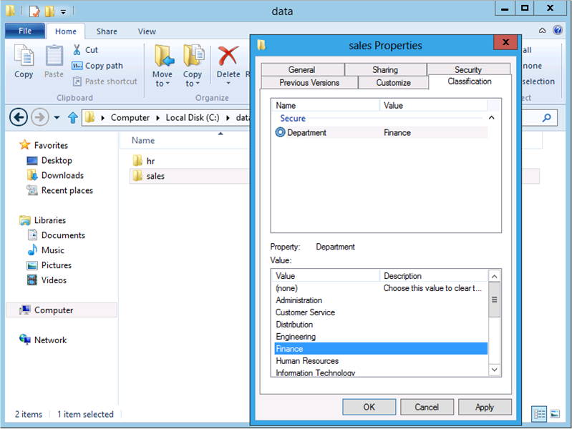
Figure 29 File Classification tab using Windows Explorer.
The manual classification tab has two lists. The top list is the list of Resource Property objects that are available for configuration on the file and folder. Windows displays the current value of the Resource Property to the right of the property name. Windows shows the value none for the resource properties that are not configured. Windows populates this list by reading the Resource Property list configured for this computer. By default, the user interface uses all the Resource Property objects that are members of the Global Resource Property List. You can configure the computer to use a specific Resource Property list using the computer Group Policy setting File Classification Infrastructure: Specify Classification Property List.
The bottom list is the list of suggested values for the selected Resource Property. Windows reads the suggested values displayed in this list from the suggested values configured on the Resource Property object, or from the attribute-based claim type object with which the suggested reference resource object shares its suggested values.
You manually classify the file by clicking the Resource Property from the list of properties and then click the value you want to assign to the Resource Property. Multi-choice resource properties provide checkboxes that allow you to select one or more values. Text-based resource properties provide a textbox in which you can manually type the Resource Property's value.
Note: | The classification tab appears after you install the File Server Resource Manager role service from the File Services role. Alternatively, you can install the Desktop Experience on Windows Server 2012 and enable the computer policy setting File Classification Infrastructure: Display Classification tab in Windows Explorer.

To Manually Classify a file
- Open Windows Explorer.
- Browse to the folder that contains the file you want to classify.
- Right-click the file name and then click Properties.
- Click the Classification tab.
- Click the Resource Property you want to configure from the list of resource properties.
- Click the suggested value you want the Resource Property to use. For multi-valued resource properties, select each checkbox next to the suggested value you want the Resource Property to use. For text-based resource properties, type the value you want the Resource Property to use.
- Repeat steps 5 and 6 until you have configured all the resource properties needed for the file.
- Click OK.

Continuous File Classification
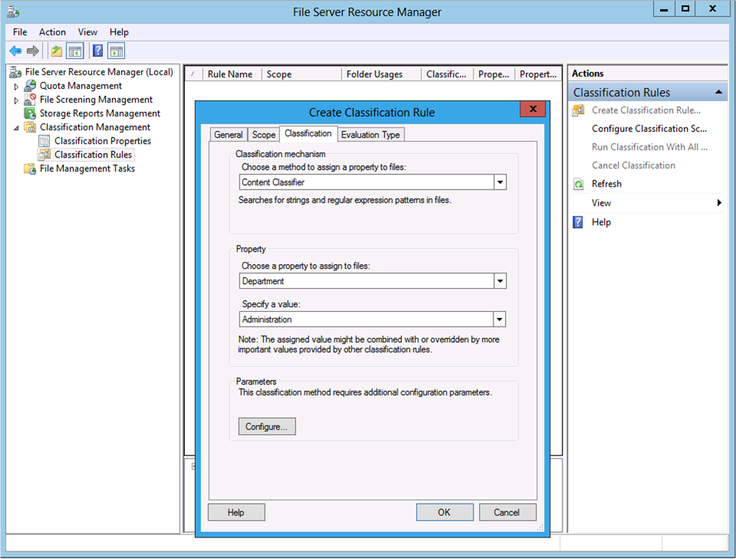
Figure 30 File Classification in the File Server Resource Manager.
Continuous file classification active performs file and folder classification on a file server with little administrator intervention. You configure continuous file classification using the File Server Resource Manager. You can install the File Server Resource Manager role service from the File Service role within Server Manager. The File Server Resource Manager allows you to:
- Define classification properties and values, also known as resource properties, which you then assign to files through classification rules.
- Create, update, and run classification rules where each rule assigns a single property and value to files within a specified directory.

Advanced Security Settings and Conditional Expressions
Windows Server 2012 and Windows 8 introduce a new user interface for managing advanced security settings on files and folders. The security settings editor is the entry point for configure access and auditing for resources hosted on Windows. The advanced portion of the security settings editor provided richer configuration options for authorization and auditing.
The Advanced Security Settings dialog in Windows Server 2012 enhances the existing configuration experience by allowing you to include conditional expressions for authorization and auditing on the file system from a Windows Server 2012 or Windows 8 computer.
Windows stores conditional expressions in permission entries, which are stored in permission entry lists. Windows understands two types of lists: a permissions entry list and an audit entry list. Both lists are stored together with additional security metadata, such as a security identifier (SID) that is representative as an owner, in a security descriptor. Security descriptors are stored with the resource and play a critical role in how Windows determines what users or groups can access the resource, what user or group owns the resource, and how Windows audits access to the resource for a particular user or group.
You can use conditional permission entries to protect file system resources based on the user's department attribute, their cost center, or their country. Also, by using device claims, you can further control authorization and auditing to file system resources based on properties of the computer from which they are accessing the resource, or if the user authenticated using a smartcard.

Advanced Security Settings
The Advanced Security Settings dialog provides you with a rich administrative experience by providing more control over how you configure authorization and auditing. The new Advanced Security Settings dialog shows the name of the resource as well as the user or group that owns the resource. Lastly, the Advanced Security Settings dialog hosts four tabs and their associated configuration components. These tabs are labeled Permissions, Auditing, Effective Access, and Share
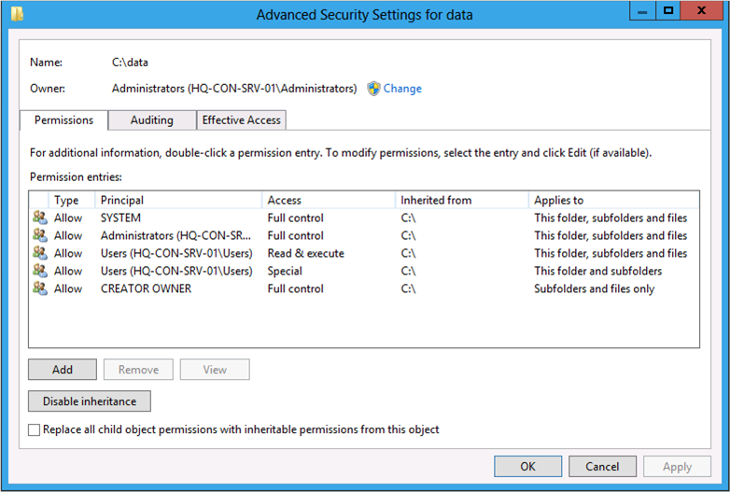
Figure 31 Advanced Security Settings editor

Name
The Name label shows the name of the resource that contains the displayed security information.

Owner
The owner listed in a security descriptor identifies the security principal whom Windows believes owns the resource for security purposes. Typically, the security principal that creates the resource becomes the owner of the resource. You can think of the security descriptor owner as an administrator for just the object they own. Owners can modify permissions of resources they own. Additionally, some features in Windows, like disk quotas, use the security descriptor owner to determine how much drive space a user or group uses.
To change the Owner of a file or folder
- Open Windows Explorer.
- Browse to the file or folder to which you want to change ownership.
- Right-click the file or folder and then click Properties.
- Click the Security tab and then click Advanced.
- Click Change (this step requires elevated access and prompt for consent).
- From the Select User, Computer, Service Account, or Group dialog box, type the name of the user or group to which you want to transfer ownership. Click Check Names to validate the user or group exists in Active Directory and then click OK.
- Click OK to apply the ownership to the new user.
Important: | You must be a local administrator of the file server have membership in the Backup Operators group to transfer ownership to security principal other than yourself. Membership in these groups provides you with the proper privileges to perform this operation.

Permissions
The Permissions tab in the Advanced Security Settings dialog provides the view of the permission entries for the file or folder and the user interface you use to manage them.

Permissions Entry List
A permissions entry list contains a list of permission entries that Windows uses to determine access. The Advanced Security Settings dialog shows the list permission entries. The list contains column headers that describe the properties of each permission entry in the list.

Column descriptions

Type
There are two types of permission entries: allow and deny. A permission entry type determines the access provided to the resource when Windows determines the permission entry is applicable to the security principal. Allow grants the security principal the associated access to the resource while deny disallows the security principal the associated access to the resource.

Principal
The Principal column identifies the security principal to which the permission entry applies. Security principals can be a user, group, or computer. The permission entry stores the security principal as a security identifier (SID). The Advanced Security Settings dialog translates the SID of the user into its name and displays the name in the Principal column.

Access
You configure each permission entry to contain one or more permissions that Windows allows or disallows to the resource. Do not confuse permission access with permissions type. The permission entry type determines if Windows allows or disallows the permission. A permission entry's access defines the actions Windows allows or disallows to the security principal when using the resource.
The Advanced Security Settings dialog shows the basic permissions for a file or folder in the Access column. Basic permissions is a combination of specific advanced permissions used to determine what Windows allows or disallows through basic permissions.
For example, the Advanced Security Settings dialog displays basic Read access in the Access column for a given permission entry. The basic Read permission contains five advanced permissions:
- Traverse folder/execute file
- List folder/read data
- Read attributes
- Read extended attributes
- Read permissions.
Windows maps a user's actions on a file into advanced permissions that it either allows or disallows. Therefore, Windows bundles these advanced permissions into a single basic permission to ease administration.
Windows defines the six basic permissions you can use to allow or disallow access to the file system. Basic permissions for a permission entry include:
- Full Control
- Modify
- Read & Execute
- Read
- Write
- Special Permissions
The Advanced Security Settings dialog shows basic permissions in the Access column. You can view a permission entry's advanced permissions by using the View button and the Show advanced permissions link from the Permission Entry dialog box.

Condition
The Condition column appears in the Advanced Security Settings dialog when one or more permission entries contain conditional expressions. This column shows the conditional expressions included for the permission entry. Remember, conditional expressions authored directly on the file or folder have the same inheritance behavior as a permission entry without a conditional expression. Therefore, files and folders below the folder may show the Condition column because of inheritance.

Inherited from
Inherited permissions entries are common on resources that are natively follow a hierarchical fashion, such as the NTFS file system. Inheritance occurs when permission entries configured at the top of the hierarchy flow down to lower entities of the hierarchy. Lower entities now have permission entries inherited from the top of the hierarchy and permission entries assigned directly to the entity. This behavior establishes two types of permission entries: explicit and inherited.
Explicit permission entries are permission entries that you configure directly on the resource, in this instance a file or folder. A file inherits permission entries from the folder in which it resides because there is a parent-child relationship between the file and the folder. When you move the file to a different folder, the inherited permission entries for that file change to reflect the new parent-child relationship; however, the explicit permission entries remain with the file. When a scenario arises, where an inherited permission entry conflicts with an explicit permission entry-- the explicit permission entry prevails.
The Inherited from column shows the resource from which the permission entry is inherited. The permission is an explicit permission entry when the column displays None. Otherwise, the column displays name of the resource that is the source of the inherited permission entry.

Applies to
The Applies to column appears in the Advanced Security Settings dialog when the current resource can act like a parent in a parent-child relationship, for example a folder on the file system. These types of resources are commonly referred to as container resources. You configure explicit permission entries on container resources just as you would on a non-container resource. However, with container resources, you can configure how inherited permission entries should flow from the parent resource to the child resources.
The Applies to column shows the inheritance options for each permission entry: inherited or explicit. However, you can only edit how permission entries propagate on explicit permission entries.
Table 12 Inheritance propagation descriptions
Inheritance Propagation Description | Behavior Explanation
This folder only | This configuration option applies the permission entry to the current folder, but prevents Windows from propagating the permission entry to any child objects.
This folder, subfolders and files | This configuration option applies the permission entry to the current folder and propagates the permission entry to all child objects.
This folder and subfolders | This configuration option applies the permission entry to the current folder and propagates the permission entry to all child folders.
This folder and files | This configuration option applies the permission entry to the current folder and propagates the permission entry to all child files.
Subfolder and files only | This configuration option does not apply the permission entry to the current folder; however, it does propagate the permission entry to all child objects.
Subfolders only | This configuration option does not apply the permission entry to the current folder; however, it does propagate the permission entry to all child folders.
Files only | This configuration option does not apply the permission entry to the current folder; however, it does propagate the permission entry to all child files.

Important: | Regardless of the inheritance propagation configuration, files and folders that have inheritance disabled do not receive any inherited permission entries. You can override this behavior by using the Replace all child object permissions with inheritable permissions from this object.

Add
Use the Add button to create a new explicit permission entry on the current resource.

Remove
Use the Remove button to remove the select permission entry from the list of permissions. You can only remove explicit permission entries using the Remove button. Use the Disable inheritance button to remove inherited permission entries.

Edit
Use the Edit button to modify the selected permission entry from the list of permissions. You can only edit explicit permission entries using the Edit button. If you do not see the Edit button, or you see the View button, then the select permission entry may be an inherited permission entry.

View
The View button replaces the Edit button when the selected permission entry is an inherited permission. This allows you to inspect the permission entry, but prevents changes to the entry.

Disable inheritance
Use the Disable inheritance button to prevent the current resource from inheriting permission entries from any resource locate above it.
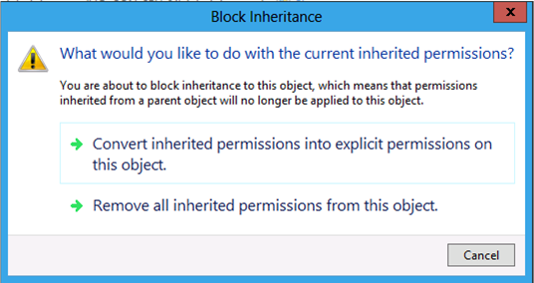
Figure 32 Block Inheritance dialog
Windows displays the Block Inheritance dialog box when you click the Disable inheritance button. From this dialog box, you decide if the currently inherited permission entries are converted to explicit permission entries, or if the access control editor removes all inherited permission entries from the resource.

Replace all child object permissions with inheritable permissions from this object
Use the Replace all child object permissions with inheritable permissions from this object checkbox when you want enable inheritance on all child objects of the parent resource. This action replaces all the explicit permissions on child objects with the inherited permissions from the parent and overrides any inheritance blockers

Permission Entry Dialog
The Advanced Security Settings dialog shows the Permission Entry dialog when you click the Add or Edit button. You use this dialog to configure the settings that make a permission entry.
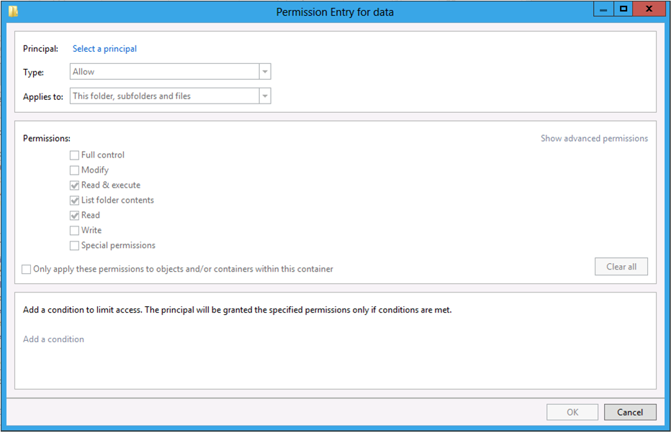
Figure 33 Permission Entry editor from the Advanced Security Settings editor.

Principal
The Principal column identifies the security principal to which the permission entry applies. Security principals can be a user, group, or computer. The permission entry stores the security principal as a security identifier (SID). The Advanced Security Settings dialog translates the SID of the user into its name and displays the name in the Principal column. Use the Select a principal link to choose a different security principal to which the permission entry applies.

Type
There are two types of permission entries: allow and deny. A permission entry type determines the access provided to the resource when Windows determines the permission entry is applicable to the security principal. Allow grants the security principal the associated access to the resource while deny disallows the security principal the associated access to the resource.
 Warning: | Using the Deny access type can cause unexpected access problems. Only use the Deny access type when it is necessary.

Permissions
The Permission section of the Permission Entry describes the basic and advanced permissions for the permission entry. You configure each permission entry to contain one or more permissions that Windows uses to allow or disallow access to the resource. Do not confuse permissions with permission type. The permission entry type determines if Windows allows or disallows the configured permissions. A permission entry's permissions define the access Windows allows or disallows to the security principal when using the resource.
The Permission Entry dialog shows the basic permissions for a file or folder. Basic permissions are a combination of specific advanced permissions used to determine the overall access of the basic permission.
For example, the Permission Entry dialog shows the basic Read permission. The basic Read permission contains five advanced permissions:
- Traverse folder/execute file
- List folder/read data
- Read attributes
- Read extended attributes
- Read permissions.
Windows maps a user's actions on a file into advanced permissions that it either allows or disallows. Therefore, Windows bundles these advanced permissions into a single basic permission to ease administration.
Windows defines the six basic permissions that you can use to allow or disallow access to the file system. Basic permissions for a permission entry include:
- Full Control
- Modify
- Read & Execute
- Read
- Write
- Special Permissions
Note: | Use the basic permissions when protecting resources whenever possible. Only use advanced permissions when application or business process justifies their use.

Click Show advanced permissions to change the permission section to show the permission entry's advanced permissions. Click Show basic permissions to change the permission section to show the permission entry's basic permission.

Clear all
Use the Clear all button to remove all access from the permission entry.

Apply these permissions to objects and/or containers within this container only
Use this configuration setting when you want to limit inheritance propagation to only one level. Selecting this box changes the scope of inheritance to single level below the targeted resource.

Auditing
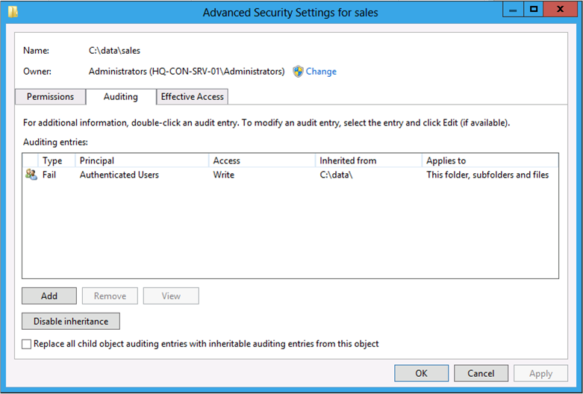
Figure 34 Audit Entry List viewed from the Advanced Security Settings editor.

Audit Entry List
The audit entry list contains a list of audit entries that Windows uses to determine how it audits access to a resource. The Advanced Security Settings dialog shows the list audit entries. The list contains column headers that describe the properties of each permission entry in the list.

Column descriptions

Type
There are three types of audit entries: success, failure, and all. An audit entry type determines how Windows audits the access to the resource when it determines the audit entry is applicable to the security principal. The success audit type only audits successful access to the resource. The failure audit type only audits failed access to the resource. The all audit type audits successful and failed access to the resource.

Principal
The principal column identifies the security principal to which the audit entry applies. Security principals can be a user, group, or computer. The audit entry stores the security principal as a security identifier (SID). The Advanced Security Settings dialog translates the SID of the user into its name and displays the name in the Principal column.

Access
You configure each audit entry to contain one or more permissions that Windows audits. Permissions define the actions a security principal can performed when using the resource, such as read or write.
The Advanced Security Settings dialog shows the basic permissions Windows audits for a file or folder in the Access column. A basic permission is a combination of specific advanced permissions used to perform the basic permission's action.
For example, the Advanced Security Settings dialog shows the basic Read permission in the Access column. The basic Read permission contains five advanced permissions:
- Traverse folder/execute file
- List folder/read data
- Read attributes
- Read extended attributes
- Read permissions.
Windows maps a user's actions on a file into advanced permissions that it audits for success, failures, or both. Therefore, Windows bundles these advanced permissions into a single basic permission to ease administration.
Windows defines the six basic permissions that you can use for auditing access to the file system. Basic permissions for a audit entry include:
- Full Control
- Modify
- Read & Execute
- Read
- Write
- Special Permissions
Note: | Use the basic permissions when protecting resources whenever possible. Only use advanced permissions when application or business process justifies their use.

The Advanced Security Settings dialog shows the basic permission in the Access column. You can view the advanced permissions of the audit entry by using the View button and the Show advanced permissions link from the Auditing Entry dialog box when the selected audit entry is an inherited audit entry.

Condition
The Condition column appears in the Advanced Security Settings dialog when one or more audit entries contain conditional expressions. This column shows the conditional expressions included for the audit entry. Remember, conditional expressions authored directly on the file and folders inherit the same as an audit entry without a conditional expression. Therefore, files and folders below the folder may show the Condition column because of inheritance.

Inherited from
Inherited audit entries are common on resources that are natively constructed in a hierarchical fashion, such as the NTFS file system. Inheritance occurs when audit entries configured at the top of the hierarchy flow down to lower entities of the hierarchy. Lower entities now have audit entries inherited from the top of the hierarchy and audit entries assigned directly to the entity. This behavior establishes two types of audit entries: explicit and inherited.
Explicit audit entries contain auditing permissions that you configure directly on the resource, in this instance a file or folder. A file inherits audit entries from the folder in which it resides because there is a parent-child relationship between the file and the folder. When you move the file to a different folder, the inherited audit entries for that file change to reflect the new parent-child relationship; however, the explicit audit entries remain with the file. When a scenario arises where an inherited audit entry conflicts with an explicit audit entry-- the explicit audit entry prevails.
The Inherited from column shows the resource from which the audit entry is inherited. The audit entry is explicitly set on the resource when the column displays None. Otherwise, the column displays name of the resource that is the source of the inherited audit entry.

Applies to
The Applies to column appears in the Advanced Security Settings dialog when the current resource can act as the parent in a parent-child relationship, for example a folder on the file system. These types of resources are commonly referred to as container resources. You configure explicit audit entries on container resources in the same fashion as non-container resource. However, with container resources, you can configure how inherited audit entries should flow from the parent resource to the child resources.
The Applies to column shows the inheritance options for each audit entry, inherited or explicit. However, you can only edit how audit entries propagate on explicit audit entries
Table 13 Auditing inheritance propagation descriptions
Inheritance Propagation Description | Behavior Explanation
This folder only | This configuration option applies the audit entry to the current folder, but prevents Windows from propagating the audit entry to any child objects.
This folder, subfolders and files | This configuration option applies the audit entry to the current folder and propagates the audit entry to all child objects.
This folder and subfolders | This configuration option applies the audit entry to the current folder and propagates the audit entry to all child folders.
This folder and files | This configuration option applies the audit entry to the current folder and propagates the audit entry to all child files.
Subfolder and files only | This configuration option does not apply the audit entry to the current folder; however, it does propagate the audit entry to all child objects.
Subfolders only | This configuration option does not apply the audit entry to the current folder; however, it does propagate the audit entry to all child folders.
Files only | This configuration option does not apply the audit entry to the current folder; however, it does propagate the audit entry to all child files.

Important: | Regardless of the inheritance propagation configuration, files and folders that have inheritance disabled do not receive any inherited audit entries. You can override this behavior by using the Replace all child object auditing entries with inheritable permissions from this object.

Add
Use the Add button to create a new explicit audit entry on the current resource.

Remove
Use the Remove button to remove the selected audit entry from the list of entries. You can only remove explicit audit entries using the Remove button. Use the Disable inheritance button to remove inherited audit entries.

Edit
Use the Edit button to modify the selected audit entry from the list of entries. You can only edit explicit audit entries using the Edit button. If you do not see the Edit button, or you see the View button, then the select audit entry may be an inherited audit entry.

View
The View button replaces the Edit button when the selected audit entry is an inherited audit entry. This allows you to inspect the audit entry, but prevents changes to the entry.

Disable inheritance
Use the Disable inheritance button to prevent the current resource from inheriting audit entries from any resources locate above it.
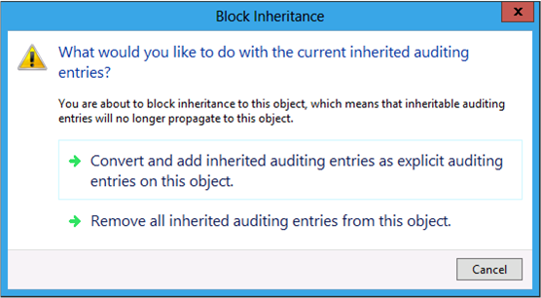
Figure 35 Block Inheritance dialog for auditing.
Windows displays the Block Inheritance dialog box when you click Disable inheritance. From this dialog box, you decide if the currently inherited audit entries are converted to explicit audit entries, or if the Advanced Security Settings dialog removes all inherited audit entries from the resource.

Replace all child object auditing entries with inheritable auditing entries from this object
Use the Replace all child object auditing entries with inheritable auditing entries from this object checkbox when you want enable inheritance on all child objects of the parent resource. This action replaces all the explicit audit entries on child objects with the inherited audit entries from the parentand overrides any inheritance blockers.

Audit Entry Dialog
The Advanced Security Settings dialog shows the Audit Entry dialog when you click the Add or Edit button from the Auditing tab. You use this dialog to configure the permissions that make up an audit entry.
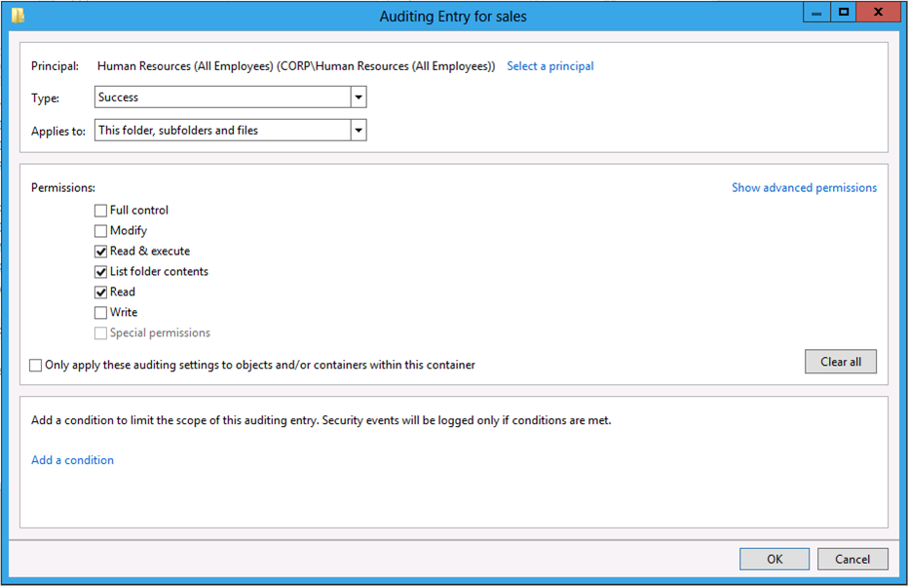
Figure 36 Audit Entry editor dialog

Principal
The Principal label identifies the security principal to which the audit entry applies. Some examples of security principals include users, groups, or computers. The audit entry stores a security principal using a security identifier (SID). The Advanced Security Settings dialog translates the SID of the user into its name and displays the name in the Principal column. Click Select a principal to choose a different security principal to which the audit entry applies.

Type
There are three types of audit entries: success, failure, and all. An audit entry type determines how Windows audits access to the resource when it determines the audit entry is applicable to the security principal. The success audit type only audits successful access to the resource. The failure audit type only audits failed access to the resource. The all audit type audits successful and failed access to the resource.

Permissions
You configure each audit entry to contain one or more permissions that Windows audits. Permissions define the actions a security principal can perform when using the resource, such as read or write.
The Auditing Entry dialog shows the basic permissions for a file or folder. A basic permission is a combination of specific advanced permissions used to perform the basic permission's action.
For example, the Auditing Entry dialog displays the basic Read permission. The basic Read permission contains five advanced permissions:
- Traverse folder/execute file
- List folder/read data
- Read attributes
- Read extended attributes
- Read permissions.
Windows maps a user's actions on a file into advanced permissions that it audits for success, failures, or both. Therefore, Windows bundles these advanced permissions into a single basic permission to ease administration.
Windows defines the six basic permissions that you can use for auditing access to the file system. Basic permissions for an audit entry include:
- Full Control
- Modify
- Read & Execute
- Read
- Write
- Special Permissions
Click Show advanced permissions to change the permission section to show the advanced permissions. Click Show basic permissions to change the permission section to show the basic permissions.
Note: | Use the basic permissions when protecting resources whenever possible. Only use advanced permissions when application or business process justifies their use.

Clear all
Use the Clear all button to remove all the permissions from the audit entry.

Apply these auditing settings to objects and/or containers within this container only
Use this configuration setting when you want to limit inheritance propagation to only one level. Selecting this box changes the scope of inheritance to single level below the targeted resource.

Effective Access
Windows Server 2012 and Windows 8 introduce a new Effective Access tab. You use the Effective Access tab to determine the effective access for a security principal from a given device. Also, the Effective Access tab allows you to model the effective access by introducing hypothetical user and device claim values. This helps you plan for future user and device claims as well as troubleshoot problems with user access to files and folders.
Figure 37 Effective Access show in the Advanced Security Settings editor

User/Group
The User/Group label identifies the security principal for which you want to determine the effective access. Security principals can be a user, group, or built-in security principal. Click Select a user to browse for a security principal.

Include group membership
Simulating a user's effective access does not include groups of which the user does not have explicit membership. Therefore, you may need to explicitly add groups when simulating effective access. By adding groups, you ensure the simulation performed when viewing effective access is as accurate as when the user accesses the file.

Device
The Device label identifies the security principal of a computer or a group of which the computer belongs. Click Select a device to browse for the device security principal.
Important: | Windows Server 2012 supports device claims. This feature provides you with the flexibility to control access and auditing using claims for both the computer and the user. Therefore, it is possible that a user claim meets the criteria for access, but the computer from which the user accesses the resource does not. In this scenario, Windows would not grant the user access to the resource.

Include a user claim
Dynamic Access Control uses claim-based access to provide versatile access and auditing in Windows Server 2012. Windows must evaluate all claims to provide reliable effective access results. You also need the ability to add claims into the evaluation process to enable you to model different access control scenarios or to help troubleshoot existing access problem.
The Effective Access tab allows you to add claims for user and devices when it evaluates the effective access. Click Include a user claim and select a user claim from the list and give the claim a value. Click Update to include the new claim and refresh the effective access with the newly added claims.
Click Remove next to the claim to remove it from the effective access evaluation. Click Update to refresh the effective access evaluation without the removed claim.

Include a device claim
Click Include a device claim and select a device claim from the list and give the claim a value. Click Update to include the new claim and refresh the effective access with the newly added claims.
Click Remove next to the claim to remove it from the effective access evaluation. Click Update to refresh the effective access evaluation without the removed claim.

Update
Use the Update button to force the Effective Access tab to refresh the effective access results.

Effective Access List
The Effective Access tab in the Advanced Security Settings dialog shows all the advanced permissions for the resource. Remember, advanced permissions represent the types of access security principals perform when accessing resources. The effective access list uses three columns to display the effective access results for a security principal.

Effective access
The Effective Access column shows the effective access for the advanced permission given the select security principal, device, and user and device claims. The column shows a red X if the effective access for the advanced permission is denied. The column shows a green checkmark if the effective access for the advanced permission is allowed.

Permission
The Permission column shows the name of the advanced permissions.

Access limited by
The Access limited by column displays one or more reasons why the effective access for the advanced permission is limited for the evaluated scenario.

Share
The Share tab on the Advanced Security Settings editor dialog provides a read-only view of the share permissions associated for the folder. This makes it easier to view share permissions without using the Folder Sharing Wizard. The Effective Access tab includes share permissions in its evaluation provided the share permissions are visible in the Advanced Security Settings editor.
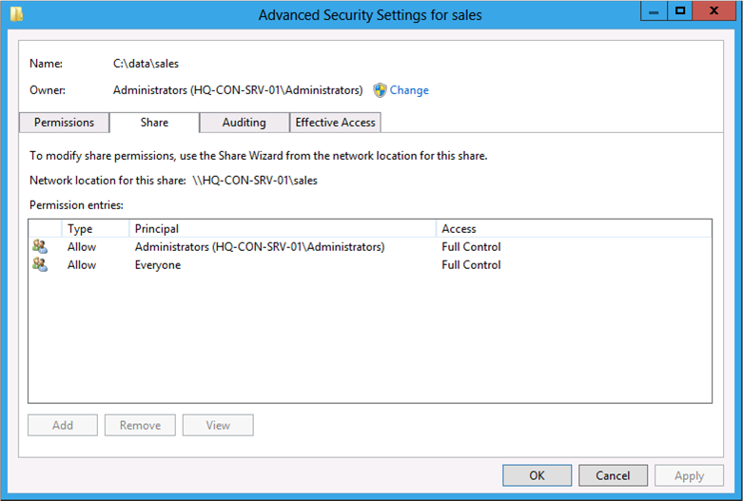
Figure 38 Share tab view from the Advanced Security Settings editor
When evaluating permissions remotely, the Share tab in the Advanced Security Settings editor shows the share used for the connection. For local files and folders, the Share tab shows the share that is nearest to the file or folder. If you share a folder with more than one shared name, the Share tab uses the first enumerated share name for the folder.

Evaluating Effective Permissions
It is good to understand how to determine effective access across multiple points of access control. To determine effective access you compare information from the access token against each point of access control (Central Access Policy, share permissions, and NTFS permissions). The result of this comparison is the user's effective access. Predicting the effective access of a resource helps you plan and configure permissions for those resources.
Important: | This section covers the information needed to determine effective permissions with and without conditional expressions manually. Manually determining effective permissions that include Central Access Policy objects is included in the Central Access Policy and NTFS permissions section.

Precedence and Canonical Ordering

Precedence
The Windows authorization sub system follows a set of rules that gives the appearance of preferring a permission entry type or access over a different permission entry type or access. However, the perception of precedence does not occur real-time— the rules of precedence are not enforced when the user access the resource. The permission entries are evaluated in order and access is allowed or disallowed based on that order. The Security settings or Advanced Security Settings editor accomplishes permission entry precedence by saving the permission entries in a specific order. The specific order in which permission entries are saved is known as canonical order.

Canonical Ordering
Canonical ordering describes the ordering the Security settings or Advanced Security Settings editor uses to ensure access to resources observes a defined behavior with regard to the permission entry’s lineage and access type.

Lineage
The permission entry’s lineage is the origin of the permission entry. Windows recognizes two types of permission entries that describe the permission entry’s lineage: explicit and inherited.

Explicit
Permission entries that originate on the current resource are known as explicit permissions. Explicit permission entries are permission entries that you manage directly on the file or folder. The Security Settings and Advanced Security Settings editor orders explicit permission entries to the top of the permission entry list. All explicit permission entries are ordered before any other permission entry type.

Inherited
Permission entries that originate higher in the resource’s lineage are known as inherited permissions. Inherited permission entries are explicit permission entries granted at some higher point in the resource’s hierarchy that propagate to the file or folders lower in the resource’s hierarchy. The Security Settings and Advanced Security Settings editor orders inherited permission entries after explicit permission entries.

Lineage order
Windows orders inherited permission entries in lineage order. Lineage order describes the order of inherited permissions where inherited permissions closest to the current folder are ordered before inherited permissions furthest from the current folder. Lineage ordering results in inherited permissions from the parent ordered before the grandparent. Inherited permissions from the grandparent are ordered before the great-grandparent. This ordering continues to traverse up the resource’s lineage until it reaches the end of the resource’s hierarchy or inheritance stops. Do not confuse lineage ordering with canonical ordering. Canonical ordering describes the entire ordering process Windows performs when saving permission and audit entries. Lineage ordering is a subset of canonical ordering that refers specifically to the way Windows orders inherited permissions based on position in the resource’s lineage.

Access Type
Windows recognizes two access types for permission entries: Deny and Allow.

Deny access types
Deny access type permissions disallow users from performing the access configured in the permission entry. Access configured in permission entries typically characterizes as specific action a user performed on the resource such as read, modify, or delete.
The Security Settings and Advanced Security Settings editors order deny permission entries before allow permission entries when saving permissions. This order ensures that Windows evaluates deny permission entries first followed by allow permission entries. This ordering is combined with lineage ordering, which results in explicit deny permission entries ordered before explicit allow permission entries.
Windows orders inherited deny permissions before inherited allow permission entries at each point of inheritance in the resource’s lineage. Therefore, inherited parent permission entries are ordered together (inherited deny and inherited allow), and then inherited grandparent permission entries are ordered together (inherited deny and inherited allow), after inherited parent permission entries.

Allow access types
Allow access type permissions permit users to perform the access configured in the permission entry. Access configured in permission entries typically characterizes as specific action a user performs on the resource such as read, modify, or delete.
The Security Settings and Advanced Security Settings editors order allow permission entries after deny permission entries when saving permissions. This order ensures that Windows evaluates deny permission entries first followed by allow permission entries. This order is combined with lineage ordering, which results in explicit deny permission entries

Results of Canonical Ordering
Canonical ordering of permission entries accomplishes gives the perception of precedence when a user accesses a file or folder. Windows uses this precedence to establish deterministic behaviors with regard to authorization decisions. Well-defined behaviors allow you to determine effective permissions of a resource manually, without using the Effective Access tab.

Table 14 Conceptual depiction of canonical ordering of permission entries
Permission Entry
Explicit Deny
Explicit Allow
Inherited Deny (Parent)
Inherited Allow (Parent)
Inherited Deny (Grandparent)
Inherited Allow (Grandparent)
Inherited Deny (Great-grandparent)
Inherited Allow (Great-grandparent)

Information from Table 14 illustrates the order in which Windows saves permission entries. This order determines effective permissions based on how Windows handles each permission type (allow or deny). In summary, conical ordering yields the ordering in Table 14. The ordering combined produces the following precedence you can use to determine effective permissions for a resource.
- An explicit deny permission entry always denies access to a resource
- An explicit allow permission entry permits access unless combined with an explicit deny permission entry, which then denies access to the resource
- An inherited deny permission entry disallows access unless combined with an explicit allow permission entry or an inherited allow permission entry that is closer in lineage to the resource than the inherited deny, which then permits access to the resource
- An inherited allow permission entry permits access unless combined with an explicit deny permission entry, or an inherited deny permission entry that is closer in lineage to the resource than the inherited allow, which then disallows access to the resource.

Important: | Windows canonically orders permission entries when saving the permission list. When Windows evaluate access to a resource, it evaluates each permission entry in list order.

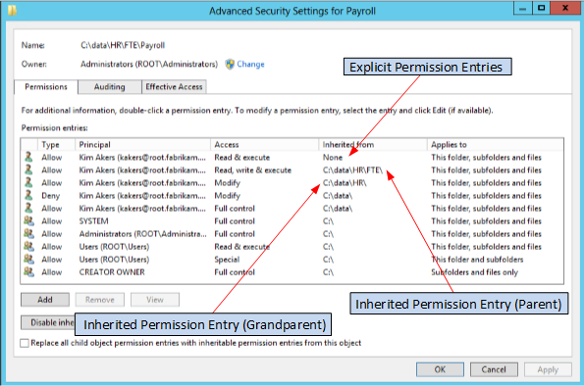
Figure 39 Advanced Security Settings dialog showing canonical ordering

Effective Permissions before Windows 8

Access Token
Windows creates an access token for each user that logs on to the computer. The authentication token contains the security identifier (SID) of the user and SIDs of all the groups to which the user belongs, directly or indirectly as in the case of nested groups. Windows uses this access token to determine if a permission entry's principal applies to the principal accessing the share by comparing the SIDs within the token against the SID of the principal of each permission entry in the permission list.
A permission list contains one or more permission entries. Each permission entry contains a principal, type, and access. The principal is a SID to which the permission entry applies-- typically a user or group. The permission entry type describes whether the permission entry allows or disallows access. The access portion of the permission entry describes the permissions a user performs when trying to use the file. Therefore, these three components define how Windows protects a given resource.

Applicability
Windows only cares about permission entries that are applicable to the user attempting to access the resource. Windows determines if a permission entry applies to the user by comparing the principal SID in the permission entries with the SIDs in the access token. If the principal SID is present in the access token, then the permission entry applies to the user. Windows includes that permission entry when evaluating access to the resource.

Explicit Access
A user encounters two points of access policy when accessing a file share hosted on a Windows file server: Share access policy and File access policy. These access policies collective represent the permissions Windows uses to determine access to files in the share. You determine effective access for the user by comparing the applicable permission entries in the file permissions list with the applicable permission entries in the share permissions list. Windows grants the access common between both lists to the user. If the access requested by the user matches the access extended to the user by Windows, then Windows applies the permission type to the user, which is either allow or disallow the requested access. This concept is known as explicit access because a permission entry appears in both lists that explicitly applies the access type to the request.

Implicit Access
However, there are some circumstances where permission entries do not share common access. Typically, this occurs when neither of the permission lists contains a common permission entry that is applicable to the user. Windows cannot grant explicit access and prevents access to the resource. This behavior is known as implicit access. Implicit access is the common reason why users cannot access a resource when the resource does not explicitly deny them access.

Share Access Policy
Share access policy, also referred to as share permissions; represent the basic access you can grant on a shared folder. On a share, you can control access to the share using Read, Change, and Full Control permissions. Windows creates these categories of access through a list of basic permissions. Basic permissions are a combination of advanced permissions.

Table 15 Basic to advanced permissions mapping
Share Permissions | Basic NTFS Permissions | Advanced NTFS Permissions
Read | Read & execute  List folder contents  Read | Traverse folder / execute file  List folder / read data  Read attributes  Read extended attributes  Read permissions
Change | Modify  Read & execute  List folder contents  Read  Write | Traverse folder / execute file  List folder / read data  Read attributes  Read extended attributes  Create files / write data  Create folders / append data  Write attributes  Write extended attributes  Delete  Read permissions
Full Control | Full control  Modify  Read & execute  Read  Write | Full control  Traverse folder / execute file  List folder / read data  Read attributes  Read extended attributes  Create files / write data  Create folders / append data  Write attributes  Write extended attributes  Delete  Read permissions  Change permissions  Take ownership

File Access Policy
Files and folders stored on NTFS volumes use permissions. The file system is a hierarchy of files and folders. Files and folders throughout the hierarchy share a parent-child relationship. This hierarchy supports the flow of permission entries from the top-most parent to the bottom-most child. This flow of permission entries is known as inheritance.
There are two categories of NTFS permission entries: explicit and inherited. Explicit file permission entries are permission entries that you assign directly to the file or folder. Inherited file permission entries are permission entries that a resource receives from its parent by virtue of inheritance.
A folder is unique in that it can be subordinate to its parent folder -- thereby acting as the child in the parent-child relationship. At the same time, the folder can act as the role of the parent in the parent-child relationship. This dual relationship role enables you to configure explicit file permission entries on the folder. Those explicit permission entries flow down the file system and become inherited file permission entries on all child files and folders. You can change how Windows propagates inherited permissions using the Advanced Security Settings editor.
Files and folders stored on NTFS volumes contain explicit and inherited permission entries. You use file permissions to determine effective access when not accessing files and folders through a share. When all the file permission entries types are Allow permission entry types, you use the least restrictive permissions (permission entries that give the user the most access) among all the file permission entries to determine effective local file access. Therefore, you determine effective access by combining all the applicable allow permission entries for the user. However, determining local effective access changes when a deny permission entry type exists among the permission entries.

Effective NTFS Access Scenario
Three users access a folder locally on a workstation with the following permission entries.
Table 16 Local NTFS permission entries for the working scenario
User | Permission type | File basic permissions | Inherited from
Harvey | Deny | Full control  Modify  Read & execute  Read  Write | None
Users | Allow | Read & execute  Read | None
Marketing | Allow | Full control  Modify  Read & execute  Read  Write | C:\

The first user, Alejandra is a member of the Users and Marketing groups. Therefore, permission entries two and three apply to her when she accesses the folder. Her effective access to the folder is Full Control (1). Allow permission entries, explicit or inherited are combined. In this scenario, Windows allows Alejandra Read permissions (Read & execute and Read) because she is a member of the Users group and because she is a member of the Marketing group. However, Windows also allows her Full Control because she is a member of the Marketing group. Windows grants the least restrictive access when evaluating multiple Apply permission entries.
The second user, Kim is a member of the Users group. Permission entry two is the only applicable permission entry. Therefore, her effective access to the folder is Read (2).
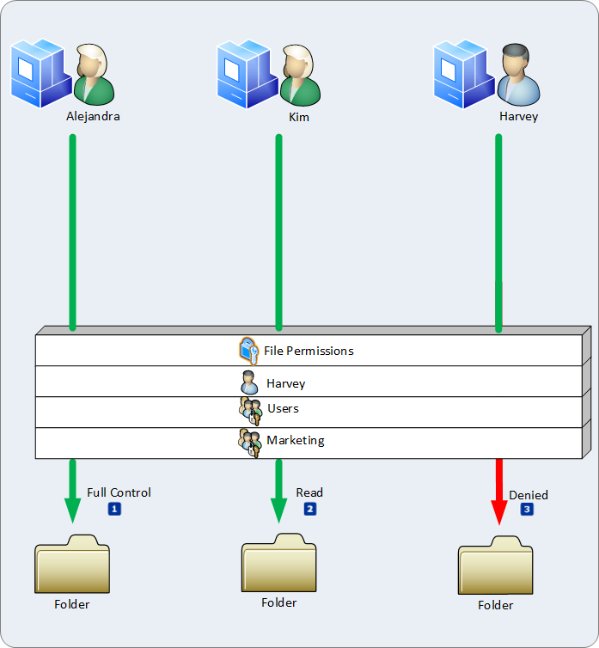
Figure 40 Conceptual view of local effective permissions.
The last user to access the folder is Harvey. Harvey is a member of the Marketing group. Permission entry one and three apply to Harvey when he accesses the folder. Permission entry one is applicable because the trustee is Harvey. Permission entry three applies as well because Harvey is a member of the Users and Marketing group. However, Windows orders the permission entries so that deny permission entries occur before allow permission entries. In this scenario, permission entry one denies access. The access denied by the permission entry is Full Control. Based on permission entry order, Windows denies Harvey access to the folder. Harvey's membership in the Marketing group is irrelevant because the explicit deny permission entry has precedence over all other permission entries (3).

Effective Share Access Scenario
Understanding effective access to the file system is a prerequisite to under understanding effective access when accessing files through a shared folder. When accessing a shared folder, Windows considers the file permission entries and share permissions to determine a user's effective access to the folder.
Table 17 Share and NTFS permission entries for the working scenario
Principal | Permission type | File basic permissions | Inherited from
Harvey | Deny | Full control  Modify  Read & execute  Read  Write | None
Users | Allow | Read & execute  Read | None
Marketing | Allow | Full control  Modify  Read & execute  Read  Write | C:\
Share Permissions
Principal | Permission type | Share permissions | N/A
Everyone | Allow | Change
Marketing | Allow | Full Control

Effective access through shares evaluates file and share permissions together. First, you evaluate the effective file permission entries. Then, you evaluate the effective file permissions with the share permissions. Permissions entries common between the effective file permission entries and the share permissions become the effective access when accessing the share. If the permission entry exists in the file permissions list or the share permission list, but not both; then, Windows does not grant the access to the user.
The permissions lists in Table 17 reflect both file permission entries and share permissions. The first user, Alejandra accesses a file through a shared folder. Alejandra is a member of the users and Marketing group. The last example determined her effective file system access was Full Control.
To determine effective access through the share, evaluate the share and file permission entries together. Permission entries common between both lists are applicable to the user. Permission entries that appear in one list or the other are not applicable. The share permissions provide Alejandra Full Control access (1). These permissions are the same as the effective file permissions. The permission entries common in both permission lists are equivalent to Full Control; therefore, Alejandra's effective access using the shared folder is Full Control (2).
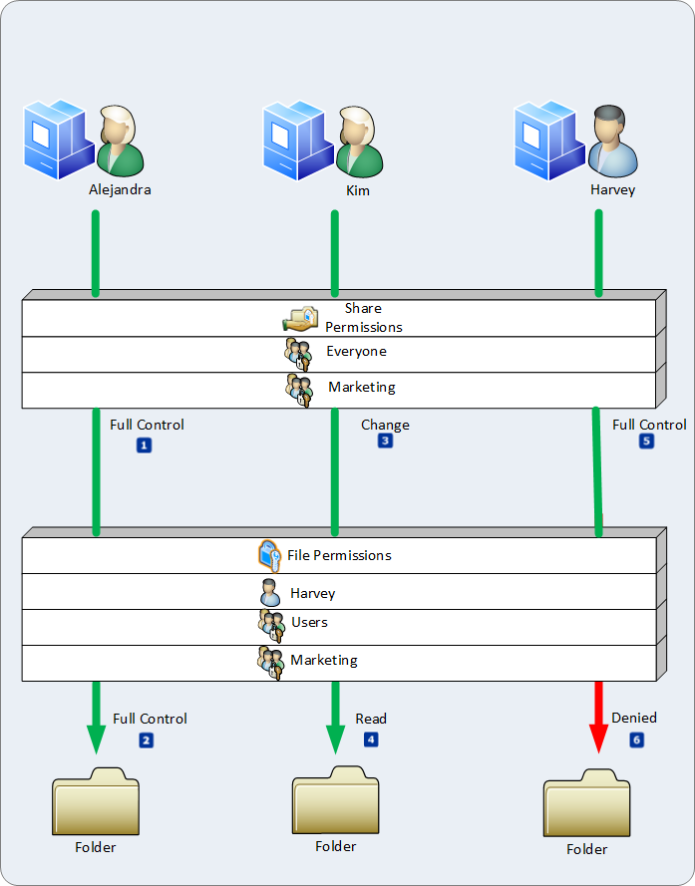
Figure 41 Conceptual representation of effective permissions using share and NTFS permission entries.

Next, Kim accesses the files through the shared folder. Kim is a member of the users group. The effective file system access for her is Read. Users have Change permissions on the share (3). Noticeably, the permissions between the two lists are not identical. You must translate the share permission into basic permission to determine the permission entries in common between the two lists.
Table 17 indicates the Change share permission is a combination of basic permissions. Those permissions include Modify, Read & execute, Read, and Write. The effective file system access Read includes the Read & execute, and Read basic permission entries. A comparison of the two lists shows permission entries common between both lists are Read and execute, and Read. Modify and write permissions entries exist only in the file permissions list. Windows determines these permissions are not applicable to Kim because they do not exist in both lists, given Kim's group membership. This results in Kim's effective access as Read when using the shared folder (4).
Lastly, Harvey accesses the file through the shared folder. Harvey is a member of the users and Marketing group. The last example identified that Harvey's effective file access denied Full Control. Again, you compare permission entries from the user's file system effective permissions and the permission entries on the share that are applicable to the user (share permissions or permission entries where the principal is the user or a group of which the user is a member).
The share permissions list includes a permission entry that allows everyone Change access and another permission entry that allows Marketing Full Control access (5). A deny permission entry wins against any allow permission entries except when the deny permission entry is inherited and the allow permission entry is explicit. Therefore, Harvey's effective share access is deny Full Control (6). The Marketing group's Full Control share permissions are not applicable because of the explicit deny.

Conditional Expression Editor
The Permission Entry and Audit Entry dialog boxes include a built-in conditional expression editor. You begin using the editor by clicking Add a condition in the conditions section, which is below the permission section in either dialog box.
The conditional expression editor starts by showing a row of individual lists. The first two lists represent the left-hand side of the claim expression. The first list represents the claim type. The second list is the name of the available claims for the claim type selected from the first list.
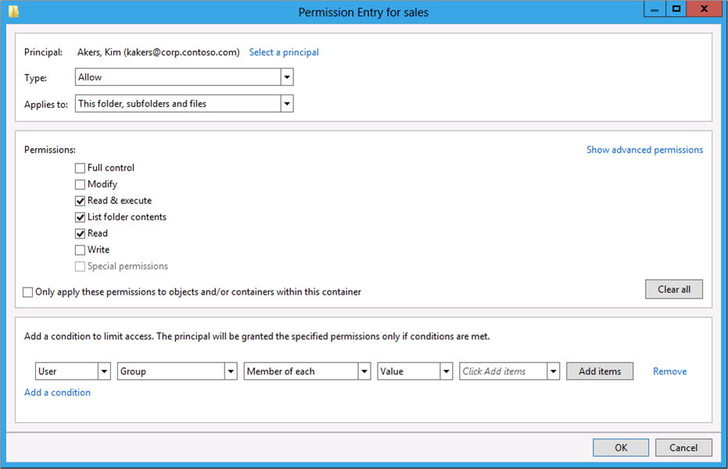
Figure 42 Expression Editor with multiple lists.
The third list is the operator used to evaluate the left-hand side claim type against the right-hand side claim type. The fourth and fifth lists represent the right-hand side of the conditional expression. The fourth list is the claim type when the expression evaluates one claim type against another claim type; otherwise, you can choose Value from the list box to represent the right-hand side as a constant value. The fifth list represents the name of the right-hand side claim type when the fourth list is a claim type. Otherwise, you use the fifth list to specify the constant value. Depending on the value type of the claim type, this item can be a list or a text box that accepts a typed value.
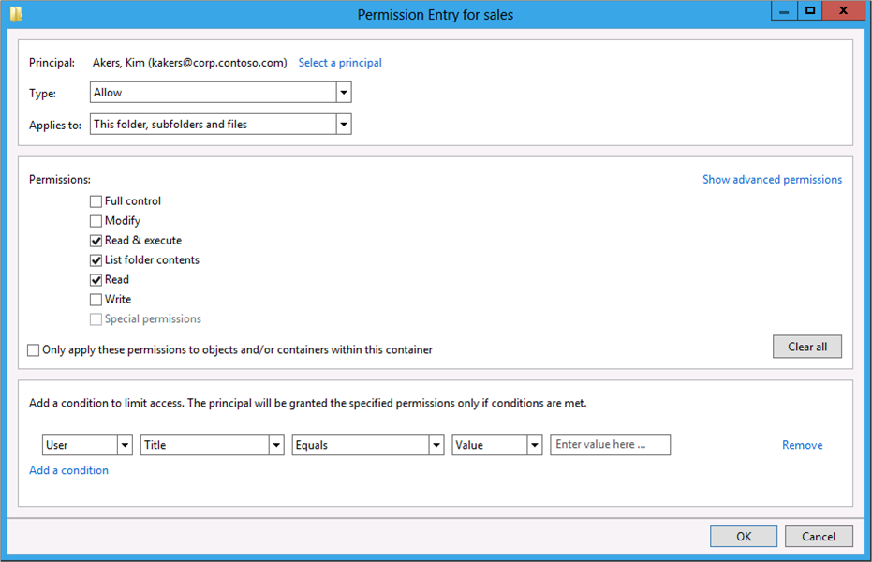
Figure 43 Expressions editor expecting a constant value.
For some claim types and logical values, an Add Items button may appear after the fifth list. Use this button to add one or more values to the left-hand side of the expression, such as when using the Member of each operator with the Group claim name.

Multiple Expressions
You can combine multiple conditional expressions using the Boolean And and Or operators. With an existing conditional expression configured, click Add a condition to insert another conditional expression. A single list appears above the new conditional expression row. Use this list to configure how Windows should evaluate the multiple conditional expressions. You can select the Boolean operator And or the Boolean operator Or from the list.
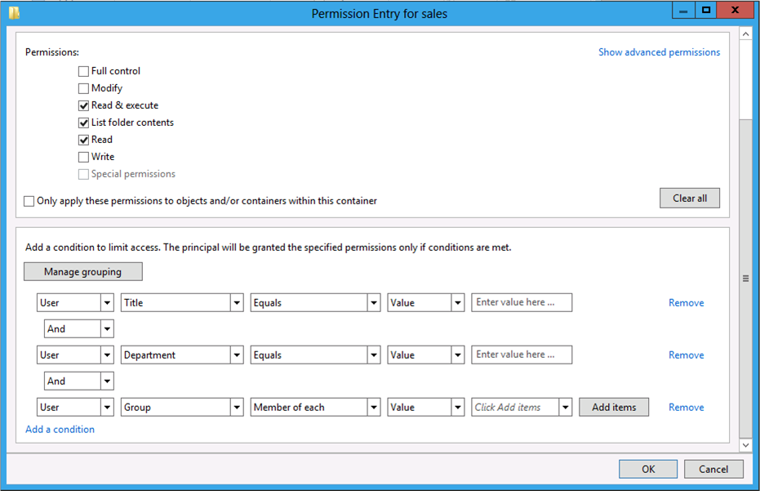
Figure 44 Expression editor containing multiple conditional expressions.

Grouping Expressions
You can group multiple conditional expressions together, which effectively treats the result of multiple conditional expressions as one result. You can then evaluate the result of a group of conditional expressions against a single conditional expression or another group of conditional expressions.
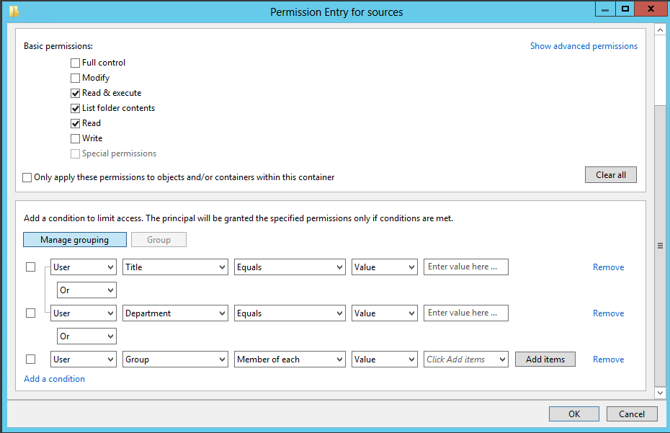
Figure 45 Expressions editor with grouped conditional expressions.
Click Manage grouping to group conditional expressions. Select the checkbox before each conditional expression you want to group together. This enables Group button. Click Group. The Group button becomes unavailable and a bracket connects the top and the bottom conditional expressions together and includes any selected conditional expression that fall between them.
Important: | You can only group sequential conditional expressions. Therefore, if you want to group three conditional expressions together, then you must create those conditional expressions one after the other. For example, if you have five conditional expressions, and you want to group three of them together; then you can group together one of the following permutations:  - 1, 2, 3  - 2, 3, 4  - 3, 4, 5  You cannot group together 1, 3, 5

Ungroup Expressions
You can ungroup conditional expressions that are grouped together. Select the checkbox of any conditional expression in the group of conditional expressions. The Group button changes to Ungroup. Click Ungroup, to disband the group of conditional expressions. The bracket connecting the top and the bottom on the group disappears and each conditional expression is evaluates as single expression.
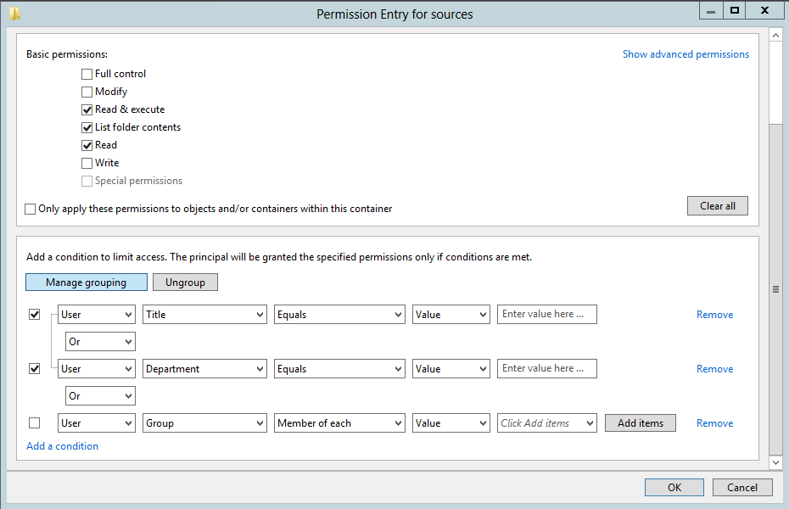
Figure 46 Expression editor showing ungroup button.

Removing Expressions
You can remove a single conditional expression or a conditional expression that is a grouped with other conditional expressions. Click Remove to remove the conditional expression from the entry. When removing a conditional expression from a group, only the deleted conditional expression is removed. The group remains as long as least two conditional expression of that group remain to anchor the group. Otherwise, the conditional expression is removed and the group is disbanded.

Conditional Expressions for Access Control
Windows 7 and Windows Server 2008 R2 introduced the framework that Windows uses to store a conditional expression in a permission or audit entry. The advanced security settings editor in Windows Server 2012 and Windows 8 takes advantage of this framework and allows you to create conditional expressions directly in a permission or audit entry. These expressions are part of the file or folders security descriptor.
To Create a Permission entry with a Conditional Expression
- Open Windows Explorer.
- Browse to the file or folder to which you want to change security.
- Right-click the file or folder and then click Properties.
- Click Security, and then click Advanced.
- Click Add to display the Permission Entry dialog box.
- Click Select a principal to choose a trustee to which the permission entry applies.
- Choose the desired Type, Applies to, and Permissions.
- Click Add to insert a conditional expression
- Configure the conditional expression using user and device claims, resource properties, and the appropriate logical operator that expresses the logic of the condition.
- Click OK three times to return to Windows Explorer.

Effective Permissions with Conditional Expressions
Previous versions of Windows determined applicability by searching for the permission entry's trustee security identifier (SID) within the security principal's access token. If the SID is present, then Windows considers the permission entry applicable to the user and includes that permission entry along with all other applicable permission entries when evaluating access.
Windows Server 2012 and Windows 8 can include one or more conditional expressions within a permission entry. Conditional expressions simply add another layer of applicable to the permission entry. The results of all conditional expressions must evaluate to true for Windows to consider the permission entry for authorization.
A permission entry can contain multiple conditional expressions, and those expression can be logically combined using the AND and OR logical operators. Additionally, conditional expressions can be grouped together, which can change the order in which Windows evaluates the expression. Consider all of these factors when authoring conditional expressions. Again, the result of all conditional expressions must evaluate to true for the permission entry to be applicable. Windows evaluates the SID in the permission entry is application to one of the SIDs in the access token. Then, Windows evaluates the conditional expression to determine if the permission entry remains applicable for authorization (expression evaluates to true). Lastly, you can only include conditional expression in NTFS permission entries. Share permission entries do not support conditional expressions.
Important: | Windows Server 2012 and Windows 8 do not support or allow you to create a conditional expression with a deny type permission entry. You can only include conditional expressions in allow type permission entries.

Table 18 Permissions with a conditional expression for the working scenario
Principal | Permission type | NTFS basic permissions | Condition | Inherited from
Harvey | Deny | Full control  Modify  Read & execute  Read  Write | None | None
Users | Allow | Read & execute  Read | User.Department=="Marketing" | None
Marketing | Allow | Full control  Modify  Read & execute  Read  Write | None | C:\
Share Permissions
User/Group | Permission type | Share permissions | N/A | N/A
Everyone | Allow | Change
Marketing | Allow | Full Control

Table 18 shows the NTFS and share permissions used in previous examples. The users in this example remain the same: Alejandra, Kim, and Harvey. Alejandra and Harvey are members of the users and marketing group, while Kim is a member of the users group. The department attribute on Kim's user account in Active Directory read Accounting. The department attribute on Alejandra and Harvey's user accounts reads Marketing.
Alejandra accesses the shared folder protected by the permissions from Table 18. Previous examples determined that Alejandra's effective NTFS access was Full Control. Windows evaluates the trustee SID and the SIDs in Alejandra's access token. Alejandra is a member of users. Next, the user's department attribute against the literal value of Marketing. Alejandra's department attribute reads Marketing; therefore, the conditional expression evaluates to true; the permission entry remains applicable to Alejandra. Conditional expressions do not directly influence effective share access, only NTFS access. You evaluate effective shared access the same.
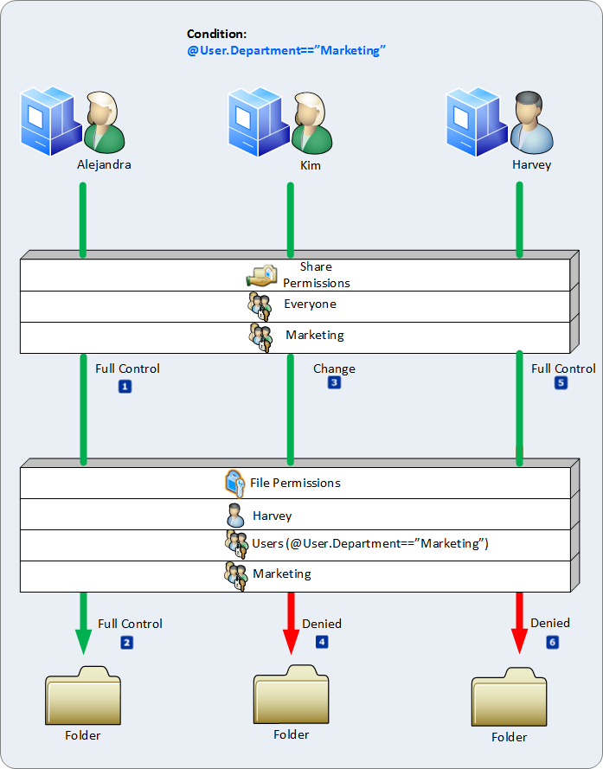
Figure 47 Conceptual view of effective permissions using share permissions and NTFS permission that include a conditional expression.

Next, Kim accesses the share folder. Previously, her effective NTFS and effective share access was Read. In the previous example, permission entry two applied to Kim. However, the conditional expression in permission entry two changes her effective NTFS permissions. Windows evaluates the trust first and then the conditional expression. Kim is a member of the users group; therefore, the trustee is applicable to Kim. Kim's department attribute in Active Directory reads Accounting. The literal value within the conditional expression reads Marketing. Kim's department attribute does not match the value within the conditional expression. Therefore, permission entry two is not applicable to Kim.
Permission entries one and three are not applicable to Kim because her access token does not contain the trustee's listed in either permission entry. None of the permission entries are applicable to Kim. In this example, Kim's effective NTFS access evaluates to an implicit deny because she is not explicitly allowed any other permission. You evaluate effective share permissions the same, remembering the priority of deny and allow permission entries and that only permissions within both lists apply to authorization. Kim's effective share access is deny for two reasons. First, her effective NTFS access is deny, which has priority and two, the effective NTFS and share permission entry lists do not have any common permissions between them.
The conditional expression include in permission entry two does not change Harvey's effective access to the share. Permission entry one remains applicable to Harvey because the trustee in this deny permission entry is Harvey. The priority of deny over allows prevails just as it did in the previous example.

Conditional Expressions for Auditing
Audit entries have applicability with regard to the security principal performing the action that Windows should audit. Windows aggregates all audit entries, explicit and inherited and you do not configure audit entries directly on the share. Using auditing, you can configure Windows to write events that relate to a specific action to the event log. Typically, these actions are similar to the actions a user performs when accessing a resource, such as read or write. You can configure Windows to write an event when the action results in a success or when the action fails. Both audit entries can exists for the same action; however, the result Windows audits is one or the other. Windows evaluates an audit entry's applicability by considering the audit entry's trustee, action, that action's result, and conditional expression

Auditing
Like permission entries, audit entries have a trustee. The trustee is the security identifier (SID) of a security principal, typically a user, computer, or group. Windows uses authorization token to determine if the audit entry applies to the user. Next, Windows determines the action the security principal performed the results of that action. A user accessed the share to read information. An audit entry for the user configured with the read permission applies to the action. The read action results in either a success or a failure.
An audit entry configured for success writes an event to the event log when the trustee of the entry applies to the security principal, when the permission performed by the security principal matches the permission in the entry, and the result of the security principal's access to the resource is successful. An audit entry configured for failure writes an event to the event log when the trustee of the entry applies to the security principal, when the permission performed by the security principal matches the permission in the entry, and the result of the security principal's access to the resource failed.

Conditional Expressions
Conditional Expression adds a layer of applicability to the audit entry. Windows evaluates all conditional expressions in an audit entry to determine if the audit entry is applicable. Just like conditional expressions in permission entries, the conditional expression in an audit entry must evaluate to true for the audit entry to apply. If the conditional expression is true, then Windows continues to evaluate the other criteria to determine if the remaining portions of the audit entry apply to the security principal, the permission, and the result of exercising the permission.

Managing and Deploying Central Access
Central Access policies for files allow organizations to centrally deploy and manage authorization policies that include conditional expressions using user claims, device claims, and resource properties. Claims are assertions about attributes of the object with which they are associated. For example, for accessing high business impact–data, a user must be a full-time employee, access from a managed device, and log on with a smart card. You define these policies in Active Directory.

Managing Central Access using the Active Directory Administrative Center
Another feature of Dynamic Access Control provided by Windows Server 2012 is Central Access. Central Access provides an organized and centralized way to enhance an organization's existing authorization policy. Central Access uses many of the new features provided in Windows Server 2012, such as claims and conditional expressions. The main components enable you manage and deploy consistent authorization throughout the enterprise using Central Access Rules and Central Access Policy objects.
Central Access Rules contain multiple criteria that Windows uses to when evaluating access. A Central Access Rule can use conditional expressions to target specific files and folders. Each Central Access Rule has multiple permission entry lists you use to manage the rule's current permission entries, proposed permission entries, or return the rule's current permission entry list to its last know list of permission entries.
Central Access Policy objects represent a collection of Central Access Rule objects that you apply to Windows Server 2012 file Servers using Group Policy. A Central Access Policy object contains a list of associated Central Access Rule objects. You manage the list of Central Access Rule objects in the same manner you manage a group memberships. Add or remove the Central Access Rules you want to include or exclude as part of the Central Access Policy object, respectively. Like group memberships, Central Access Rule membership is a linked value. This means that one Central Access Rule can have membership with multiple Central Access Policy objects.

Central Access Rule
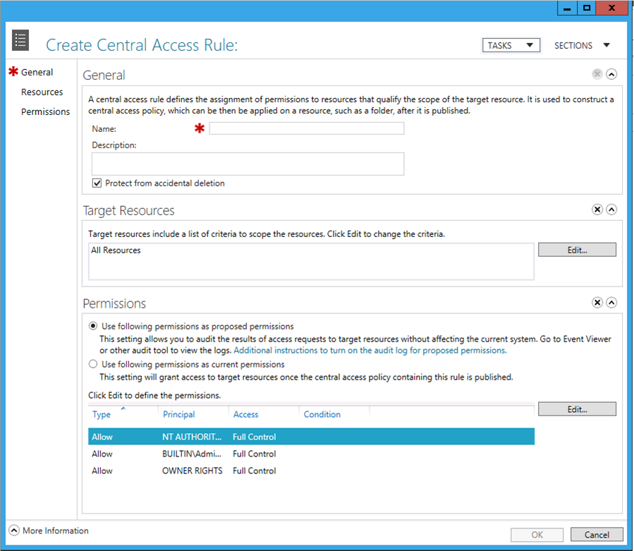
Figure 48 Central Access Rule creation using the Active Directory Administrative Center

General

Name
The Name box holds the unique display name given to the Central Access Rule. Windows uses the name when presenting it as a choice throughout the user interface. The Name box accepts alphanumeric characters as valid data.

Description
The Description box holds a short description about the Central Access Rule. The description can contain alphanumeric characters. Its content typically includes purpose, department usage, or business justification.

Protect from accidental deletion
The Protect from accidental deletion check box protects the newly created Central Access Rule from accidental deletion by users. By default, only Domain and Enterprise administrators have the permission to create, modify, and delete Central Access Rules. However, it is a best practice to safeguard these objects from accidental deletion.
Selecting the Protect from accidental deletion check box prohibits all users, including Domain and Enterprise administrators from deleting the object. The Active Directory Administrative Center applies this protection through a permission entry. When this box is selected, the Active Directory Administrative Center adds an explicit permission entry to the newly created Central Access Rule that disallows the built-in security principal Everyone delete access.
Accidental deletion protection is removed when this box is cleared and the explicit permission entry to disallow delete access is removed.

Target Resources
You use the Targeted Resource section to create a scope of applicability for the access rule. You create the scope by using resource properties within one or more conditional expressions. You can join these conditional expressions using logical operators like AND and OR. Additionally, you can group condition expressions together to use the combine result of two or more joined conditional expression as a single result.
The Targeted Resource box displays the currently configured conditional expression used to control the rule's applicability. By default, newly created Central Access Rules apply to All Resources.
Use the Edit button to show the conditional expression editor for the Central Access Rule. Windows displays the rule's existing scope, if configured or displays an empty scope. Windows considers an empty Target Resource scope to apply to all resources. See the Conditional Expression Editor section to learn how to configure a conditional expression. The expression must evaluate to true for Windows to consider the Central Access Rule during authorization.

Permissions
The permission section of the Create Central Access Rule dialog box has different views depending on if you are creating a new Central Access Rule or editing an existing Central Access Rule.

New Central Access Rule

Use following permissions as proposed permissions
Use the Use following permissions as proposed permissions option to add the permission entries in the permission list to the list of proposed permission entries for the newly created Central Access Rule. You use the proposed permission list; combined with file system auditing, to model the effective access users have to the resource without changing the permission entries in the current permissions list. Proposed permissions write a special audit event to the event log that describes the proposed effective access for the user.

Use following permissions as current permissions
Use the Use following permissions as current permissions option to add the permission entries in the permission list to the list of current permissions entries for the newly created Central Access Rule. The current permissions list represents the additional permissions Windows considers when the Central Access Rule is deployed to a file server. Central Access Rules do not replace the existing security. Windows evaluates permission entries from Central Access Rule's current permissions list, NTFS, and share permissions lists when making authorization decisions.

Viewing or Editing a Central Access Rule

Current permissions
The Current Permissions section appears when you view or edit an existing Central Access Rule. The current permissions list shows the permission entries that determine access to the resources targeted by the Central Access Rule. These permission entries become effective once you deploy the Central Access Rule using a Central Access Policy to a Windows Server 2012 file server.
Use the Edit button to show the Advanced Security Settings editor. Use this editor to manage permission entries for the rule's current permissions.

Proposed permissions
The Proposed Permissions section appears when you view or edit an existing Central Access Rule. The proposed permissions list; combined with file system auditing, shows the effective access difference for the current security principal between the list of current permission entries and the list of proposed permission entries in the System event log. However, the list of proposed permission entries does not affect a user's access. Select the Enable permission staging configuration check box to configure a Central Access Rule to enable the Proposed Permissions section. Clear the checkbox to remove and disabled the Proposed Permissions section.
Note: | The Proposed Permission section is unavailable when you clear the Enabled permission staging configuration check box. The permission entries remain visible until you close the dialog.

Use the Edit button to show the Advanced Security Settings editor. Use this editor to manage permission entries for the rule's proposed permissions.
Use the Apply Proposed button to copy the permission entries from the proposed permissions list to the current permissions lists. This action replaces the current permission entries; it does not merge the proposed permission entries with the current permission entries.
Use the Copy from Current button to copy the current permission entries into the proposed permissions list. This replaces the permission entries in the proposed permissions list with the permission entries from the current permissions list. This action does not merge the permission entries from either list.

Previous permissions
The Previous permissions section appears when you view or edit an existing Central Access Rule. The previous permissions list is empty until you modify and save the Central Access Rule's current permissions list. Windows copies the prior current permission entries to the previous permissions list and then saves the new current permissions list and the previous permissions list. The pervious permission list only contains the previous permission entries. The Active Directory Administrative Center does not maintain a history of permissions entries in the previous permissions list.
Use the Restore to Current button to copy the permission entries in the previous permissions list to the current permissions list. This action is a copy, thereby replacing the permission entries in the current permissions list. This action does not combine the permission entries.

Create a Central Access Rule
To Create a Central Access Rule using the Active Directory Administrative Center
- Start the Active Directory Administrative Center.
- Click Dynamic Access Control in the navigation pane. Then double-click Central Access Rules in the management list.
- From the Tasks pane, click New and then click Central Access Rule.
- Type the Name and Description of the Central Access Rule.
- Select or clear the Protect from accidental deletion check box.
- Configure the Central Access Rule's scope using the Target Resources section.
- Configure the initial permissions list as either a proposed or current permissions list from the Permissions section.
- Click Edit to configure the initial list of permission entries.
- Click OK.

Edit a Central Access Rule
To Create a Central Access Rule using the Active Directory Administrative Center
- Start the Active Directory Administrative Center.
- Click Dynamic Access Control in the navigation pane. Then double-click Central Access Rules in the management list.
- Click the Central Access Rule you want to edit and then click Properties from the Tasks pane.
- Modify the Description.
Note: | You cannot edit the name of an existing Central Access Rule. You must delete the Central Access Rule and create a new one.

- Select or clear the Protect from accidental deletion check box.
- Modify the rule's scope using the Target Resources section.
- Use the Edit button in the Current Permissions section to modify the rule's current permissions list.
- Select the Enable permission staging configuration check box in the Proposed Permissions section to add proposed permission entries to the rule
  - Use the Edit button to modify the list of proposed permission entries.
  - Use the Apply Proposed button to apply the list of proposed permission entries to the current permissions list.
  - Use the Copy from Current button to copy the list of current permission entries to the proposed permissions list.
  - Clear the Enable permission staging configuration check box in the Proposed Permissions section to remove the list of proposed permission entries from the rule.
- Use the Restore to Current button in the Previous Permission section to copy the list of previous permission entries to the current permissions list. This button is unavailable if this list is empty.
- Click OK.

Delete a Central Access Rule
To Create a Central Access Rule using the Active Directory Administrative Center
- Start the Active Directory Administrative Center.
- Click Dynamic Access Control in the navigation pane. Then double-click Central Access Rules in the management list.
- Click the Central Access Rule you want to edit and then click Delete from the Tasks pane.
- Click Yes to confirm the deletion.
Tip: | Windows may prompt you with a dialog stating you do not have sufficient permission to delete the rule. If you encounter this dialog, then modify the rule and clear the Protect from accidental deletion check box. If this check box is cleared, then examine the object's security and ensure you have permission to delete the rule.

Central Access Policy object
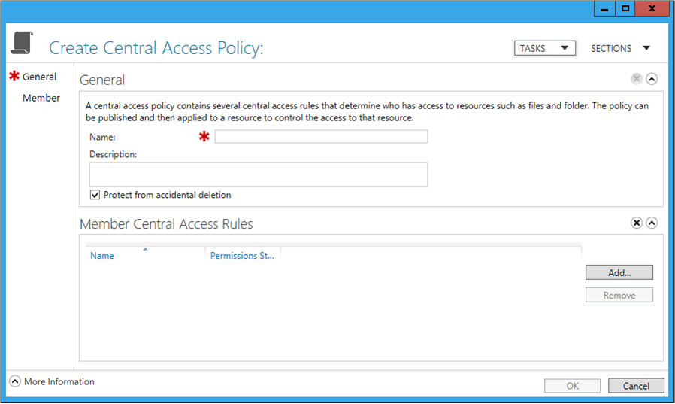
Figure 49 New Central Access Policy Creation using the Active Directory Administrative Center

General

Name
The Name box holds the unique display name given to the Central Access Policy. Windows uses the name when presenting it as a choice throughout the user interface. The Name box accepts alphanumeric characters as valid data.

Description
The Description box holds a short description about the Central Access Policy. The description can contain alphanumeric characters. Its content typically includes purpose, department usage, or business justification.

Protect from accidental deletion
The Protect from accidental deletion check box protects the newly created Central Access Policy from accidental deletion by users. By default, only Domain and Enterprise administrators have the permission to create, modify, and delete Central Access Policy objects. However, it is a good best practice to safeguard these objects from accidental deletion.
Selecting the Protect from accidental deletion check box prohibits all users, including Domain and Enterprise administrators, from deleting the object. The Active Directory Administrative Center applies accidental delete protection through a permission entry. When this box is selected, the Active Directory Administrative Center adds an explicit permission entry to the newly created Central Access Policy that disallows the built-in security principal Everyone delete access.
Accidental deletion protection is removed when this box is cleared and the explicit permission entry to disallow delete access is removed.

Member
Use the Member section to manage rule membership for the Central Access Policy. Within this section, you can add or remove Central Access rules from the Central Access Policy's membership list.
Use the Add button to show the Add Central Access Rules dialog box. Select one or more rules from the Central Access Rules list and click the double right-angled-brackets button to add the selected rules to the list. Select one or more of recently added rules from the Add the following central access rules list and click the double left-angled-brackets button to remove the selected Central Access Rule from the list.
Use the Remove button to remove the currently selected Central Access Rule from the Central Access Policy.

Name
The Name column in the Member Central Access Rules section lists the names of Central Access Rules that are members of the Central Access Policy.

Permission State
The Permission State column shows the permissions lists currently used by the named Central Access Rule. Valid permission state values include Proposed and Current.

Create a Central Access Policy object
To Create a Central Access Policy using the Active Directory Administrative Center
- Start the Active Directory Administrative Center.
- Click Dynamic Access Control in the navigation pane. Then double-click Central Access Policies in the management list.
- From the Tasks pane, click New and then click Central Access Policy.
- Type the Name and Description of the Central Access Policy.
- Select or clear the Protect from accidental deletion check box.
- Click the Add button from the Member Central Access Rules section to add Central Access Rule objects to the Central Access Policy's membership list. Or, select one or more Central Access Rule objects from the membership list and click Remove to remove the rule from the membership list.
- Click OK.

Edit a Central Access Policy object
To Edit a Central Access Policy using the Active Directory Administrative Center
- Start the Active Directory Administrative Center.
- Click Dynamic Access Control in the navigation pane. Then double-click Central Access Policies in the management list.
- Click the Central Access Policy you want to edit from the management list and then click Properties from the Tasks pane.
Note: | You cannot edit name of the Central Access Policy.

- Edit the Description of the Central Access Policy.
- Use the Add and Remove buttons from the Member Central Access Rules section to add or remove Central Access Rule objects.
- Click OK.

Delete a Central Access Policy object
To Delete a Central Access Policy using the Active Directory Administrative Center
- Start the Active Directory Administrative Center.
- Click Dynamic Access Control in the navigation pane. Then double-click Central Access Policies in the management list.
- Click the Central Access Policy you want to delete from the management list and then click Delete from the Tasks pane.

Managing Central Access using Windows PowerShell
The Active Directory module for Windows PowerShell provides cmdlets that you can use to manage Central Access Rules and Central Access Policies.

Central Access Rule
You create a Central Access Rule using the New-ADCentralAccessRule Active Directory cmdlet. This cmdlet behaves in a manner similar to a command line application, so you can treat and think of cmdlet as a command line application. You identify configuration options by passing arguments to the cmdlet.

Create a Central Policy Rule
Create a New Central Access Rule using Windows PowerShell
New-ADCentralAccessRule
-CurrentAcl:"O:SYG:SYD:AR(A;;FA;;WD)"
-Description:"Rule 3 Description"
-Name:"Rule3"
-ProposedAcl:"O:SYG:SYD:(A;;FA;;;OW)(A;;FA;;;SY)"
-ProtectFromAccidentalDeletion:$true
-ResourceCondition:(@RESOURCE.Department_MS =='"Sales'")

CurrentAcl
Use the CurrentAcl argument to specify the list of permission entries that represent the current permissions list for the Central Access Rule. You represent the list of permission entries in this argument using Security Descriptor Definition Language (SDDL).
SDDL is text-based shorthand used to represent permission and audit entries within Windows. SDDL uses string representations of security identifiers (SIDs), permissions entries (also known as Access Control Entries), and permission lists (also known as Access Control Lists). You can read more information about SDDL from the Security Descriptor Definition Language MSDN web page (http://msdn.microsoft.com/en-us/library/windows/desktop/aa379567(v=VS.85).aspx).

Example
-CurrentAcl:"O:SYG:SYD:AR(A;;FA;;WD)"

Description
Use the Description argument to provide a short description that clarifies the purpose or existence of the Central Access Rule.

Example
-Description:"This is a Central Access Rule description."

Name
Use the Name argument to configure the new Central Access Rule with a name that is used for display purposes.

Example
-Name:"Department"

ProposedAcl
Use the ProposedAcl argument to specify the list of permission entries that represent the proposed permissions list for the Central Access Rule. You use proposed permissions list with file system auditing to model the access differences between the current permissions list and the proposed permissions list. You represent the list of permissions in this argument using SDDL.
SDDL is text-based shorthand used to represent permission and audit entries within Windows. SDDL uses string representations of security identifiers (SIDs), permissions entries (also known as Access Control Entries), and permission lists (also known as Access Control Lists). You can read more information about SDDL from the Security Descriptor Definition Language MSDN web page (http://msdn.microsoft.com/en-us/library/windows/desktop/aa379567(v=VS.85).aspx).
Give the ProposedAcl argument the $null value if you do not want the Central Access Rule to contain a list of proposed permissions.

Example
-ProposedAcl:"O:SYG:SYD:(A;;FA;;;OW)(A;;FA;;;SY)"

ProtectedFromAccidentalDeletion
Use the ProtectedFromAccidentalDeletion argument to enable or disable protection against deletion when an administrator tries to delete the claim type.

Example
-ProtectFromAccidentalDeletion:$true
-ProtectFromAccidentalDeletion:$false

ResourceCondition
Use the ResourceCondition argument to create a scope of applicability for the access rule. You create the scope by using resource properties in one or more conditional expressions. You join these conditional expressions using logical operators like AND and OR. Additionally, you can group conditional expressions together to use the combined result of two or more joined conditional expression as a single result. The ResourceCondition argument is equivalent to the Targeted Resource box in the user interface.

Example
-ResourceCondition:"(@RESOURCE.Department_MS=='"Sales'")

Server
Use the optional Server argument to force the responsibility of creating the new Central Access Rule to a specific server. Suffix the argument with the fully qualified domain name of the computer you want to create the new Central Access Rule.

Example
-Server:"hq-con-dc-01.corp.contoso.com"

Edit a Central Access Rule
You can modify a Central Access Rule using the Set-ADCentralAccessRule Active Directory cmdlet. This cmdlet behaves in a manner similar to a command line application, so you can think of cmdlets as a command line application. You identify configuration options by passing arguments to the cmdlet.
To Edit a Central Access Rule using Windows PowerShell
Set-ADCentralAccessRule
-CurrentAcl:"O:SYG:SYD:AR(A;;FA;;WD)"
-Description:"Rule 3 Description"
-Identity:"CN=ExampleAccessRule,CN=Central Access Rules,CN=Claims Configuration,CN=Services,CN=Configuration,DC=contoso,DC=com"
-ProposedAcl:"O:SYG:SYD:(A;;FA;;;OW)(A;;FA;;;SY)"
-ProtectFromAccidentalDeletion:$true
-ResourceCondition:"(@RESOURCE.Department_MS=='"Sales'")

CurrentAcl
Use the CurrentAcl argument to specify the list of permission entries that represent the current permissions list for the Central Access Rule. You represent the list of permissions in this argument using Security Descriptor Definition Language (SDDL).
SDDL is text-based shorthand used to represent permission and audit entries within Windows. SDDL uses string representations of security identifiers (SIDs), permissions entries (also known as Access Control Entries), and permission lists (also known as Access Control Lists). You can read more information about SDDL from the Security Descriptor Definition Language MSDN web page (http://msdn.microsoft.com/en-us/library/windows/desktop/aa379567(v=VS.85).aspx).

Example
-CurrentAcl:"O:SYG:SYD:AR(A;;FA;;WD)"

Description
Use the Description argument to provide a short description that clarifies the purpose or existence of the Central Access Rule.

Example
-Description:"This is a Central Access Rule description."

Identity
Use the Identity argument to specific the Central Access Rule on which the Set-ADCentralAccessRule cmdlet performs the action. A valid identity argument includes the object's display name, name, distinguished name, or globally unique identifier (GUID).

Example
-Identity:"CN=ExampleAccessRule,CN=Central Access Rules,CN=Claims Configuration,CN=Services,CN=Configuration,DC=contoso,DC=com"

ProposedAcl
Use the ProposedAcl argument to specify the list of permission entries that represent the proposed permissions list for the Central Access Rule. You use the proposed permissions list with file system auditing to model the access differences between the current permissions list and the proposed permissions list. You represent the list of permissions in this argument using SDDL.
SDDL is text-based shorthand used to represent permission and audit entries within Windows. SDDL uses string representations of security identifiers (SIDs), permissions entries (also known as Access Control Entries), and permission lists (also known as Access Control Lists). You can read more information about SDDL from the Security Descriptor Definition Language MSDN web page (http://msdn.microsoft.com/en-us/library/windows/desktop/aa379567(v=VS.85).aspx).
Give the ProposedAcl argument the $null value if you do not want the Central Access Rule to contain a list of proposed permissions.

Example
-ProposedAcl:"O:SYG:SYD:(A;;FA;;;OW)(A;;FA;;;SY)"

ProtectedFromAccidentalDeletion
Use the ProtectedFromAccidentalDeletion argument to enable or disable protection against deletion when an administrator tries to delete the claim type.

Example
-ProtectFromAccidentalDeletion:$true
-ProtectFromAccidentalDeletion:$false

ResourceCondition
Use the ResourceCondition argument to create a scope of applicability for the access rule. You create the scope by using resource properties in one or more conditional expressions. You can join these conditional expressions using logical operators like AND and OR. Additionally, you can group conditional expressions together to use the combined result of two or more joined conditional expression as a single result. The ResourceCondition argument is equivalent to the Targeted Resource box in the user interface.

Example
-ResourceCondition:"(@RESOURCE.Department_MS=='"Sales'")

Server
Use the optional Server argument to force the responsibility of creating the new Central Access Rule to a specific server. Suffix the argument with the fullyqualified domain name of the computer you want to create the new Central Access Rule.

Example
-Server:"hq-con-dc-01.corp.contoso.com"
Important: | You cannot edit the name of an existing Central Access Rule. You must delete the Central Access Rule and create a new one.

Remove a Central Access Rule
You can delete a Central Access Rule using the Remove-ADCentralAccessRule Active Directory cmdlet.
To Remove a Central Access Rule using PowerShell
Remove-ADCentralAccessRule
-Identity:"CN=ExampleAccessRule,CN=Central Access Rules,CN=Claims Configuration,CN=Services,CN=Configuration,DC=contoso,DC=com"

Identity
Use the Identity argument to specific the Central Access Rule on which the Remove-ADCentralAccessRule cmdlet performs the action. A valid identity argument includes the object's display name, name, distinguished name, or globally unique identifier (GUID).

Example
-Identity:"CN=ExampleAccessRule,CN=Central Access Rules,CN=Claims Configuration,CN=Services,CN=Configuration,DC=contoso,DC=com"

Server
Use the optional Server argument to force the responsibility of removing the Central Access Rule to a specific server. Suffix the argument with the fully qualified domain name of the computer you want to remove the Central Access Rule object.

Example
-Server:"hq-con-dc-01.corp.contoso.com"

Central Access Policy object
You create a Central Access Policy using the New-ADCentralAccessPolicy Active Directory cmdlet. This cmdlet behaves in a manner similar to a command line application, so you can treat and think of cmdlet as a command line application. You identify configuration options by passing arguments to the cmdlet.

Create a Central Access Policy object
To create a New Central Access Policy using Windows PowerShell
New-ADCentralAccessPolicy
-Description:"Central Access Policy Description"
-Name:"Department_Central_Access_Policy"

Description
Use the Description argument to provide a short description that clarifies the purpose or existence of the Central Access Policy.

Example
-Description:"This is a Central Access Policy description."

Name
Use the Name argument to configure the new Central Access Policy with a name that is used for display purposes.

Example
-Name:"Department"

ProtectedFromAccidentalDeletion
Use the ProtectedFromAccidentalDeletion argument to enable or disable protection against deletion when an administrator tries to delete the Central Access Policy.

Example
-ProtectFromAccidentalDeletion:$true
-ProtectFromAccidentalDeletion:$false

Server
Use the optional Server argument to force the responsibility performing the requested action to a specific server. Suffix the argument with the fully qualified domain name of the computer you want to create the new Central Access Policy.

Example
-Server:"hq-con-dc-01.corp.contoso.com"

Edit a Central Access Policy object
Use the Set-ADCentralAccessPolicy Active Directory cmdlet to edit a Central Access Policy.
To edit a Central Access Policy using PowerShell
Set-ADCentralAccessPolicy
-Identity:"CN=ExampleAccesspolicy,CN=Central Access Policies,CN=Claims Configuration,CN=Services,CN=Configuration,DC=contoso,DC=com"
-Description:"Central Access Policy Description"

Description
Use the Description argument to provide a short description that clarifies the purpose or existence of the Central Access Policy.

Example
-Description:"This is a claim type description."

Identity
Use the Identity argument to specific the Central Access Policy on which the Set-ADCentralAccessPolicy cmdlet performs the action. A valid identity argument includes the object's display name, name, distinguished name, or globally unique identifier (GUID).

Example
-Identity:"CN=ExampleAccesspolicy,CN=Central Access Policies,CN=Claims Configuration,CN=Services,CN=Configuration,DC=contoso,DC=com"

ProtectedFromAccidentalDeletion
Use the ProtectedFromAccidentalDeletion argument to enable or disable protection against deletion when an administrator tries to delete the Central Access Policy.

Example
-ProtectFromAccidentalDeletion:$true
-ProtectFromAccidentalDeletion:$false

Server
Use the optional Server argument to force the responsibility performing the requested action to a specific server. Suffix the argument with the fully qualified domain name of the computer you want to modify the Central Access Policy.

Example
-Server:"hq-con-dc-01.corp.contoso.com"
Important: | You cannot modify the name of a Central Access Policy. Create a new Central Access Policy with the desired name and delete the old policy.

Remove a Central Access Policy object
You can delete a Central Access Policy using the Remove-ADCentralAccessPolicy Active Directory cmdlet.
To remove a Central Access Policy using Windows PowerShell
Remove-ADCentralAccessPolicy
-Identity:"CN=ExampleAccessPolicy,CN=Central Access Policies,CN=Claims Configuration,CN=Services,CN=Configuration,DC=contoso,DC=com"

Identity
Use the Identity argument to specific the Central Access Policy you want to delete. A valid identity argument includes the object's display name, name, distinguished name, or globally unique identifier (GUID).

Example
-Identity:"CN=ExampleAccesspolicy,CN=Central Access Policies,CN=Claims Configuration,CN=Services,CN=Configuration,DC=contoso,DC=com"

Server
Use the optional Server argument to force the responsibility of performing the requested action to a specific server. Suffix the argument with the fully qualified domain name of the computer you want to remove the Central Access Policy.

Example
-Server:"hq-con-dc-01.corp.contoso.com"

Viewing a Central Access Policy using Windows Powershell
You can view the details of a Central Access Policy object using the Active Directory module for Windows PowerShell. Use the Get-ADCentralAccessPolicy cmdlets to display information about Central Access Policy objects.
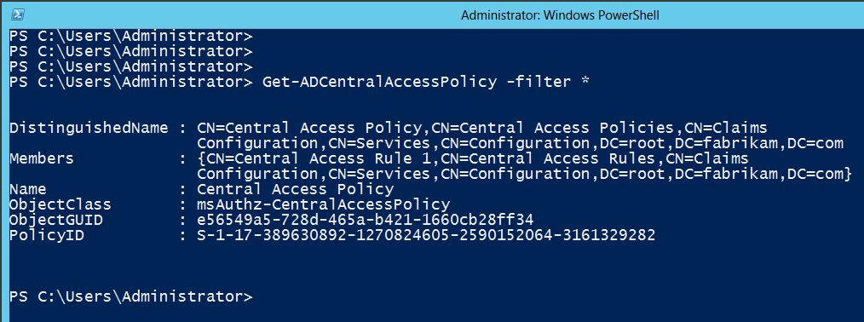
Figure 50 Output of the Get-ADCentralAccessPolicy cmdlet.

Figure 45 shows the information associated with a Central Access Policy object. The out from the Get-ADCentralAccessPolicy cmdlets shows the objects distinguished name and the display name (listed as Name). The member information lists the distinguished name of all the Central Access Rule objects that are members of the Central Access Policy object. The PolicyID attribute is the unique identifier of the Central Access Policy object. Windows uses the PolicyID value to link the Central Access Policy to files and folders on the file server.

Add or Remove a Central Access Rule to a Central Access Policy object
You manage a Central Access Policy's rule membership list using the Add-ADCentralAccessPolicyMember and Remove-ADCentralAccessPolicyMember Active Directory cmdlets. Both cmdlets share the same arguments with the single difference being that the Add-ADCentralAccessPolicyMember cmdlet adds the values of the Members argument to identified Central Access Policy. The Remove-ADCentralAccessPolicyMember cmdlet deletes the values of the Members argument from the identified Central Access Policy.
Add-ADCentralAccessPolicyMember
-Identity:"CN=ExampleAccesspolicy,CN=Central Access Policies,CN=Claims Configuration,CN=Services,CN=Configuration,DC=contoso,DC=com"
-Members:"CN=ExampleAccessRule,CN=Central Access Rules,CN=Claims Configuration,CN=Services,CN=Configuration,DC=contoso,DC=com"

Remove-ADCentralAccessPolicyMember
-Identity:"CN=ExampleAccesspolicy,CN=Central Access Policies,CN=Claims Configuration,CN=Services,CN=Configuration,DC=contoso,DC=com"
-Members:"CN=ExampleAccessRule,CN=Central Access Rules,CN=Claims Configuration,CN=Services,CN=Configuration,DC=contoso,DC=com"

Identity
Use the Identity argument to specific the Central Access Policy on which the Set-ADCentralAccessPolicy or Remove-ADCentralAccessPolicy cmdlet performs the action. A valid identity argument includes the object's display name, name, distinguished name, or globally unique identifier (GUID).

Example
-Identity:"CN=ExampleAccesspolicy,CN=Central Access Policies,CN=Claims Configuration,CN=Services,CN=Configuration,DC=contoso,DC=com"

Members
Use the Members argument to specify the list of Central Access Rules that become members of the Central Access Policy when using the Add-ADCentralAccessPolicyMember cmdlet, or to specify the list of Central Access Rules that are removed from the identified Central Access Policy when using the Remove-ADCentralAccessPolicyMember cmdlet

Example
-Members:"CN=ExampleAccessRule,CN=Central Access Rules,CN=Claims Configuration,CN=Services,CN=Configuration,DC=contoso,DC=com"

Server
Use the optional Server argument to force the responsibility performing the requested action to a specific server. Suffix the argument with the fully qualified domain name of the computer you want to add or remove the Central Access Rule from the Central Access Policy object.

Example
-Server:"hq-con-dc-01.corp.contoso.com"

Deploying Central Access Policy to File Servers
You need to deploy Central Access Policies to Windows Server 2012 file servers. Deploying Central Access Policies is a two-step process. The first step has you deploying the actual Central Access Policy to the file servers throughout your enterprise using Group Policy. The second step has you applying the deployed Central Access Policy to one or more folders on the file server.

Deploying Central Access Policy using Group Policy
Central Access Policy deployment uses Group Policy for deployment. You deploy Central Access Policies to computers using the Computer Configuration namespace of Group Policy. The Computer Configuration namespace hosts the security policy for the computer under the Windows Settings\Security Settings node. The Security Settings node is the parent node to many child nodes, one of which that is named File System

File System Security Policy Settings
The File System node under Security Settings existed in previous versions of Windows. You use this node to deploy permissions to files and folders on the computer that receives the Group Policy. Windows Server 2012 extends the File System node's functionality by allowing you to assign one or more Central Access Policies to the Group Policy object. The Central Access Policies included in the Group Policy object are then deployed to the file server when it applies the Group Policy. This allows you to select the Central Access Policy that applies to each shared folder.
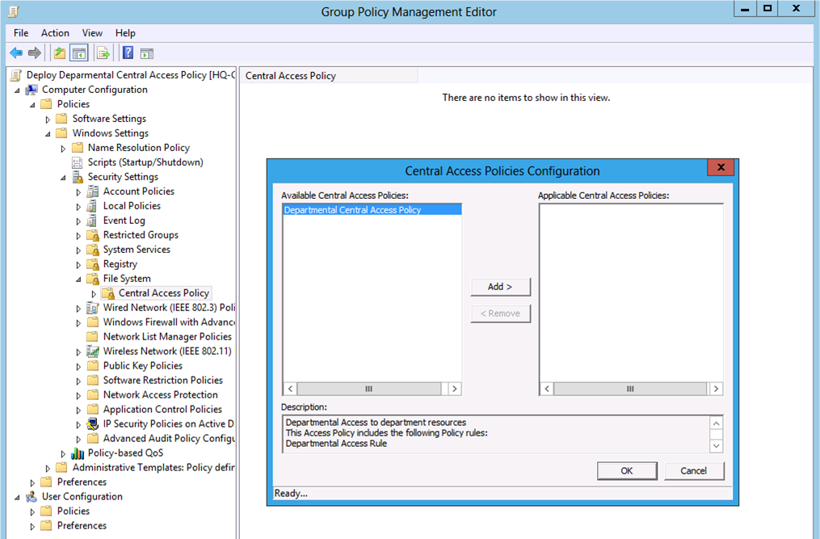
Figure 51 Configure a Central Access Policy in a Group Policy object.

Add Central Access Policy objects to a Group Policy object
To add a Central Access to a Group Policy objet
- Start the Group Policy Management Console (GPMC).
- Expand the Forest and then Domains node in the navigation pane.
- Expand the domain name in the navigation pane for the domain in which you want to create the Group Policy object that contains the Central Access Policy.
- Right-click the Group Policy Objects node and then click New.
- Provide a name for the new Group Policy object in the New GPO dialog box and then click OK
- Right-click the newly created Group Policy object in the details pane and click Edit
- In the Group Policy Management Editor under Computer Configuration, expand Policies, expand Windows Settings, and then expand Security Settings.
- Expand the File Systems node. Right-click Central Access Policy and then click Manage Central Access Policies…
- In the Central Access Policies Configuration dialog box, select the Central Access Policy you want to add to the Group Policy object from the Available Central Access Policies list.
- Click Add to move the selected Central Access Policy to the Applicable Central Access Policies list. Click OK when the Applicable Central Access Policies list contains all the Central Access policies you want to deploy.
- Close the Group Policy Management Editor to return to the Group Policy Management Console. Link the newly created Group Policy object containing the Central Access Policies to a scope of management that includes the Windows Server 2012 file server that receives the Central Access Policy.
- Close the Group Policy Management Console.

How are Central Access Polices stored in a GPO
Windows Security Policy extends the Group Policy Management Editor included with Windows Server 2012 to write Central Access Policy information into the Group Policy object. When you close the Group Policy Management Editor, the security settings Group Policy Management Editor extension saves information about the Central Access Policies you configured in the Applicable Central Access Policies list.
The security settings Group Policy Management Editor extension saves configured Central Access Policy information on the domain's SYSVOL for the associated Group Policy object in an .INF file. Windows represents a Group Policy object a single instance of policy. However, a Group Policy object is two relational object joined by sharing the same global unique identifier (GUID). The Group Policy Container object resides in Active Directory. The Group Policy Template resides on the domain's SYSVOL folder, which is hosted and shared by all domain controllers in the domain.
A domain's shared SYSVOL folder contains a policies folder. All the Group Policy objects in the domain store their Group Policy Template under the policies folder. The Group Policy Management Console names each folder on the policies folder using the GUID of the Group Policy object. Each GUID folder represents a single GPO and stored most of the GPOs configuration information. A GPO configured with Central Access Policies has a CAP.INF file stored under GUID_FOLDER\Machine\Microsoft\Windows NT\Cap. The .INF file contains the distinguished name of each Central Access Policy configured in the Group Policy object. The actual Central Access Policy configuration remains in Active Directory, not in the Group Policy object. The Central Access Policy Configuration Group Policy client-side extension reads this information when Group Policy applies to file server.

Applying Central Access Policy to Folders
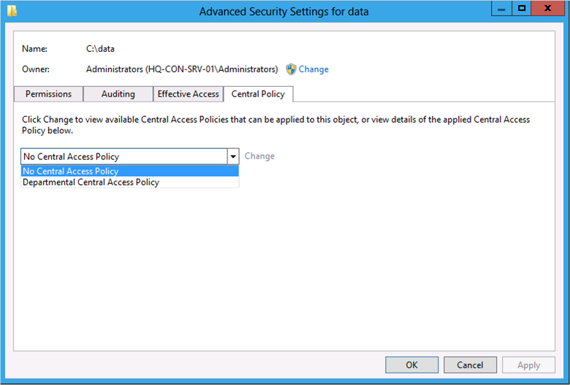
Figure 52 Central Access Policy deployed to server and configured on the data folder.
Windows Server 2012 allows you to deploy Central Access Polices to Windows Server 2012 file servers. Each Group Policy used to deploy Central Access Policy can include multiple Central Access Policies. Therefore, you need to configure folders on the file server to use Central Access Policies when determining a user's access to the folder.

Configuring Folders to use a Central Access Policy
You can configure folders on Windows Server 2012 file server only after you have deployed on or more Central Access Polices using Group Policy. Create a resultant set of policy (RSOP) report on the file server to determine if Group Policy successfully applied Central Access Policies to the file Server.
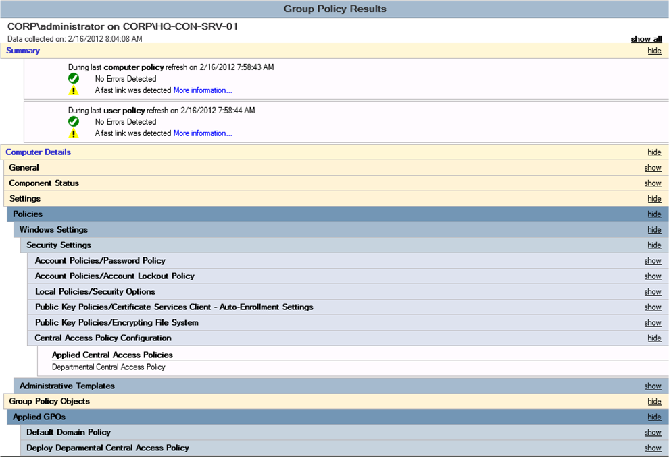
Figure 53 GPResults output showing applied central access policies

Verify Central Access Policies applied
To create and view an RSOP report to confirm Central Access Policies applied to the file server
- Open an elevated command prompt.
- Type gpresult /h rsop.html.
- When gpresult completes, type start rsop.html to view the resultant set of policy report in the default web browser.
- Look for a report section titled Central Access Policy Configuration under Computer Details\Settings\Windows Settings\Security Settings section.
- Confirm Central Access Policies are applying to the file server.

Configure a folder to use Central Access Policy
Use the Advanced Security Settings Editor to configure a folder to use a Central Access Policy.
To configure a folder to use a Central Access Policy
- Open Windows Explorer.
- Navigate to the folder you want to configure to use a Central Access Policy.
- Right-click the folder and click Properties.
- In the folder's property dialog box, click Security and then click Advanced.
- Click the Central Policy tab In the Advanced Security Settings editor.
Tip: | The Central Policy tab does not show in the Advanced Security Settings editor unless the file server has received Group Policy objects that receive one or more Central Access Policies.

- Click Change to enable the Central Access Policy list.
- Select the Central Access Policy to apply to this folder from the list of Central Access Policies. After you select the Central Access Policy, a list of Central Access Rules that are members of the selected Central Access Policy appear below the Central Access Policy list. Use the chevrons to expand the rule and view its configuration.
- Click OK to apply to the Central Access Policy to the folder.

How Windows stores Central Access Policy links
Successfully deployed Central Access Policy objects appear in the list of central access policies in the Central Policy tab of the Advanced Security Settings Editor. Windows creates an association between the Central Access Policy and the folder on the file system where you link a Central Access Policy.
Windows stores this association in the system access control list (SACL) of the file or folder's security descriptor. The Central Policy tab creates this association using the AddScopedPolicyIDAce. The API insert the Central Access policy object's policy identifier as the last entry in the system access control list. The policy identifier resembles a security identifier; however, policy identifiers begin with S-1-17. This identifier prefix uniquely identifies and delineates a Central Access policy object's policy identifier from a security identifier. This creates the association between the Central Access Policy and the folder. The association enables Windows to identify files and folders that are protected by Central Access Policy.
 Critical: | Linking a Central Access Policy object to a file or folder changes the security descriptor of the file and folder. Changing the security descriptor changes the file. Changing the security descriptor generates a change order when the file is replicated using Distributed File System Replication (DFSR) or File Replication Service (FRS).  Understand the replication ramifications when applying Central Access Policies to files and folders that are replicated using these technologies.  Once you applied the Central Access Policy to the replicated file or folder, you can change the permissions protecting the file or folder using the Central Access Policy, which does not change the file or folders security descriptor. The files or folders security descriptor changes only when you link or unlink a Central Access Policy to or from the file or folder.

How File Servers receive Central Access Policies
The Windows Server 2012 file server receives Central Access Policies through Group Policy. When Group Policy applies, the Group Policy Central Access Policy Configuration client side extension reads the CAP.INF file from the domain controller. The CAP.INF file contains the distinguished name of each Central Access Policy deployed in the Group Policy. The distinguished name provides the name and location of where the Central Access Policy resides in Active Directory. This is how the client extension determines the Central Access Policies deployed in the GPO and where the actual Central Access Policy configuration resides in Active Directory.
The Central Access Policy Configuration client side extension knows the deployed Central Access Policies; however, it does not have any configuration information, which is needed by the Advanced Security Settings editor to display the list of applied Central Access Policies. The client side extension uses LDAP, connects to Active Directory, and reads the configuration data stored in each Central Access Policy. The client side extension (CSE) also reads all of the Central Access Rules that are members of each Central Access Policy. The client side extension writes this information to the parent registry key located at
HKEY_LOCAL_MACHINE\SYSTEM\CurrentControlSet\Control\Lsa\CentralizedAccessPolicies
Note: | The maximum amount of time the Group Policy Central Access Policy Configuration client side extension waits to refresh Central Access Policies is 120 minutes, regardless if Group Policy detected any changes to the Group Policy object. This ensures that file server has the latest Central Access Policies on the next Group Policy refresh once the 120 minute time limit has expired.

Two registry keys appear under the parent registry key when file server applies Group Policy: CAPEs and CAPs. The CAPs registry key stores all the Central Access Policy objects that apply to the computer. The CAPEs registry key stores all of the Central Access Rules that are linked to the Central Access Policies deployed to the file server. The CSE sequentially numbers child registry keys under the CAPEs and CAPs registry keys. Each number represents a unique Central Access Rule and Central Access Policy respectively.

Registry entries for Central Access Rules
Each Central Access Rule deployed in a Central Access Policy has a set of values stored in the registry. These names and values correspond to the rule's configuration in Active Directory.
Table 19 Central Access Rules registry value names and descriptions
Value Name | Description
AppliesTo | Contains a binary representation of the conditional expression for the rule's Target Resources.
ChangeID | A timestamp that is the whenChanged attribute on the Central Access Rule object in AD at the time object was most recently read by the file server.
Description | The Central Access Rule's description.
Flags | Used internally to increases performance during access checks.
Name | The name of the Central Access Rule.
SD | The binary representation of the permission entries in the Central Access Rule's current permissions list.
StagedSD | The binary representation of the permission entries in the Central Access Rule's proposed permissions list

Registry entries for Central Access Policies
Table 20 Central access policy registry value names and descriptions
Value name | Description
CAPEs | The binary representation of the Central Access Rules linked to the Central Access Policy.
CAPID | The binary representation of the Central Access Policy's unique identifier. This information comes from the msAuthz-CentralAccessPolidyID attribute on the Central Access Policy object in Active Directory.
ChangeID | A timestamp that is the whenChanged attribute on the Central Access Rule object in AD at the time object was most recently read by the file server.
Description | The Central Access Policy's description.
Flags | Used internally to increases performance during access checks.
Name | The name of the Central Access Policy.

When Group Policy applies, the Central Policy Configuration client side extension, implemented in auditcse.dll, reads the Central Access Policies in the CAP.INF file. The CSE then reads each of the Central Access Rules from the each Central Access Policy's membership list. Then, the CSE writes the information into the registry. The Central Access Policies and Central Access Rules are then applied to the Local Security Authority. These Central Access Policies are affective for the file server until the Group Policy object containing the Central Access Policies changes, or 120 minutes has passed without Central Access Policies refreshing. If either occurs, then the CSE updates the registry and the Local Security Authority during the next Group Policy refresh.
Important: | The Central Access Rules of a deployed Central Access Policy can change without the Central Access Policy or the Group Policy object changing. It for this reason that the Central Access Policy Configuration CSE forcibly refreshes the Central Access Polices on the next Group Policy refresh after 120 minutes has past. Use GPUPDATE /FORCE on the file server to immediately update the deployed Central Access Policies for the file server.

Modeling Central Access using Proposed Permissions
Windows Server 2012 and Central Access Policies provide a unique feature that allows you model permission entries without affecting your production. Permission modeling is a simple way to introduce "what if" scenarios for Central Access Polices. You model future permission entries in Central Access Policies by configuring the Proposed Permission portion of a Central Access Rule and enabling Central Access Policy Staging auditing.

Proposed Permissions
You configured proposed permission entries on a Central Access Rule. The permission entries used in a proposed permissions list are the same kind of permission entries used in the current permissions list; however, how Windows uses each permission list is different.
Windows uses the permission entries in the current permissions list to determine access to the file or folder. Effective access to the file or folder can be any combination of permission entries from share, NTFS, and Central Access Policy, which contain Central Access Rules that hold the current permissions list. The important thing to remember is that permission entries in the current permissions list affect access to files and folder in production.
Permissions entries in the proposed permissions list help you model new permission entries in Central Access Rules without the risk of negatively affecting production. You configure proposed permissions as you would configure current permissions. Windows uses the proposed permissions list and file system auditing to show the access difference a user receives from the current permissions list and the proposed permissions list.
Proposed permissions are a component of the Central Access Rule. Central Access Rules only provide allow access; you cannot disallow access using deny permission entries. You can only include allow permission entries in proposed permissions lists. See Central Access Rule under the Managing Central Access using the Active Directory Administrative Center for more information.

Central Access Policy Staging auditing
Proposed permissions are only effective when you configure advanced auditing to report access differences to the event log. Ideally, you want to enable advanced auditing using domain-based Group Policy. Using domain-based Group Policy allows you to configure auditing one time, but apply it to many computers. Alternatively, you can enable advanced auditing using the computer's Local Group Policy. You manage advanced auditing settings through the Advanced Audit Policy located under Computer Configuration\Policies\Windows Settings\Security Settings.
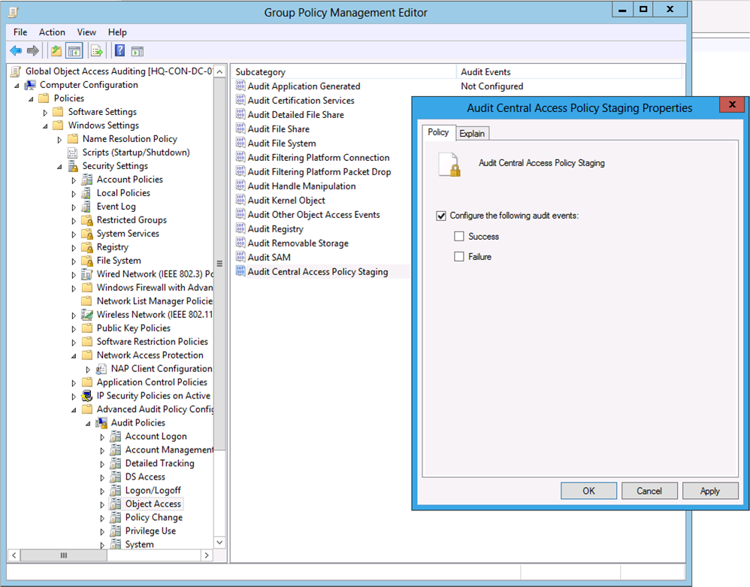
Figure 54 Central Access Policy Staging Auditing Group Policy setting.

Configure Central Access Policy Staging auditing
To configure Central Access Policy Staging auditing
- Open the Group Policy Management Console.
- Create a new Group Policy object or select an existing Group Policy object.
- Right-click the Group Policy object from step 2 and click Edit.
- In the navigation pane under Computer Configuration, expand Policies, Windows Settings, and Security Settings.
- Expand Advanced Audit Policy Configuration and expand Audit Policies.
- Click Object Access. Double-click Audit Central Access Policy Staging.
- Configure the policy setting to audit success or failure events, or both.
- Click OK.
- Close the Group Policy Management Editor.
- Configure a scope of management to the Group Policy object containing the audit policy settings so that policy settings apply to the file server on which you want Central Access Policy Staging auditing to occur.

Success and Failure Audit Events
With Central Access Policy Staging auditing enabled, Windows write an event to the security event log when a user accesses a file or folder and the effective access allowed with the Central Access Policy's current permissions list differs from permission entries listed in the Central Access Policy's proposed permissions list.

Success events
Windows writes a success event to the security event log when the effective access of the Central Access Policy's current permissions list allows access but the effective access of the Central Access Policy's proposed permissions list disallows access.

Failure events
Windows writes a failure event to the security event log when the Central Access Policy's current permissions list disallows the requested access but the Central Access Policy's proposed permissions allow the requested access.
Note: | Central Access Policy staging auditing can potentially log a large number of events on file servers where the proposed permissions significantly differ from the current permissions.

Example
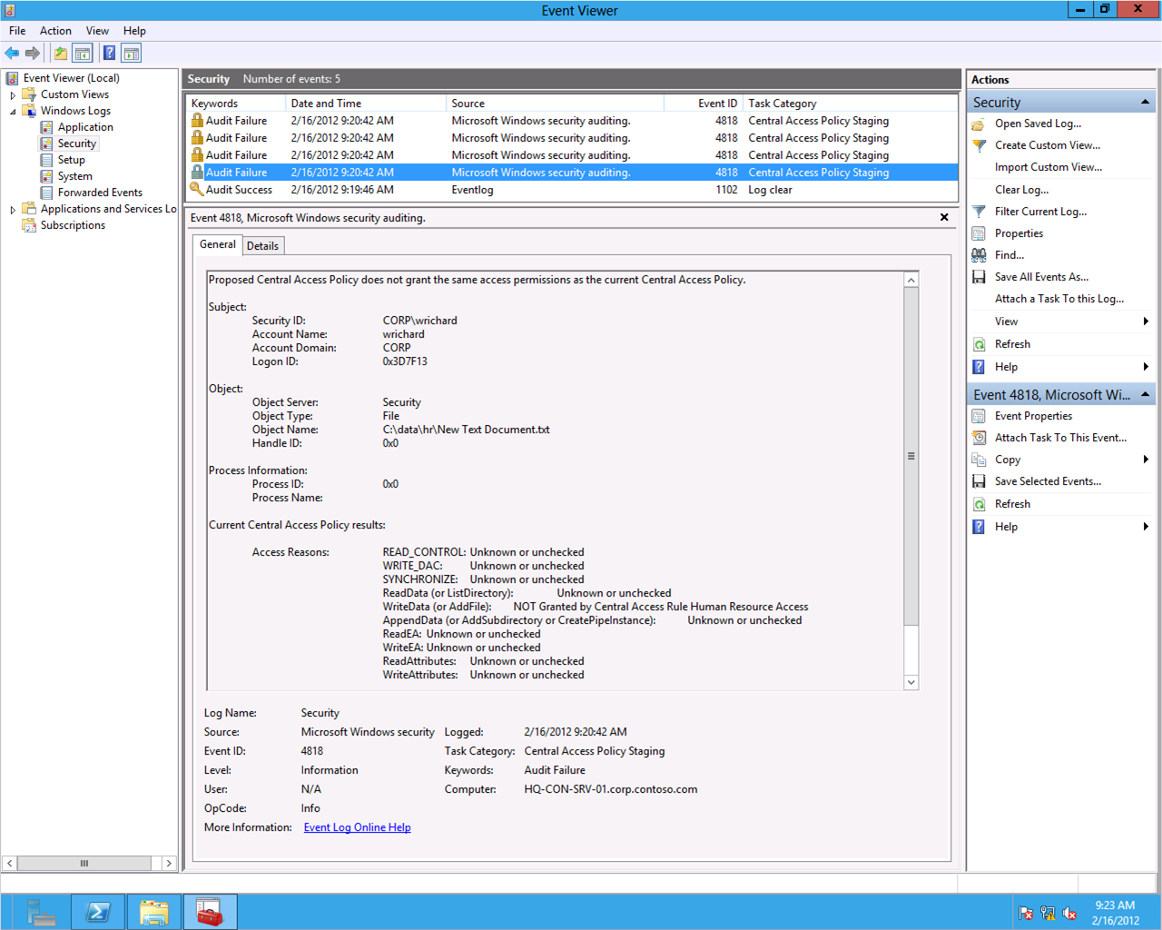
Figure 55 Central Access Staging Audit Event ID 4818 on the file server
Wendy is a member of the Human Resources group. The Windows Server 2012 Server hosting the file services role receives a Central Access Policy through Group Policy. The Central Access Policy contains a Central Access Rule configured for the Human Resources group. The current permissions for the Central Access Rule provide the Human Resources group with Read Permissions. The proposed permissions for the same Central Access Rule model permissions for the Human Resources group with Full Control permissions.
Wendy connects to a shared folder hosted on the Windows Server 2012 file server that receives the Central Access policy. Windows allows Wendy to read the contents of the folder. When attempts to create a new file in the folder. Windows disallows Wendy the required access to write to the folder.
You view the Security event log on the file server hosting the share on which Wendy attempt to create a new file. The Security event log shows one or more audit failure event log entries with the event ID 4818. The information provided in the failed audit event log entry explains that the proposed permissions of the Central Access Policy does not provide the same access as the current permissions. Additional information in the event includes:
- Subject information, which is security principal requesting the access
- The object, which is the file or folder for which the user requests access
- Access reason, which identifies the requested access that differs between the proposed and current permissions of the Central Access Policy.

Effective Access using Central Access Policy
You determine effective access for a security principal when using Central Access policies the same as when determining effective access for Share and NTFS permissions. Central Access policies simply provide another permission list from which Windows uses to determine a security principal's access to a folder or file. You can use Central Access Policy in the following scenarios
- Central Access Policy and NTFS permissions
- Share permissions, Central Access Policy, and NTFS permissions

Central Access Policy and NTFS permissions
You determine effective access when using Central Access policy and NTFS permissions the same as if you were using share and NTFS permissions. First, determine the effective NTFS permission. Remember, NTFS permissions use the least restrictive applicable permissions. Next, determine the effective permissions of the Central Access Policy's current permissions list as if they were NTFS permissions. Finally, determine the combined effective permissions by identifying the permission entries that are common between the Central Access policy's current permissions list and the folders NTFS permissions.

Share permissions, Central Access Policy, and NTFS permissions
You determine effective access for files or folders secured by share permissions, current permissions from a Central Access Polices, and NTFS permissions essentially the same as folders secured by share and NTFS permissions. You determine effective access for share and NTFS permissions the same. Next, you determine the effective access for the applicable current permission entries from the applied Central Access Policy, as if they were NTFS permissions. If a Central Access policy contains multiple Central Access rules, then treat each Central Access rule as a point of access control. Lastly, you determine the combined effective permissions by identifying the permission entries that are common among the share, Central Access Policy (all Central Access rules), and NTFS permissions. The permission entry must exist in all points of access control for it to be part of the user's effective access. A permission entry existing in only one or two of the points of access control is not part of the user's effective access.
Table 21 Permissions entries for share, NTFS, and central access policy scenario
Principal | Permission type | NTFS basic permissions | Condition | Inherited from
Harvey | Deny | Full control  Modify  Read & execute  Read  Write | None | None
Users | Allow | Read & execute  Read | None | None
Marketing | Allow | Full control  Modify  Read & execute  Read  Write | None | C:\
Central Access Policy
User/Group | Permission type | Share permissions | Condition | N/A
Everyone | Allow | Change | @User.Department=="Marketing"
Share Permissions
User/Group | Permission type | Share permissions | N/A | N/A
Everyone | Allow | Change
Marketing | Allow | Full Control

The permissions lists in Table 21 reflect file, share and Central Access Policy permissions. The first user, Alejandra, access a file through a share folder. Alejandra is a member of the users and Marketing group. The access Windows allows her through the share is Full Control (1).
You deploy a Central Access Policy to the file server that contains a Central Access Rule that permits the built-in group Everyone an access of Full Control on the condition that the user has a Department claim that equals Marketing. Alejandra has a Department user claim in her token that equals Marketing; therefore, the Central Access Policy permits her the access of Full Control (2).
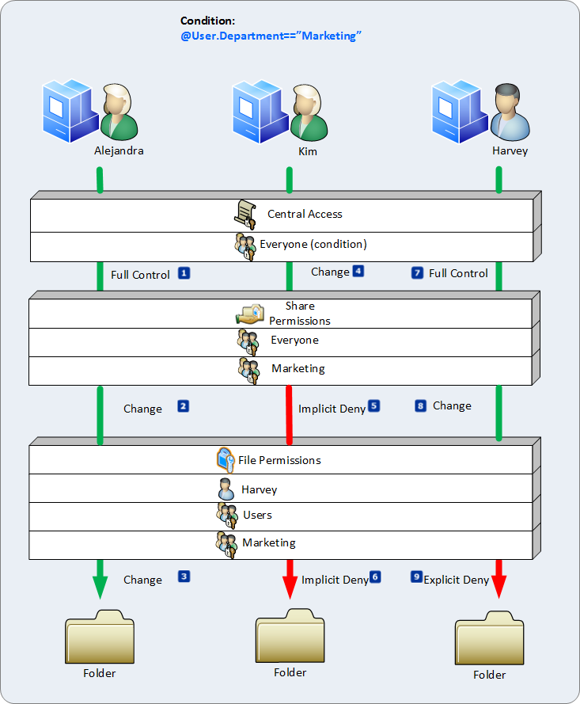
Figure 56 Effective Permissions using share, Central Access Policy, and file permissions for the working scenario.
To determine effective permissions for Alejandra, you evaluate the share, Central Access Policy, and file permission entries together. Permission entries common among the lists are applicable to the user. Permission entries that appear in one or two of the three lists are not applicable. The share permissions permit Alejandra Full Control access. The Central Access Policy permits her with Full Control access. The file system permissions permit her full control access. Therefore, the permissions are consistent among all three points of access control. This makes the effective permissions for Alejandra Full Control when access this shared folder on this file server (3).
Next, Kim accesses the files through the shared folder. Kim is a member of the Users group. The access Windows allows her through the share is Change because of her membership in the Users group (4).
The Central Access Policy deployed to the file server contains a Central Access Rule that permits the built-in group Everyone an access of Full control on the condition that the user has a Department claim that equals Marketing. Kim’s access token does not contain a Department claim with the value Marketing; therefore, the rule in the Central Access Policy does not apply to Kim because her access does not pass the condition.
No other permission entrees in the Central Access Policy are applicable to Kim. Therefore, the Central Access Policy does not have any permission entries that are explicitly granted to Kim, or to any groups to which Kim has membership. The lack of explicit permissions means the Central Access Policy implicitly denies Kim access (5).
To determine effective permissions for Kim, you evaluate the share, Central Access Policy, and file permission entries together. Permission entries common among the permission lists are applicable to the user. Permission entries that appear in one or two of the three lists are not applicable. The share permissions permit Kim Change access. The Central Access Policy disallows Kim any access because she does not receive any explicit permissions. The file system permissions permit members of the Users group Read access. Read permissions from the file system and Change permissions from the Share have Read permissions common between the two. However, the Central Access Policy does not provide any access to Kim. Therefore, no permissions are common among all three points of access and Kim’s effective access is deny Full Control (6).
Lastly, Harvey accesses the file through the shared folder. Harvey is a member of the Users and Marketing group. Like Alejandra, Harvey is permitted Full Control access to the file share because of his membership in the Marketing group (7).
The last example identified that Harvey's effective file access denied Full Control. Again, you compare permission entries from the user's file system effective permissions and the permission entries on the share that are applicable to the user (share permissions or permission entries where the principal is the user or a group of which the user is a member).
You deploy a Central Access Policy to the file server that contains a Central Access Rule that permits the built-in group Everyone Full Control access on the condition that the user has a Department claim that equals Marketing. Harvey has a Department user claim in his token that equals Marketing; therefore, the Central Access Policy permits him Full Control access (8).
To determine effective permissions for Harvey, you evaluate share, Central Access Policy, and file permission entries together. Permission entries common among the permission lists are applicable to the user. Permission entries that appear in one or two of the three lists are not applicable. The share permissions permit Harvey Full Control access. The Central Access Policy permits Harvey Full Control access because his access token includes a Department user claim with a value of Marketing. However, the file system permissions include an explicit Deny for Harvey. The Full Control access permitted by share and Central Access Policy are nullified by the deny Full Control file system permission. Therefore, Harvey’s effective permission is deny Full Control (9).

Managing and Deploying Claims-based Global Object Access Auditing

Windows Server 2008 R2 introduced functionality that allowed you to deploy file and registry auditing to a computer rather than on the individual resources. You accomplished this configuration using Global Object Access Auditing. With Global Object Access Auditing, Windows stores the audit entries in the Local Security Authority. This feature allows you to deploy file system auditing to terabytes of data without changing the audit entries on the thousands of files and folders. In addition, Global Object Access Auditing ensures auditing occurs regardless of what changes local file server administrators may have made to individual audit entries (http://technet.microsoft.com/en-us/library/dd772630(WS.10).aspx).
Windows Server 2012 extends Global Object Access Auditing by allowing you to configure claims and resource properties in conditional expressions and to include those conditional expressions within the Global Object Access Auditing policy settings.

Managing Global Object Access Auditing
The Global Object Access Auditing feature in Windows 8 and Windows Server 2012 allows you to configure object access auditing for every file and folder in the file system for the computer. You use this policy setting to centrally manage and configure Windows to monitor every file and folder on the computer.
Global Object Access Auditing is more beneficial over traditional auditing. With traditional auditing, you must manually add audit entries to each file and folder for Windows to record an audit event. This can be overwhelming on file servers hosting terabytes of data. Also, modifying audit entries on a files changes the file. This change causes files monitor by the Distributed File Replication Service (DFSR) to send changes to its partners. Mass changes can slow replication convergence. Global Object Access Auditing solves both of these problems because the policy setting does modify files or folders. Windows stores the configuration in memory, and applies the audit entries when the user accesses the file or folder.
You also use Global Object Access Auditing to help with compliance reporting. Traditional auditing requires audit entries directly on the files or folders. Local administrators and file owners can modify audit entries. Using Global Object Access Auditing ensures that Windows audits all files and folders on the file system, regardless of their direct audit entries. And, Windows 8 and Windows Server 2012 aggregates audit entries among files, folders, and multiple Global Object Access Auditing policy settings.

Configuring Global Object Access Auditing
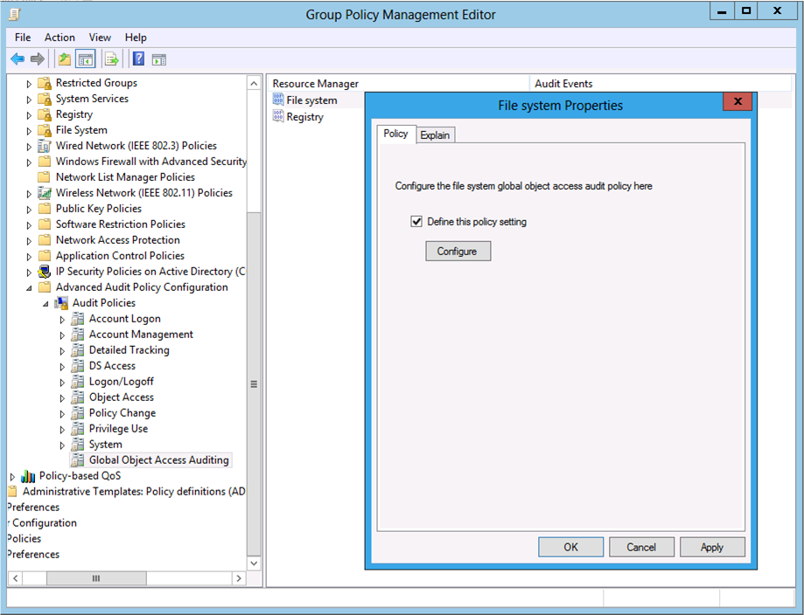
Figure 57 Global Object Access Auditing File System Group Policy setting.
You configure Global Object Access Auditing by when you enable Object Access auditing and Global Object Access Auditing. Enabling Object Auditing turns on auditing for the computer that applies the policy setting. However, enabling auditing alone does not always generate auditing events. The resource, in the instance files and folders, must contain audit entries.
The audit entries, like permissions, defined a permission, or action asserted by the user when connecting to a resource. That action is associated with a type of audit entry: success or failure. Windows compares the audit entries type and the permission on the audit entry against the result of the user asserting that permission on a resource. Windows then records a successful audit event if the result is successful, and a failure event of the result of using the permission failed.
You avoid creating auditing entries on each file and folder by using Global Object Access Auditing. You define all the file system audit entries in a single centrally managed policy and deploy the policy using Group Policy. Windows applies the audit entries dynamically, at the time of access, without modifying the file in any way.

Domain-based Policy
The ideal way to configure Global Object Access Auditing for the enterprise is to use the security policy of a domain-based group policy object. The two security policy settings needed to enabled Global Object Access Auditing are located at
Computer Configuration\Windows Settings\Security Settings\Advanced Audit Policy\Audit Policies\Object Access\Audit File System
Computer Configuration\Windows Settings\Security Settings\Advanced Audit Policy\Audit Policy\Global Object Access Auditing\File System

Note: | You can configure Global Object Access Auditing in the computer's Local Computer Policy for stand-alone computers. Domain-joined computers should always utilize domain-based Group Policy when possible.

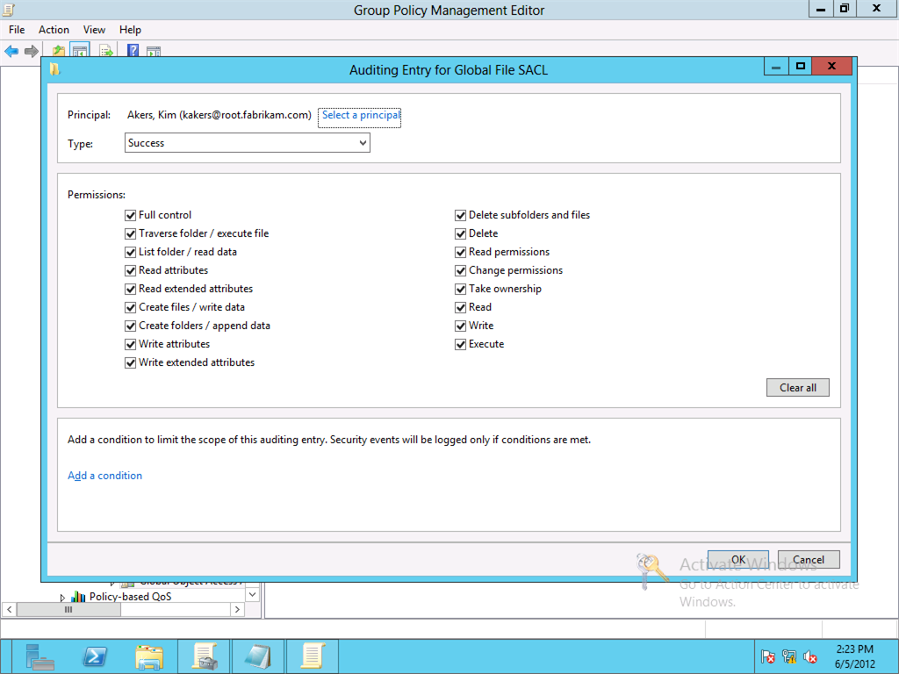
Figure 58 Audit Entry for Global Object Access file auditing.
First, you enable the File System Global Object Access Auditing policy setting. Then, you configure the list of audit entries you want to deploy through the policy setting. When you click Configure on the policy's property page, the Advanced Security Settings editor appears and shows the Auditing tab. This tab is a familiar configuration point, as it is the same tab you use to configure auditing directly on a file or folder.
One benefit of using the new Advanced Security Settings editor for creating audit entries is that add value of using claims and resource properties in conditional expressions. Windows evaluates conditional expression in the same manner that it does when they exist on permission entries-- it is simply another layer of applicability. If the conditional expression on the audit entry evaluates to false, then Windows ignores that audit entry and continues to evaluate the next entry.
This enhancement to Global Object Access Auditing allow you to create a single audit policy that can audit files and folders differently based on claims and resource properties used during the time its accessed. For example, a Read success audit entry for Authenticated Users with a conditional expression of @Resource.department == "Accounting". The result of this audit entry causes Windows to audit all successful read access by any authenticated user to a file folder as long as the department property on the resource is accounting. Windows ignores this audit entry for files and folders that do not have the value accounting in their department property.

Configure Global Object Access Policy
To configure a Global Object Access Policy
- Open the Group Policy Management Console.
- Create a new Group Policy object or select an existing Group Policy object.
- Right-click the Group Policy object from step 2 and click Edit.
- In the navigation pane under Computer Configuration, expand Policies, Windows Settings, and Security Settings.
- Expand Advanced Audit Policy Configuration and expand Audit Policies.
- Click Global Object Access Auditing. Double-click File System from the detail pane.
- Select Define this policy setting in the File system Properties dialog box and then click Configure.
- Click Add to insert new audit entry.
- In the Auditing Entry for Global File SACL dialog, select a principal to whom the audit entry applies, permissions, and one or more conditional expressions. Click OK.
- Repeat step 8 and 9 until the policy is configured as desired.
- Click OK.

Deploying Global Object Access Auditing

Applying Global Access Auditing to a File Server
Deploying Global Object Access Auditing is easy because it is a Group Policy setting. This means you apply Global Object Access Auditing as you apply any other Group Policy setting. Simply include the GPO containing the Global Object Access Auditing policy setting in the scope of a computer object and refresh Group Policy on the computer.
Important: | Remember that you must also enable File System Object Access Auditing for the Global Object Access Auditing policy to audit information based on the policy's audit entries.

Policy behaviors
Windows 7 and Windows Server 2008 R2 introduced Global Object Access Auditing. Windows 8 and Windows Server 2012 include an enhanced version. The enhancements introduced with Windows Server 2012 are not compatible with Windows 7 and Windows Server 2008 R2. Windows 7 and Windows Server 2008 R2 fail to process Global Object Access Auditing Policies that contain conditional expressions. Therefore, you should create two separate Global Object Access Policies-- one for each operating system and ensure the policy for Windows 7 does not have audit entries containing conditional expressions.
Another behavior change between Windows 7 and Windows 8 is the resulting set of polices when you apply more than one Global Access Auditing Policy using Group Policy. Windows 7 only applies the Global Object Access Policy settings from the winning Group Policy object. Typically, the winning Group Policy object is the Group Policy object containing the Global Object Access Policy that applied last. This behavior changes in Windows 8 and Windows Server 2012.
Windows Server 2012 aggregates the audit entries together, from all sources-- files, folders, and multiple Global Object Access Policies. This new behavior provides the most detailed auditing experience for files and folders and ensures that Windows evaluates all auditing entries, regardless of which Group Policy object applies them.

Confirming Policy applied to the file server
Create a Group Policy results report to confirm you successfully deployed the Global Object Access Auditing policy. You create a Group Policy report by opening an elevated command windows and type GPRESULT /H rsop.html. Then, open the rsop.html file in a web browser and search for the section titled Global Object Access Auditing - File.

Combining File system and Global Object Access Auditing
Windows combines audit entries configured on files and folders with the audit entries defined in the Global Object Access Auditing policy. However, there are some caveats with regard to Global Object Access Auditing policies, conditional expressions and multiple policies applying to a computer.

Windows 7 and Windows Server 2008 R2
Global Object Access Auditing policies that include conditional expressions fail when applied to Windows 7. This failure occurs because the earlier versions of Windows cannot convert the string representation of the audit entries containing conditional expressions into their binary equivalent.
Windows 7 and 2008 R2 only apply the winning Group Policy object when multiple Global Object Access Auditing policy settings apply to the computer. Windows determines the winning Group Policy object as the last Group Policy object that applies to the computer and contains Global Object Access Auditing policy settings. Conflicting settings from Global Object Access Auditing policy settings in other Group Policy objects do not apply.

Windows 8 and Windows Server 2012
Windows 8 and Windows Server 2012 are aware of conditional expressions. Therefore, you can use them in Global Object Access Auditing policies that are targeted for Windows 8 and Windows Server 2012 computers.
Windows 8 applies an aggregate of all the audit entries from multiple Global Object Access Auditing policies rather than only applying audit entries from the winning Group Policy object.
Because of the differences of how each operating system handles Global Object Access Auditing policies, you should create separate Global Object Access Auditing policies for each operating system and apply them respectively.

Claim Transformations and Policies
Windows Server 2012 introduces support for claim-based authorization. Claims simply are assertions made by a trusted source about a security principal. The trusted sources are Windows Server 2012 domain controllers. Domain controllers issue claims for security principals. These claims are valid among all the Windows Server 2012 domain controllers within the forest.
However, Windows Server 2012 domain controllers handle claims that traverse forest trusts differently than the trusts between domains in the same forest. Also, the behavior is different depending on if the domain is the trusted or the trusting domain. Additionally, you may want to limit the claims that Windows sends or receives across a forest trust. Or, you may encounter constraints that require Windows to transform the claim before it sends or receives the claim for use by a domain controller. Windows Server 2012 allows you to configure domain controllers to filter and transform claims across a forest trust using Claim Transformation Policies.

Scenarios
Windows Server 2012 you to filter or transform incoming and outgoing claims that traverse a forest trust. Windows provides three basic scenarios for filtering and transforming claims. These scenarios include value-based filtering, claim type-based filtering, and claim type-based transformation.

Value-based filtering
Value-based filtering is claim filtering that is based on the value of a claim. You implement value-based filtering in the trusted forest. This allows the trusted forest to prevent claims with certain values from being sent to the trusting forest.
Domain controllers in trusting forests can use value-based filtering as guard against elevation of privilege by filtering the incoming claims with specific values from entering the forest.

Claim type-based filtering
Claim type-based filtering is claim filtering that is based on the type of claim rather than the value of the claim. With Windows claims, you identify the claim type by the identifier of the claim type. You use claim type-based filtering in the trusted forest. Claim type-based filtering prevents Windows from sending claims that disclose information to the trusting forest.
Domain controllers in trusting forests can use claim-type based filtering in the same fashion as value-based filtering, which is to filtering incoming claims from the trusted domain based on their claim type.

Claim type-based transformation
Claim transformation manipulates a claim before sending it to it intended target. You use claim type-based transformation in the trusted forest to generalize a known claim that contains specific information. You can use transformations to generalize the claim-type, the claim value, or both. Generalizing claim information allows you to limit how much claim detail you exchange with the trusting forest.
Domain controllers in a trusting forest can use claim-type-based transformation to translate incoming claims into a claim type that is based on an attribute in the forest. Claim-transformations allow the trusted and trusting forests to agree on common claim type that is not based on an Active Directory attribute. This prevents each forest from exposing claim-types based on their attributes, but still allows both parties to exchange claim information across the trust.

Claim Transformation and Filtering
Windows Server 2012 introduces a way to filter and transform claims across forest trusts using Claim Transformation Policies. Claim Transformation Policy object include one or more rules that describe if Windows should use the claim, filter the claim, or transform the claim crossing forest trusts. You create rules using a claim Transformation Rules Language. The Local Security Authority uses a transform engine to evaluate these rules, in their compiled form, and issues, filters, or transforms the input claim.
Important: | Transformation Rule Language closely resembles Claim Rules Language used in Active Directory Federation Services (AD FS). However, the Transformation Rule Language does not support all the functionality of the Claims Rules Language.

Transform Engine
The Windows Server 2012 claim transform engine is responsible for compiling, filtering, and transforming input claims before they are used. The transformation engine is actually performs two duties. The engine parses and compiles rules found on transformation policy objects and transforms input claims based on compiled rules into output claims. The transformation engine implementation consists of ntdsai.dll, which runs inside the lsass.exe process and the files TRLParserInterface.dll, TRLParserInterop.dll, TRLParser.dll, and TransformationRulesParser.exe.
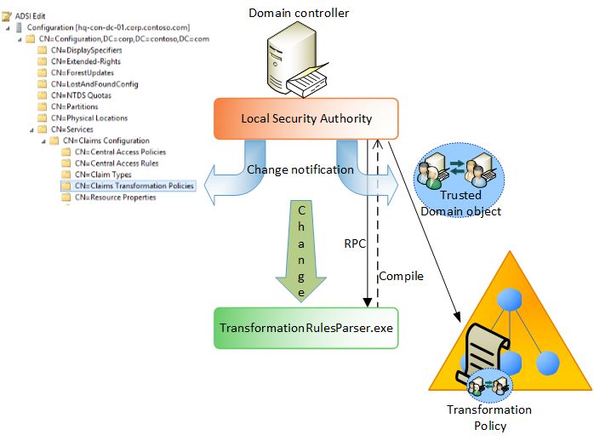
Figure 59 Conceptual representation of claim transformation rule engine.

You create Transformation rules when you create a Transformation Policy object. The transform engine (TransformationRulesParser.exe) parses and validates the transformation rule language. Once validated, the transform engine compiles the rule and stores the compiled output on the transformation policy object. The transformation engine then uses the compiled rules on the transform policy object to determine which input claims it filters and which input claims it transform into output claims.

Parsing and Compiling Rules
The transformation engine parses and compiles rules using TransformationRulesParser.exe. A portion of the transformation engine runs within the Lsass.exe process. The transformation engine registers change notification for changes on all transformation policy objects within the transformation policy object container. The transformation policy container resides in the configuration partition in Active Directory. The transformation engine receives notification of any changes made to the trusted domain object.
When the transformation engine receives a change notification, it then triggers a single instance of the TransformationRulesParser.exe. Next, the transformation engine within the Lsass.exe process establishes a mutually authenticated RPC connection to the TransformationRulesParser.exe process and sends the transformation rule language version of the rule to the rules parser. The rules parser validates the transformation rule language and translates the transformation rule language into a compiled version. The rules parser returns the compiled version of the rule to the transformation engine that runs within the Lsass.exe where they are cached. The transformation engine then saves the compiled rules in an attribute on the transformation policy object.
As previously stated, the transformation engine compiles rules when Windows notifies it that a transformation policy object in the transformation policy object container has changed, when trusted domain object has changed, or when starting Lsass.exe. Also, during startup, the transform engine cache's the compiled rules within the Lsass.exe process.
The transformation rules parser has a default idle wait time of five minutes. The parser begins measuring idle time after it completes its last request. If Lsass.exe does not send any further requests with in the five minute period, then the parser process terminates. Lsass.exe starts the process again when it is notified of change that occurs with the trusted domain object or a transformation policy object.
For troubleshooting purposes, you can control the length of parser's idle wait timeout. To change the idle wait timeout, use the HKLM\System\CurrentControlSet\Control\Lsa\Transformation registry key. Under that key, create a 32-bit DWORD registry value name ParserIdleWaitTime. Enter a value measured in seconds for the duration the parser should wait idle before exiting.

Claim Filtering and Transformation
The transform engine is also responsible for claim filtering and transformation. Claim transformation and filtering occurs in the Lsass.exe process. The claim transform engine receives a list of claims from the user's PAC as a claim input list. The transform engine iterates through the list of compiled rules from the linked transformation policy object comparing the input claim against each compiled rule. If the evaluated result of the claim rule and the input claim return true, then the transform engine processes the issue clause found in the rule. The transform engine inserts the claim resulting from the processing rule's issue clause into the claim output list. An input claim can match zero or more rules, which explains why an input claim can appear in the claim output list multiple times. The transform engine resolves this problem by performing one last pass on the output list and removes duplicate claims from the claim output list. The transform engine then passes the claim output list to Kerberos and Kerberos uses the claim output list as the list of claims that traverse the forest trust in the user's PAC.
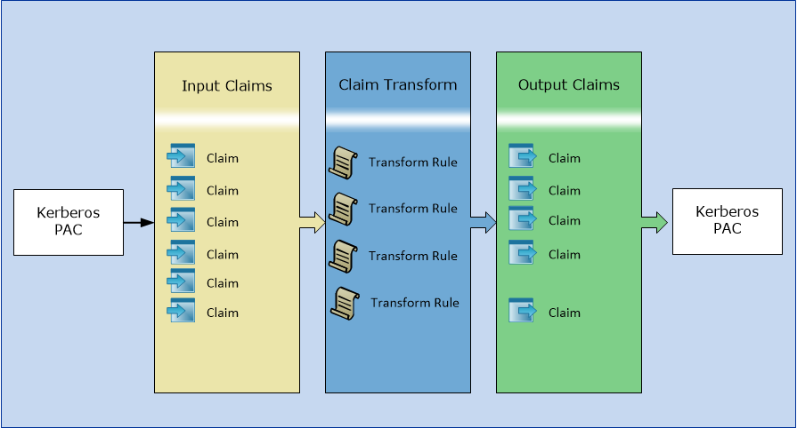
Figure 60 Claim processing pipeline

The Lsass.exe process has predetermined behaviors of how it transforms claims, outside the behaviors described when using transformation rule language. Remember that claim transformation only occurs across forest trusts and you must link a claim transformation policy to the trusted or trusting forest. It is important to understand if the forest is the trusted or trusting forest as this is basis for linking transformation policy objects to trusted forests. Trusted and trusting domains have different default behaviors when transforming claims.
Typically, the trusted forest is the forest that contains user accounts, and the trusting forest contains resources you want allow the trusted users to access. This represents a one-way trust. In a two-way trust, each forest can be the trusted and trusting forest. Therefore, a one-way trust presents two opportunities to transform or filter claims-- when the claim leaves the forest and when the claim enters the forest. A two-way trust presents four total opportunities to transform or filter claims-- two for each trust in each direction.
By default, domain controllers in the trusted forest allow all claims to pass across the forest trust. Domain controllers in the trusting forest drop all incoming claims they receive from the trusted forest. Therefore, the trusted forest sends claims across the trust while trusting forest receive claims across the trust.
For example, a one-way forest trust exists between the corp.contoso.com forest and the litware.com forest. In this example, corp.contoso.com is the trusted domain and litware.com is trusting domain. A user from the corp.contoso.com forest accesses a resource in the litware.com forest. The domain controller in the corp.contoso.com forest must send a ticket with the user's claims using Kerberos to the domain controller in the litware.com forest.
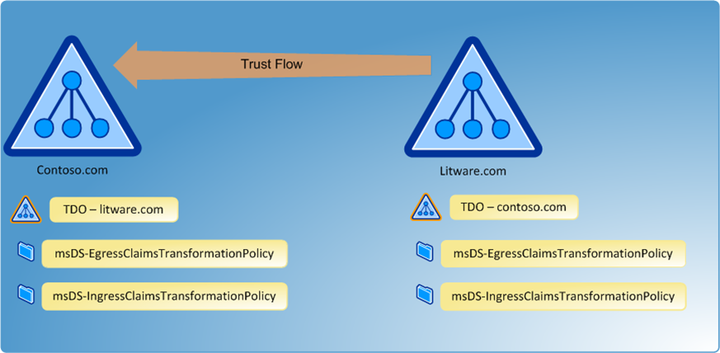
Figure 61 Objects and attributes used with claim transformation and one-way forest trust.

The corp.contoso.com domain controller looks for a Trusted Domain Object in its Active Directory that matches the trusting domain, in this instance litware.com. The trustDirection attribute on the litware.com trusted domain object has a value of one, which indicates the trust between litware.com and corp.contoso.com is an inbound trust. A trusted domain object marked as an inbound trust indicates the forest hosting the trusted domain object is the trusted partner and the forest name on the trusted domain object is the trusting partner. This confirms that corp.contoso.com is the trusted forest and litware.com is the trusting forest.
Claims flow against the direction of the trust. Therefore, the established one-way trust between the corp.contoso.com forest and the litware.com forest flow from litware.com to corp.contoso.com. This means that claims flow from corp.contoso.com to litware.com, the opposite direction of the trust. In other words, the claim leaves the corp.contoso.com forest and enters the litware.com forest
The litware.com trusted domain object (hosted in the corp.contoso.com forest's Active Directory) has two attributes that are significant in transforming and filtering claims across a forest trust: msDS-IngressClaimsTransformationPolicy and msDS-EgressClaimsTransformationPolicy. Windows uses these attributes to link transformation policy object to a forest's trust.
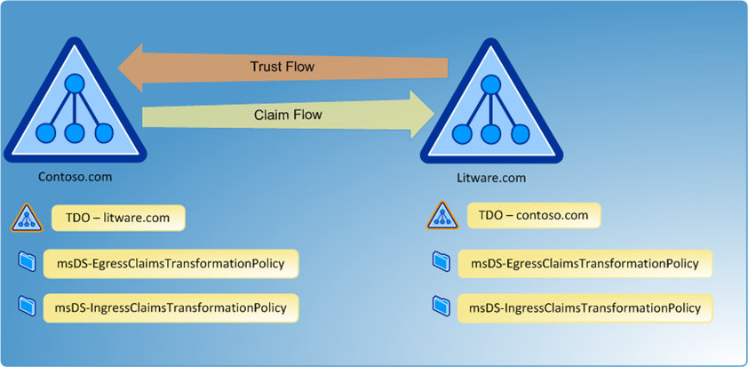
Figure 62 Claims flow opposite of the trust direction.
The attribute used depends on how the forest is used in the context of the trust. In this example, Windows uses the corp.contoso.com forest as the trusted forest. Trusted forests send claims to the trusting forest. Therefore, you link a transformation policy object to the litware.com trusted domain object's msDS-EgressClaimsTransformationPolicy attribute to transform or filter claims before Windows sends them across the forest trust. The litware.com is the trusting forest. Trusting forests receive claims from trusted forests. Therefore, you link a transformation policy object to the corp.contoso.com trusted domain object's msDS-IngressClaimsTransformationPolicy attribute to transform or filter claims before Windows issues them in the litware.com forest.
In the example, the domain controller in corp.contoso.com recognizes it must include claims that are destined to cross the forest trust. The domain controller in the corp.contoso.com forest locates the trusted domain object with the name that matches the trusting forest. The domain controllers understand its domain is the trusted forest. It also understand the request comes from the trusting domain and makes the determination that it must transform claims before providing the final list of claims to Kerberos. The domain controller looks for the transformation policy linked to the msDS-EgressClaimsTransformationPolicy attribute of the trusted domain object for the trusting domain. Its reads the policy, processes the rules, which builds an output list of claims. Lsass.exe removes any duplicates from the list of outgoing claims and then passes the list to Kerberos for inclusion in the PAC.
The domain controller in litware.com receives the incoming PAC that has the list of claims. Before using the PAC authorization requests, the domain controller must transform and filter claims from the claims included in the PAC from the trusted domain. By default, a trusting domain drops all incoming claims.
The trusting domain controller receives the PAC from the trusting domain. The domain controller looks up the trusting domain's trusted domain object in its Active Directory. The trusting domain, litware.com, understands it is the trusting forest. Trusting forests receive claims. Therefore, the domain controller in litware.com looks for the msDS-IngressClaimsTransformationPolicy attribute on the corp.contoso.com trusted domain object to determine if it should transform or filter claims. If a transformation policy object is not linked, then the domain controller drops all incoming claims. Otherwise, the domain controller reads and processes the rules included in the claim transformation policy and creates an output list of claims. Windows removes any duplicates from the output list of claims and then hands the list to Kerberos for inclusion in the user's PAC.
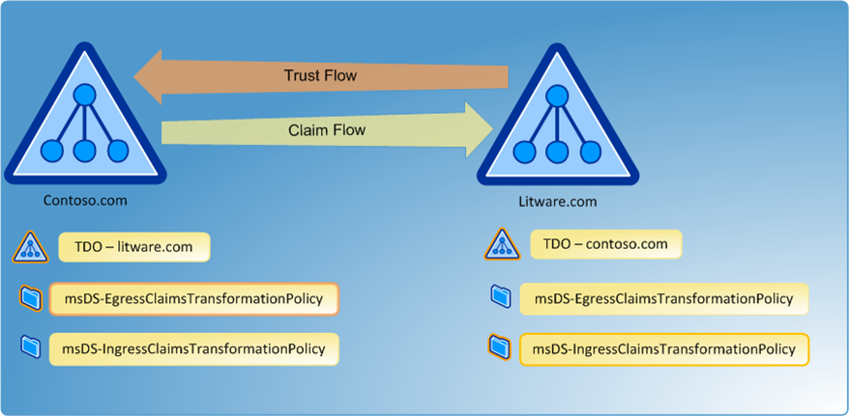
Figure 63 Claim Transformation Policy links to the Trusted Domain object in the current domain.
Two-way trust relationships are simply two, one-way trusts with each trust flowing in the opposite direction. This means that each forest can be a trusted or a trusting domain, which makes it important to understand whether you are using the forest as a trusted or trusting forest. Otherwise, you could link the transformation policy to the wrong attribute on the trusted domain object, which is unlikely to produce the correct claims transformation or filtering.
Table 22 Claim Transformation summary for trusted domains
Summary - Trusted Domain
Trust Flow | Inbound
Claim Flow | Outbound
TDO Attribute Used | msDS-EgressClaimsTransformationPolicy
Default Claims Behavior | Send All Claims

Table 23 Claim Transformation summary for trusting domains
Summary - Trusting Domain
Trust Flow | Outbound
Claim Flow | Inbound
TDO Attribute Used | msDS-IngressClaimsTransformationPolicy
Default Claim Behavior | Drop All Claims

The transform engine drops claims on a trust in any direction if any of the following occurs.
- An error occurs when reading transformation rules from Active Directory
- An error occurs when reading compiled transformation rules from Active Directory
- A parsing error occurs when compiling transformation rules into their compiled form

Managing and Deploying Claims Transformation Policies
Windows Server 2012 performs claim filtering and transformation when claims cross a forest trust. Trusted forests can transform and filter claims before the cross the trust and Trusting domains can transform and filter claims before the domain controller uses the PAC information for Kerberos authentication.
Claim transformation and filtering is possible because of Claim Transformation policy objects. You link Claim Transformation policy objects to trusted domain objects. When establishing a trust between to domains or forests, Windows creates a trusted domain object in each domain using the name of the opposite side of the trust. The trusted domain object provides Windows with information that describes the type of trust established and the trust role each domain or forest assumes when the trust is used.
Domain controllers use two attributes on the trusted domain object to determine which Claim Transformation policy it should use during claim transformation and filter. The msDS-EgressClaimsTransformationPolicy linked attribute stores the link for the transformation policy used to transform and filter claims leaving the forest. The msDS-IngressClaimsTranformationPolicy linked attribute stores the link to the transformation policy used to transform and filter claims entering the forest.

Claim Transformation Policy
Claims Transformation Policy objects are Active Directory objects that you can link to one or more forest trusts. Claims Transformation Policy objects contain a set of claim transformation rules authored in transformation rule language, which is a subset of the claims rule language used by Active Directory Federation Services.
Windows stores Claim Transformation Policy objects in the Claims Transformation Policies container, which is found under CN=Claims Configuration, CN=Servcies, CN=Configuration. Domain Administrators and Enterprise Administrators can create, edit, or delete Transformation Policy objects.
Windows stores most of the claim transformation information in four attributes on a Claim Transformation object. These attributes are the most significant outside of the Transformation Policy object's name and distinguished name. These attributes include:
- msDS-TransformationRules
- msDS-TransformationRulesCompiled
- msDS-TDOIngressBL
- msDS-TDOEgressBL
The msDS-TransformationRules and msDS-TransformationRulesCompiled store the same information, but in a separate format. The msDS-TransformationRules stores an XML representation of the transformation rules that describe how Windows transforms and filters claims. The msDS-TransformationRulesCompiled attribute stores the same information in a compiled binary format. This format improves the Windows' performance with transforming and filtering claims. The Lsass.exe process is responsible for parsing and compiling the rules. Rules are compiled shortly after the domain controller starts. The domain controller only compiles rules in linked Transformation Policy objects, and rules included in linked Transformation policies when a user attempts to access a resource that would require the rule. Also, the domain controller compiles rules in linked Transformation policies shortly after they've been updated.
The msDS-TDOEgressBL and msDS-TDOIngressBL attributes are back linked to the msDS-EgressTransformationPolicy and the msDS-IngressTransformationPolicy attributes found on trusted domain objects in Active Directory. Linked attributes are paired: a forward link and backwards link. A forward linked attribute has a single value while a backward linked object has a multiple values. Linked value attributes create one-to-many relationship that tracks the one-to-many between the forward link and backward link, respectively.
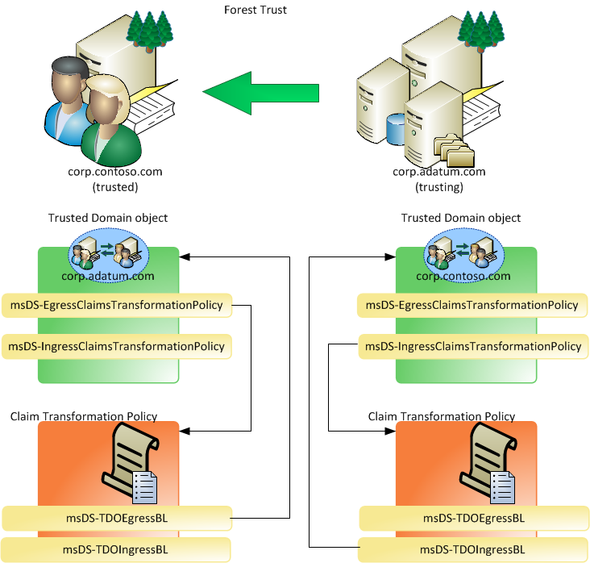
Figure 64 Claim Transformation Policy and link relationship

Claim Transformation Policy objects contain the backward link attribute, while the trusted domain object stores the forward link attribute. In this configuration, you can view the backward link attribute (msDS-TDOEgressBL and msDS-TDOIngressBL) to determine how many times the Transformation Policy object has been linked to a trusted domain object, and to which trusted domain objects it was linked.
You configure a Claims Transformation Policy to hold one or more transformation rules. Windows stores the multiple rules in a single Transformation Policy object. You then link the Transformation Policy object to either the ingress or the egress policy attribute on a trusted domain object. You can link a Transformation Policy object to multiple trusted domain objects; however, each ingress and egress policy attribute may only contain one linked Transformation Policy object.

Transformation Rules
Windows creates most of the transformation rules for you when you create a Transformation Policy object. However, you may encounters scenarios where you have to author a custom transformation rule.

Transformation Rule Language
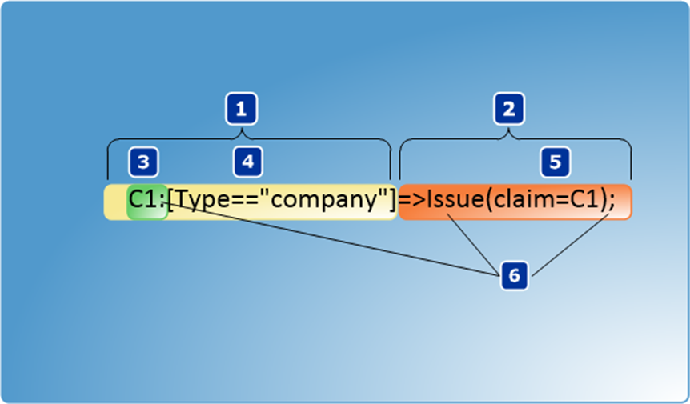
Transformation Rule Language is a subset of the Claims Rule Language used in Active Directory Federation Service. Transformation Rule Language syntax divides a single rule into two main parts: the condition statement (1) and the issue statement (2). The condition statement has two sub components: the claim identifier (3) and the condition (4). The issue statement contains keywords and delimiters (6) and an issue expression (5).
During claims transformation and filtering, Lsass.exe has a list of input claims, and one or more claim rules. A claim rule begins with claim identifier and ends with a semicolon. The transform engine evaluates the list of input claims against the list of transformation rules.
The engine evaluates the claim at the beginning of the input list with the condition statement in the first rule in the transformation rule list. If the condition statement evaluation is true, then the transform engine processes the issue statement, which inserts a claim into the output claim list. If the condition statement evaluation is false, then the transform engine ignores the issue statement, which does not insert a claim into the list of output claims-- effectively dropping the claim.
The transform engine then moves to the next rule in the list of transformation rules and evaluates the same claim as before with the condition statement of the new rule. This cycle continues until the transform engine evaluates the first claim in the list of input claims against the entire list of transformation rules. Then, the transform engine retrieves the next rule from the list of input rules and evaluates it against each rule in the list of transformation rules until it reaches the end of the list of rules. The inner and outer cycle of evaluation continues until each input claim is evaluated against each rule in the list of rules. This process builds a list output claims.

Claim object
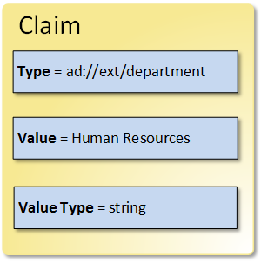
The transform engine reads a claim into memory and then evaluates the claim against each rule in the list of transformation rules. To help facilitate the evaluation, the transform engine transform the claim into an object and properties, much like a user or group object in Active Directory. The claim object implemented in Transformation Rule Language has three properties: type, value, and valueType.

Type
The type property of the claim object represents the type of claim. The claim type in a Windows authorization claim refers to the identifier of the claim. All attribute-based claims come exclusively from Active Directory. Windows Server 2012 does not support external attribute stores like those that Active Directory Federation Services can support.

Value
The value property of the claim object represents the actual value stored in the claim. For example, the transform engine evaluates a claim from the input list. The claim's type (also noted as Claim.Type) is "ad://ext/Surname/1". The claim's value (also noted as Claim.Value) is "Reynolds"

ValueType
The last property of the claim object describes the type of data stored in its value (also noted as Claim.ValueType). The Transformation Rule Language supports four value types that you can use to describe the data in the value property. These value types can be one of the following: int64, uint64, string, Boolean
Important: | The Claim Transformation Language requires you to always include the valueType property in a rule that contains the value property. Also, you must include the value and valueType properties consecutively in a claim transformation rule. You cannot separate the two inclusions with the claim.Type property.

Condition Statement
A transformation rule begins with a condition statement. The condition statement has two components: a claim identifier and a condition.

Claim Identifier
The claim identifier is a unique variable that represented the current claim as an object. The claim identifier by itself represents the entire claim object, which includes the type, value, and valueType properties. You indicate the end of claim identifier with a colon (:).
The most commonly used claim identifier begins with a capital "C" followed by the number 1 (C1). Because a single condition statement can have multiple conditions, you may need to create another claim identifier to use in a second condition. In these scenarios, simply increment the numeric value used in the last claim identifier to create a second unique claim identifier. More information about using multiple claim identifiers is provided later.
Note: | The transform engine evaluates one claim at a time. The engine never loads the next input claim until the current claim is evaluated against all the rules. Rules that have multiple claim identifiers all refer to the same claim-- the current one, but use different identifiers for readability.

Condition
The condition component of the condition statement contains a logical, or Boolean, expression that evaluate to true or false. The condition begins with an opening bracket ([ ), the logical expression, and ends with a closing bracket ( ]). The logical expression with the brackets contains a left-hand-side value (LHS) and a right-hand-side value (RHS) separated by a logical operator. In the condition statement, the LHS value is a property of the claim object. The RHS value of the condition is text enclosed between double-quotation marks.
Note: | Within the condition, the claim object is assumed to be the claim identifier that precedes the condition. The claim identifier qualifier is not needed within the condition, and you can simply use the property name.

The Transformation Rule Language contains four operators that you can used when authoring conditions.
Table 24 Operators supported in transformation rule language
Operator | Description
== | Equal To-- the LHS value is equal to the RHS value
!= | Not Equal-- the LHS value is not equal to the RHS value
=~ | Regular Expression Equal-- the LHS value equals the results of the regular expression in the RHS value
!~ | Regular Expression Not Equal-- the LHS value is not equal to the results of the regular expression in the RHS value

For example, consider the following condition statement.
C1:[Type=="ad://ext/company/1"]
The claim identifier C1 represents the current claim from the input claim list. The condition, between the brackets, follows the claim identifier. The LHS value of the condition represents the Type property of the current claim object ( C1 is an implied prefix). The RHS value is a literal-- the identifier ad://ext/company/1 enclosed in double quotation marks. The condition's operator is the equal to (==) operator. Therefore, the condition statement of this rule is "if the current claim's type equals ad://ext/company/1.
The condition is a logical expression, so when reading the condition you'll want prefix the condition with the word "if". The condition result must be either true or false. If the condition is false, then the current claim is evaluated against the next rule. A false condition equates to the transform engine dropping the input claim for that rule. However, the engine evaluates the current claim against the remaining rules in the list. Another rule condition could evaluate to true, and pass the claim that was dropped by a previous rule to the output claim list. If the condition is true, then the transform engine processes the issue statement.

Issue Statement
An issue statement includes an issue expression enclosed in parentheses. The issue keyword and delimiters precede the issue expression. The issue statement in a transformation rule passes a claim to the output claim list. Typically, the claim passed to the output claim list is the same as the current claim; however, it is not required. You can use the current claim in the condition, but author an issue statement builds a new claim for the output claim. This allows the transform engine to transform claims.
The issue statement follows the final closing bracket of the last condition in the condition statement. The issue statement begins with the issue statement delimiter (=>) followed by the keyword issue. The issue keyword informs the transform engine to insert a claim into the output list. The issue expression follows the issue keyword and is enclosed between parentheses. The issue expression describes how the transform engine creates the output claim.
You defined the output claim through the issue expression. An issue expression can issue the current claim, or a new claim as the output claim. When creating a new claim, the issue expression must include all three properties of the claim. You identify each property of the new claim in the issue expression by their property names: type, value, or valueType. You can create a new output claim by combining values from the current input claim with new values. However, if the issue expression uses the value property, then it must also include the valueType property, and you must define both properties together-- the type property cannot separate the value and valueType properties within an issue expression.

Forward Rule Example
C1:[Type=="ad://ext/title/1"]=>Issue(claim=C1);
The example shows a complete transformation rule. The rule has a condition statement and an issue statement. The condition statement assumes the claim identifier as variable representing the current claim from the input list. The condition compares the value of the current claim's Type property to the literal value "ad://ext/title/1". If the condition is false, the engine ignores the issue statement and evaluates the next rule against the current claim. If the condition is true, then the engine processes the issuance statement.
The issue statement begins with the issue statement delimiter and issue keyword. An issue expression resides between the parentheses. The issue expression contains three components: a left-hand-side (LHS) value, an operator, and a right-hand-side (RHS) value. The issue expression in this example uses the built-in variable name claim, which is an instance of a claim object that represents the output claim, an assignment operator represented by a single equal sign (=), and the claim identifier variable C1, which is an instance of a claim object, which represents the current input claim.
Important: | An assignment operator simply transfers the right-hand-side (RHS) value to the left-hand-side (LHS) value.  A logically equivalent means the LHS and the RHS values represent the same type of entity. If the LHS value is an instance of the entire claim object, then the RHS value must be an instance of the entire claim object. Likewise, if the LHS value is a property of a claim object instance, then the RHS value must be a property of a claim object instance.

The issue expression in this example assigns the current input claim to the output claim. The rule in this example passes the current input claim to the output claim provided the current input claim is a "title" type claim.

Transformation Rule Example
C1:[Type=="ad://ext/title/1"]=>Issue(type="ad://ext/role/1", value=C1.value, valueType=C1.valueType);
This example shows a complete transformation rule. The rule contains a condition statement and an issue statement. The condition statement begins with the claim identifier variable C1, which represents the current input claim. The condition determines if the value in the current input claim's Type property equals the literal value "ad://ext/title/1". If the condition returns false, then the transform engine ignores the issue statement and evaluates the current input claim against the next transformation rule. If the condition returns true, then it processes the issue statement.
The issue statement begins with the proper notation; however, the issue expression portion is longer than the previous example. In this example, the issue statement contains three issue expressions, which are comma delimited. A complete issue expression has a LHS value, an assignment operator (=), and RHS value, and the LHS and RHS values must be logically equivalent.
The issue expression uses the property of the claim object. Therefore, the RHS value must be value that can be assigned to a property. The first issue expression assigns the value "ad://ext/role/1" to the output claim's Type property.
The second issue expression is also a property of a claim object -- the Value property of the output claim. However, the RHS value is not a literal as in the first issue expression. The RHS value uses the claim identifier variable C1 and accesses the Value property of C1, which represents the value of the current input claim. The second issue expression assigns the value of the input claim's Value property to the output claim's Value property.
The third issue expression mimics the behavior of the second issue expression. The LHS value uses the ValueType property. The RHS value uses the claim identifier variable C1 and accesses the ValueType property of the C1 variable, which represents the current input claim's valueType. The third issue expression assigns the value of the input claim's ValueType property to the output claim's ValueType property.
The issue statement completes and reaches the end of the rule, which is indicated by the semicolon (;). The issue expression in this example assigns the values in the Value and ValueType properties of the current input claim to the Value and ValueType properties of the output claim. However, the Type property of the output claim differs from the current incoming claim.
The rule in this example transforms the input claim's value and valueType to a newly created "ad://ext/role/1" claim type provided the current input claim type is a "ad://ext/title/1" type claim.

Empty Condition Forward Rule
C1:[]=>Issue(Claim=C1);
This claim rule is an example of an empty condition forward rule. The condition within the condition statement is empty. The transformation rule language always evaluates an empty condition as true. This means, the transform engine always processes the issue statement. You use an empty condition rule when you want to ensure that all input claims are passed to output claims. Also, you can use an empty rule condition to insert a new claim into the list of output claims.

Multiple Condition Rule
C1:[type="ad://ext/company/1", value="contoso", valuetype="string"] &&
C2:[type="ad://ext/title/1", value="CEO", valuetype="string"]
=>Issue(type="ad://ext/role/1", value="Executive", valuetype="string");
This claim rule has one condition statement; however, it has two conditions joined with a logical AND (&&) operator. The logical AND operator combines the result of two Boolean expressions (true or false) or into one Boolean value. Therefore, the transform engine processes this rule different from a single condition rule.
A transformation rule condition always evaluates to true or false. When you combined multiple conditions within a single rule, you are instructing the transform engine to process issue statement if all the conditions evaluate to true. If any conditions in the condition statement evaluates to false, then the entire condition statement is false and the transform engine ignores the issue statement and continue processing the remaining rules or input claims.
In this example, the first condition in the condition statement, C1, evaluates three properties of the current input claim. The transform engine evaluates this condition, and if true, then evaluates the second condition, C2. When evaluating C2, the transform engine cycles through all the input claims again to determine if the second condition is true or false. If false, then the transform engine views the entire condition statement as false. The entire condition statement is false because we logically AND the result of the first condition with the result of the second condition. The rules for a logical AND are simple-- if both expressions in each side of the logical AND are true, then the result of the AND is true. All other scenarios return a false result.
Table 25 True table for conditional evaluations
Expression | Result
TRUE && FALSE | FALSE
FALSE && TRUE | FALSE
FALSE && FALSE | FALSE
TRUE && TRUE | TRUE

This rules issues an output claim with the claim type "ad://ext/role/1", a value of "Executive", and a value type of "string". The condition upon which this claim is issued is based on the input claim with the type of "ad://ext/company/1" with a value of "contoso" and a value type of "string" exists AND an input claim with a type of "ad://ext/title/1" with a value of "CEO" and a value type of "string" also exists in the list of input claims.
Multiple conditions provide the means to author complex transformation rules; however, not without a cost. The transform engine processes all the rules in a given policy against all the rules from the claim input list. Each additional condition accrues an additional cycle through the input claims. This means that a complex multiple condition rule with many conditions could affect the performance of the claim transformation. Try to keep claim rules as simple as possible.
Important: | Transformation Rule Language only allows the logical AND (&&) operator to join multiple conditions within a condition statement. The natural processing of transformation rules automatically use a logical OR (||) when combining multiple rules within a single transformation policy.

Multiple Rules
A Claim Transformation Policy object holds one or more transformation rules. The transform engine recognizes the end of a transformation rule when it encounters a semicolon (;) while parsing the contents of all the rules. The transform engine interprets any content after the semicolon as a new rule. Therefore, the content must follow the syntax of a new transformation rule, such as beginning with a claim identifier, a well-formed condition statement and issue statement.
C1:[]=>Issue(Claim=C1);C1:[Type!="ad://ext/Company/1"]=>Issue(claim=C1);
This example contains two claim transformation rules. The first rule is an empty condition rule that simply passes any input claim as an output claim. The first rule ends at the semicolon and the second rule begins immediately after the semicolon-- no spaces.
The second rule begins with a claim identifier, C1. You can reuse the claim identifier as long you only use it once within each rule. Therefore, if you have a list of 10 rules, you can use the C1 claim identifier in all 10 rules. You cannot reuse a claim identifier within the same rule, for example when using multiple conditions in the same rule. Each claim identifier must be unique within the rule.

Contradicting Rules
The transform engine evaluates the condition in each rule, and processes the issue statement if the condition is true. The issue statement inserts a claim into the output claim list, which then passes the list to Kerberos. In a list of rules, it is possible for the transform engine to encounter a rule that forces it to drop the input claim, but then have the next rule pass the input claim to the output claim list, or vice versa. Therefore, it is important to understand a transformation rule cannot "un-issued" a claim from the list of output claims. The transform engine does not use any logic to reconcile a rule that drops an input claim against a rule that passes an input claim.
Consider the multiple rules example. The first rule identifier is an empty rule condition. An empty rule condition always returns true. The issue statement in rule passes the current input claim to the list of output claims. Essentially, all claims are forwarded to the output claim list. However, the second rule condition checks that the current input claim type does not equal "Company". So, this rule passes all input claims to the list of output claims as long as the claim type does not equal "ad://ext/Company/1". These two rules contradict each other.
If the input claim type equals "ad://ext/Company/1", then the first rule passes the current input claim into the output claim list. However, the second rule drops the current input claim from entering the output claim list. The result of these rules includes the "ad://ext/company/1" claim in the output list. Rules are processed in order and in the context the current input claim. One rule does not know the outcome of the previous or the next rule (multiple condition rules excluded). And, the transform engine process the rules first-in-first-out. So, ensure that if you have a transformation rule that drops an input claim, make sure another rule does not pass the claim

Filter Rules
The transform engine uses transformation rules two ways: transform and filter. A transform rules simply makes a change to the input claim so that the input claim and the output claim are different from each other. A filter rule decides if the transform engine should drop or pass the input claim to the output claim list-- the different being that the issue statement from one modifies or issues a completely new claim, or simply forward the input claim unchanged. There are four ways to filter a claim: pass everything, drop everything, pass everything except, and drop everything except.
It is important to understand that filters rules simply pass or drop-- not allow or deny. The transform engine does not allow or deny input claims. Technically, all rules are inclusive rules. This means that the condition you provide in the rules determines what the rule includes into the output claim list. Filter rules are unique in that you author the rule condition statement inversely to the desired outcome.

Pass Everything
A pass everything filter rule includes everything in the output claim list. To author this rule, you use an empty condition with a forwarding issue statement. Remember, a forwarding issue statement issues the input claim unmodified and typically looks like =>Issue(claim=C1). The condition statement is inverse to the desired outcome. You want the rule to pass everything; so, you configure the condition empty (nothing).
C1:[]=>Issue(claim=C1);

Drop Everything
A drop everything filter rule includes nothing in the output claim list. To author this rule, you use the not equal regular expression operator (!~) with the wildcard regular expression ("*"). The wildcard regular expression represents "anything", which would normally pass everything to the output claim list. However, the condition operator inverts the logic of the rule so that the transform engine only passes the input claim if the input claim does not equal "anything". Therefore, the only way the condition statement can return true, is when a claim is not present.
C1:[type!~"*"]=>Issue(claim=C1);

Pass Everything Except
A pass everything except filter rule passes everything but what is identified in the condition statement. To author this rule, you use the not equal operator (!=) and make the right-hand-side value reflect the claim you do not want to pass to the output claim list.
C1:[type!="ad://ext/company/1"]=>Issue(claim=C1);
This rule passes any input claim to the output claim list as long as the claim type does not equal "ad://ext/company/1". Therefore, the rule passes everything, but drops the input claim "ad://ext/company/1".

Drop Everything Except
A drop everything except filter rule
A pass everything except filter rule drops everything but what is identified in the condition statement. To author this rule, you use the equal operator (==) and make the right-hand side value reflect the claim you want to pass to the output claim list.
C1:[type=="ad://ext/company/1"]=>Issue(claim=C1);
This rule drops any input claim from the output claim list as long as the claim type does not equal "ad://ext/company/1". Therefore, the rules everything, but passes the input claim "ad://ext/company/1".

Managing Claims Transformation Policies
You manage Claim Transformation policy objects using the Active Directory provider for Windows PowerShell.
Important: | Windows Server 2012 does not provide a graphical user interface for managing Claim Transformation policy objects-- only Windows PowerShell cmdlets.

Create a Claim Transformation Policy
Create a New Claim Transformation Policy using PowerShell
New-ADClaimTransformPolicy
-Description:"Claim Transformation Policy Description"
-Name:"Pass All Claims Policy"
-ProtectFromAccidentalDeletion:$true
-AllowAll | -DenyAll | -AllowAllExcept:claimType,… | -DenyAllExcept:claimType… |-Rule:list_of_transformation_rules
-Server:hq-con-dc-01.corp.contoso.com

Description
Use the Description argument to provide a short description that clarifies the purpose or existence of the Claim Transformation Policy.

Example
-Description:"This is a Claim Transformation Policy Description."

Name
Use the Name argument to configure the new Claim Transformation Policy with a name.

Example
-Name:"Pass All Claims Policy"

ProtectedFromAccidentalDeletion
Use the ProtectedFromAccidentalDeletion argument to enable or disable protection against deletion when an administrator tries to delete the Claim Transformation policy..

Example
-ProtectFromAccidentalDeletion:$true
-ProtectFromAccidentalDeletion:$false

Server
Use the optional Server argument to force the responsibility of creating the new transformation policy to a specific server. Suffix the argument with the fully qualified domain name of the computer you want to create the new claim type.

Example
-Server:"hq-con-dc-01.corp.contoso.com"

AllowAll
Use the AllowAll argument to include a pass-everything rule in the transformation policy.

Example
-AllowAll

AllowAllExcept
Use the AllowAllExcept argument to include a pass-everything-except rule in the transformation policy. Follow the AllowAllExcept argument with a comma delimited list of claim types. The rules created from using this argument pass all claim types except those included in the comma-delimited list of claim types.

Example
-AllowAllExcept:ad://ext/company/1,ad://ext/title/1,ad://ext/department/1

DenyAll
Use the DenyAll argument to include a drop-everything rule in the transformation policy.

Example
-DenyAll

DenyAllExcept
Use the DenyAllExcept argument to include a drop-everything-except rule in the transformation policy. Follow the DenyAllExcept argument with a comma delimited list of claim types. The rules created from using this argument drop all claim types except those included in the comma delimited list of claim types.

Example
-DenyAllExcept:ad://ext/company/1,ad://ext/title/1,ad://ext/department/1

Rule
Use the Rule argument to assign a custom rule to a claim transformation policy. Format custom rules passed with argument using Transformation Rule Language. Use the rule argument to create rules that transform claims or filter claims based on value and value type. For claim-type filtering, use the AllowAll, AllowAllExcept, DenyAll, or DenyAllExcept arguments.

Example
-Rule:'C1[value="contoso",valueType="string"]=>Issue(claim=C1)';
Important: | Transformation Rule Language natively uses double quotation marks to indicate the value associated to a claim attribute. Ensure you enclose the all of the rules between single quotation marks (').

Modify a Claim Transformation Policy
Modify a Claim Transformation Policy using PowerShell
Set-ADClaimTransformPolicy
-Description:"Claim Transformation Policy Description"
-Identity:"Allow All"
-ProtectFromAccidentalDeletion:$true
-AllowAll | -DenyAll | -AllowAllExcept:claimType,… | -DenyAllExcept:claimType… |-Rule:list_of_transformation_rules
-Server:hq-con-dc-01.corp.contoso.com

Description
Use the Description argument to provide a short description that clarifies the purpose or existence of the Claim Transformation Policy.

Example
-Description:"This is a Claim Transformation Policy Description."

Identity
Use the Identity argument to specify the claim transformation policy on which the Set-ADClaimTransformPolicy cmdlet performs the action. A valid identity argument includes the object's display name, name, distinguished name, or globally unique identifier (GUID).

Example
-Identity:"Allow All"

ProtectedFromAccidentalDeletion
Use the ProtectedFromAccidentalDeletion argument to enable or disable protection against deletion when an administrator tries to delete the Claim Transformation policy..

Example
-ProtectFromAccidentalDeletion:$true
-ProtectFromAccidentalDeletion:$false

Server
Use the optional Server argument to force the responsibility of modifying the new transformation policy to a specific server. Suffix the argument with the fully qualified domain name of the computer you want to create the new claim type.

Example
-Server:"hq-con-dc-01.corp.contoso.com"

AllowAll
Use the AllowAll argument to include a pass-everything rule in the transformation policy.

Example
-AllowAll

AllowAllExcept
Use the AllowAllExcept argument to include a pass-everything-except rule in the transformation policy. Follow the AllowAllExcept argument with a comma delimited list of claim types. The rules created from using this argument pass all claim types except those included in the comma-delimited list of claim types.

Example
-AllowAllExcept:ad://ext/company/1,ad://ext/title/1,ad://ext/department/1

DenyAll
Use the DenyAll argument to include a drop-everything rule in the transformation policy.

Example
-DenyAll

DenyAllExcept
Use the DenyAllExcept argument to include a drop-everything-except rule in the transformation policy. Follow the DenyAllExcept argument with a comma delimited list of claim types. The rules created from using this argument drop all claim types except those included in the comma delimited list of claim types.

Example
-DenyAllExcept:ad://ext/company/1,ad://ext/title/1,ad://ext/department/1

Rule
Use the Rule argument to assign a custom rule to a claim transformation policy. Format custom rules passed with argument using Transformation Rule Language. Use the rule argument to create rules that transform claims or filter claims based on value and value type. For claim-type filtering, use the AllowAll, AllowAllExcept, DenyAll, or DenyAllExcept arguments.

Example
-Rule:C1[value="contoso",valueType="string"]=>Issue(claim=C1);
Important: | Transformation Rule Language natively uses double quotation marks to indicate the value associated to a claim attribute. Ensure you enclose the all of the rules between single quotation marks (').

Remove a Claim Transformation Policy
Remove a Claim Transformation Policy using PowerShell
Remove-ADClaimTransformPolicy
-Identity:"Allow All"
-Server:hq-con-dc-01.corp.contoso.com

Identity
Use the Identity argument to specify the claim transformation policy on which the Set-ADClaimTransformPolicy cmdlet performs the action. A valid identity argument includes the object's display name, name, distinguished name, or globally unique identifier (GUID).

Example
-Identity:"Allow All"

Server
Use the optional Server argument to force the responsibility of deleting the transformation policy to a specific server. Suffix the argument with the fully qualified domain name of the computer you want to create the new claim type.

Example
-Server:"hq-con-dc-01.corp.contoso.com"

Display a Claim Transformation Policy
Display a Claim Transformation Policy using PowerShell
Get-ADClaimTransformPolicy
-Identity:"Allow All"
-Server:hq-con-dc-01.corp.contoso.com

Identity
Use the Identity argument to specify the claim transformation policy on which the Get-ADClaimTransformPolicy cmdlet performs the action. A valid identity argument includes the object's display name, name, distinguished name, or globally unique identifier (GUID).

Example
-Identity:"Allow All"

Server
Use the optional Server argument to force the responsibility of retrieving the new claim type from a specific server. Suffix the argument with the fully qualified domain name of the computer you want to create the new claim type.

Example
-Server:"hq-con-dc-01.corp.contoso.com"

Output
DistinguishedName : CN=Allow All,CN=Claims Transformation Policies,CN=Claims Co
nfiguration,CN=Services,CN=Configuration,DC=litware,DC=com
IncomingTrust : {}
Name : Allow All
ObjectClass : msDS-ClaimsTransformationPolicyType
ObjectGUID : 0935f0ce-a420-4c3d-b816-80cc54bc10f3
OutgoingTrust : {CN=corp.contoso.com,CN=System,DC=litware,DC=com}
Rule : C1:[]=>Issue(claim=C1);

Deploying Claims Transformation Policies
Claim Transformation occurs across forest trusts. Windows Server 2012 transforms claims across forest trusts that have a linked claim transformation policy. Active Directory forests can transform or filter claim entering the forest or claims exiting the forest.
Windows forests can participate in two trust roles. A forest can be the trusted forest, a trusting forest, or both. The direction of a Windows trust flows from the trusting forest to the trusted forest. Kerberos claims flow in the opposite direction of the forest trust. Therefore, claims flow from the trusted domain to the trusting domain.
Claims exit the trusted domain, traverse the forest trust, and enter the trusting domain. Claim flow provides Windows with two opportunities to transform or filter trusts. The first opportunity to transform or filter a claim is when the claim leaves the trusted domain, before traversing the forest trust. The second opportunity to transform or filter claims is when the claims enter the trusting domain, before Windows uses the claims for authorization. A two-way trust is when the forest acts as both a trusted and a trusting domain with the same another forest-- two, one-way trusts each in a different direction.
Claims flow out, or exit, a trusted forest and flow into, or enter a trusting forest. Each forest trust role has a default behavior on how it handles claims. Trusted forests pass all claims across the forest trust, while trusting forests block all claims entering the forest. You must link a transformation policy to correct trust role to override the default claim-routing behavior.

Linking Transformation Policy object to Forests
Claim transformation policies override default claim behavior across forest trusts when you link the transformation policy object to the trusted domain object that represents the trusting or trusted forest. A single trusted domain object has two attribute to which you can link a transformation policy object: msDS-IngressClaimsTransformationPolicy and msDS-EgressClaimsTranformationPolicy.
Remember, claims flow from the trusted forest to the trusting forest. Windows has a source and target forest when it sends claim across a forest trust. Each forest has a trusted domain object that represents the forest on the opposite side of the trust and that share the same name. This means the trusted forest has a trusted domain object with the name of the trusting forest in its Active Directory. Likewise, the trusting forest has a trusted domain object with the name of the trusted forest in its Active Directory. These objects describe the trust relationship between the two forests and how Windows transforms claims between them.
A trusted forest uses the transformation policy object linked to the msDS-EgressClaimsTranformationPolicy attribute of the trusting forest's trusted domain object to transform or filter claims before they are sent to the trusting forest. A trusting forest uses the transformation policy object linked to the msDS-IngressClaimsTransformationPolicy attribute of the trusted forest's trusted domain object to transform or filter claims before they are used for authorization in the trusting forest. Two-way trusts are simply two, one-way trusts; therefore, the transformation works exactly the same, but in the opposite direction.
Important: | The attribute Windows uses to retrieve the transformation policy is based on the forest hosting the trusted domain object. The trusted forest uses the msDS-EgressClaimsTranformationPolicy. The trusting forest uses the msDS-IngressClaimsTransformationPolicy. An easy way to remember this is the trusted forest has the letter "E" in the name; therefore, it uses the "Egress" attribute. The trusting forest has the letter "I" in the name; therefore, it uses the "Ingress" attribute.

Managing Claim Transformation Links

Linking a Claim Transformation Policy
Linking a Claim Transformation Policy using PowerShell
Set-ADClaimTransformLink
-Identity:corp.contoso.com
-Policy:"Allow All"
-TrustRole:trusting

Identity
Use the Identity argument to specify the name of the forest that resides on the opposite side of the current forest's trust relationship.

Example
-Identity:corp.contoso.com

Policy
Use the Policy argument to specify the name

Example
-Policy:"Allow All"

TrustRole
Use the TrustRole argument to specify the current forest's role in the current forest trust relationship. Suffix the TrustRole argument with Trusted if the current forest is the trusted forest. Suffix the TrustRole argument with Trusting if the current forest is the trusting forest.

Example
-TrustRole:Trusted
-TrustRole:Trusting

Server
Use the optional Server argument to force the responsibility of linking transformation policy to the trusted domain object to a specific server. Suffix the argument with the fully qualified domain name of the computer you want to create the new claim type.

Example
-Server:"root-2012-dc1.root.fabrikam.com"

Removing a Claim Transformation Policy
Removing a Claim Transformation Policy using PowerShell
Clear-ADClaimTransformLink
-Identity:corp.contoso.com
-Policy:"Allow All"
-TrustRole:trusting

Identity
Use the Identity argument to specify the name of the forest that resides on the opposite side of the forest trust relationship.

Example
-Identity:corp.contoso.com

Policy
Use the Policy argument to specify the name

Example
-Policy:"Allow All"

TrustRole
Use the TrustRole argument to specify the current forest's role in the current forest trust relationship. Suffix the TrustRole argument with Trusted if the current forest is the trusted forest. Suffix the TrustRole argument with Trusting if the current forest is the trusting forest.

Example
-TrustRole:Trusted
-TrustRole:Trusting

Server
Use the optional Server argument to force the responsibility of removing transformation policy from the trusted domain object to a specific server. Suffix the argument with the fully qualified domain name of the computer you want to create the new claim type.

Example
-Server:"root-2012-dc1.root.fabrikam.com"

Confirm a Claim Transformation Policy Link
Confirm a Claim Transformation Policy Link using PowerShell
Get-ADTrust
-Identity:corp.contoso.com

Identity
Use the Identity argument to specify the name of the forest that resides on the opposite side of the forest trust relationship.

Example
-Identity:corp.contoso.com

Server
Use the optional Server argument to force the responsibility of reading the trusted domain object to a specific server. Suffix the argument with the fully qualified domain name of the computer you want to create the new claim type.

Example
-Server:"lit-2012-dc1.root.litware.com"

Ouptut
Direction : Outbound
DisallowTransivity : False
DistinguishedName : CN=corp.contoso.com,CN=System,DC=litware,DC=com
ForestTransitive : True
IntraForest : False
IsTreeParent : False
IsTreeRoot : False
Name : corp.contoso.com
ObjectClass : trustedDomain
ObjectGUID : 981fde38-c881-464c-883a-6610b1b8b9f9
SelectiveAuthentication : False
SIDFilteringForestAware : False
SIDFilteringQuarantined : False
Source : DC=litware,DC=com
Target : corp.contoso.com
TGTDelegation : False
TrustAttributes : 8
TrustedPolicy :
TrustingPolicy : CN=Allow All,CN=Claims Transformation
Policies,CN=Claims Configuration,CN=Services,CN=Confi
guration,DC=litware,DC=com
TrustType : Uplevel
UplevelOnly : False
UsesAESKeys : False
UsesRC4Encryption : False

Troubleshooting Dynamic Access Control
Dynamic Access Control in Windows Server 2012 uses multiple technologies. You configure Dynamic Access Control across multiple components. Multiple configuration points can make it increasingly difficult to troubleshoot Dynamic Access Control with regard to user access to files and folders. Understanding how Dynamic Access Control works is a prerequisite for successfully troubleshooting it when it does not work.

General Troubleshooting Methodology
Dynamic Access Control's configuration spans multiple component technologies in Windows Server 2012. This distributed configuration creates many possible failure points. Fortunately, the most efficient way to troubleshoot Dynamic Access Control similarly follows the deployment process of Dynamic Access Control. Each phases of deployment depends on the previous phases working correctly. Troubleshooting, with a few caveats, follows this same general methodology.
For example, a user must authenticate before an access token is created. Windows cannot create claims in an access token unless the domain, specifically the KDC, is configure to support claims and Kerberos armoring, and the claim types must be defined in the forest. This example describes how each component must be correctly configured for the next component to perform its function, and for the overall scenario for Dynamic Access Control to work.
The method of troubleshooting uses the following logic
- The infrastructure must support Dynamic Access Control
  - Windows Server 2012 Domain Controllers with claims and Kerberos armoring enabled
  - Windows 8 and Windows Server 2012 member servers with claims and Kerberos armoring enabled
  - Windows Server 2012 file servers
    - Client support for versions of Windows earlier than Windows 8 require the file server configuration to include User-to-User authentication requests
    - Must be configured to support compound authentication when device claims are used outside of Central Access Policy
  - Windows 8 domain computers
    - Required only when using device claims
- User and computer attributes used as source attributes for claim types must include data and the data included in the attribute must be accurate
- Claim Types must be defined and enabled in the forest of the security principal using the claims
- Secure Resource Properties must be defined, enabled, and members of the Global Resource Property list in the forest of the computer hosting the resource
- Classify files and folders
- Create Central Access Rules and Central Access Policies in the forest of the computer hosting the resource
- Deploy Central Access Policies to Windows Server 2012 file servers using Group Policy
  - Associate deployed Central Access Policies to folders on Windows Server 2012 file servers
  - Optionally, create explicit permission entries, which can include conditional expressions, on files and folders
    - Must be configured to support compound authentication when device claims are used outside of Central Access Policy
- Create Global Object Access Auditing Policies
- Deploy Global Object Access Auditing Policies using Group Policy
  - Optionally, create explicit auditing entries, which can include conditional expressions, on files and folders
    - Must be configured to support compound authentication when device claims are used outside of Central Access Policy
Troubleshoot access to resources protected with Dynamic Access Control as you would any access control issue. The only difference between the two troubleshooting techniques is the number of items to check. The methodologies are quite similar. You determining effective permissions the same as in previous version of Windows-- Dynamic Access Control simply inserts more permissions entries for evaluation.
Troubleshooting Dynamic Access control can be intimidating because of the multiple points of configuration. As the number of configuration points increases, so does the ease at which the overall scenario can be misconfigured. Most issues with Dynamic Access Control are a result of the multiple points of configuration and can be resolved by walking through the configuration from the beginning.

Infrastructure
Windows requires authentication before it can authorize access to a file system resource. Authentication is Windows validating who the user is, using the domain as an authoritative source of validation. Authorization is Windows deciding whether it should allow or disallow a user from accessing a resource.
As mentioned earlier, Windows authorization relies on an access token that is created after the user has authenticated to the domain. The access token creates authorization data such as the user's SIDs, the groups to which the user is a member, claims about the user, and in some cases authorization data about the computer. If authentication does not work, then authorization will not work. It is pointless to troubleshoot authorization unless you know authentication works correctly. In this example, working correctly means that the domain controller authenticates a user with user claim information as part of the upcoming authorization process.
The first step in troubleshooting Dynamic Access Control is to verify the infrastructure supports claims. Consider the following items when validating an environment is properly configured to support claims. You must answer yes to the question does my environment support the way I want to use Dynamic Access Control?

Domain controller

Windows 8 and Windows Server 2012 member computers
Windows 8 and Windows Server 2012 member servers must support claims and Kerberos armoring before they can receive Windows authorization claims. Ensure the Kerberos client for these computers supports claims and Kerberos armoring.

Windows Server 2012 Domain Controller
The client computer must locate at least one Windows Server 2012 domain controller. Windows Server 2012 domain controllers are the only domain controllers that can issue claims during authentication requests. Ensure you have enabled claims and Kerberos armoring on the domain controller and that the domain supports the configured level of claim support.

More than one Windows Server 2012 Domain Controller
Windows 8 computers using Dynamic Access Control must use a Windows Server 2012 domain controller for authentication. Ensure you have an adequate number of Windows Server 2012 domain controllers to service authentication for each site containing computers running Windows 8 or Windows Server 2012.
An adequate number is relative to the number of domain controllers and the number of Windows 8 computers you have in the environment. It is important to remember that Windows 8 computers configured to use Dynamic Access Control only use Windows Server 2012 domain controllers. This means that a Windows 8 computer in a site that does not contain a domain controller running Windows Server 2012 will not use a domain controller in the site. This can cause significant delays during logons.
Refer to the Planning an adequate number of Windows Server 2012 Domain Controllers section of the document to estimate an adequate number of Windows Server 2012 domain controllers for your environment.
The only proper way to determine if there are enough domain controllers to service Kerberos requests with claims is to collect current Authentication requests. Performance Monitor counters to use to help determine authentication load include:
- Security System-Wide Statistics/KDC AS-Requests
- Security System-Wide Statistics/KDC AS-Requests with claims
- Security System-Wide Statistics/KDC AS-Requests with FAST
- Security System-Wide Statistics/KDC S4U2Self Requests with claims
- Security System-Wide Statistics/KDC TGS Requests
- Security System-Wide Statistics/KDC TGS Requests with FAST

Configure Domain Controllers to Support Dynamic Access Control
The Windows Server 2012 domain controller must be configured for Dynamic Access Control. The most common way to configure domain controllers to support Dynamic Access Control is to deploy a Group Policy object to the Domain Controllers organizational unit.
The Group Policy setting to enable Dynamic Access Control for domain controllers is an Administrative Template policy setting located at Computer Configuration\Policies\Administrative Templates\System\KDC\KDC support for claims, compound authentication and Kerberos armoring..
Ensure you configured the appropriate setting for the domain and the Group Policy object applis to the Windows Server 2012 domain controller. Use the Group Policy Management Console or the GPRESULT.EXE command to determine the Group Policy settings that apply to the domain controller.
gpresult /h rsop.htm

Active Directory
The domain controller must be able to find the information used for claim processing from Active Directory in order to present the information for inclusion the security principal's PAC of their Kerberos ticket.

Create Claim Types in Active Directory
Use the Active Directory Administrative Center and the following troubleshooting guidance to ensure you configured the Active Directory component of Dynamic Access Control.
- Claim types have a scope: they either apply to users and computers or only to users
- Claim types have two states: enabled and disabled. Domain controllers ignore disabled claim types
- Attribute-based claim types are sourced from an attribute in Active Directory. Domain controllers do not collect claim information from empty Active Directory attributes.
- Claim types are configured per-forest

File Server
One of the great features of Dynamic Access Control is that it works with operating systems earlier than Windows 8. However, you must configure the file server to support this configuration.

Apply Permissions and Auditing to the File Server
- The file server must be a domain joined Windows Server 2012 file server
- If the client computer running versions of Windows earlier than Windows 8, then consider:
  - You must configure the file server to attempt S4U2Self authentication to obtain claim information. You configure this security option using Group Policy and deploy it to the Windows Server 2012 file server. The security policy is located at Computer Configuration\Policies\Windows Settings\Security Settings\Local Policies\Security Options\Microsoft network server: Attempt S4U2Self to obtain claim information.
  - Cannot use device claims. Device claims requires a Windows 8 client computer.
- If you are using device claims in explicit permission or auditing entries, then consider:
  - You must configure the file server to support authorization with client device information. You configure this Kerberos setting using an Administrative Template setting using Group Policy and deploy it to the Windows Server 2012 file server. The policy setting is located at Computer Configuration\Policies\Administrative Template\Systems\Kerberos\Support compound authentication.

Authentication
The precursory event to any other part of Dynamic Access Control working is the ability for the security principal to receive claims along with other authorization information in their PAC, and subsequently use that information in an access token.
User claims flow from Active Directory to the security token through Kerberos. When you logon, Kerberos asks your domain controller for authentication data in the form of a ticket. This includes your user SID, groups, and user claims. Whenever you access a service (for example, a file server), the ticket is presented to resource domain control, which validates that it trusts the content of the ticket, then issues its own ticket with the same payload. This payload is then converted into an NT security token on the file server, which can be used in access checks.

User Claims
A successful answer to the question does my environment support the way I want to use Dynamic Access Control moves you to the next phase in troubleshooting and the next question.
Does the user's access token contain claim information?

Claim Information is Dynamic
Windows authorization claims are based on the values of user (or computer) attributes at the time of the logon. Claim information can potentially be dynamic depending on the value of the attribute at the time Windows creates the access token. Therefore, where and when you check for user claims is an important factor to consider

Claims Types are Specific
You determine if a claim type is applicable for users and computer or only users. Verify the claim you are expecting to see in the user's token is applicable to user classes. You can verify this by viewing the msDS-ClaimTypeAppliesToClass attribute on the claim type object using the attribute editor in the Active Directory Administrative Center.

Confirm User Claims using Event Logs
You can confirm claims issued by Windows Server 2012 domain controllers using two different types of event logging.

Audit events
The easiest way to determine if the user's token contains claim information is to review the event log on the file server. A user performs a network logon when accessing a file on a file server. You can configure the file server to audit user and device claim information located in the user's logon token during logon. Network logon audit event number 4624 contains claim information about the security principal performing the network logon. The general information include a Subject section that includes information about the security principal and a User Claims section that has the list of claims, if any, issued by the domain controller.
You enable user and device claim information by enabling the Audit Logon and Audit User/Device Claims audit policy settings located in the computer security policy under Advanced Audit Policy Configuration, Logon/Logoff.
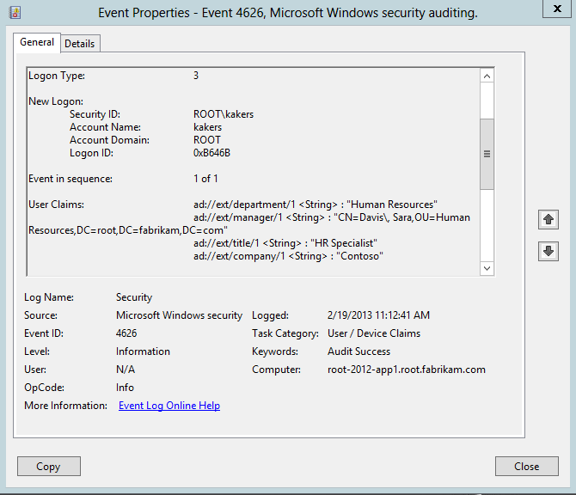
Figure 65 Audit event 4626 on the file server from a network authentication including claims.

Operational events
You can find another set of events to confirm the claims from an authorization token in the LSA operational event log. If you suspect claims at the file server differ from the claims reported in the cached logon on the client, then you can enable LSA operational logging to report the claims it received during creation of the authorization token.
Using the troubleshooting concepts found in the Logon as the User section of this document enables you view and confirm the domain controller is issuing the correct claims and ensure that string claim values match the values in conditional access control entries. You enable LSA operational event logging using the Event Viewer. Once opened, expand the Applications and Services Logs node, the Windows node, and the LSA node. Right-click the Operational node and click Enable Log.
The LSA operational event ID 301 contain claims related information for the user logon on the file server. From this event log, you can confirm the event lists all the user claims for the user and values of those claims are accurate.
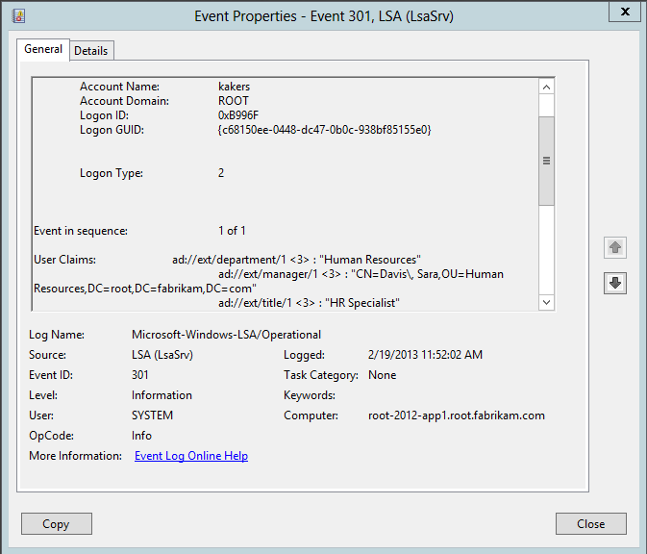
Figure 66 LSA operational event id 301 containing user claim information.
The event ID 300 is another event that Windows creates during logons in the LSA operational log. This event is similar to event ID 301; however, the information provided in this event corresponds to implied group memberships or contextual group memberships (remember group membership is actually a claim; therefore, groups inserted into the authentication token during its creation are also known as contextual claims).
Implied group membership is when Windows inserts the security identifier of the group into the authorization token during creation; the user does not have explicit membership to the designated group. A common example of contextual groups is the Domain Users group. By default, no user is explicitly a member of the Domain Users group. However, each users that successfully authenticates the domain has the security identifier for the Domain Users group in their authorization token because Windows insert this and other security identifiers in your token when it is created. Event ID 300 shows a list of all the contextual groups included in the authorization token during creation.
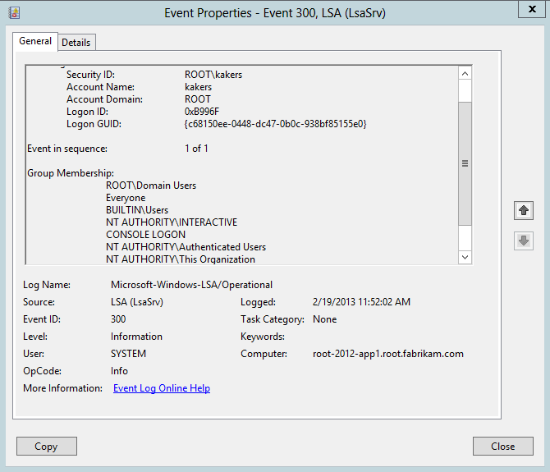
Figure 67 LSA operational event 300 display contextual groups from a logon.

Show User claims on the Client
Another way to determine if the user's token contains claim information is to use the WHOAMI.EXE command line utility with the /claims argument.
whoami /claims
You can use the output of the WHOAMI /claim command to confirm the environment is properly configured to support Dynamic Access Control. Claim information present in the output of the command's results confirms the domain controller can issue claims; however, additional configurations may be needed to support device claims or computer running earlier versions of Windows. The presence of claim information simply confirms the domain controller can issue user claims.

Use WHOAMI to Show User Claims
The WHOAMI command shows a list of claims and their values for the current user. The WHOAMI command does not show any information if there is not any claim information for the current user. If you expect to see claims and they are not shown using the WHOAMI command, then proceed to the Confirm Claims Processing portion of this document.
Note: | You can check the claims for a given security principal using Windows PowerShell and the WindowsIdentity .NET class library.  (New-Object System.Security.Principal.WindowsIdentity("upn_of_principal")).UserClaims  This command returns successfully regardless if the infrastructure is configured to support Dynamic Access Control. However, the results from the command do not show UserClaims for the user. This command uses SF4U2User

Figure 68 WHOAMI /CLAIMS for Sara Davis

Show User claims on the File Server
There are two important concepts to remember when troubleshooting access problems on a remote server: the user performs a network logon and the network logon occurs on the file server.
Running WHOAMI on the local computer confirms that a domain controller in the same site as the computer is configured to issue claims. However, this information could potentially change when the user accesses a share on a file server using Dynamic Access Control. The security principal, typically a user, authenticates to the file server using a network logon. This authentication occurs from the perspective of the file server. The Active Directory site in which the file server resides is the site used to discover a domain controller. The domain controller used by the file server must support Dynamic Access Control to use claim information for authorization decisions. Therefore, always run WHOAMI from the file server, as the user, when troubleshooting access to remote servers using Dynamic Access Controls.

Logon as the User
The easiest way to run the WHOAMI command in the context of the user is to use the RUNAS command from an elevated command prompt. Also, it's unlikely that you'll know the user's password.
To work around knowledge of the user's password, create a temporary copy of the problematic user account and troubleshoot with the temporary user account. Alternatively, you can change the user's password for troubleshooting and select the Change password at next logon options to reset their password after troubleshooting.
Use the RUNAS command on the file server to start a command window as the problematic user.
Runas /user:domainname\username cmd.exe
The command prompts for the user's password. Typing the correct password starts a command window under the credentials of the user.

Use WHOAMI to Show User Claims
Run the WHOAMI command in newly created command window for the problematic user.
The WHOAMI command shows a list of claims and their values for the current user. The WHOAMI command does not show any information if there is not any claim information for the current user. If you expect to see claims and they are not shown using the WHOAMI command, then proceed to the Confirm Claims Processing portion of this document.
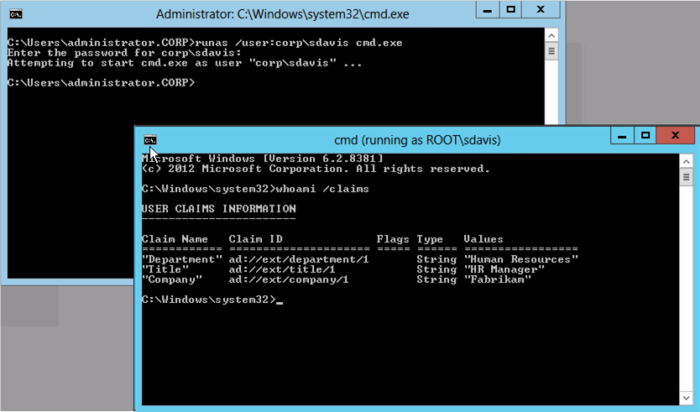
Figure 69 WHOAMI /CLAIMS from a RUNAS command window.

Confirm Claims Processing
There are many reasons why claims may not be present for the user. It is important not to troubleshoot into the problem any further until you confirm the domain controller issues claims for the user.
The most common reason for missing claims is a misconfiguration in one or more aspects of the environment. However, the environment has multiple points of configuration, which makes it difficult to a configuration point at which to begin. Windows 8 solves this problem by including additional authorization data for the user that we can use to determine if Windows claims processing completed successfully.

Claim Valid SID
Windows inserts a security identifier (SID) into the access token upon successful completion of claims processing. This SID only exists in the user's (or device's) PAC if you successfully configured the domain controller to support Dynamic Access Control. Again, you use the WHOAMI command to show the list if groups to which the user belongs, as well as any contextual groups (groups added during logon) for the access token.

Use WHOAM to Show User Groups
Use the WHOAMI command with the /groups argument to display the list of groups that are contained in the user's access token. You should perform this step on the file server as the user (see Logon as the User section).
Whoami /groups /fo list
The WHOAMI /groups command shows the list of groups from the user's access token. You want to look for the Claims Valid group, or a group with the security identifier of S-1-5-21-0-0-0-497.
Group Name: NT AUTHORITY\Claims Valid
Type: Well-known group
SID: S-1-5-21-0-0-0-497
Attributes: Mandatory group, Enabled by default, Enabled group
The presence of the Claims Valid group in the list of groups provides certainty that the domain controller issuing user claims was running Windows Server 2012 and that the domain is configured to support Dynamic Access Control.
The absence of the Claims Valid group in the list of groups provides certainty that the domain controller is not issuing claims. You should troubleshoot the infrastructure to diagnose why the domain controller does not observe your configuration to support Dynamic Access Control (see Infrastructure ).

User Claims traversing a Forest Trust
User's authenticating across a forest trust introduces additional complexity into diagnosing authorization issues. You should begin your troubleshooting in the forest where the user resides. Ensure your domain controllers in the user's forest support Dynamic Access Control and issue user claims. Do not troubleshoot the resource side of the forest trust until you are certain that the user's domain controllers issue user claims in their existing domain. Follow the beginning of this section using a computer and user from the user's forest.
Important: | Do not troubleshoot the resource side of the forest trust until you are certain that the user's domain controllers issue user claims in their existing domain.

Once you are certain the user forest's domain controllers support Dynamic Access Control and issue user claims, you should then troubleshoot user claims as they enter the trusting forest.
Remember from Claims Transformation and Policies sections the default claim routing for claims across a forest trusts. Trusted domains pass all claims while trusting domains drop all claims. It is important to establish the direction of the trust at beginning of your troubleshooting. Establishing the trusts is important because it provides the context of whether the claim is incoming (trusting) or outgoing (trusted). This distinction is important because it determines where you link Claim Transformation Polices.
You have established which domain is the trusted and trusting. Now, you need to use the Active Directory cmdlet Get-ADTrust to inventory the trusts in both domains. From the information collected using Get-ADTrust, verify if there is a Claims Transformation Policy object linked to either domain. Use Get-ADClaimTransformPolicy to collection information about any linked Claims Transformation Policy objects.

Claims Transformation Policy linked to the Trusted Domain
You have validated that domain controllers in the trusted domain can issue claims. Next, check that the trusted forest sends the claims across the trust. By default, trusted forests pass all claims to the trusted forest. However, an incorrectly configured Claims Transformation Policy could prevent the claims from flowing to the trusting domain.
Use the Get-ADTrust cmdlet in the trusted domain to confirm the domain does not have a linked Claims Transformation Policy. Unlink any linked Claims Transformation Policy in the trusted domain until you confirm claims flow across the trust and are issued in the trusting domain.
Important: | Unlink any linked Claims Transformation Policy in the trusted domain until you confirm claims flow across the trust and are issued in the trusting domain.

Check the Directory Services log on the domain controllers, but this time in the trusting domains. Look for event IDs numbered 2923, 2924, 2925, 2926, or 2950. These events indicate claims transformation engine dropped claims due to a problem with the transformation rule or policy.

No Claims Transformation Policy linked to the Trusting Domain
Claims do not flow across a forest trust without a Claims Transformation Policy linked to the trusting forest domain. If the infrastructure supports claims, then the Claims Valid groups should be present in the user token; however, claims are absence. This is the symptom of the forest domain dropping claims as then enter from the trusted domain.
Configure the trusting domain to allow claims across the trust by creating a simple Claims Transformation Policy that allows all claims using the New-ADClaimTransformPolicy cmdlet. Correctly link the newly created Claims Transformation Policy object to the in the trusting domain, to the trusted domain (see Lesson 9: Claim Transformations and Policies).

Claims Transformation Policies linked to the Trusting Domain
Claims only flow across a forest trust when the rules of the Claims Transformation Policy allow claims to pass. Rules on existing Claims Transformation Policy objects determine claims that it drops and claims that it passes. It is likely that an existing Claims Transformation Policy does not allow the claims to pass into the domain.
The easiest way to diagnose the Claims Transformation Policy as in the case where claims do not appearing in the token is to unlink the current Claims Transformation Policy, create a temporary Claims Transformation Policy object that allows all claims to pass, and link the temporary Claims Transformation Policy. Claims appearing after this configuration change are most likely dropped by the rule included in the Claims Transformation Policy.
Copy the rule from the production Claims Transformation Policy to the temporary Claims Transformation Policy. Continue modifying the rule and validating user claims using the temporary Claims Transformation policy until the rule produces the correct outcome. Transfer the new rule to the production Claims Transformation Policy with the understanding that the new rule becomes effective for all forest trusts where the Claims Transformation Policy is linked.
Important: | Claims Transformation Policy objects are linked to domain trusts. Modifying the rules on an existing Claims Transformation Policy affects claims across trusts where the policy you link the policy.

Alternatively, you can use the Get-ADClaimTransformPolicy cmdlet to display the rule of the currently linked Claims Transformation Policy object. Evaluate the rules against the list of claims gathered earlier when troubleshooting exclusively in the user's forest. This evaluation can determine the claims dropped by the Claims Transformation Policy and the claims passed by the Claims Transformation Policy.

Semantically Different Claim IDs
Domain controllers can only issue claims that are known in the forest. Claim types define claims for the forest. Claims traversing a forest trust begin in the user's forest and eventually arrive in the resource (trusting) forest. A trusting forest can only issue a claim from a trusted forest, in its forest, when the claim type created in its forest has the identical claim type ID. Create a claim type in the resource forest using the semantically identical claim ID type. Use a transformed-based claim type if you want do not want to use an Active Directory attribute as the source of the incoming claim.

Claims Transformation Problems
Claims filtered by either the lack of a Claims Transformation Policy or an incorrect rule included in a Claims Transformation Policy do not show in the Directory Services event log. These events are not errors and represent the transformation engine working correctly. However, claims dropped by the trusting domain due to an error with the transformation rule or Claims Transformation Policy is an error. Windows logs errors that occur during claims transformation processing to the Directory Service event log.

Directory Services Event Logs
Check the Directory Services event log in the trusting forest. To this point, you are certain that the trusted domain issues claims and the trusted forest does not have any Claims Transformation Policies linked.
You should check the Directory Services log on the domain controllers, but this time in the trusting domains. Look for event IDs numbered 2923, 2924, 2925, 2926, or 2950. These events indicate claims transformation engine dropped claims due to a problem with the transformation rule or policy.

Summary
By now, it should be clear that authentication is critical to Dynamic Access Control functioning correctly. User's must receive claims when they authenticate for file servers to use claims to base authorization decisions. It is possible for authentication to occur and the user not receive claims in their access token. This is the likeliest of scenarios when Dynamic Access Control is misconfigured. You should only proceed to the next phase of troubleshooting when you are certain that the domain controllers successfully issue claims in the access token and you can view these claims using the troubleshooting tools described in this section.
Important: | Do not proceed further in the troubleshooting until you are certain your domain controller issues user claims. If traversing a trust, ensure your claims and traverse the trust.

Critical: | Windows Server 2012 domain controllers do not issue claims when the authentication method uses NTLM. The authentication method must use Kerberos for the Windows Server 2012 domain controller.

Access Problem
A user's inability to access files and folders using Dynamic Access Control is complicated by virtue of how multiple components interoperate. You should only troubleshoot access problems after you have confirmed the infrastructure supports and is configured to use Dynamic Access Control (see Infrastructure), and you have confirmed that domain controllers issue user claims with correct information (see Authentication).

Effective Access
Your first troubleshooting step after confirming the infrastructure is correct and authentication issues claims is to use the Effective Access tab from the Advanced Security Settings editor. The Advanced Security Settings editor accounts for explicit conditional expression permission entries, Central Access Policies and their associated rules, share permission, and user and device claims. The Advanced Security Settings editor remotely tells a file server to simulate a logon of the user and device selected, inserts additional user and device claims in the evaluation, and gathers permissions from the file system, share, and Central Access Policies.
The Effective Access tab represents the easiest way to diagnose problems with users accessing files and folders on Windows Server 2012 file servers. Use the results from the Effective Access tab to which aspect of access control to troubleshoot next. Typically, the Effective Access tab identifies possible problems with red X's in the Access limited by column.
The Effective Access dialog's Access limited by column for file system resources can show Share, File Permissions, and the names of any Central Access Policy that applies to the file folder on the file server. The Access limited by column indicates the point of access control Windows believes is responsible for limiting access to files or folders.
The Effective Access tab lists all points of access control that limits the specified permission for the designated security principal (and device, optionally). Therefore, each entry in the Access limited by column can show one, or more limitations. Each limitation listed either specifically limits the security principal's access or does not provide access to the security principal.
For example, a security principal that is implicitly denied access occurs when none of the points of access control provide access. In this scenario, the Effective Access tab shows limitations for all points of access control (Share, File Permissions, and Central Access Policies applied to the folder). Each point of access control requires investigation to ensure it allows the security principal the designated access.
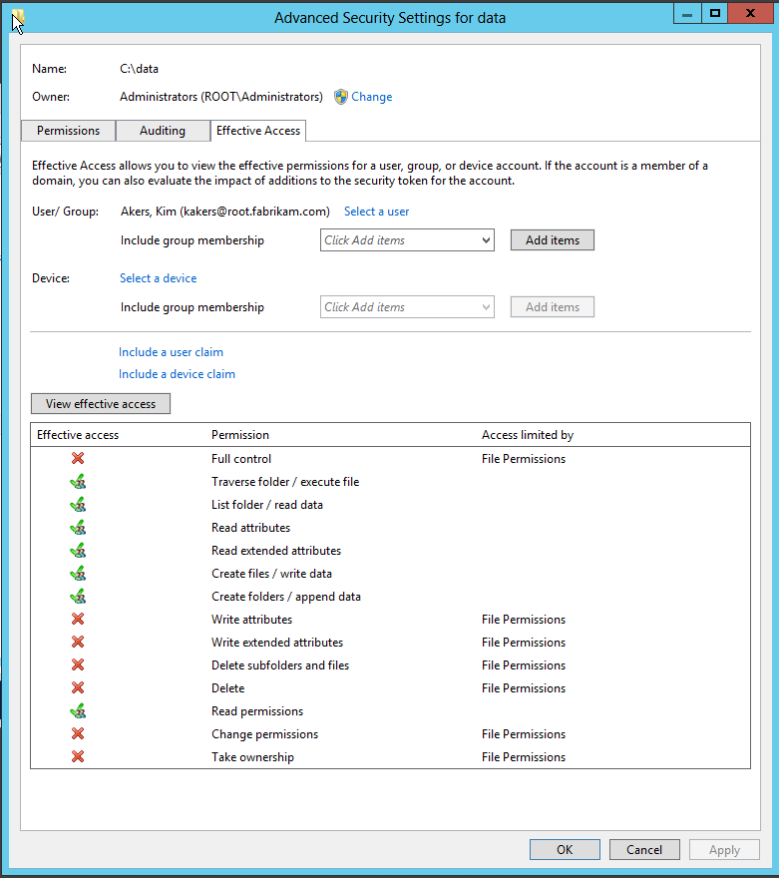
Figure 70 Effective Access tab used for troubleshooting.

Manual Evaluation
Alternatively, you can manually evaluate effective permissions of a user's access to a file and folder. Use the claim information gathered during infrastructure troubleshooting with share, file, and Central Access Policy permission entries.

Allow and Deny Type Permission Entries
Windows 8 canonically orders permission entry types in the same manner as previous version of Windows. Canonical ordering of permissions creates the precedence observed when a user accesses a resource. Deny type permission entries are ordered before Allow type permission entries.

Explicit Permissions vs. Inherited Permissions
Permission entry inheritance is included in canonical ordering, which creates the precedence observed when accessing a resource. Explicit permission entries configured higher in the file system, such as the root of the volume, can propagate to folder and sub folders beneath it. Windows orders explicit permissions first in the list, while observing Allow and Deny type ordering.
Windows then orders inherited permission entries reverse of the order in which they are inherited, while observing Allow and Deny type ordering. This equates to permission entries inherited from the parent folder ordered before permission entries inherited from the grandparent folder, and subsequent folders higher in the hierarchy. Therefore, permission entries inherited furthest from the current folder are ordered at the bottom while permission entries inherited closest to the current folder are ordered to the top of the list of inherited permissions. To summarize, the rules of canonical ordering are:
- Explicit Deny type permission entries
- Explicit Allow type permission entries
- Inherited Deny type permission entries from the parent
- Inherited Allow type permission entries from the parent
- Inherited Deny type permission entries from the grandparent
- Inherited Allow type permission entries from the grandparent
- Allow and Deny inheritance continues to traverse upward until it reaches the root of the volume

Conditional Permission Entries
Conditional permission entries are applicable to users and computers when:
- The principal on the permission entry matches the user or one of the groups listed in the user's access token
- The conditional expression, if present, in the permissions entry must evaluate to true

Effective Permissions without Central Access Policy
You calculate effective permissions without Central Access Policies in the same manner as with previous versions of Windows. Permissions common in both share and file system permission entries combined (ANDed together), which results with the most restrictive permissions to files and folders (see Evaluating Effective Permissions).

Effective Permissions with Central Access Policy
You evaluate effective permissions with Central Access Policies in the same manner-- you simply consider yet another set of permissions entries to determine effective permissions. Using Central Access Policies, you aggregate permissions common among share, file system, and Central Access Policies permission entries (ANDed together), which results with the most restrictive permissions to files and folders (see Evaluating Effective Permissions).

Summary
The methods of troubleshooting access problems in Windows Server 2012 has not changed significantly, but the infrastructure has. Dynamic Access Control introduces server and infrastructure needs that must be in place and working before Windows can provided access using Dynamic Access Control. There are only subtle differences to consider with determining effective permissions.

Common Misconfigurations

Central Access Policy and Rules
Central Access Policies enable you to central configure and deploy Central Access Rules to file servers. Central Access Rules contain current and proposed permission entries. You use current permission entries as additional means to configure access to file system resources. You use proposed permission entries to model future permission entries to determine how proposed permission entries would affect access in the production environment, if they were the current permissions in the Central Access Rule.
Common misconfiguration issues regarding Central Access Policy include:
- Missing membership of one or more Central Access Rules.
- The Group Policy object containing the Central Access Policy object does not apply to the file server.
- Broken or latent Active Directory and/or Sysvol replication.
- The conditional permission entry in the Central Access Rule evaluates to false, which results in the rule not providing access to the security principal.
- The Target Resources condition in a Central Access Rule evaluates to false, which prevents the Central Access Rule from being applicable to the folder protected by the Central Access Policy.
You resolve the previously listed misconfigurations by reviewing the Managing and Deploying Central Access and the Advanced Security Settings and Conditional Expressions sections. Misconfigurations like missing Central Access Rule memberships or incorrectly authored conditional expressions are resolved by understanding their implementation, as their implementations are correct, but the results they produce are incorrect. Other aspects of these misconfigurations involve troubleshooting technologies upon which Dynamic Access Control and Central Access Policy are dependent.
Central Access Policy has significant dependencies on other technologies. Troubleshooting dependent technologies is outside the scope of this document. Troubleshooting skills needed to be successful to troubleshoot Central Access Policy dependencies include:
- Active Directory and Active Directory replication
- Sysvol replication (including File Replication Service and Distributed File Replication Service)
- Network protocols (example TCP/IP, LDAP, RPC, and SMB)
The following topics are known behaviors and configuration issues specific to Central Access Policies and Central Access Rules.

Behaviors

Users cannot see files after a Central Access Policy is applied to a shared folder
This symptom describes a scenario where a file server hosts a shared folder to which user often access. A Central Access Policy is deployed to the file server and applied to folders. Users now report that their data is missing. Users have access to the shared folder, but they cannot see the data in the shared folder.
This scenario exists when Central Access Policies are combined with Access Based Enumeration. Windows evaluates the effective permission entries common among share permissions, file permissions, and current permissions included in Central Access Rules that are deployed using Central Access Policies. The additional permissions can disallow the user's access to the files and sub folders on the file server. The user's perception is that their data is missing.
The behavior common because Access Based Enumeration is enabled on the shared folder, which is designed to hide folders to which the user does not have access. Use Server Manager, File and Storage Services role, Shares to modify the properties of the share and disable Access Based Enumeration.
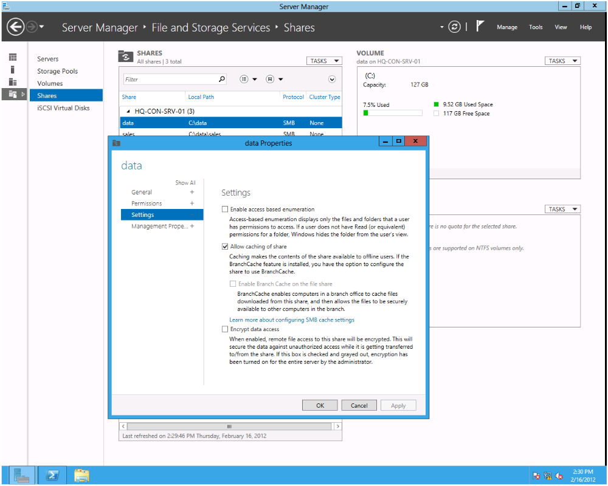
Figure 71 Configuring Access Based Enumeration using Server Manager

Central Access Policy disallows access when it was not expected
You deploy Central Access Policy objects to file servers to further control user access to files and folders. Central Access Policy use Central Access Rules to apply permission entries to files and folder through Central Access Policy and Group Policy. Applied permission entries in Central Access Rules are combined with share and file system permissions to determine the user's effective access to files and folders.
After deploying a Central Access Policy, users may no longer have access to files and folders, while the expected behavior is they should have access to files and folders.
You resolve this scenario similarly to troubleshooting a general access problem. However, you have identified that the only change to the environment is the deployment of a Central Access Policy to the file server.

Event Logs
First, use event viewer and review the Security-Audit-Configuration-Client event log. Confirm Group Policy applied Central Access Policy objects by locating an event with an event ID 202 that includes the names of the applied Central Access Policy objects.
An event with an event ID of 209 present in the event log, or the absence of any event with an event ID of 202 should be investigated. Using the event viewer, review the System event log for events with event ID's 6145 or 6147 and with the event source LSA. These events provide more information to help diagnose why Central Access Policies failed when applying to the computer.

Central Policy Tab
In this scenario, on the file server, use the Central Policy tab and target the Advanced Security Settings editor on the folder to which you deployed the Central Access Policy.
The tab should show the name of the applied Central Access Policy. If the Effective Access tab shows Central Access Policy ID( looks similar to a security identifier), then validate the Central Access Policy was created and deployed correctly, and Active Directory replication correctly works the domain controller contacted by the file server.
If the Central Policy tab shows the name of the Central Access Policy, then use the Effective Access tab to identify what point of access control limits the security principal's access. Understand that you may need to insert contextual device or user claims, such as @user.smartcard == true, using the Effective Access tab to simulate claims that are only included during real-time access check and not during the simulated logon performed by the Effective Access tab.

Central Access Policy allows access when it was not expected
You deploy Central Access Policy objects to file servers to further control user access to files and folders. Central Access Policy use Central Access Rules to apply permission entries to files and folder through Central Access Policy and Group Policy. Applied permission entries in Central Access Rules are combined with share and file system permissions to determine the user's effective access to files and folders.
After deploying a Central Access Policy, users are allowed access to files and folders, while the expected behavior is they should be disallowed access to files and folders.
Reviewing the Managing and Deploying Central Access to determine if the Central Access Policy was properly created and deployed.

Event Logs
First, use event viewer and review the Security-Audit-Configuration-Client event log. Confirm Group Policy applied Central Access Policy objects by locating an event with an event ID 202 that includes the names of the applied Central Access Policy objects.
An event with an event ID of 209 present in the event log, or the absence of any event with an event ID of 202 should be investigated. Using the event viewer, review the System event log for events with event ID's 6145 or 6147 and with the event source LSA. These events provide more information to help diagnose why Central Access Policies failed when applying to the computer.

Advanced Security Settings Editor
You can confirm the file server can lookup Central Policy object on a domain controller by targeting the Advanced Security Settings editor on the file server to the folder where Windows incorrectly allows access. However, if there is a problems specific to Central Access Policies or Rules may require specific troubleshooting.

Central Policy Tab
The Central Policy tab appears on any file server to which you applied a Central Access Policy using Group Policy. If that tab does not appear in the Advanced Security Settings editor, then the file server has not successfully received a Central Access Policy. You should troubleshoot Group Policy and ensure the Group Policy object containing the Central Access Policy applies to the file server. You can start in this direction by running GPUPDATE /FORCE from an elevated command prompt. The command prompt must be elevated to refresh computer policy, which is the scope to which you deploy Central Access Policy objects.
The Central Policy tab should show the name of the Central Access Policy applied to the file server. If the Central Policy tab shows the Central Access Policy ID (looks similar to a SID), then there is a problem with the file server looking up the Central Access Policy on the domain controller. Windows treats unknown Central Access Policy as if they are not applicable to the folder, and access is based on share and file system permissions.
If the Central Access tab shows the name of the Central Access Policy, then lookups from the file server to the domain controller are working.

Resource Condition and Resource Properties
You need to confirm the resource conditions in the member rules of the Central Access Policy apply to the folder to which you assigned the Central Access Policy. You can use the Active Directory Administrative Center to view the Central Access Rules that are members of the problematic Central Access Policy. Alternatively, you can use the Get-ADCentralAccessPolicy cmdlet to show the member rules of a Central Access Policy and then use the Get-ADCentral AccessRules cmdlet to show the resource condition of each member rule.
You evaluate the conditional expression in the resource condition against the resource properties of the folder. You view the Resource Properties of a file or folder using the Classification tab using Windows Explorer on the file server. On Windows Server 2012 servers, the Classification tab appears on the properties of a file or folder if you have the File Server Resource Manager installed from the File Services role, or you install Desktop Experience from the User Interfaces and Infrastructure feature, and you enabled the File Classification Infrastructure: Display Classification tab in Windows Explorer policy setting enabled.
Alternatively, you can view the resource properties using Windows PowerShell
$fobj = new-object -comobject FSRM.FSRMClassificaitonManager
$fobj.EnumFileProperties("c:\data")
Verify the resource conditions of the Central Access Rule apply to the folder based on the Resource Properties of the folder

Device Claims and Contextual Groups
Effective Access performs a simulated logon that does not consider device claims and contextual groups. Device claims are claims included in authorization data based on the computer from which you access the file server. Contextual groups are security identifiers that are inserted into authorization data during the authentication process, such as the Claim Valid group. You need to account for these pieces of authorization data and understand this data could be preventing the user from accessing the folder.
Use the Effective Access tab and manually insert device claims for the computer when evaluating effective access to the folder. You can view the device claims for the computer using the following Windows PowerShell command.
$(new-object System.Security.Principal.WindowsIdentity("computer@fqdn")
Use the WHOAMI utility with the /GROUPS argument to list the groups from the security principal and compare the list if groups to the principals on the permissions on the share, file system, and Central Access Rules. Use the Advanced Security Settings editor to view share and file system permission entries. Alternatively, you can use Windows PowerShell cmdlets to gather the appropriate information. Use the Get-Acl cmdlet to display file system permissions. Use the Get-SmbShareAccess cmdlet to view share permissions. Use the Get-ADCentralAccessRules cmdlet to view current permissions of Central Access Rules.
Critical: | ICACLS does not show conditional expressions in the default output. If you use ICACLS to display permissions on a file or folders, then you must use the /SAVE argument to output the SDDL format in a file.

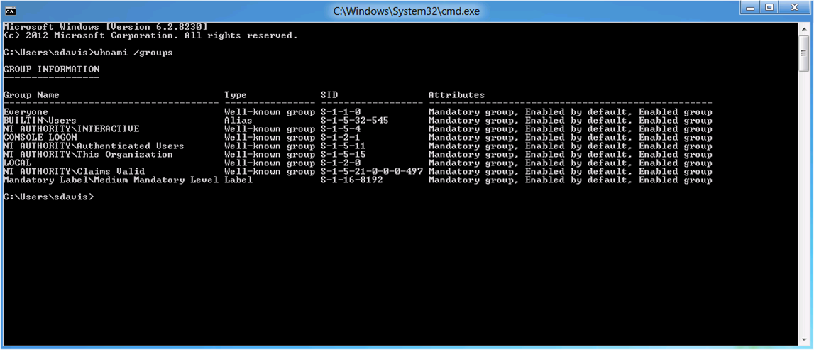
Figure 72 WHOAMI /groups for Sara Davis

Configuration Problems

Central Access Policy not visible in the GP Management
The Group Policy infrastructure is responsible for applying Central Access Policy objects to Windows Server 2012 file servers. You use the Group Policy Management Console and the Group Policy Management editor to configure Central Access Policy Deployment. There are instances where Central Access Polices may not appear in the Group Policy Management Editor.

Group Policy Object Anatomy
To better troubleshoot this scenario, you must understand the basic anatomy of a Group Policy object, how they are stored, and how they propagate throughout the domain. Central Access Policy objects are objects stored in the configuration partition of Active Directory. However, Central Access Policy deployed using Group Policy is a text file that contains a list of Central Access Policy objects assigned to the Group Policy objects on the domain controller's Policies folder of the Sysvol shared folder. The text file, CAP.INF, contains a list of distinguished names of Central Access Policy objects. The actual Central Access Policy configuration remains stored in Active Directory.

Group Policy Management Editor
The Group Policy Management Editor uses two parts of information to display Central Access Policy. The editor reads the CAP.INF file when you click the Central Access Policy node under the File System, Security Settings of a Group Policy object. The Group Policy Management Editor then locates all Central Access Policy objects in the forest to show in Available Central Access Policies list. And the editor locates all the Central Access Policy objects listed in the CAP.INF file and shows them in the Applicable Central Access Policies list.

Domain Controller Connectivity
The Group Policy management tools require connectivity to a domain controller. You cannot edit a domain-based Group Policy object if the management tools cannot locate a writable domain controller. However, transient networking conditions can allow Group Policy management tools to open, but create errors contacting domain controllers when managing the deployment of Central Access Policy objects. Network connectivity to a domain controller is required to management view Central Access Policy objects in the Group Policy Management Editor.

Active Directory
As previously mentioned, Windows creates Central Access Policy objects in Active Directory. The Central Access Policy object can only appear in the Group Policy Management Editor if the object exists in the Central Access Policies container in the forest's configuration partition. Use the Active Directory Administrative Center or ADSIEDIT.MSC and locate the Central Access Policy in Active Directory. A deleted policy is the most likely cause of a missing Central Access Policy object. If your forest supports Active Directory Recycle Bin, then you use LDP.EXE to view recycled objects in the configuration partition. Then, use the Restore-ADObject cmdlet to restore the Central Access Policy object.

Active Directory and Sysvol Replication
The Active Directory Administrative Center creates Central Access Policy objects in Active Directory. The Active Directory Administrative Center performs this write operation on a single domain controller. Active Directory Replication is responsible for propagating this change to all other domain controllers. Active Directory replication intervals vary based on the type of replication. Intra-site (replication between domain controllers in the same site) replication interval defaults to 15 seconds. Inter-site (replication between domain controllers in different sites) defaults to three hours.
Central Access Policy objects may be missing from the Available Central Access Policies list because the objects have not replicated to the domain controller used by the Group Policy Management Editor. Close the Group Policy Management Editor and select a different domain controller. Edit the same Group Policy object containing the Central Access Policies and determine if the policies are visible in the list.
Central Access Policy objects may be missing from the Applicable Central Access Policies list because the CAP.INF has not replicated to the domain controller used by the Group Policy Management Editor. The Group Policy Management Console does not directly control which domain controller it using when writing to the Sysvol shared folder.
Sysvol shared folder access use the Distributed File System (DFS) client to select an active domain controller. Use Windows Explorer from the same computer from which you manage Central Access Policy deployment and open the properties of the domains Sysvol shared folder. Use the DFS tab to show the active domain controller. Directly view Sysvol folder on domain controller listed as the active domain controller in the DFS tab. Ensure the CAP.INF file is under the appropriate policy folder.

Central Access Policy staging events are not written in the Security event log
Central Access Rules, which you deploy using Central Access Policy objects, enable you to configure proposed permissions. Proposed permissions enable you to model future permissions in a production environment without affecting user access (See Modeling Central Access using Proposed Permissions). Proposed permissions combined with auditing produce audit events that you can aggregate to determine if the proposed permission accomplished the desired access. Audit events not appearing in the Security event log is typically a symptom of misconfiguring Central Access Policy.
It is important to remember that, when deployed correctly, Windows configured using Central Access Policy and proposed permissions only records audit events when the effective access resulting from the use of proposed permissions differs than the effective access resulting from the user of current permissions. Audit events are not recorded when the effective access from current and proposed permissions produced the same effective access.

Central Policy Tab
The Central Policy tab appears on any file server to which you applied a Central Access Policy using Group Policy. If that tab does not appear in the Advanced Security Settings editor, then the file server has not successfully received a Central Access Policy. You should troubleshoot Group Policy and ensure the Group Policy object containing the Central Access Policy applies to the file server. You can start in this direction by running GPUPDATE /FORCE from an elevated command prompt. The command prompt must be elevated to refresh computer policy, which is the scope to which you deploy Central Access Policy objects.

Auditing Enabled
You must enable staged Central Access Policy auditing to audit the effective access of Central Access Policy using proposed permissions. You configure this setting for the computer under Advanced Audit Policy Configuration in the Security Settings of a Group Policy object. Additionally, after configuring the security policy setting in the Group Policy object, you must deploy the Group Policy object containing the setting to the computer.
You can easily determine if you successfully deployed the Audit Central Access Policy Staging object access auditing setting by reviewing a resultant set of policy report for the computer created using the Group Policy Management Console or the GPRESULT.EXE command to determine the Group Policy settings that apply to the file server.
gpresult /h rsop.htm
Important: | You must run GPRESULT.EXE from an elevated command prompt to return computer's resultant set of policy.

Resource Properties
Windows Server 2012 enables you to use file classification data as part of the authorization data. File Classification data used in authorization decisions are known as secure Resource Properties. You configure secure Resource Properties using the Active Directory Administrative Center or Windows PowerShell. Once configured, you can apply values to configured Resource Properties two ways: the File Server Resource Manager and the File Classification Tab using Windows Explorer.
Important: | Troubleshooting Continuous File Classification using the File Server Resource Manager (FSRM) is outside the scope of this document.

Classification tab does not appear in Windows Explorer
You can use the Classification tab from the file properties dialog to classify files and folders. The Classification tab is installed with the Desktop Experience feature, or by installing the File Server Resource Manager (FSRM) role. By default, the Classification tab is not visible unless the FSRM is installed on the file server. You can override this behavior using a Computer Group Policy setting File Classification Infrastructure: Display Classification tab in Windows Explorer.

Classification Tab Installation
Ensure you have the feature or role that includes the Classification tab installed on the computer you are using to classify files and folders. Windows Server 2012 file servers have the Classification tab installed by either installing the File Server Resource Manager role, or by installing the Desktop Experience feature.
The Classification tab only appears on file servers where the File Server Resource Manager is installed. The Classification tab does not appear by on Windows 8 computers or Windows Server 2012 file servers where you install the Desktop Experience feature. To show the Classification tab in Windows Explorer, enable the File Classification Infrastructure: Display Classification tab in Windows Explorer policy.

Group Policy Results
You can easily determine if the computer or file server receives a Group Policy object containing the File Classification Infrastructure: Display Classification tab in Windows Explorer policy setting by reviewing a resultant set of policy report. You create the report using the Group Policy Management Console or the GPRESULT.EXE command to determine the Group Policy settings that apply to the file server.
gpresult /h rsop.htm
Important: | You must run GPRESULT.EXE from an elevated command prompt to return computer's resultant set of policy.

Classification Tab does not show newly configured Resource Property
The Classification tab reads Resource Property information from Active Directory when you start it for the first time. The tab caches the information it reads from Active Directory locally. The tab updates this information once an hour. Therefore, it is possible for the Classification tab not show newly configured resource properties.

Refresh the Local Cache
You may need to refresh the locally cached classification information to see newly configured Resource Properties to be visible in the Classification tab.

Using File Server Resource Manger
You can use the File Server Resource Manager (FSRM) management console to update the locally cached classification information. The classification information that is cached locally is updated when you open the FSRM management console. Alternatively, you can use the File Server Resource Manager module for Windows PowerShell to refresh the locally cached classification on Windows Server 2012 file servers that have the FSRM role installed. From a Windows PowerShell prompt, type the following cmdlet to update the locally cached classification information.
Update-FsrmClassificationPropertyDefinition

Using the Classification tab in Windows Explorer
You can configure Windows Explorer in Windows 8 and Windows Server 2012 file servers to show the Classification tab. This enables you to classify files and folders without installing the File Server Resource Manager role. In this configuration, the Classification tab updates its local cache classification information once an hour. The Classification tab saves the last time it synchronized the classification information in Active Directory to the locally cached information in the registry. To force the Classification tab to update its local cache with information from Active Directory, delete the following registry value name.
Registry Key: HKLM\Software\Microsoft\FileClassificationInfrastructure
Value Name: AdLastSync
Alternatively, you can use the REG.EXE command from an elevated command window to remove the ADLastSync registry value.
reg delete HKLM\Software\Microsoft\FileClassificationInfrastructure /v AdLastSync /f

Active Directory Replication
The Active Directory Administrative Center creates Resource Property objects in Active Directory. The Active Directory Administrative Center performs this write operation on a single domain controller. Active Directory Replication is responsible for propagating this change to all other domain controllers. Active Directory replication intervals vary based on the type of replication. Intra-site (replication between domain controllers in the same site) replication interval defaults to 15 seconds. Inter-site (replication between domain controllers in different sites) defaults to three hours.
Resource Property objects may be missing from the Classification tab because the objects have not replicated to the domain controller used by the Classification tab. Use the Change domain controller task from the Active Directory Administrative Center and check all the domain controllers in same site as the client show the missing Resource Property object. Alternatively, you can use advanced Active Directory troubleshooting skills and confirm that Active Directory replication for the domain is working correctly.

Resource Property List
Resource Properties are organized through Resource Property lists. You can configure computers running Windows 8 and Windows Server 2012 to use a specific Resource Property list. Newly create Resource Property objects that are not members of the Resource Property list used by these computers do not show in the Classification tab.
Determine if the computer received a Group Policy containing a custom Resource Property list configuration by reviewing a resultant set of policy report from the computer. You create the report using the Group Policy Management Console or the GPRESULT.EXE command to determine the Group Policy settings that apply to the computer.
gpresult /h rsop.htm
Important: | You must run GPRESULT.EXE from an elevated command prompt to return computer's resultant set of policy.

Look for the File Classification Infrastructure: Specify Classification Properties List policy setting under the computer configuration of the resultant set of policy report. The value shown in this setting is the Resource Property List used by the Classification tab. Windows 8 computers use the Global Resource Property list when they are not configured to use a specific Resource Property list.

Resource Property List Membership
The Classification tab only shows the members from the configured Resource Property list or the members of the Global Resource Property list when a specific list does not apply to the file server. Therefore, you need to make sure the newly created Resource Property is a member of the correct Resource Property list.
Use the Active Directory Administrative Center to view the memberships of the previously identified Resource Property list configured for the computer or file server. Verify the newly created Resource Property is a member of the Resource Property list applied to the computer or file server.
Important: | It is common for a Resource Property object to have multiple Resource Property list memberships. This enables you to configure specific computers to use specific lists where you can share Resource Properties across lists-- accounting computers only show Resource Properties relevant to classifying accounting data.  It is important to remember that when using Resource Properties for authorization that the Resource Property must be a member of the Global Resource Property list to use the Resource Property in conditional expressions.

Event Log
If the Classification tab continues not to show newly, created Resource Properties, check the Application event log for errors with an event source of SRMSVC. These events can be used to determine if the computer is having difficulty synchronizing classification data from Active Directory to its local cache.

Users cannot view or assign a Resource Property to a file or folder
Some users may have difficulties with viewing or assigning a Resource Property to files or folders. The inability to view or assign a Resource Property to a file or folder is a common symptom of a user with incorrect permission entries for the file or folder.
A user needs a permission entry that allows the user the basic Read permissions to view the Resource Properties on the file or folder. A user needs to have a permission entry that allows the user the basic Write permissions to modify or assign Resource Properties on a file or folder.

Global Object Access Auditing
Global Object Access Auditing provides enables you to configure and deploy centralized auditing on file system resources to computer running Windows 8 and Windows Server 2012. Audit events appear in the event the log when a) auditing is enabled and, b) the audited resource is configure to report success or failed audit events.

Audit events do not appear in the System event log
Global Object Access Auditing is configure and deployed using Group Policy. Typically, auditing events does not appear in the System event log because of a misconfiguration. The most common points of misconfiguration occur with deploying Group Policy or Group Policy does not apply, auditing is not enabled for the resource, or the resource is not configure to trigger success or failure audit events.

Enable Auditing
The first part of configuring auditing is to enable it. You must configure Windows to report success and failure audit events. Windows provides multiple categories through which you can enable specific types of auditing. You enable file system auditing using the Object Access category under Advanced Audit Policy Configuration in the Security Settings portion of a Group Policy object.
You configure Windows to audit the file system by enabling the Audit File System security policy setting. Use the Group Policy Management Console and the Group Policy Management Editor to enable this security policy setting to audit success, failures, or both events. Windows does not audit the file system if this security policy setting remains not configured. Ensure the type of audit event you expect to see in the event log is enabled in the auditing security policy setting. For example, you must enable success auditing in the security policy setting for success auditing entries to trigger a success event.

Configure Resources for Auditing using Global Object Access Auditing
The second part of configuring auditing is to configure the file system to report audit information. Each file on the file system has a list of audit entries that Windows uses to record audit events in the System event log. Audit entries define the type of audit (success or failure) and permissions for Windows audits (See Managing and Deploying Claims-based Global Access Auditing). Use Global Object Access Auditing to configure file system auditing for the entire computer, rather than each file or folder. The Global Object Access Auditing security setting is a list of audit entries that are deployed to domain-joined computers using Group Policy.
Use the Group Policy Management Console and the Group Policy Management Editor to verify the correct auditing entries exists in the Group Policy object. For example, an audit entry with the audit type of Failure with the Principal James Low and an Access of Write will only create a Failed audit event if:
- File System auditing is configured for Failure audits
- The user James Low is accessing the file
- The access James Low is attempting is one of the advanced permissions that comprises the basic Write permission
Ensure the auditing event you expect to see in the System event log has a corresponding audit entry configured in the File System Global Object Access Auditing security policy setting.

Conditional Expressions
Windows 8 and Windows Server 2012 enable you to configure conditional expressions on audit entries. Conditional expressions are Boolean expression included in an audit entry that evaluate user or device claims or resource claims to other user or device claims, Resource Properties, or constant values. The results of these evaluations act as an additional criterion of applicability.
Ensure the audit event you expect to see in the System event log is not limited by a conditional expression that evaluates to false. A conditional expression evaluating falsely does not trigger an audit event for the corresponding access and corresponding trustee.

Group Policy
Auditing and Global Object Access Auditing have a significant dependency on Group Policy. You use Group Policy to deploy auditing security policy setting and Global Object Access Auditing Settings to computer. You can easily determine if the computer or file server receives a Group Policy object containing the audit and Global Object Access Auditing policy setting by reviewing a resultant set of policy report. You create the report using the Group Policy Management Console or the GPRESULT.EXE command to determine the Group Policy settings that apply to the file server.
gpresult /h rsop.htm
Important: | You must run GPRESULT.EXE from an elevated command prompt to return computer's resultant set of policy.

Alternatively, you can use the AUDITPOL.EXE from an elevated command prompt to see the computer's audit and Global Object Access Auditing policy settings. To show the object access auditing configuration for the computer, run the following command from an elevated command prompt
auditpol /get /category:"Object Access"
To show if Global Object Access Auditing is applied to the computer, run the following command from an elevated command prompt
Auditpol /resourceSACL /type:File /view

Event Logs
You can further determine problems resulting from Global Object Access Auditing not creating audit events by examining the Security-Audit-Configuration-Client for event with event IDs 100 through 116.

Advanced Security Settings Editor
You use the Advanced Security Settings editor to manage permission and audit entries, to assign deployed Central Access Policy objects to folders, to manage conditional expressions in permission and audit entries, and to simulate effective access for a security principal to a folder.
The following section identifies common misconfigurations and known behaviors that may present challenges when using the Advanced Security Settings editor.

The Central Policy Tab is not visible or the Central Policy Tab does not show a specific Central Access Policy

Central Policy Tab
The Central Policy tab appears on any file server to which you applied a Central Access Policy using Group Policy. If that tab does not appear in the Advanced Security Settings editor, then the file server has not successfully received a Central Access Policy. You should troubleshoot Group Policy and ensure the Group Policy object containing the Central Access Policy applies to the file server. You can start in this direction by running GPUPDATE /FORCE from an elevated command prompt. The command prompt must be elevated to refresh computer policy, which is the scope to which you deploy Central Access Policy objects.
The Central Access tab only shows Central Access Policy objects that are configured in Group Policy objects and those Group Policy objects are deployed to Windows Server 2012 file servers. The most likely cause of this symptom is:
- The Group Policy containing the Central Access Policy did not apply to the computer
- The Group Policy is not configured with that Central Access Policy

Event Logs
View the events logs after confirming Group Policy successfully applies to the computer. On the file server, view the Security-Audit-Configuration-Client operational log under the Applications and Service Logs for events that detail the application of Central Access Policy objects to the computer during Group Policy processing. Events with an event ID value of 202 are informative events that identify the list of applicable Group Policy objects. Events with event ID values of 209 and 213 are error events. Error events containing an error value of 0xD0000505 are indicative of the Local Security Authority on the file server rejecting the Central Access Policy as invalid. The most common causes of an invalid Central Access Policy include:
- Either the Central Access Policy or member Central Access Rule was deleted from Active Directory, but remains configured
- The security information contained in the Central Access Policy is invalid—most likely missing an owner or a group, contains a deny permission entry, or is malformed
- The Central Access Policy object or member Central Access Rule object is missing a required attribute
A missing Central Access Policy from the Central Policy tab and a Security-Audit-Configuration-Client event log free of error event usually indicates that the Group Policy deployed to the file server did not apply to the computer, or the Group Policy object deployed to the file server is not configured with a Central Access Policy.
You can identify problematic Central Access Policies mentioned in the Securtiy-Audit-Configuration-Client event log by reviewing the System event log for an error event with an event ID value of 6145 and an event source of LSASRV. This event provides the distinguished names of all the Central Access Policy objects with which the Local Security Authority had problems.

Active Directory
Windows creates Central Access Policy objects in Active Directory. The Central Access Policy object can only appear in the Group Policy Management Editor if the object exists in the Central Access Policies container in the forest's configuration partition. Use the Active Directory Administrative Center or ADSIEDIT.MSC and locate the Central Access Policy in Active Directory. A deleted policy is the most likely cause of a missing Central Access Policy object. If your forest supports Active Directory Recycle Bin, then you use LDP.EXE to view recycled objects in the configuration partition. Then, use the Restore-ADObject cmdlet to restore the Central Access Policy object.

Active Directory and Sysvol Replication
The Active Directory Administrative Center creates Central Access Policy objects in Active Directory. The Active Directory Administrative Center performs this write operation on a single domain controller. Active Directory Replication is responsible for propagating this change to all other domain controllers. Active Directory replication intervals vary based on the type of replication. Intra-site (replication between domain controllers in the same site) replication interval defaults to 15 seconds. Inter-site (replication between domain controllers in different sites) defaults to three hours.
Central Access Policy objects may be missing from the Available Central Access Policies list because the objects have not replicated to the domain controller used by the Group Policy Management Editor. Close the Group Policy Management Editor and select a different domain controller. Edit the same Group Policy object containing the Central Access Policies and determine if the policies are visible in the list.
Central Access Policy objects may be missing from the Applicable Central Access Policies list because the CAP.INF has not replicated to the domain controller used by the Group Policy Management Editor. The Group Policy Management Console does not directly control which domain controller it using when writing to the Sysvol shared folder.
Sysvol shared folder access use the Distributed File System (DFS) client to select an active domain controller. Use Windows Explorer from the same computer from which you manage Central Access Policy deployment and open the properties of the domains Sysvol shared folder. Use the DFS tab to show the active domain controller. Directly view Sysvol folder on domain controller listed as the active domain controller in the DFS tab. Ensure the CAP.INF file is under the appropriate policy folder.

Registry Settings
As previously mentioned, Central Access Policy objects deployed through Group Policy are stored in the CAP.INF file the shared Sysvol folder of domain controllers. During Group Policy processing, the Central Access Policy Configuration Group Policy client-side extension reads the distinguished names of each Central Access Policy stored in the CAP.INF file and then hands this information to the Local Security Authority.
The Local Security Authority uses the distinguished names to read each Central Access Policy object and it’s linked Central Access Rules from Active Directory. The Local Security Policy determines there are changes among the Central Access Policy objects or the linked Central Access Rules and updates the values in memory and writes the inventory of Central Access Policy and Central Access Rules to the registry. Any error encountered by the Local Security Authority during this process cancels the entire update and write to the registry. Canceling the update process leaves the last known Central Access Policy and Central Access Rules in use and present in the registry.
The Advanced Security Settings editor uses the following registry values to determine if it should show the Central Access tab and what Central Access Policies it should in the tab. You can confirm that Group Policy applies and that the Central Access Policy Configuration Group Policy client-side extension work by monitoring the following registry value for changes immediately following a GPUPDATE /FORCE command from an elevated command prompt.
Registry Key: HKLM\System\CurrentControlSet\Control\Lsa\CentralizedAccessPolicies\CAPEs
HKLM\System\CurrentControlSet\Control\Lsa\CentralizedAccessPolicies\CAPs

The Conditional Expression editor does not show a specific claim type
The Advanced Security Settings editor retrieves claim type and Resource Property information from Active Directory and displays them appropriately with a User, Device, or Resource condition statement. There are known behaviors that are symptoms of misconfigurations. This behaviors and increases your frustration when using the Advanced Security Settings editor and with the overall deployment of Dynamic Access Control.

Domain Connectivity
Windows stores all User and device claims as well as Resource Properties in the Active Directory configuration partition. As previously mentioned, the Advanced Security Settings editor reads this information to display the appropriate claim type and resource properties in the conditional expression editor portion of the dialog. The dialog depends on reading information from Active Directory. Therefore, network connectivity to a domain controller is required for the dialog to work correctly. Additionally, the information is stored in the domain. Therefore, you also need to ensure that the current security credentials used to view the dialog are domain credentials. Using the Advanced Security Settings editor with non-domain credentials or without network connectivity to a domain controller does not work.

Claim Types
The Advanced Security Settings editor only displays claim types that exist in Active Directory. You create user and device claim types using the Active Directory Administrative Center or Windows PowerShell. Both of these forms of management create claim type objects in Active Directory.

Claim Type State
A claim type object can be in one of two states: enabled or disabled. Disabled claim types are not issue by the domain controller and; therefore, are not inserted into the Kerberos ticket by the KDC. Furthermore, the Advanced Security Settings editor does not show disabled claim types in the conditional expression editor portion of the dialog. The Active Directory Administrative Center, by default, creates all claim types enabled. Claim types created using Windows PowerShell are disabled by default.

Claim Type Scope
All claim type object have a scope that defines their scope. A claim type’s scope determines the claim type’s applicability. Claim types apply to either a user, or user and other class objects such as computers and managed service accounts. Therefore, the User prefix in the Advanced Security Settings editor only shows claim type objects where the msDS-ClaimTypeAppliesToClass attribute includes the distinguished name of the User class object from the schema partition.
For example, an attribute claim type sourced from the dNSHostName attribute does not apply to user class objects. Therefore, the conditional expression editor in the Advanced Security Settings editor does not show this claim type in the list of available claim types when you use the User prefix.
Verify that claim types not shown in the Advanced Security Settings editor exists in Active Directory and the claim type objects are enabled. Also, verify claim type scope is valid for the prefix you use in the conditional expression editor.

Resource Property
Resource Property objects are stored in Active Directory. Like claim type objects, Resource Property objects also have an enabled and disabled state. You can create Resource Property objects using the Active Directory Administrative Center or Windows PowerShell. The Active Directory Administrative Center, by default, creates all Resource Property objects enabled. Resource Property objects created using Windows PowerShell are disabled by default.
Verify the secure Resource Property not shown in the Advanced Security Settings editor exists in Active Directory. Ensure the secure Resource Property is enabled. Lastly, verify the Resource Property you want to appear in the Advanced Security Settings editor has the Is used for authorization check box selected.
Important: | You must decide if the Resource Property object is to be a secure Resource Property object at the time you create it. You cannot modify this configuration on an existing Resource Property object. You can only use secure Resource Property objects for authorization decisions.

Global Resource Property List
You can configure a Resource Property object as a member of multiple Resource Property lists. This enables you to deploy a specific set of Resource Properties to specific computers and file servers.
The Advanced Security Settings editor only shows the secure Resource Property members of the Global Resource Property list. Unlike the Classification tab, you cannot configure the Advanced Security Settings editor to use a different Resource Property list.
Verify the secure Resource Property is a member of the Global Resource Property list.

Active Directory Replication
The Active Directory Administrative Center creates claim type, Resource Property and Resource Property list objects in Active Directory. The Active Directory Administrative Center performs read and write operations on a single domain controller. Active Directory Replication is responsible for propagating this change to all other domain controllers. Active Directory replication intervals vary based on the type of replication. Intra-site (replication between domain controllers in the same site) replication interval defaults to 15 seconds. Inter-site (replication between domain controllers in different sites) defaults to three hours.
These objects may be missing from Advanced Security Settings editor because they have not replicated to the domain controller used by the Advanced Security Setting editor. Use the Change domain controller task from the Active Directory Administrative Center and check all the domain controllers in same site as the computer show the missing objects. Alternatively, you can use advanced Active Directory troubleshooting skills and confirm that Active Directory replication for the domain is working correctly.

Portions of the Advanced Security Settings editor are unavailable and I cannot change settings
There are some circumstances where portions of the Advanced Security Settings editor prevent you from making changes or limit the changes you can make to removing conditional expressions or permission and audit entries.

Domain Connectivity
Windows stores all User and device claims as well as Resource Properties in the Active Directory configuration partition. The Advanced Security Settings editor reads this information to display the appropriate claim type and resource properties in the conditional expression editor portion of the dialog. The dialog depends on reading information from Active Directory. Therefore, network connectivity to a domain controller is required for the dialog to work correctly. Additionally, the information is stored in the domain. Therefore, you also need to ensure that the current security credentials used to view the dialog are domain credentials. Using the Advanced Security Settings editor with non-domain credentials or without network connectivity to a domain controller does not work.
If you encounter the Unable to contact Active Directory to access and verify claim types error, then troubleshoot the domain connectivity problem (do not forget to consider firewalls as a source of the problem). Close and reopen the Advanced Security Settings editor to verify you have resolved the connectivity problem.

Edit Mode
The Advanced Security Settings editor has two modes: view and edit. The view mode shows permission or audit entries; however, you cannot modify them in the view mode. All entries are read-only when the Advanced Security Settings editor is opened in view mode. View mode is a symptom from one or more of the following:
- The selected permission entry is an inherited permission entry.
- You do not have permission to modify the permission entry.
Verify the permission entry is not an inherited permission entry. You can identify this symptom easily as the text on the Edit button changes to read View. Also, the Inherited from column in the Advanced Security Settings editor reads None. To edit the inherited permission entry, open the Advanced Security Settings editor on the file location shown in the Inherited from column.
Lacking permissions to edit a permission entry is easily resolved by granting permissions on the file or folder to the user. However, you may have permissions to edit the permission entry and simply need to elevate your token to enable the permissions and privileges needs to perform the edit. This option is available if the Advanced Security Settings editor shows the Change Permissions button. Click Change Permissions to change the mode of the Advanced Security Settings editor from view mode to edit mode.

Complex or Invalid Conditional Expression
You use the conditional expression editor in the Advanced Security Settings editor to author conditions based on claim types and Resource Properties that must evaluate to true for the permission entry to apply. The conditional expression editor allows you to author conditional expressions, group conditional expressions, and evaluate conditional expressions using Boolean operators such as AND. However, some conditions created with the condition expression editor can be too complex. Conditions too complex for the conditional expression editor result in only allowing you to remove the condition.

Unsupported conditions
Windows 8 does not support using the NOT operator in a conditional expression. Conditional expressions containing the NOT operator force the Advanced Security Settings editor into a limited edit mode. In this mode, the editor enables you to remove the permission entry that contains the unsupported conditional expression. The Advanced Security Settings editor prevents the use of any unsupported conditions. However, these conditions can be added using Security Descriptor Definition Language (SDDL) and Windows PowerShell.
You can use Windows PowerShell to correct the unsupported permission entry. This requires a firm understanding of the Security Descriptor Definition Language. Use the Windows PowerShell cmdlet to display the SDDL string of the permission entry. Remove the unsupported condition from the string and then use the Set-Acl cmdlet to set the permission entries on the file or folder.
(get-acl –path:”path_to_folder_file”).SDDL
Another aspect of conditional expressions that may force the conditional expression editor into a limited edit mode is a condition that includes multiple levels of nested conditions. In practice, you want to keep conditional expression as simple as possible to ease processing and troubleshooting. As with an unsupported condition, the conditional expression editor enters a limited edit mode that enables you to fix the problem and then save the conditional expression.

Invalid Condition
The management tools included in Windows Server 2012 perform well at limiting invalid data during the creation of claim type objects, Resource Property objects, and conditional expressions. However, creating these objects using other means and APIs can in avertedly create objects and conditional expressions with invalid data. The Advanced Security Settings responds to invalid conditions by entering a limited edit mode. This limited edit mode allows you to fix the invalid condition, but otherwise prevents you from making any additional changes until you fix the invalid condition.

Unknown Claim Type or Resource Property
The Advanced Security Settings editor enables you to select claim type and Resource Property objects that you have previously created in Active Directory. Windows stores the conditional expression you create from these selections in the permission or audit entry.
Windows does not enforce any referential integrity check that prevents you from deleting a claim type or Resource Property object that is used by one or more conditional expressions. Therefore, it is possible to have conditional expressions that reference one or more claim type or Resource Property object.
Verify the claim type and Resource Property objects exists on all the Windows Server 2012 domain controllers in the same site as the computer from which you are managing. If the object exists on all domain controllers, then ensure the object in question is enabled on all domain controllers. The Advanced Security Settings editor considers disabled object as unknown objects. You may be able to recover accidentally deleted objects if the domain has the Active Directory Recycle Bin feature enabled at the time of the deletion. Otherwise, remove the unknown claim types or Resource properties from the conditional expression.

Incompatible Operators
Conditional expressions are essentially Boolean expressions that evaluate left-hand-side (LHS) value(s) against a right-hand-side (RHS) value(s). The operator that separates the two values determines the type of evaluation. All evaluations produce a result of true or false. For example, equal to operator(==) makes an evaluation that says the LHS value is the same as the RHS value. If both values are equal, then the conditional expression is true; otherwise, the conditional expression evaluates to false.
For expressions to determine things such as equality, greater than, or less than, the entity on each side of the operator must be compatible for comparison. Therefore, claim types and resource properties have underlying types, such as string, number, or Boolean, to help with evaluating like type objects. For example, a claim type with a source attribute represented as an integer is not compatible for evaluation with a claim type with a source attribute represented as a string (see Claim Data Types and Conditional Operators). The following table describes incompatibilities among data types and operators.
Table 26 Incompatible data types and operators
Operators | Compatible
EXISTS  NOT EXISTS | Only allowed for Resource Properties
ANY_OF | Allowed when the Resource Property or claim type on the LHS of the operator is an integer, multi-valued integer, string, or multi-valued string
CONTAINS | Allowed when the Resource Property or claim type on the LHS of the operator is multi-valued integer or multi-valued string
EQUALS  NOT EQUALS | Allowed when the Resource Property of claim type on the LHS of the operator is not multi-valued and the RHS is a single value
LESS THAN  LESS THAN OR EQUALS  GREATER THAN  GREATHER THAN OR EQUALS | Allowed when the Resource Property or claim type on the LHS of the operator is not multi-valued and is an integer and the RHS is a single value
MEMBER OF  MEMBER OF ANY | Allowed when the reserved user claim type Group is the LHS of the operator
DEVICE MEMBER OF  DEVICE MEMBER OF ANY | Allowed when the reserved device claim type Group is the LHS of the operator

Using Table 26, verify the operator selected in the conditional expression is compatible with claim type or Resource Property you want to use as the RHS of the expression. As a test, reverse the LHS and RHS values to see if the conditional expression editor still constrains the use of both values. Typically, the values are incompatible and you will need to reevaluate the data types used on values, especially on claim type and Resource Property objects configured with suggested values.
Important: | Resource Property object support multiple list-based data types. Be sure to use the Single-valued Choice data type for scenarios where only one value from a list of suggested values is valid.

Active Directory Replication
The Active Directory Administrative Center creates claim type, Resource Property and Resource Property list objects in Active Directory. The Active Directory Administrative Center performs read and write operations on a single domain controller. Active Directory Replication is responsible for propagating this change to all other domain controllers. Active Directory replication intervals vary based on the type of replication. Intra-site (replication between domain controllers in the same site) replication interval defaults to 15 seconds. Inter-site (replication between domain controllers in different sites) defaults to three hours.
These objects may be missing from Advanced Security Settings editor because they have not replicated to the domain controller used by the Advanced Security Setting editor. Use the Change domain controller task from the Active Directory Administrative Center and check all the domain controllers in same site as the computer show the missing objects. Alternatively, you can use advanced Active Directory troubleshooting skills and confirm that Active Directory replication for the domain is working correctly.

Help Desk or equivalent personnel cannot use the Effective Access tab
The Effective Access tab found on the Advanced Security Settings editor is a valuable tool you can use to troubleshoot access problems to files, folders, and files and folders through shared folders. The Effective Access tab can be a valuable for delegated administrators as well. The Effective Access tab provides intuitive error messages for the most common misconfigurations that prevent non-administrators from using the Effective Access tab.

The effective access rights shown are based on group membership on this computer. For more accurate results, calculate effective access rights on the target server.
A warning message with the preceding text indicates that the remote file servers does not support remote access check. The most likely cause of this symptom comes from the remote file server not running Windows Server 2012. Verify the remote file server is running Windows Server 2012.

The RPC server is unavailable. Please enable the Netlogon Service Authz (RPC) firewall rule on the target server and try again.
The Effective Access tab uses the RPC protocol to communicate with the remote file server. It is this communication that causes the remote file server to simulate effective access and return the results to the computer used to determine the effective access. Therefore, RPC communication from end-to-end is essential for the Effective Access tab to work correctly.
A warning message with the preceding text indicates that Netlogon Authorization RPC traffic cannot communicate with the remote file server. To resolve this problem, use the Windows Firewall with Advanced Security and enable the Netlogon Service Authz (RPC) inbound firewall rule on the file server.

You do not have permission to evaluate effective access rights for the remote resource. Contact the administrator of the target server.
You must have permissions to use the Effective Access tab, which is granted to file server administrators by default. You configure users to use the Effective Access tab by making the user a member of the Access Control Assistance Operators group on the file server. Verify the domain user is a member of the Access Control Assistance Operators groups on the file server. If you have confirmed the domain user is a member of the Access Control Assistance Operators group on the file server and the user remains unable to evaluate effective access for the remote resource, verify the following registry value is not present on the file server.
Registry Key: HKLM\System\CurrentControlSet\Services\Netlogon\Parameters
Value Name: RemoteAccessCheckDacl
Back up this registry value and then delete this registry value. Deleting this registry value returns the permission entries for remote effective permissions to their defaults, which allows members of the local Access Control Assistance Operators group to perform effective access remotely.

Help Desk or equivalent personnel cannot see information in the Share tab in the Advanced Security Settings Editor
The Advanced Security Settings Editor includes a Share tab that enables you to view the share permission entries for the share folder. This allows the Effective Access tab to incorporate share permissions in the effective access results. By default, file server administrators should be able to view share information in the Advanced Security Settings Editor.

The requested security information is either unavailable or can’t be displayed

File Server
If you are not a local administrator on the remote file server, then you may only use the Share tab to display share permissions on resource hosted in Windows Server 2012 file servers. Ensure the server hosting the targeted share is running Windows Server 2012.

Authentication
The Effective Access and Shares tabs require the connection to the remote server to use Kerberos. Ensure your connection to the file server is by name (computer name or fully qualified computer name) and not by the computer’s IP address.
Use the KLIST tickets command from an elevated command prompt on the client computer to display the list of Kerberos tickets. Verify a ticket exists with the following:
- The Client portion of the ticket contains the user principal name of the current user
- The Server portion of the ticket reports the service principal name (SPN) with the prefix cifs/ followed by the name of fully qualified computer name
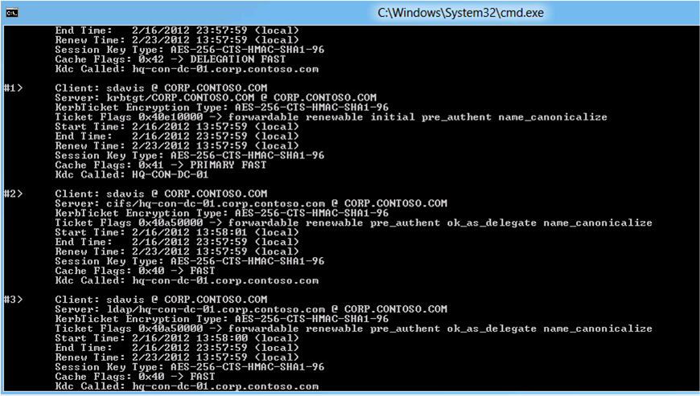
Figure 73 KLIST tickets output.

Firewall
The Share tab needs to communicate with the remote file server using Windows Remote Management. Verify a Windows Firewall rule exists and is enabled on the file server for Windows Remote Management. Continue to troubleshoot network connectivity as needed to ensure client-to-file server connectivity is operational, including simultaneous network traces on the client and fileserver.

Windows Remote Management
As previously mentioned, the Share tab depends on communicating with the file server using Windows Remote Management RPC. The dependency requires the Windows Remote Management service running on the file server. Verify the service is configured to start automatically and is running. You can use the SC command to query the configuration of the remote server
SC \\serverName query winmgmt

Remote Management
Non-administrators must be members of the Remote Management User group on the remote file server to view share permissions. Verify the user using the Share tab has membership to the Remote Management User group on the remote file server.

Share Permissions
Non-administrators must have Read share permissions to view share permissions of a file share on a remote file server. Verify the user using the Share tab has Read share permissions to the file share.

Troubleshooting Summary
Troubleshooting access issues is challenging because number of possible combination and permutation of file permission entries. Canonical ordering further complicates the scenario when evaluating effective permissions of inherited permission entries.
Troubleshooting Dynamic Access Control access issues begins with linear troubleshooting included in the General Troubleshooting Methodology portion of this document. This linear approach that includes:
- Validating the infrastructure supports Dynamic Access Control
- Verifying Kerberos authentication and claims issuance
- Investigate Access Problem
Access problems that do not include components specific to Dynamic Access Control, such as claims and Central Access Policy objects can begin with Access Problem section under the General Troubleshooting Methodology of this document as the infrastructure and authentication methods have little significance in the end result of authentication.

Infrastructure
Access issues using Dynamic Access Control begin with an infrastructure that supports using Dynamic Access Control. Configurations relevant to configuring the infrastructure to support Dynamic Access Control relevant to the infrastructure include:
- The operating system running on the domain controller
- The number of domain controllers
- The proximity of domain controllers relative to Windows 8 clients
- Dynamic Access Control Group Policy settings
- Active Directory configurations for claim types and Resource Properties

Authentication
Issues with user access and Dynamic Access Control can result from using the wrong authentication protocol, domain controller, or other common misconfiguration issues. Dynamic Access Control requires Kerberos authentication to issue user and device claims. Furthermore, Windows can pass or drop user and device claims when traversing forest trusts, which can produce symptoms of access problems.

General Access Problems
Access Problems represents issues that are not caused by infrastructure or authentication configuration issues. These issues are typically the result of a misconfiguring share, file system, or Central Access Rule permission entries that do not provide permission for the requested access. You should use access problem troubleshooting methods only when you have confirmed the infrastructure and authentication support the authentication.

